Relais:
Finder Relais per 547B, 10k Vorswiderstand an Basis

LED:
LED3 1300 GE
* 2,4 V, 20mA ==> 130 OHM Vorwiderstand bei 5V

Pinbelegung:
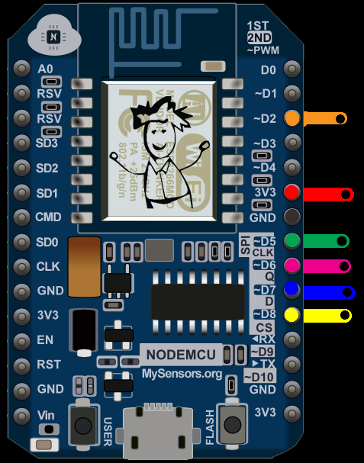
D3: LED
D4: Relais
Vin 5V
GND

NodeMCU
NodeMCU custom build by frightanic.com
branch: master
commit: 98d3b46e2c11068f361154a564ce75a048c9dadc
SSL: false
modules: file,gpio,net,node,pwm,tmr,uart,wifi
build built on: 2016-08-10 16:05
powered by Lua 5.1.4 on SDK 1.5.4.1(39cb9a32)

