Provisional Patent: Acetate Ester of 5-MeO-DMT
Title: Acetate Ester Derivative of 5-MeO-DMT for Psychiatric Therapy

Abstract
The invention relates to the acetate ester of 5-MeO-DMT, a serotonergic psychedelic prodrug designed to improve pharmacokinetics, stability, and therapeutic utility in neuropsychiatric applications. It provides synthesis methods, formulation guidance, pharmacodynamic rationale, and therapeutic use claims.

Chemical Structure
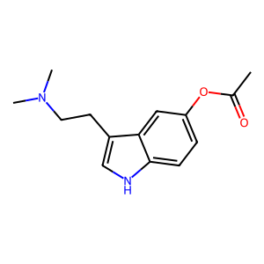
Figure 1. Structure of the Acetate ester analog of 5-MeO-DMT.

Background
Tryptamine psychedelics such as 5-MeO-DMT have shown therapeutic promise in treating various mental health disorders. However, limitations such as rapid metabolism and poor oral bioavailability can be addressed using prodrug strategies. The acetate ester may offer improved onset/duration profiles and stability.

Summary of the Invention
This patent discloses a novel acetate ester prodrug of 5-MeO-DMT with potential clinical use. It includes synthesis methodology, predicted pharmacokinetic improvements, and therapeutic uses.

Claims (Informal)
1. A compound comprising the acetate ester of 5-MeO-DMT.
2. A pharmaceutical composition comprising the compound.
3. A method of treating depression, PTSD, or anxiety using the composition.

