1. When you first execute the program you will see the following dialog.

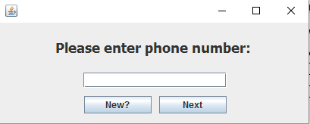

If you are a new customer simply push the ‘New?’ button.

If you are a previous customer, simply enter your phone number into the blank and click the next button and proceed to the 3rd step of this guide.

1. For new customers the following dialog will appear:

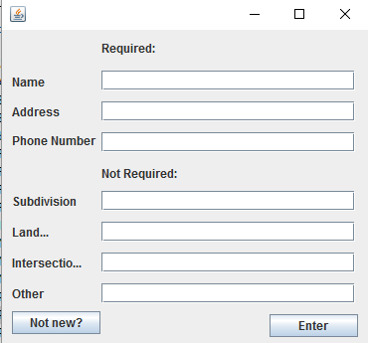

Simply fill out the fields into the blanks, being sure to enter the first and last name for the name field. The Optional fields can be filled out to give better directions to the person delivering your order, but is not necessary. After this step proceed to step 4

1. 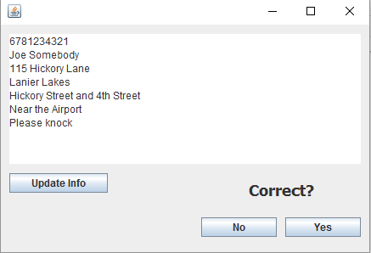

This dialog will pull your information from previous orders, if any information is incorrect simply click the update button to make changes. Once you are sure that the information is correct click yes to go to the next section.

1. 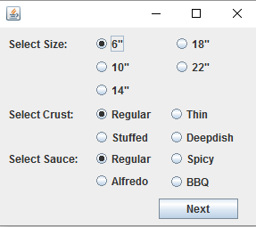  
   This dialog will ask for the size of your pizza, the type of crust and what kind of sauce you would like. Once you have made your selections you can click next.
2. 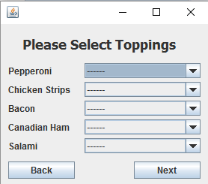  
   This dialog will give you the options to pick your toppings, if you don’t want a particular topping you can leave it as “-----“ Otherwise your options are the left side of the pizza, the right side, the whole pizza or to double the amount on the pizza. Once you have made your selections you can click next.
3. 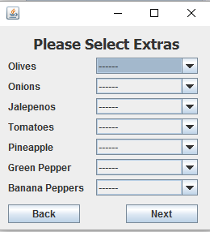  
   This dialog gives you the option to pick other toppings. The options are right side, left side, or whole pizza. Once again if you do not want an option simply leave the field as “-----“. Once you are finished you may click next.
4. 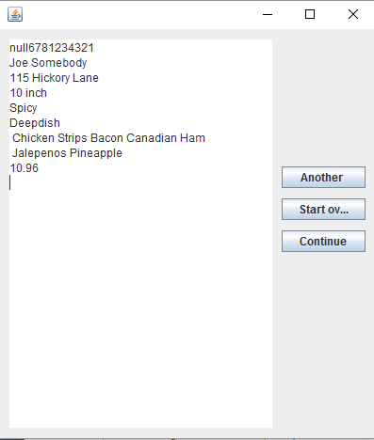  
   Now you are on a screen that shows your current order, and a total of how much it will be. If you would like to add another pizza, you can click “Another” if you want to start over with your order you can click “Start over” and if you are satisfied with your order click continue to go to the drink menu.
5. 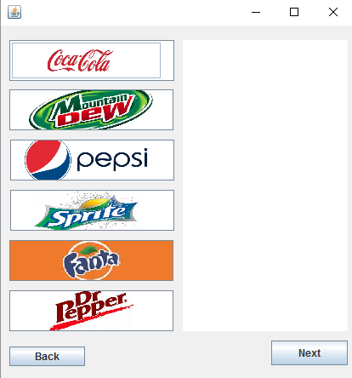  
   This is the drink menu, you can click on each logo to add a drink to your order, you can add multiples of each by clicking on it the desired times and each will show up on the right hand side. Once you are satisfied with your drinks you can click next. ( if you have made a mistake you can click continue and click change selection on the next dialog.
6. 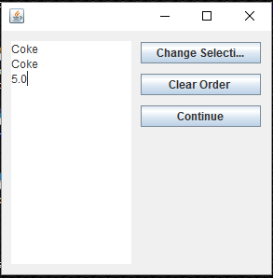  
   This is the conformation of your drink order, if you have made a mistake you can click on ‘Change Selection’ to return to the previous screen and make your correct drink selection. If you have changed your mind about your entire order, you can click ‘Clear Order’ to be returned to the beginning of the pizza creation process. Otherwise if you are happy with your selections you can click ‘Continue’.
7. 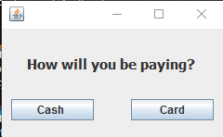  
   This is the next pop up that will come up that will ask you if you are paying with Cash or a Card. If You are paying with Cash the next window will be a dialogue showing your total and a final confirmation to complete the order. If you are paying with a card you will receive another pop up.
8. 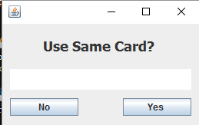  
   This will be the dialog you will receive when you select a card, if you are using the same credit card as before you can select yes, and it will charge your card from your previous order. If you are not using the same card, you will select No, and it will give you a dialog window to update your card information.
9. 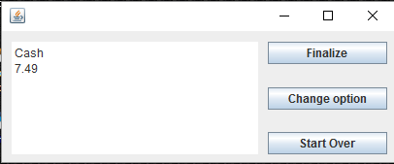  
   This is the dialog that will show you your payment option and the grand total of your order, If everything is correct you can click finalize order and it will take you to the very last screen.
10. 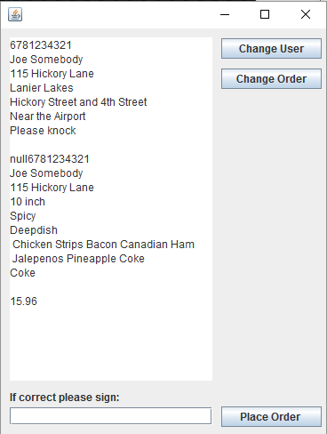  
    This is the final dialog at the end of your order. If everything is correct you just have to digitally sign the line at the bottom of the window and place the order. If there is any information that is incorrect about your information, you can click the ‘Change User’ button to make the appropriate changes to your information. If anything is wrong with your order you can click the ‘Change Order’ button to make changes to your order. Otherwise if everything is correct, just Place your order, sit back and relax and wait for your pizza order to be delivered to you.