# COMP 421

# DATABASE SYSTEM

# ONLINE BOOK STORE DATABASE

## ILAN BEN-BRITH 260478181

## JUSTIN DOMINGUE 260588454

## DANIEL PHAM 260526252

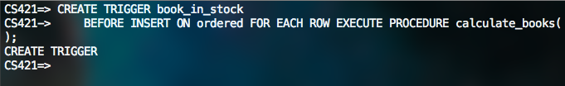

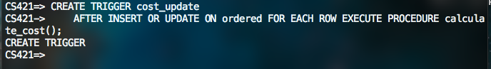

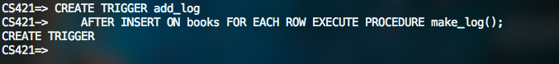

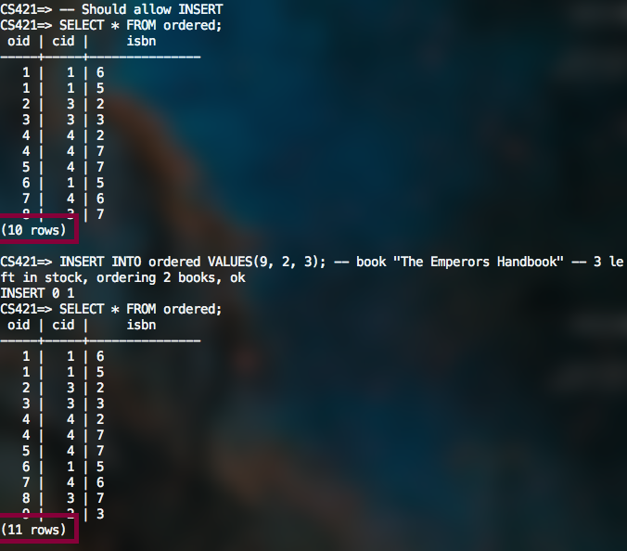

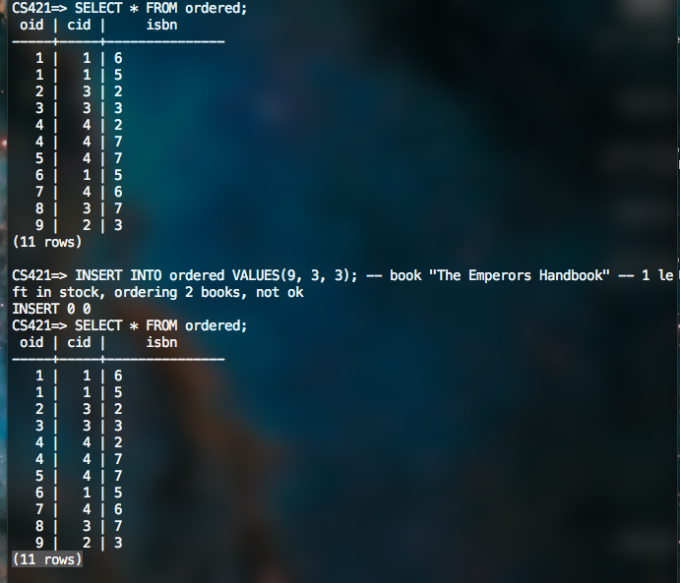

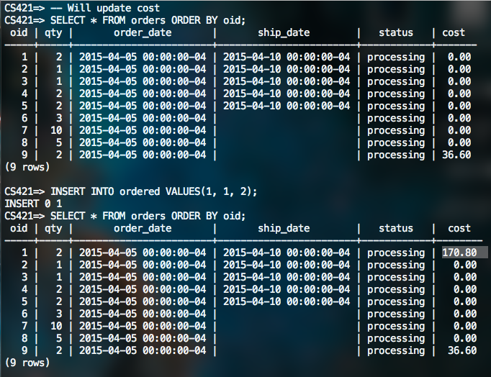

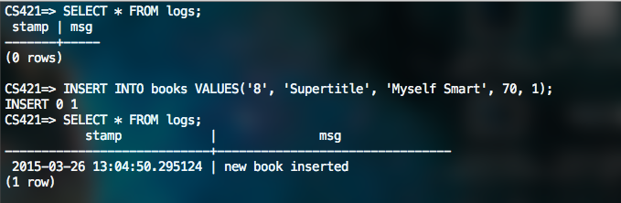

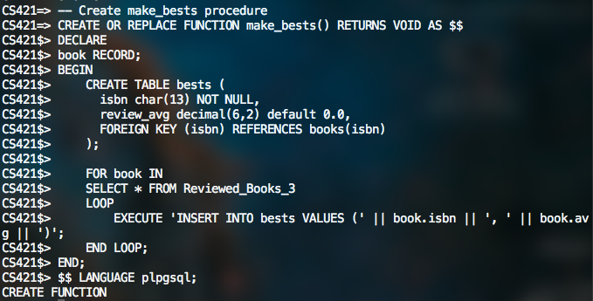

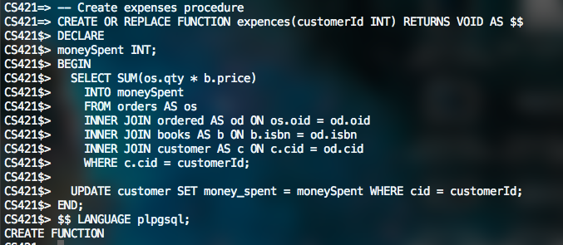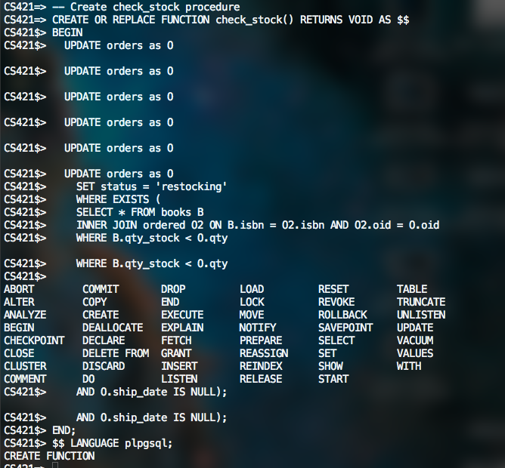

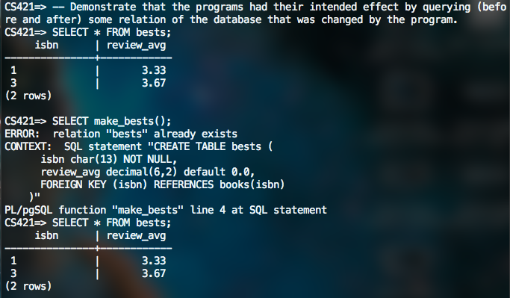

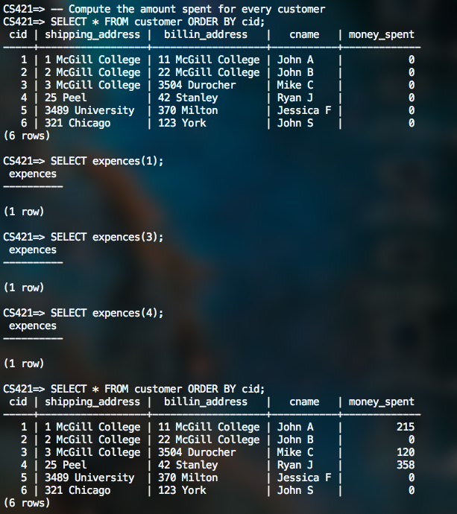

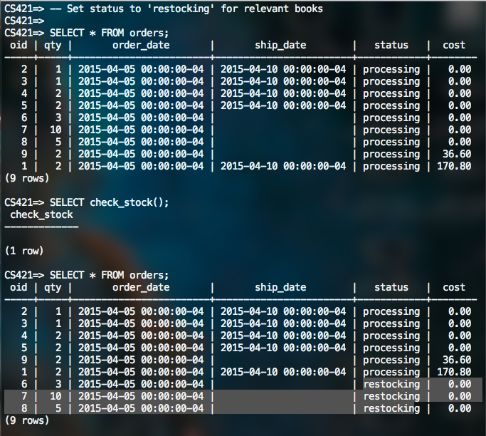

Macintosh HD:Users:justindomingue:Desktop:Screen Shot 2015-03-26 at 1.09.10 PM.png

Macintosh HD:Users:justindomingue:Desktop:Screen Shot 2015-03-26 at 1.09.23 PM.png

Macintosh HD:Users:justindomingue:Desktop:Screen Shot 2015-03-26 at 1.09.35 PM.png