Experiment 5

20th March 2019

Aim: To be able to write bash scripts

---------------------------------------------------------------------------------------------
---------------------------------------------------------------------------------------------

1. Write a shell script to show various system configuration like
1. Currently logged user and his login name
2. Your current shell
3. Your home directory
4. Your operating system type
5. Your current path setting
6. Your current working directory
7. Number of users currently logged in

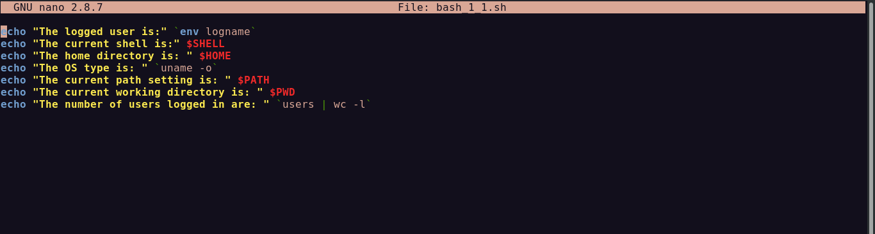
Most of the information can be got from the system environment variables. The variable names can be seen in the bash command env and can be seen using $<variable-name>

‘users’ returns all the logged on devices

The output is as follows:

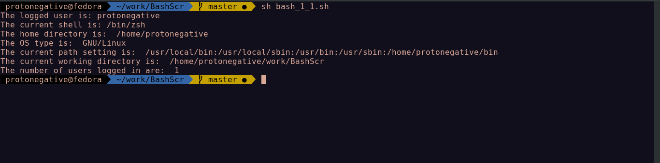

---------------------------------------------------------------------------------------------

2. Write a shell script to show various system configurations like
1. Your OS and version, release number, kernel version
2. All available shells
3. Computer CPU information like processor type, speed etc
4. Memory information
5. Hard disk information like size of hard-disk, cache memory, model etc
6. File system (Mounted)

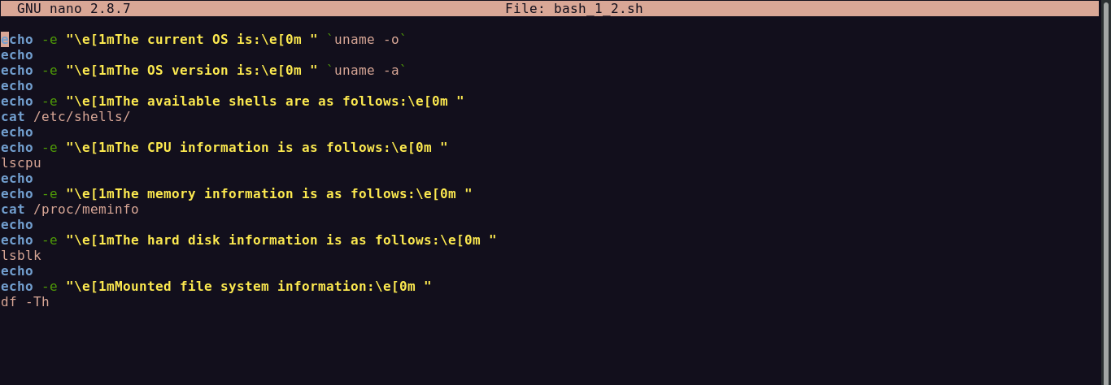
The OS information can be found using the command ‘uname’.
The file ‘shells’ in /etc contains all the available shells
The CPU information can be seen using lscpu
The memory information can be seen in the file ‘meminfo’ in /proc
The hard-disk info can be found using lsblk
The mounted file system information can be found using command df
The output is as follows:

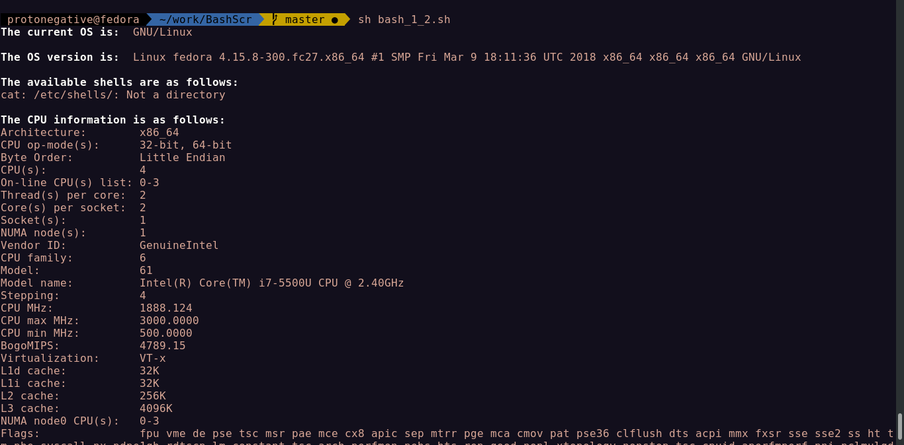
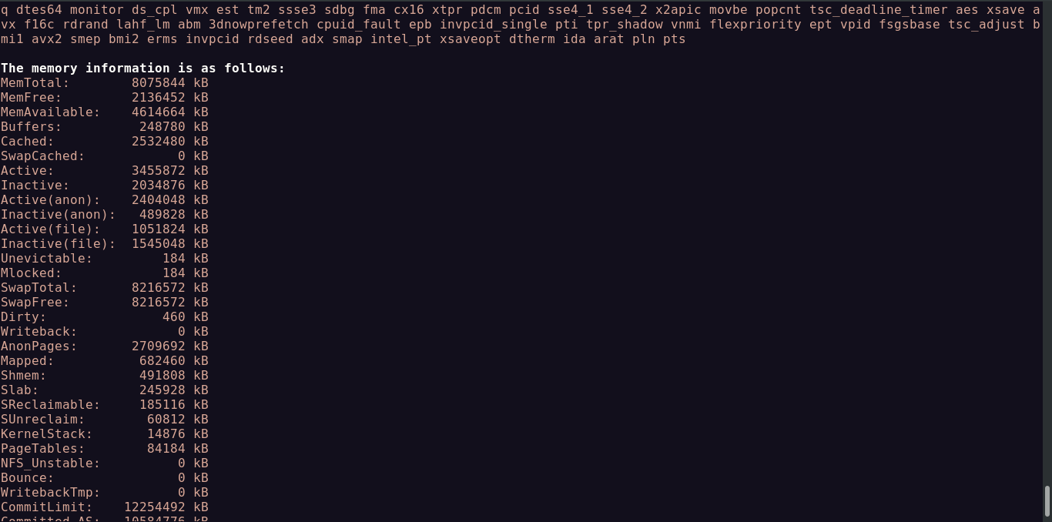

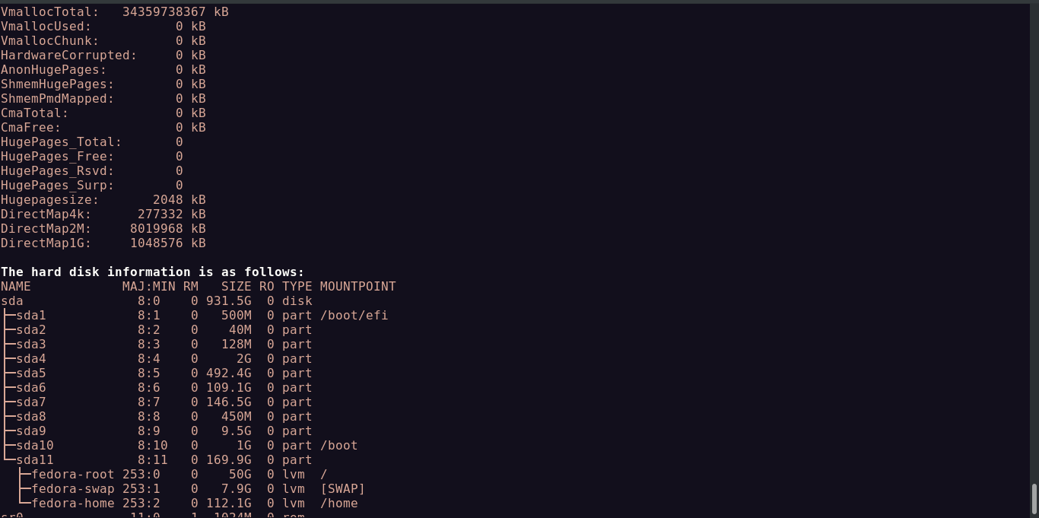

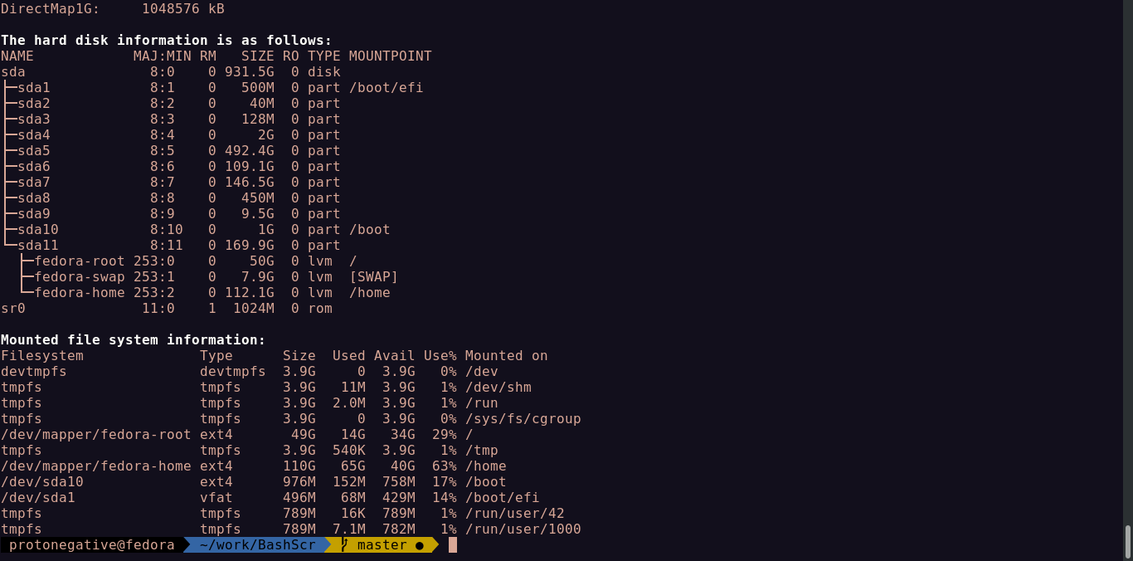

---------------------------------------------------------------------------------------------

3. Write a shell script to implement a menu driven calculator with following functions
1. Addition
2. Subtraction
3. Multiplication
4. Division
5. Modulus

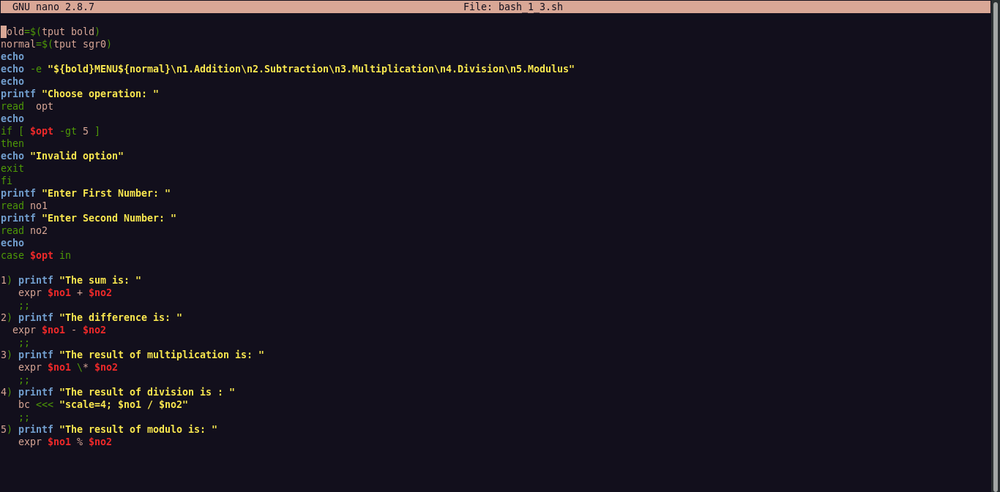
The read command can be used to accept an input and store in a variable.
‘expr’ can be used to evaluate a numerical expression.
‘bc’ or basic calculator can be used to evaluate an expression but the arguments are piped or from a file

The output is as follows:

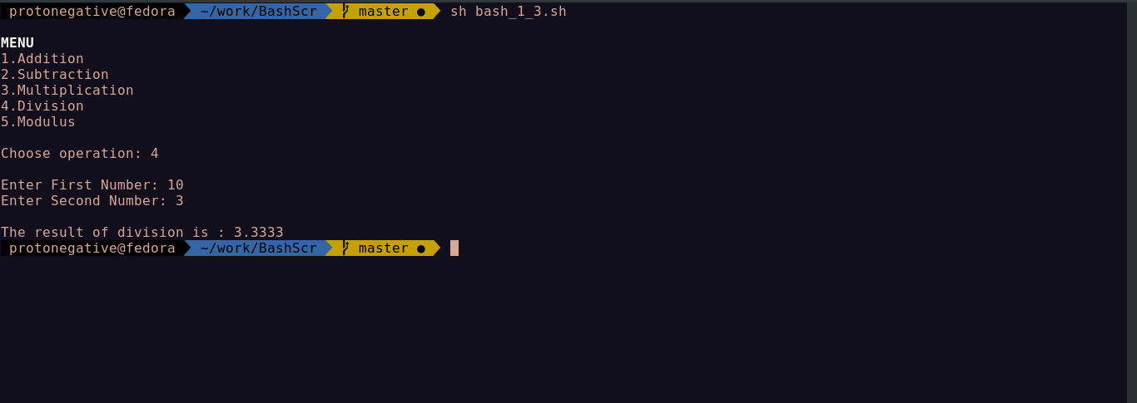

---------------------------------------------------------------------------------------------

4. Write a script called addnames that is to be called as follows ./addnames ulist username

Here ulist is the name of the file that contains list of user names and username is a
particular student’s username. The script should
1. Check that the correct number of arguments was received and print a message,
in case the
number of arguments is incorrect
2. Check whether the ulist file exists and print an error message if it does not
3. Check whether the username already exists in the file. If the username exists,
print a
message stating that the name already exists. Otherwise, add the username to the
end of
the list.

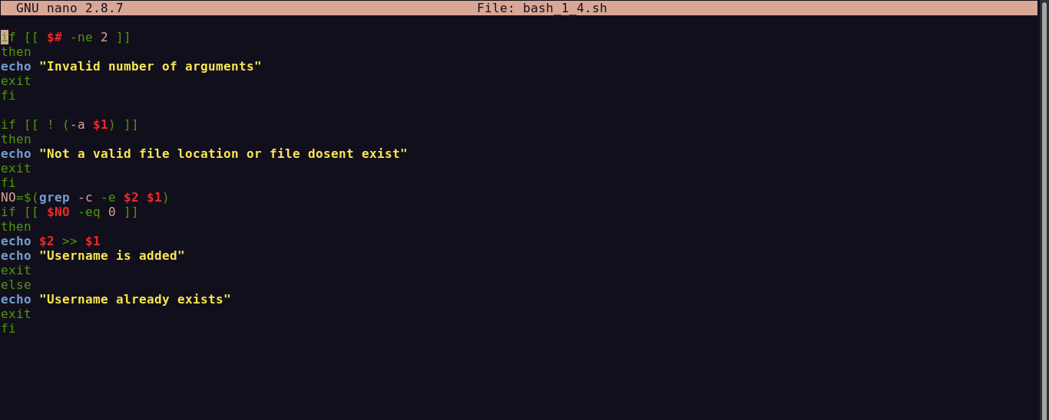
The number of arguments($#) are checked if equal to zero and corresponding error message is shown.
The first argument is checked to see if it is an existing file(-a)
The main operation is done using simple bash commands.

The output is as follows:

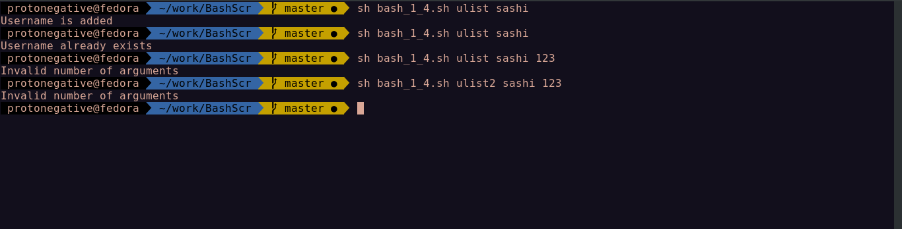

---------------------------------------------------------------------------------------------

5. Write a Shell script which starts on system boot up and kills every process which uses more than a specified amount of memory or CPU.

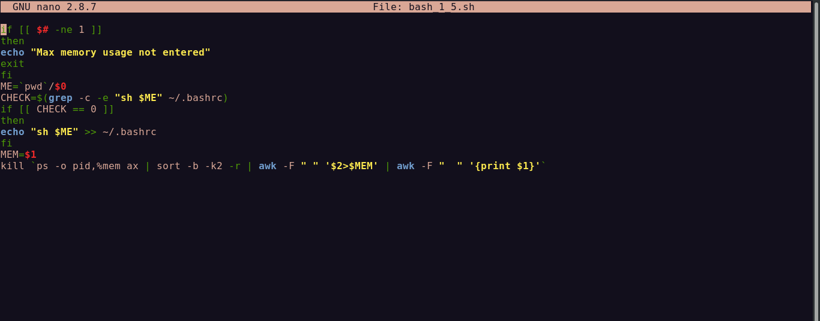

‘ps’ shows running processes and their memory usage in percentages and hence the corresponding PID’s can be obtained and can be killed.

Result: Understood how to write bash scripts.

---------------------------------------------------------------------------------------------
eof
---------------------------------------------------------------------------------------------

