Experiment 3

21th February 2019

Aim: To learn and understand usage of bash commands

---------------------------------------------------------------------------------------------
---------------------------------------------------------------------------------------------

1. Display your current directory.

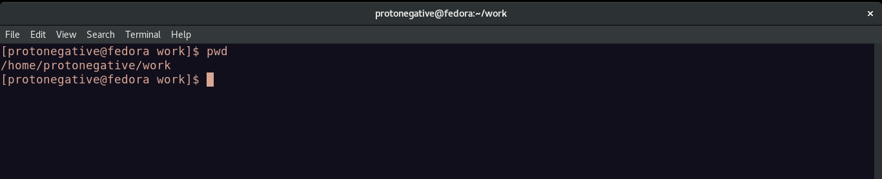
2. Change to the /etc directory.

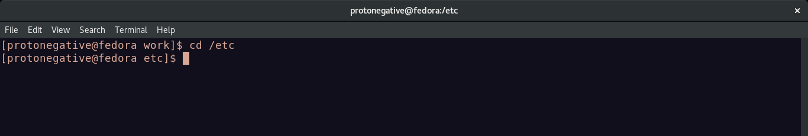
3. Now, change to your home directory using a single command.

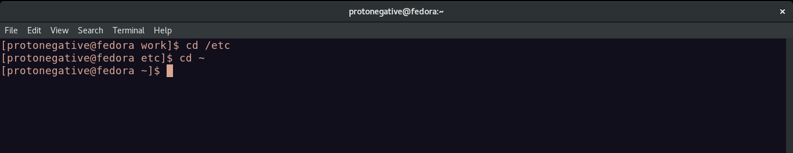
4. Change to the parent directory of the current directory.

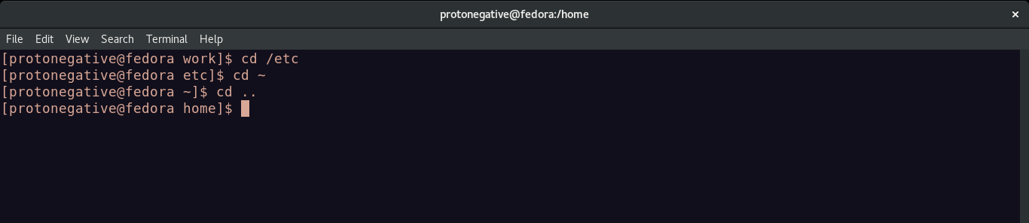
5. Go to the root directory.

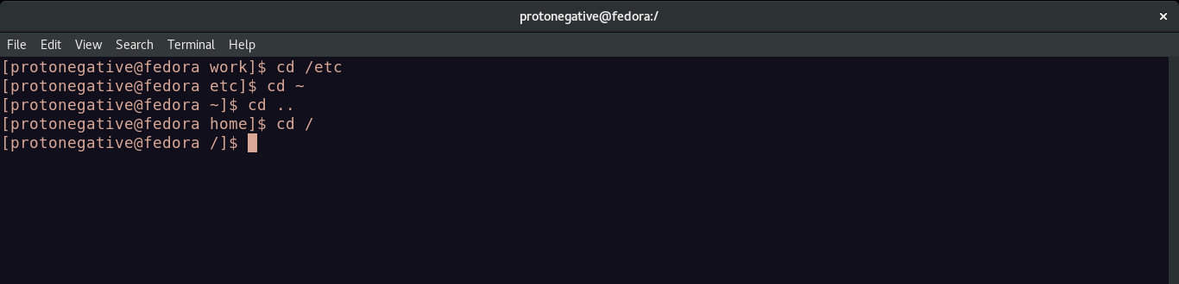
6. Give a long listing of the root directory.

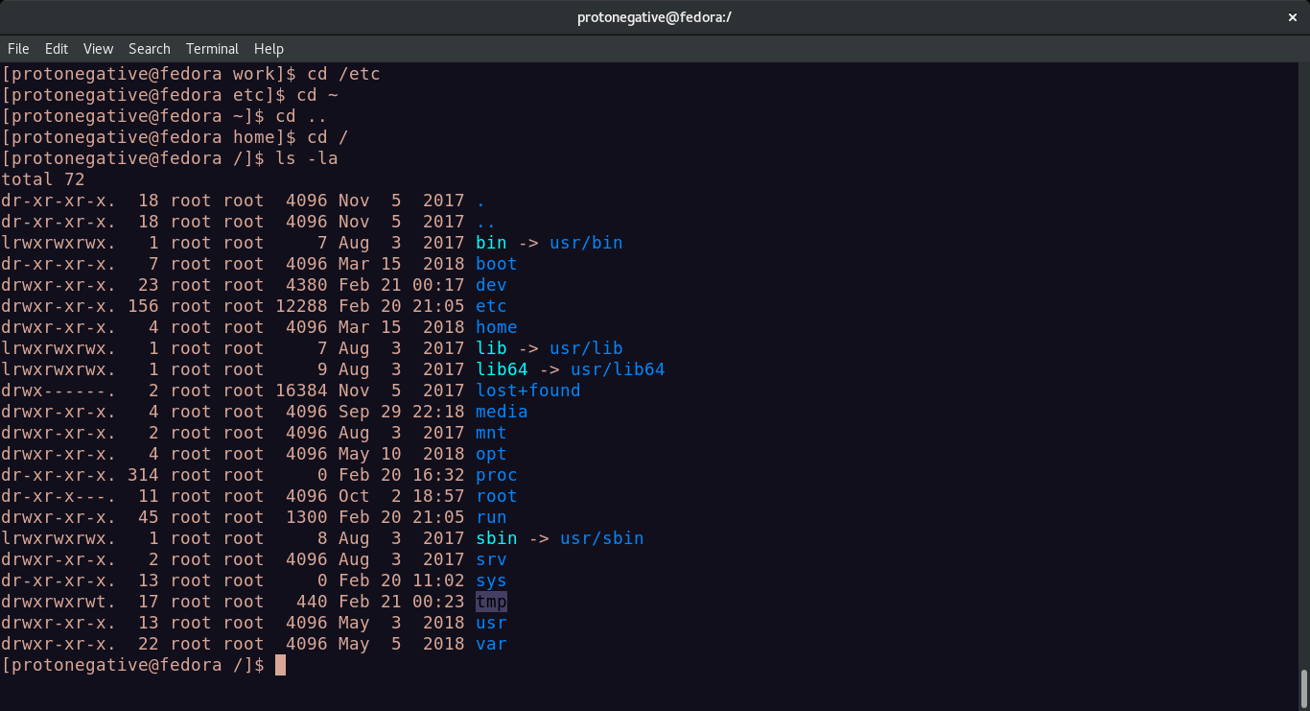
7. Give a listing of the last 10 files in the root directory.

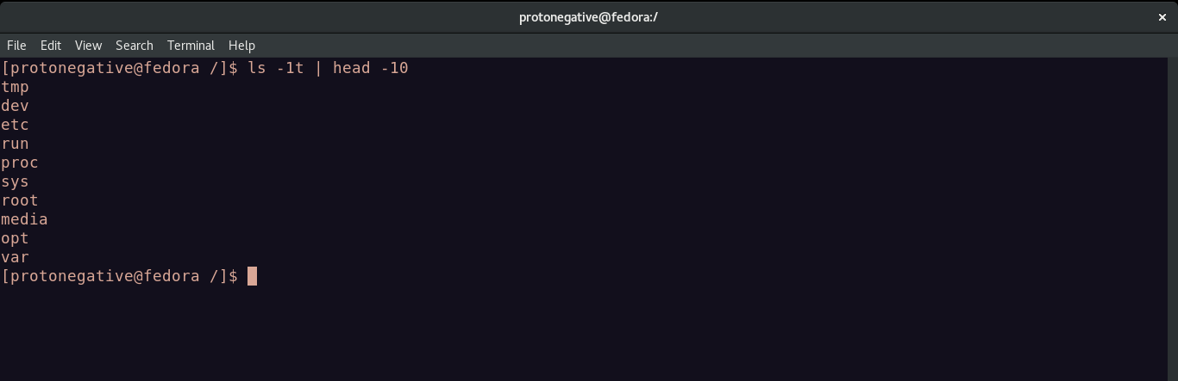
8. Stay where you are, and list the contents of /etc.

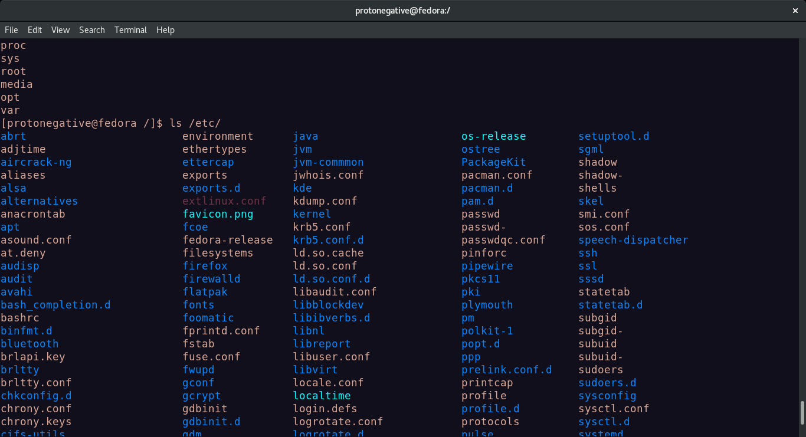
9. Create a directory testdir in your home directory.

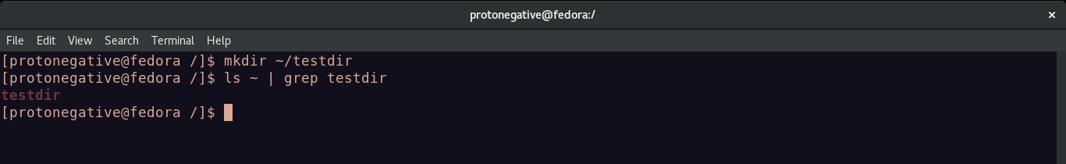
10. Change to the /etc directory, stay there and create a directory newdir in your home
directory(using a single command).

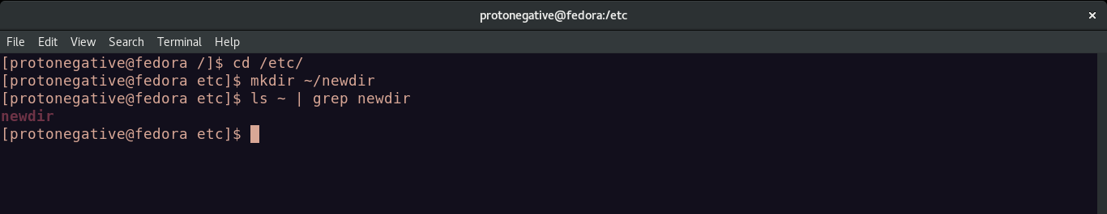
11. Create in one command the directories ~/dir1/dir2/dir3 (dir3 is a subdirectory from
dir2,)

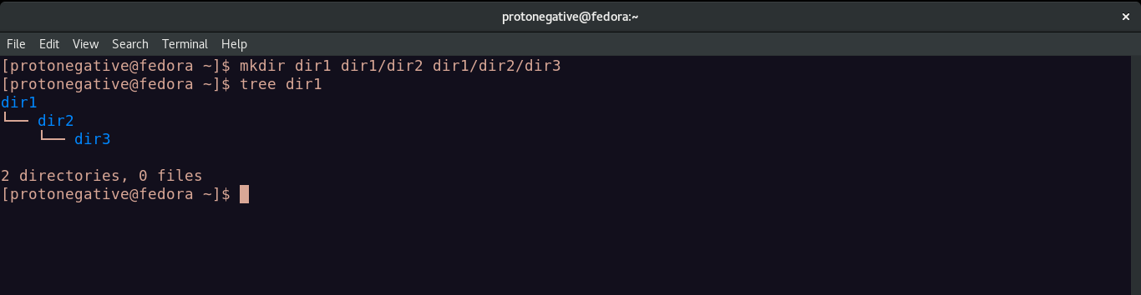
12. Display the calendar for April 2019.

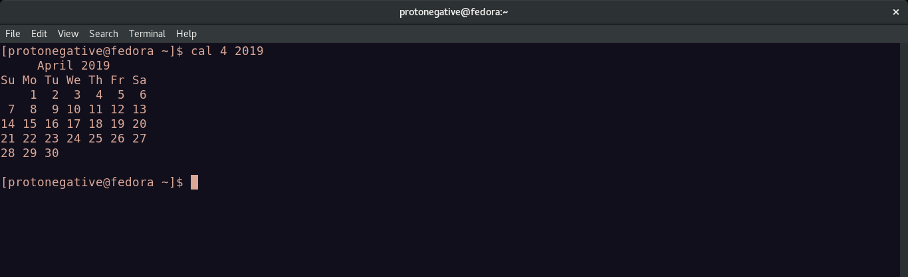
13. Display that ‘There are ................ files in my current directory’ . The ..... should be
filled with the count of the files.

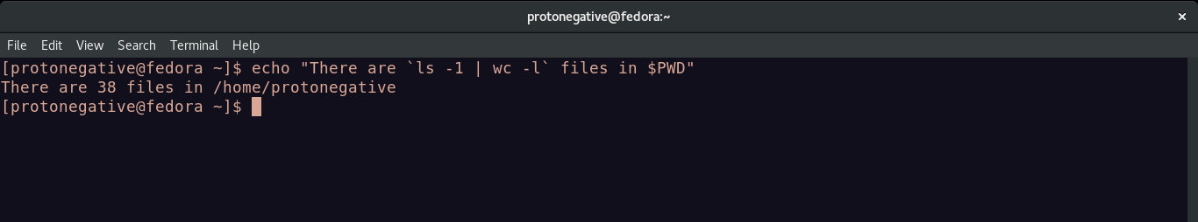
14. List all the files (including hidden files) in your home directory.

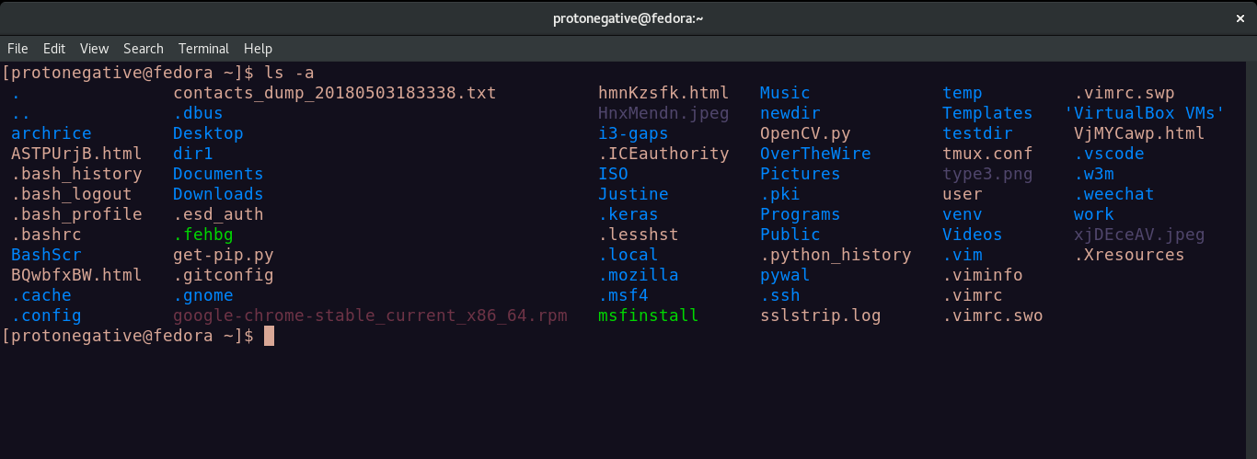
15. Redirect the output of the above command to a new file FileList.txt.

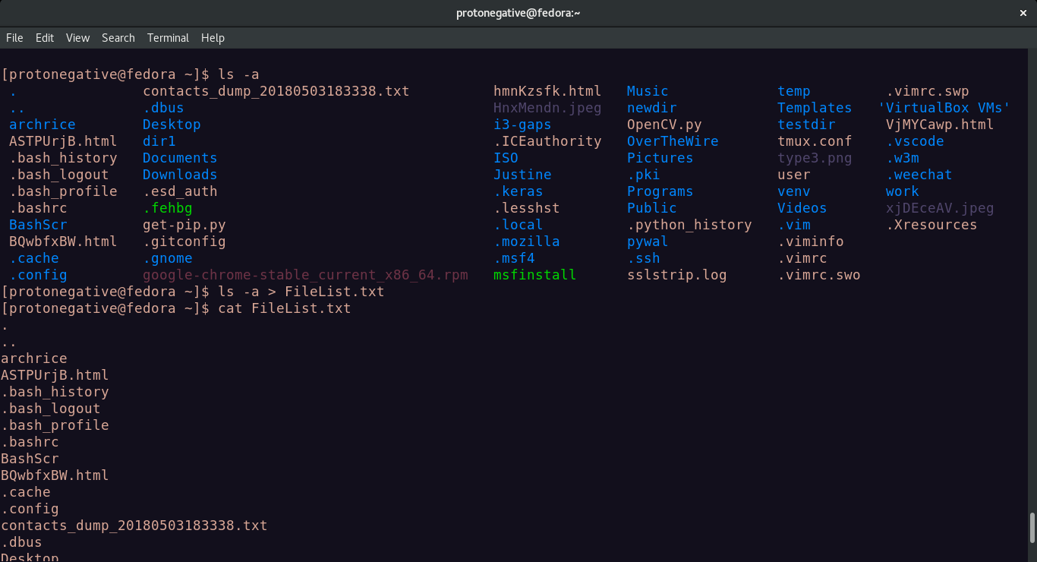
16. Redirect the number of lines of FileList.txt to CountFile.txt.

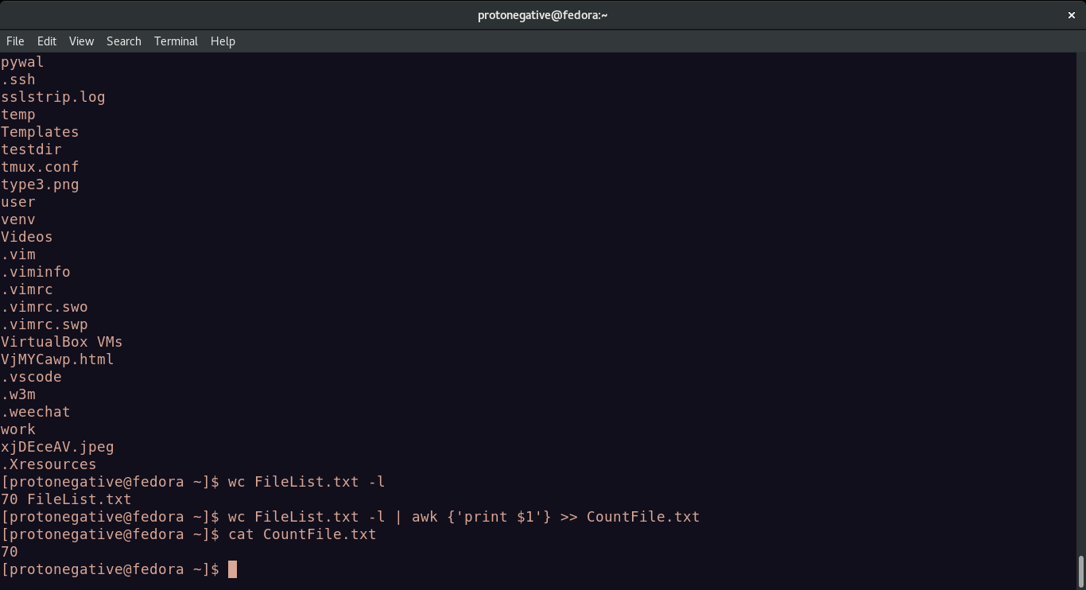
17. List all the files in your home directory starting with ‘s’ .

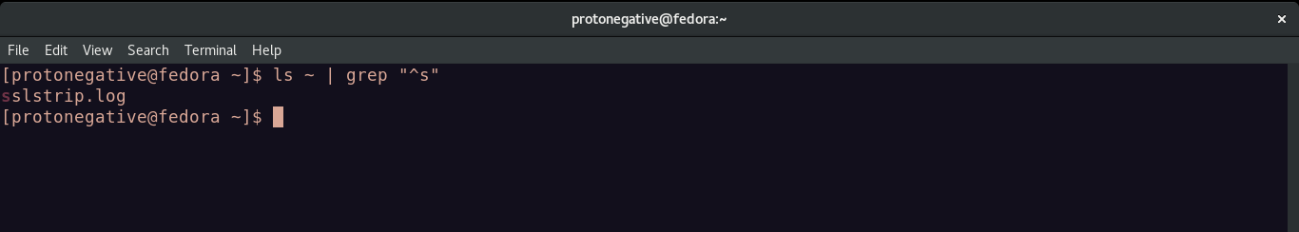
18. List all the file-names starting with “a”, “b” or “s” .

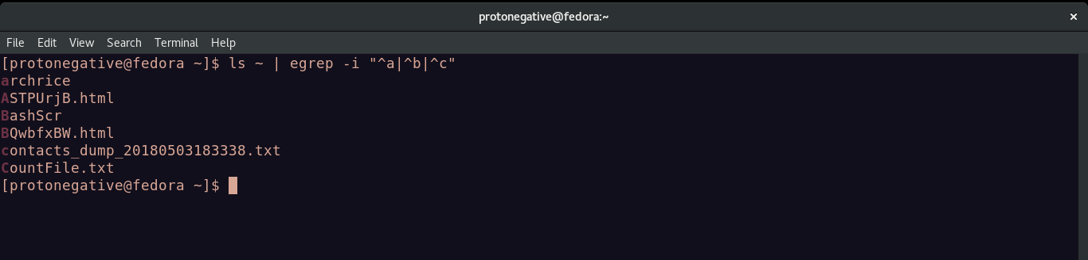
19. Create two files ‘Countries.txt’, containing country names and their corresponding
capital cities and ‘Story.txt’ contains some arbitrary lines of text.

Result: Understood the usage of certain bash commands
---------------------------------------------------------------------------------------------
eof
---------------------------------------------------------------------------------------------

