Experiment 6

25th March 2019

Aim: To write and execute bash scripts.

---------------------------------------------------------------------------------------------
---------------------------------------------------------------------------------------------

1. Write a shell script that displays a special listing showing the
permissions, size filename and last modification time of filename
supplied as arguments. Provide suitable headers using the printf
command.

editor=====================================================

if [[ $# -eq 0 ]]
then
echo "No file specified as an argument"
exit
fi
for file in $*
do
if [[ !(-a $file) ]]
then
echo "Enter a valid files as arguments"
exit
fi
done
for file in $*
do
NAME=`basename $file`
PERMS=`ls -lah $file | awk -F " " '{print $1}'`
SIZE=`ls -lah $file | awk -F " " '{print $5}'`
DATE=`ls -lah $file | awk -F " " '{print $6 " " $7 " " $8 }'`

printf "The name of file is: $NAME\nThe last modified date is: $DATE"
printf "\nThe permissions are: $PERMS\nThe size is: $SIZE\n\n"

done

========================================================end

Output:

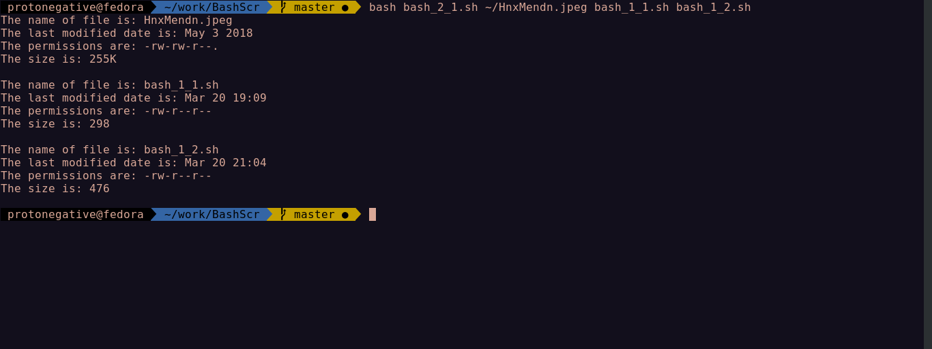
---------------------------------------------------------------------------------------------

2. Write a script that compares two directories dir1 and dir2(supplied as
arguments) and copies to dir1 from dir2 every file that is not present in
dir1.

editor=====================================================

if [[ $# -ne 2 ]]
then
echo "Enter two directories as argument"
exit
fi

if [[ !(-d $1 && -d $2) ]]
then
echo "Enter valid directories"
exit
fi

NAME2=`basename $2`
diff $1 $2 | grep -w "$NAME2" | awk -F ": " '{print $2}' >> b.temp
while read line
do
cp "$2/$line" $1
done < b.temp
rm b.temp

========================================================end

Output:

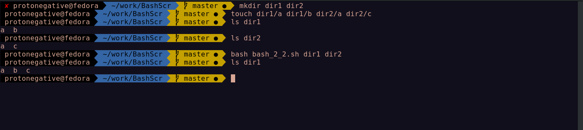
---------------------------------------------------------------------------------------------

3. Write a shell script that accepts two file names as arguments, checks if
the permissions for these files are identical and if the permissions are
identical,output common permissions and otherwise output each file
name followed by its permissions.

editor=====================================================

if [[ $# -ne 2 ]]
then
echo "Enter two files as argument"
exit
fi

if [[ !(-a $1 && -a $2) ]]
then
echo "Enter valid files"
exit
fi

PERMS1=`ls -lah $1 | awk -F " " '{print $1}'`
PERMS2=`ls -lah $2 | awk -F " " '{print $1}'`

if [[ $PERMS1 == $PERMS2 ]]
then
echo "The common permission is: $PERMS1"
else
echo "The permission for $1 is: $PERMS1"
echo "The permission for $2 is: $PERMS2"
fi

========================================================end

Output:

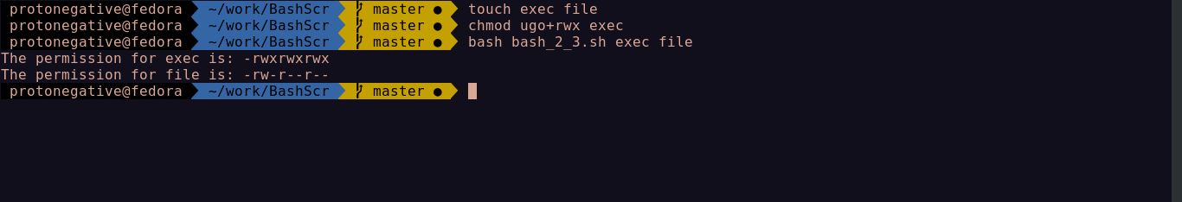

---------------------------------------------------------------------------------------------

4. Write a shell script which receives two file names as arguments. It
should check whether the two file contents are same or not. If they are
same then second file should be deleted.

editor=====================================================

if [[ $# -ne 2 ]]
then
echo "Enter two files as argument"
exit
fi

if [[ !(-f $2 && -f $2) ]]
then
echo "Enter valid files"
exit
fi

(cmp -s $1 $2) && (rm $2; echo "Deleted repeated file") || (echo "Different files...not deleted")

========================================================end

Output:

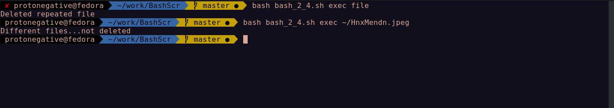

---------------------------------------------------------------------------------------------

5. Write a shell script that, given a file name as the argument will count
vowels, blank spaces, characters, number of line and symbols.

editor=====================================================

if [[ $# -ne 1 ]]
then
echo "Enter file as argument"
exit
fi

if [[ !(-a $1) ]]
then
echo "Enter valid file"
exit
fi
SYM=0
BS=`grep -o ' ' $1 | wc -l`
CHA=`wc -c $1 | awk '{print $1}'`
V=0
L=`wc -l $1 | awk '{print $1}'`
while read -n1 c
do
if [[ $c == *['!'@#\$%^\&*()_+]* ]]
then
((SYM++))
elif [[ $c == *[aAeEiIoOuU]* ]]
then
((V++))
fi
done < "$1"
echo "The number of lines are: $L"
echo "The number of vowels are: $V"
echo "The number of characters are: $CHA"
echo "The number of spaces are: $BS"
echo "The number of symbols are: $SYM"

========================================================end

Output:

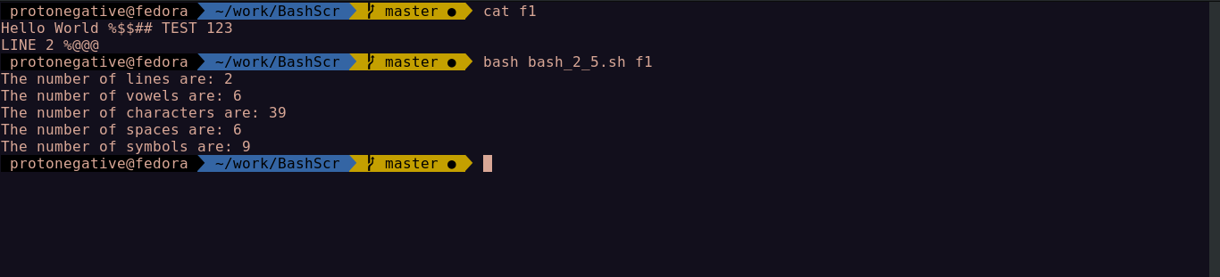

---------------------------------------------------------------------------------------------

6. Write a shell script that will take an input file and remove identical lines.

editor=====================================================

if [[ $# -ne 1 ]]
then
echo "Enter file as argument"
exit
fi

if [[ !(-a $1) ]]
then
echo "Enter valid file"
exit
fi
awk '!a[$0]++' $1 >> b.temp
rm $1
mv b.temp $1

========================================================end

Output:

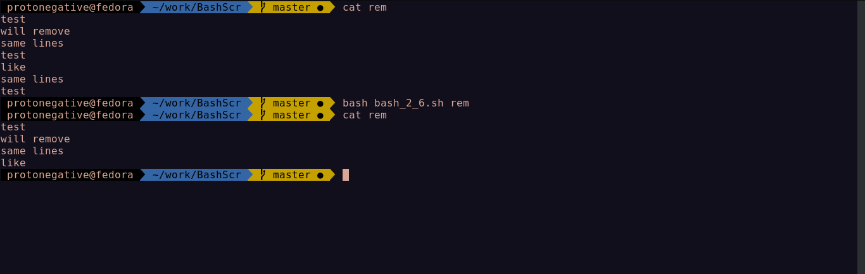
---------------------------------------------------------------------------------------------
7. Write a shell script that displays a list of all the files in the current
directory to which the user has read, write and execute permissions.

editor=====================================================

ls -lAh $PWD | awk -F " " '{print $1 " " $9}' > b.temp
while read l
do
PERM=`echo $l | awk '{print $1}'`
USRPERM=${PERM:7:3}
if [[ $USRPERM == "rwx" ]]
then
echo "$l"
fi
done < b.temp
rm b.temp

========================================================end

Output:

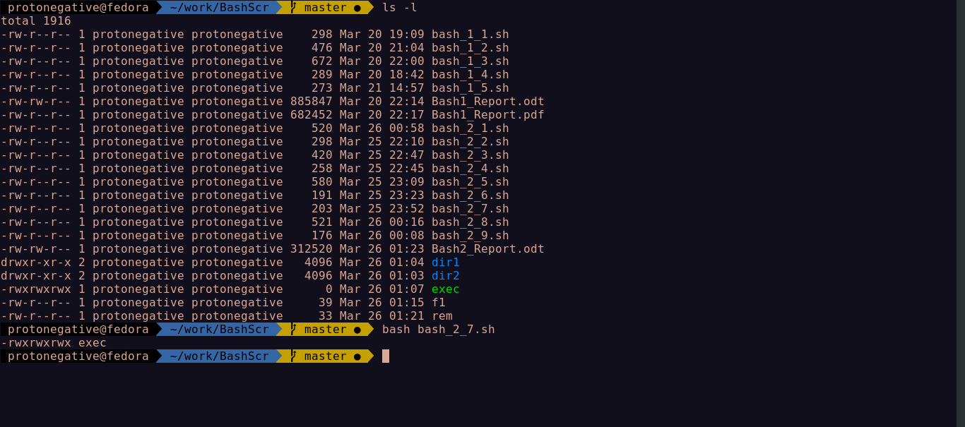

---------------------------------------------------------------------------------------------
8. Write a shell script that folds long lines into 40 columns. Thus any line
that exceeds 40 characters must be broken after 40th ; a \ is to be
appended as the indication of folding and the processing is to be
continued with the residue. The input is to be through a text file created
by the user.

editor=====================================================

if [[ $# -ne 1 ]]
then
echo "Enter file as argument"
exit
fi

if [[ !(-a $1) ]]
then
echo "Enter valid file"
exit
fi

n=`wc -l $1 | cut -d " " -f 1`
i=1

while [ $i -le $n ]
do
line=`sed -n "$i p" $1`
cc=`echo $line | wc -c | cut -d " " -f 1`
while [ $cc -ge 40 ]
do
ext=`echo $line | cut -c 41-`
line=`echo $line | cut -c 1-40`
echo "$line \\"
line=$ext
cc=`echo $ext | wc -c | cut -d " " -f 1`
done
echo "$line"
i=`expr $i + 1`
done

========================================================end

Output:

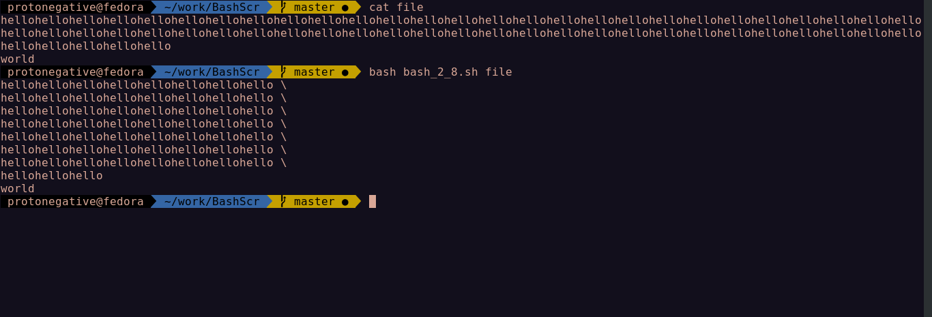

---------------------------------------------------------------------------------------------

9. Write a shell script to delete all lines containing a specific word in one or
more file supplied as argument to it.

Editor=====================================================

if [ $# -eq 0 ]
then
echo "Enter atleast one file"
exit
fi

echo "Enter word to be searched"
read word

for file in $*
do
sed "/$word/d" $file > b.temp
mv b.temp $file
done

========================================================end

Output:

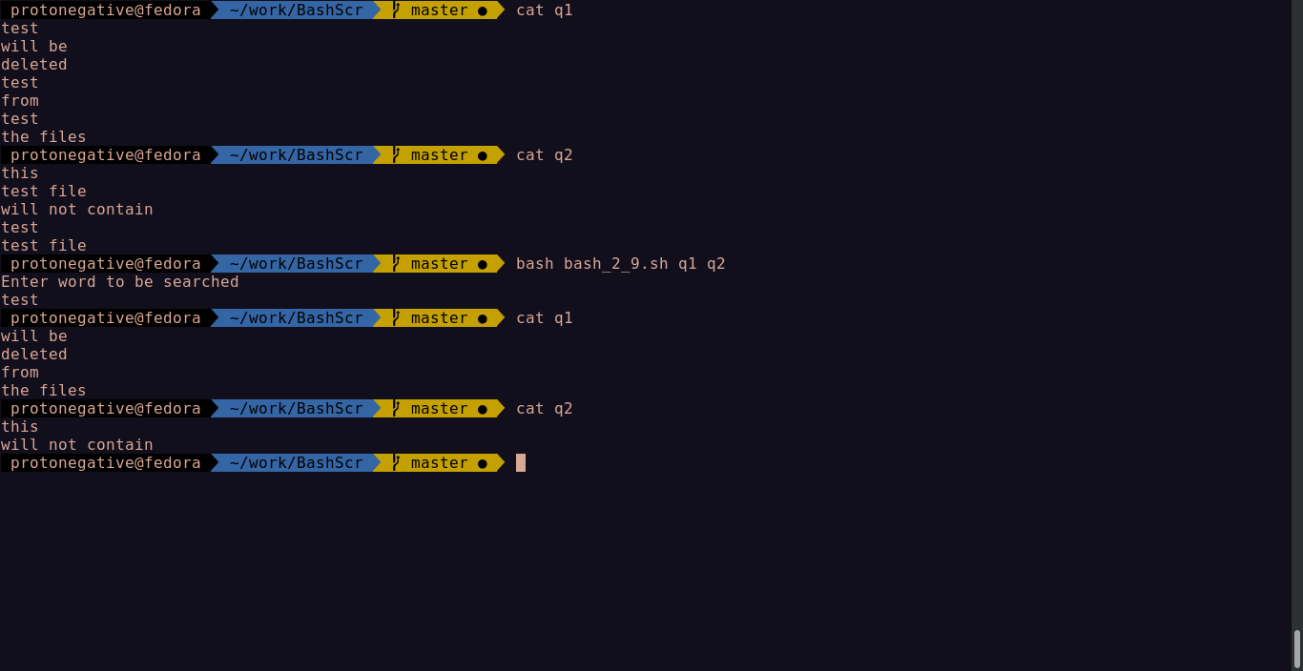

-------------------------------------------------------------------------------------------
eof
---------------------------------------------------------------------------------------------

