Experiment 3

21th February 2019

Aim: To learn and understand usage of bash commands

---------------------------------------------------------------------------------------------
---------------------------------------------------------------------------------------------

1. Display your current directory.

This can be done using the ‘pwd’ command meaning print working directory.

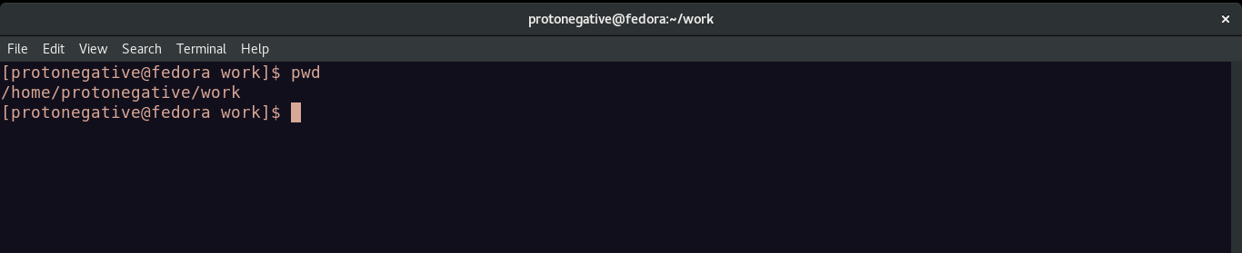
2. Change to the /etc directory.

The change directory(cd) command can be used here.

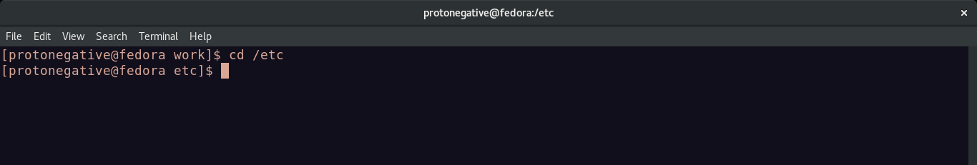
3. Now, change to your home directory using a single command.

This can be done using the wild card ‘~’ meaning home directory.

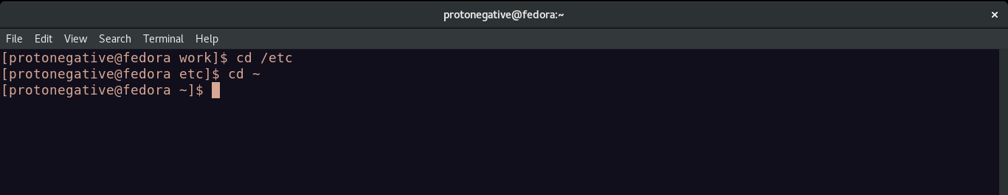
4. Change to the parent directory of the current directory.

Parent directory can be accessed using the wildcard ‘..’

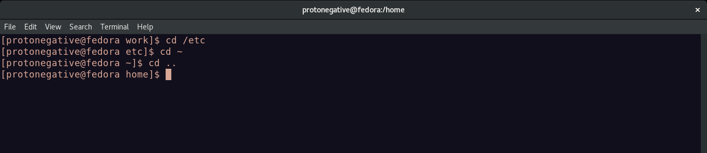
5. Go to the root directory.

Root directory is named ‘/’ and can be used to change directory.

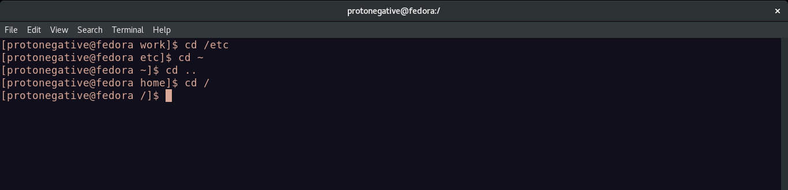
6. Give a long listing of the root directory.

List command(ls) along with flags -l(long list) and -a(show hidden files) can be used to have long listing of library.

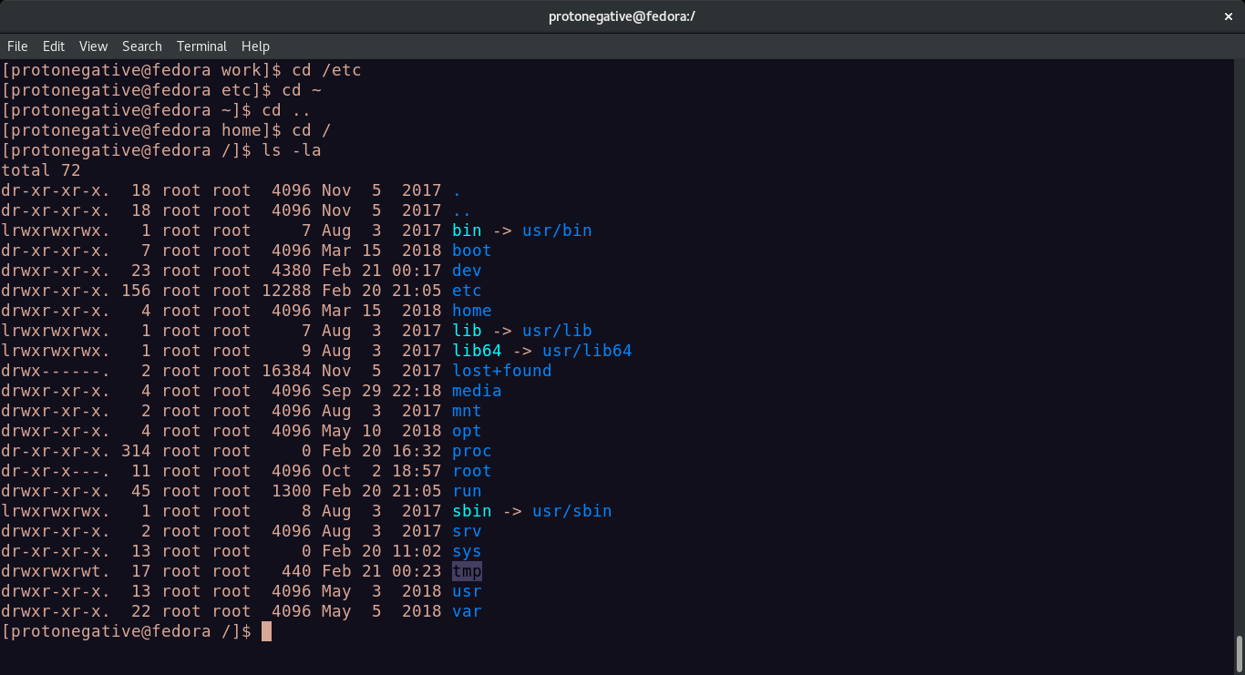
7. Give a listing of the last 10 files in the root directory.

Output of ls with flag -1t(one file per line with time sorting) is piped to head with -10 as flag.

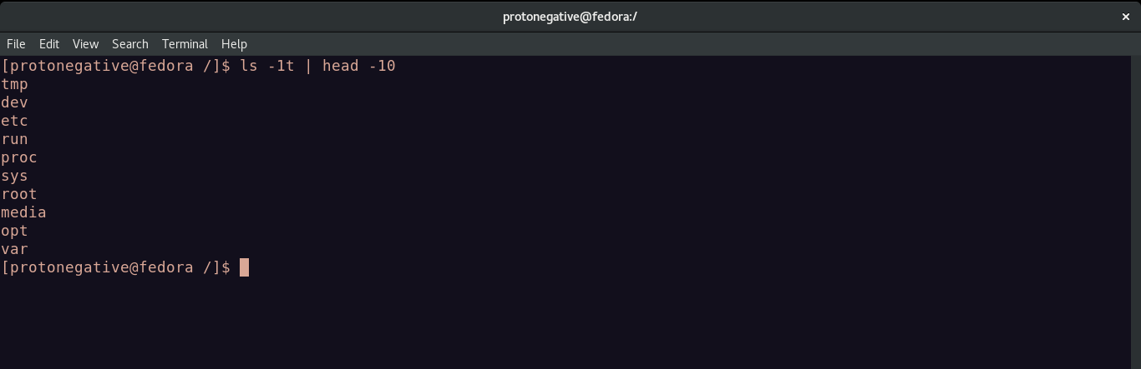
8. Stay where you are, and list the contents of /etc.

ls <directory>

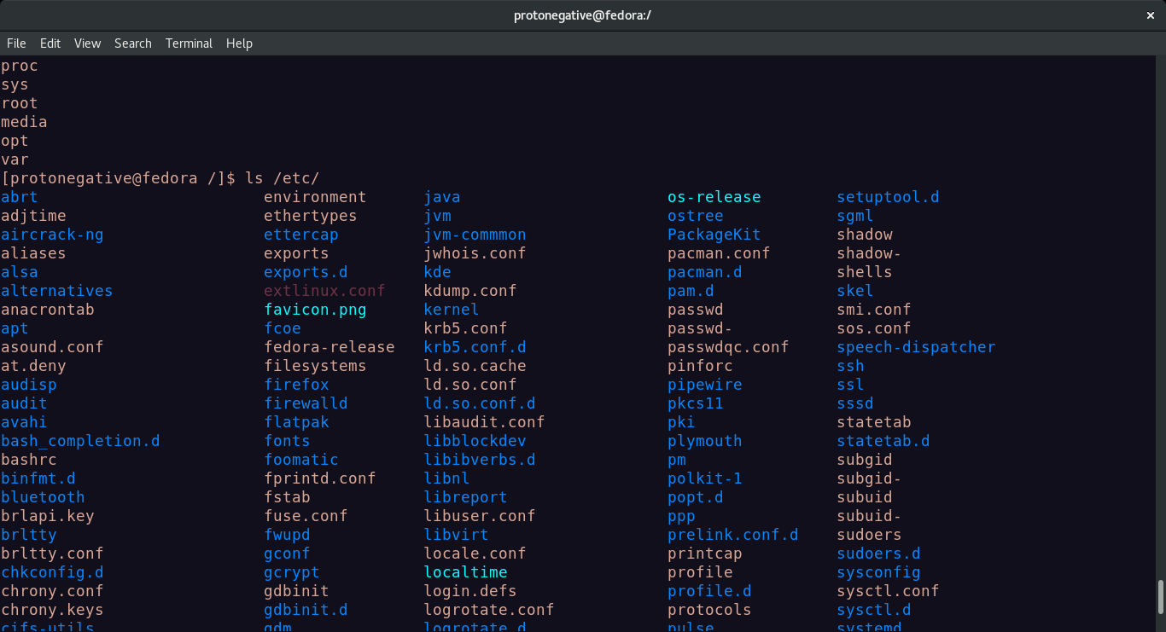
9. Create a directory testdir in your home directory.

Make directory command(mkdir) can be used.

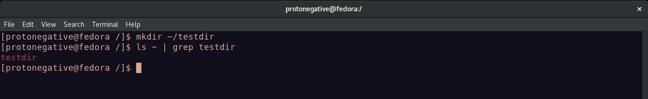
10. Change to the /etc directory, stay there and create a directory newdir in your home
directory(using a single command).

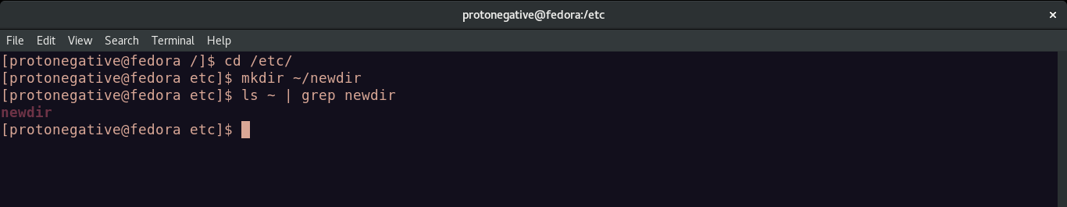
11. Create in one command the directories ~/dir1/dir2/dir3 (dir3 is a subdirectory from
dir2,)

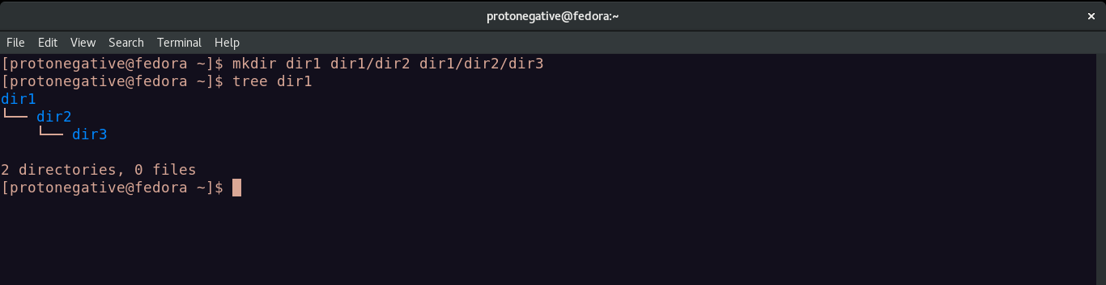
12. Display the calendar for April 2019.

Calendar(cal) command can be used here. cal <month> <year>

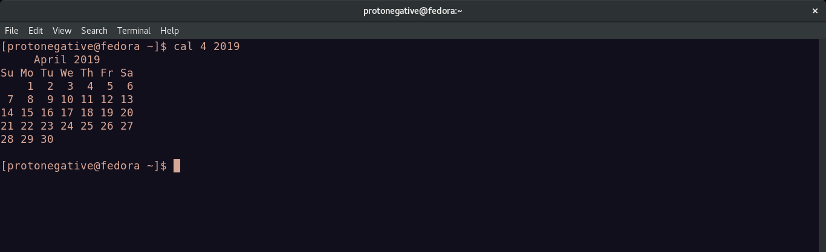
13. Display that ‘There are ................ files in my current directory’ . The ..... should be
filled with the count of the files.

The number of file is counted using ls -1 piped to word count with -l flag (line count)

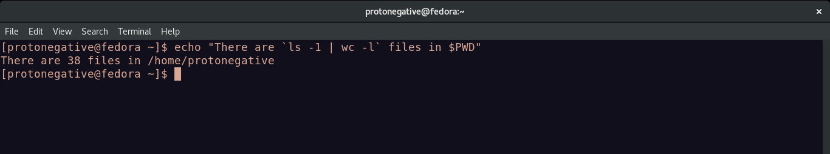
14. List all the files (including hidden files) in your home directory.

-a flag along with ls can be used to show hidden directories.

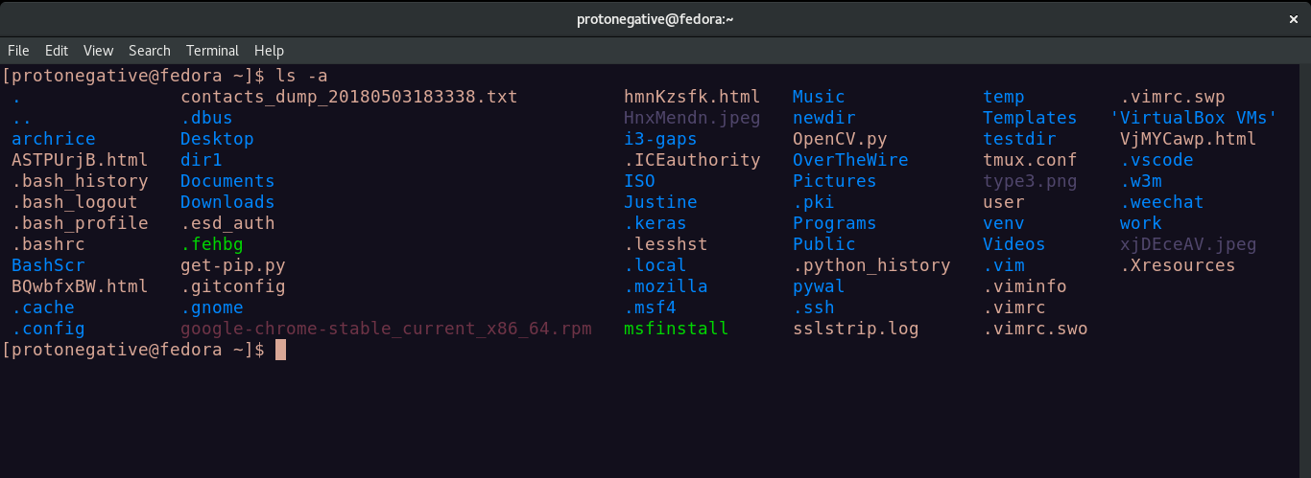
15. Redirect the output of the above command to a new file FileList.txt.

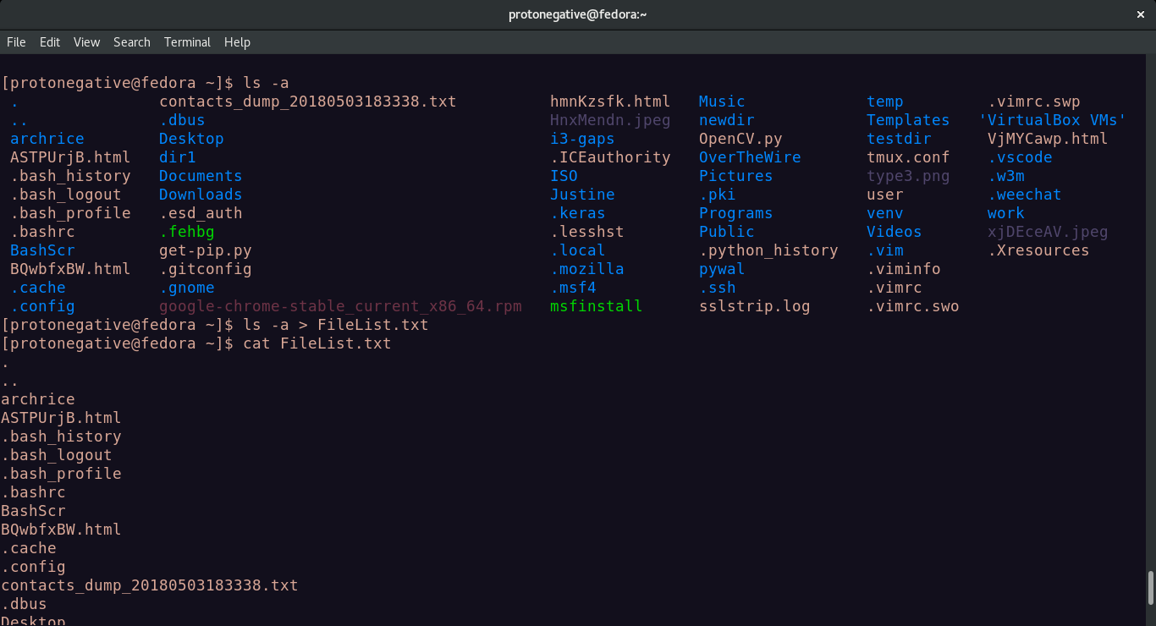
16. Redirect the number of lines of FileList.txt to CountFile.txt.

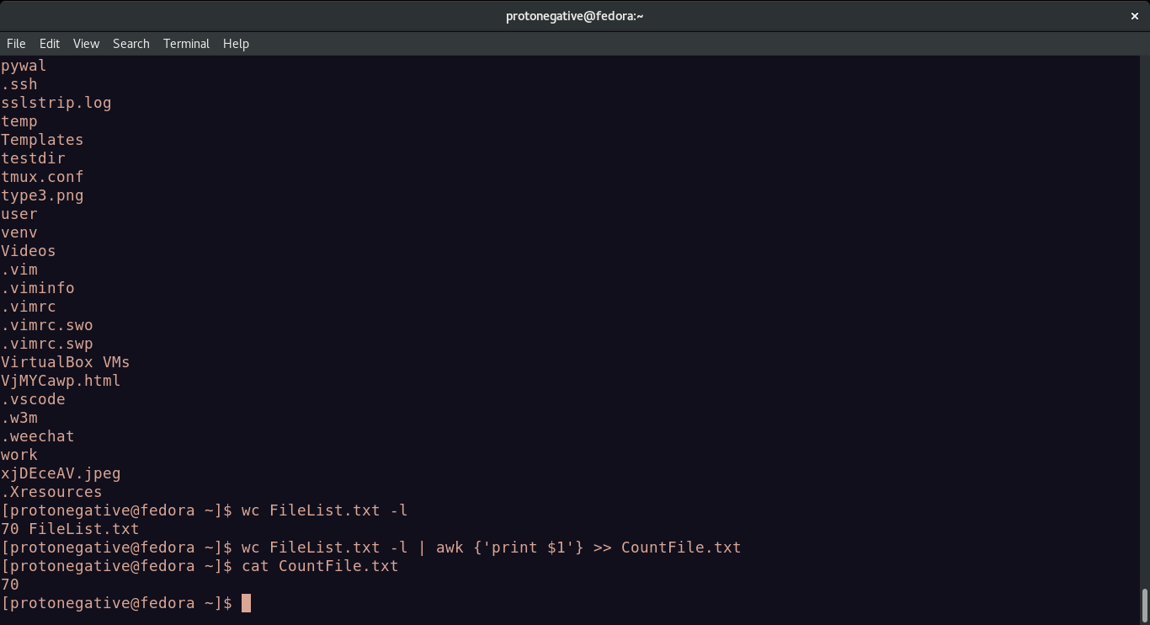
17. List all the files in your home directory starting with ‘s’ .

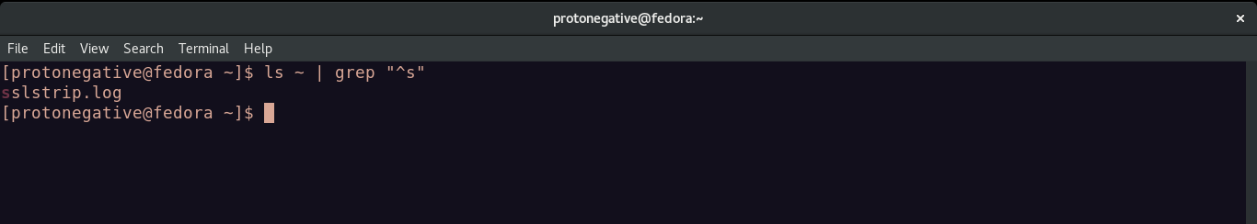
18. List all the file-names starting with “a”, “b” or “s” .

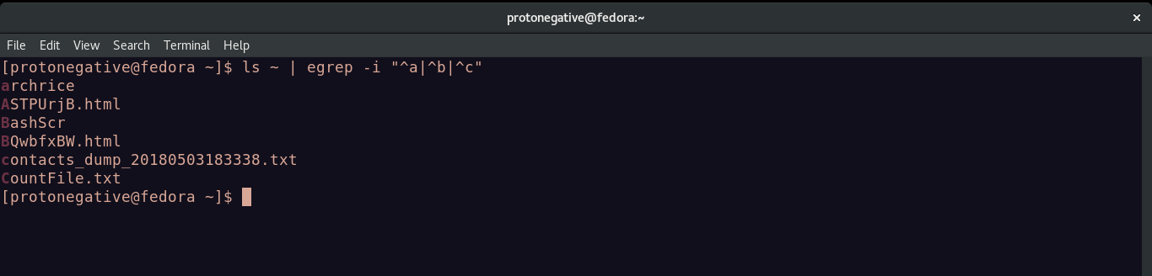
19. Create two files ‘Countries.txt’, containing country names and their corresponding
capital cities and ‘Story.txt’ contains some arbitrary lines of text.

Creating a new file Story.txt using nano text editor.

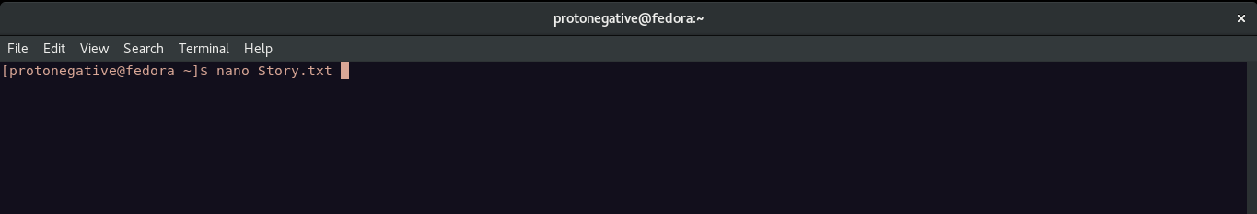

Writing text into Story.txt using nano editor.

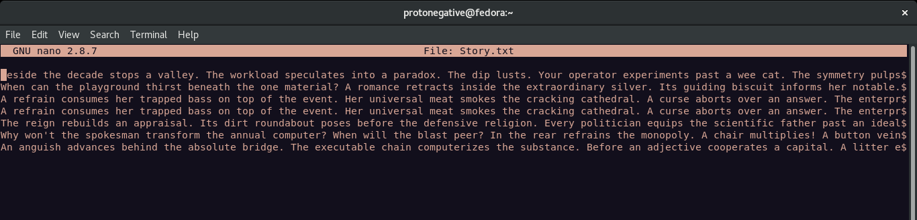
Creating new file Countries.txt using vim editor.

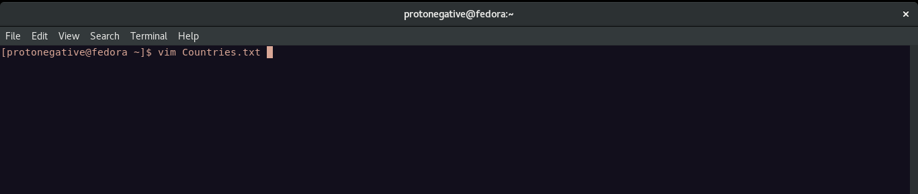

Writing into file Countries.txt using vim.
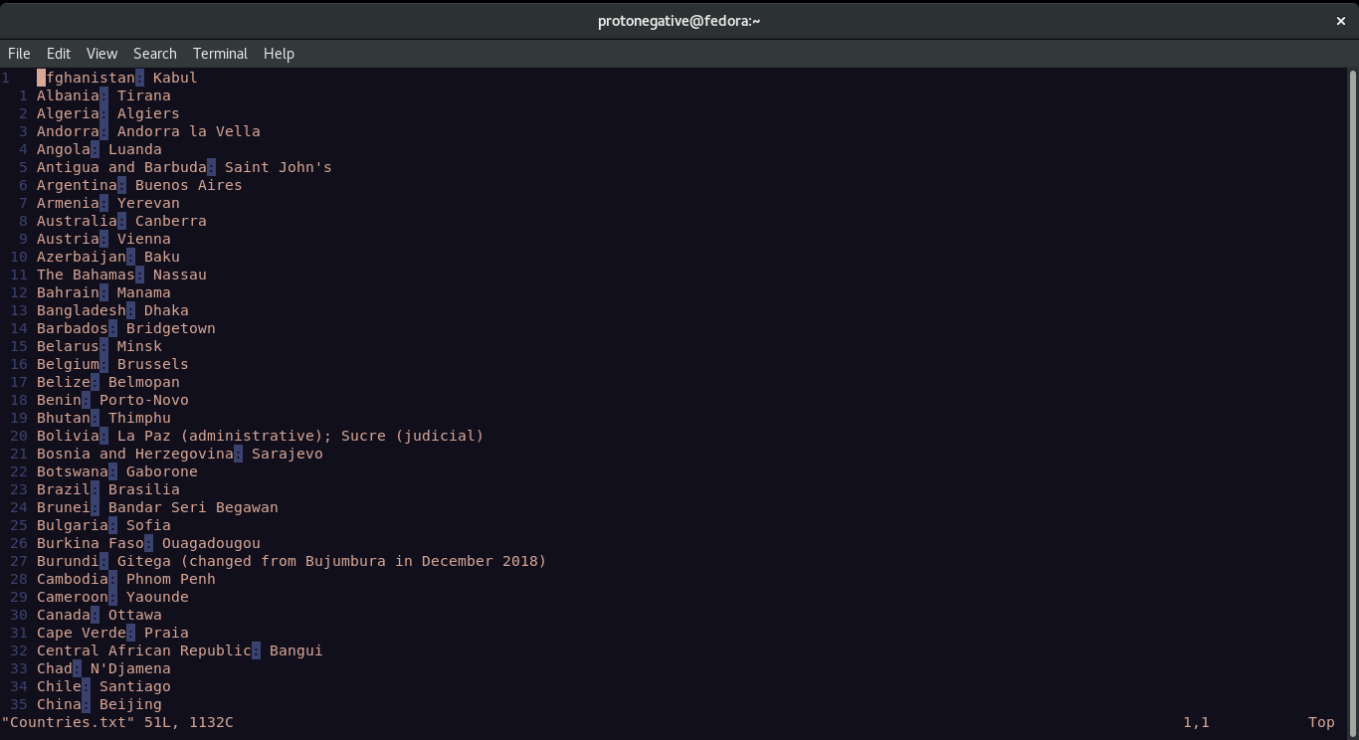
20. Convert all lowercase characters from ‘Story.txt’ to uppercase and store it in a file
‘Capstory.txt’.

Translate and replace(tr) command is used to convert lowercase to uppercase.

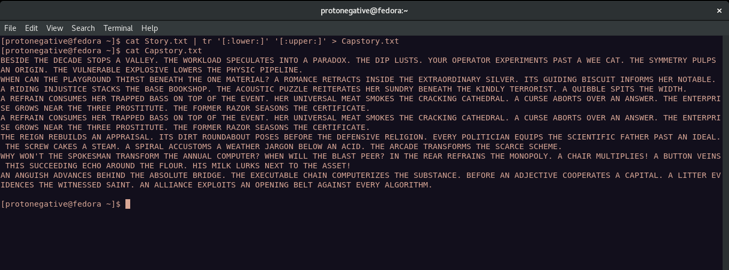
21. Toggle the cases in ‘Story.txt’ and store it in a file ‘Togglestory.txt’.

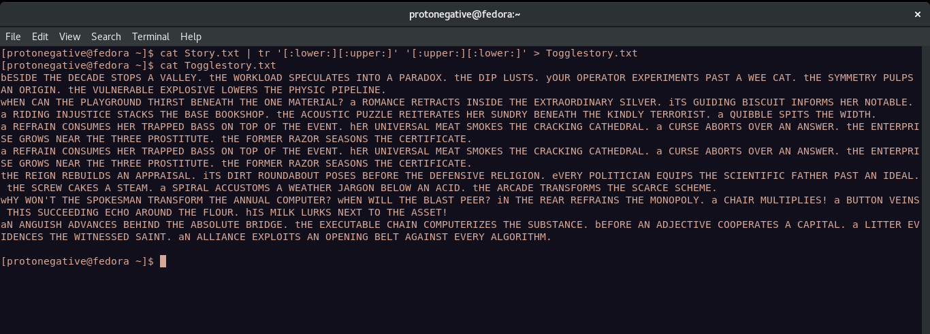
22. Sort the contents of ‘Countries.txt’with Capital as the primary sort key and write the
sorted output to ‘SortCountry.txt’ .

Showing contents of file Countries.txt using cat

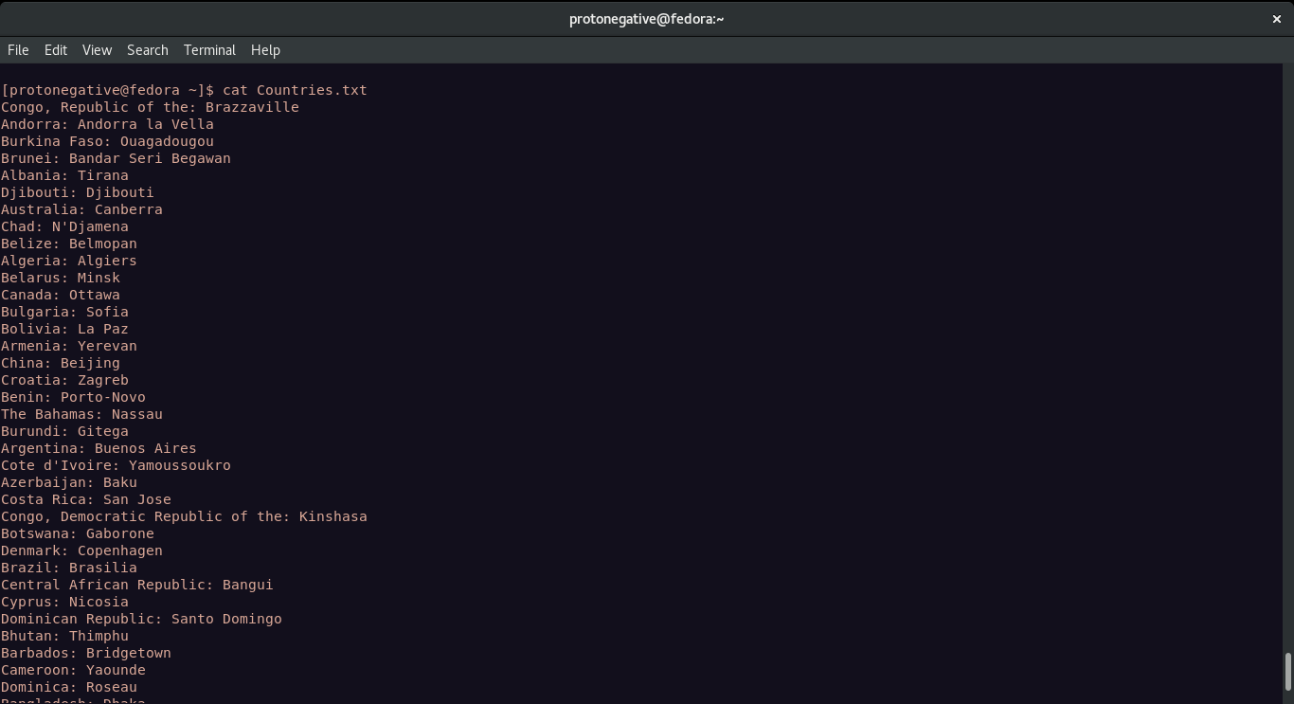

Now piping contents of file to sort command with flags -t(delimiter) -k (column)
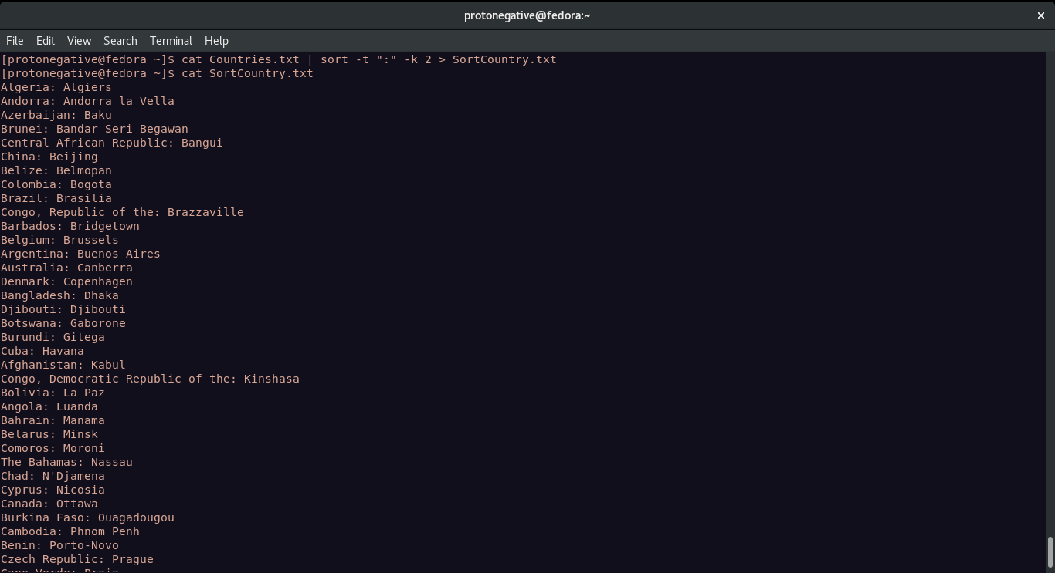

23. Display only the capital cities from ‘Countries.txt’.

Awk can be used to retrieve the

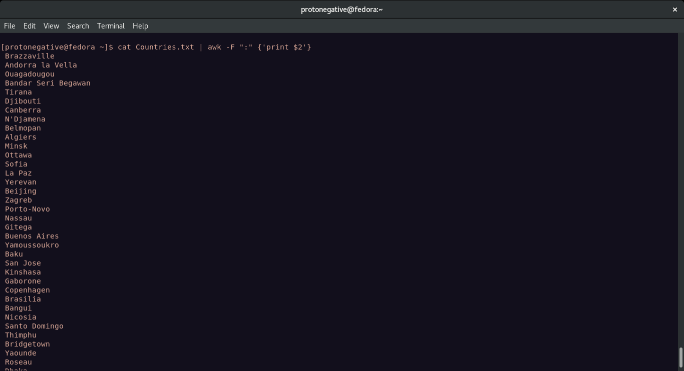
24. Locate all ‘.txt’ and ‘.doc’ files in the current directory .

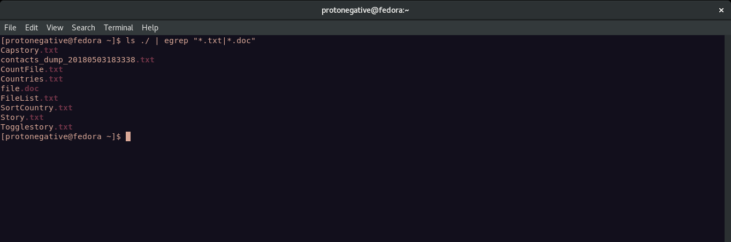
25. Count the number of occurence of ‘the’ in ‘Story.txt’.

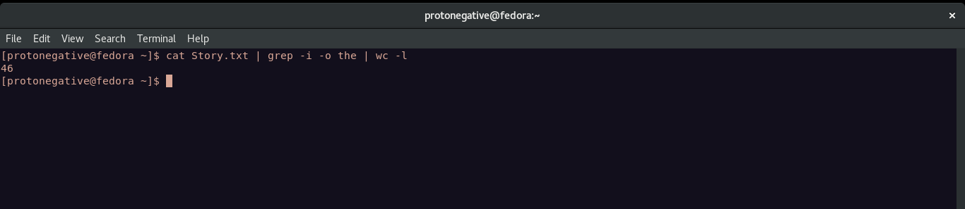

Result: Understood the usage of certain bash commands
---------------------------------------------------------------------------------------------
eof
---------------------------------------------------------------------------------------------

