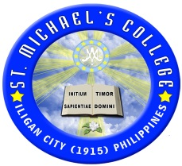
St. Michael’s College

9200 Iligan City, Philippines
Tel Nos. (063) 222-1990 ; 221-2810 - President’s Office (063) 221-3812 (Registrar’s Office) connecting to all offices (063) 225-3610 (HRM Laboratory)
Telefax (063) 223-8109 (President’s Office) Telefax (063) 221-5325 (Finance Office) Telephone (063) 221-7134 (BED-Tibanga Campus)

WEBSITE : www.smciligan.edu.ph EMAIL: info@smciligan.edu.ph PAASCU LEVEL - 3 Accredited Basic Education Department
Business, Liberal Arts & Education College Programs

DOCUMENTATION
PROGRAM  (if applicable) |   
ACTIVITY / PROJECT / SEMINAR / WORKSHOP | RESEARCH CAMP
SPONSORING INSTITUTION  (if applicable) | Research office with the coordination of Vice president of academic affairs
DATE/S / TIME / AY | MAY 26-28,2023
VENUE | Montegolo farm ,Manolo fortich Bukidnon
SPEAKER/S | International Presenters
PARTICIPANT/S | HIGHER EDUCATION DEPARTMENT – SELECTED STAFF AND FACULTY
Note: Please scan /attach on page 3 and 4 the program and the certificate (as applicable)
Please print 2 copies and send the soft file of this documentation at smc_ovpa@yahoo.com
Please attach in the hard copy the approved activity proposal, if applicable.

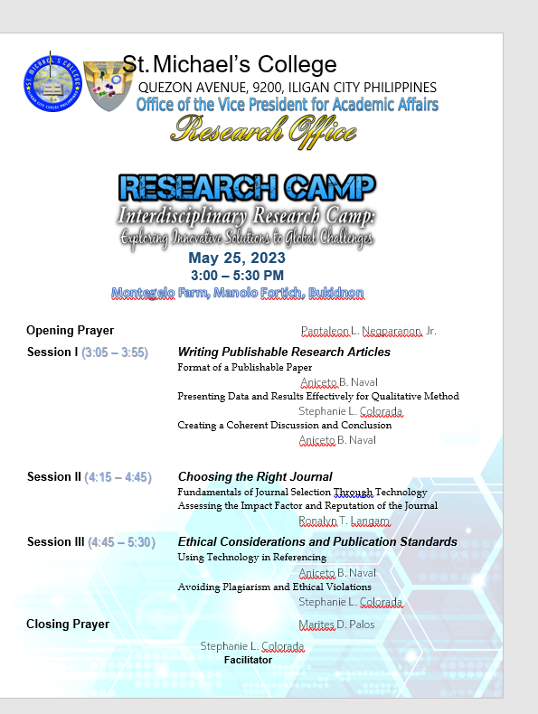

The program of the activity
PHOTOS

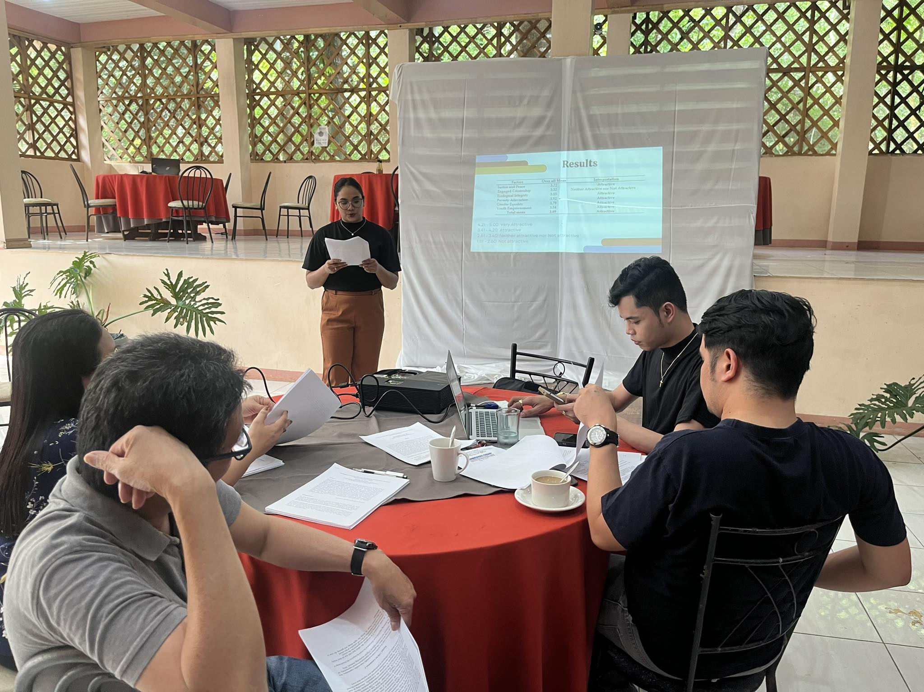

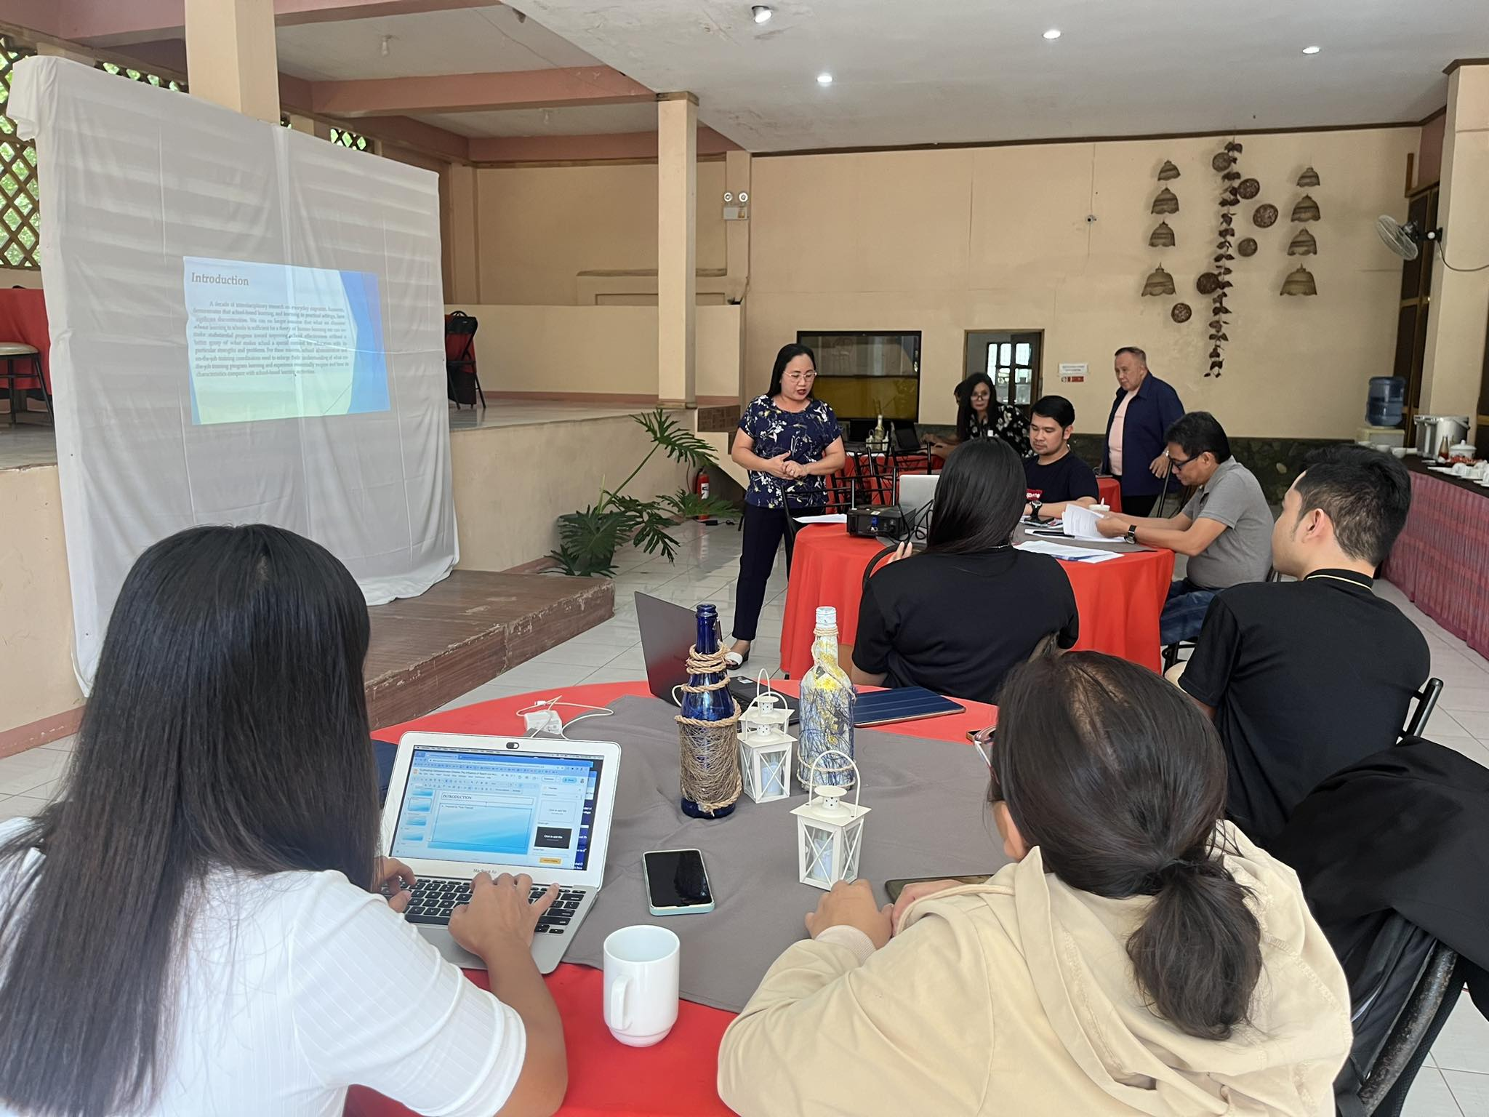

The presenters during the oral presentation.

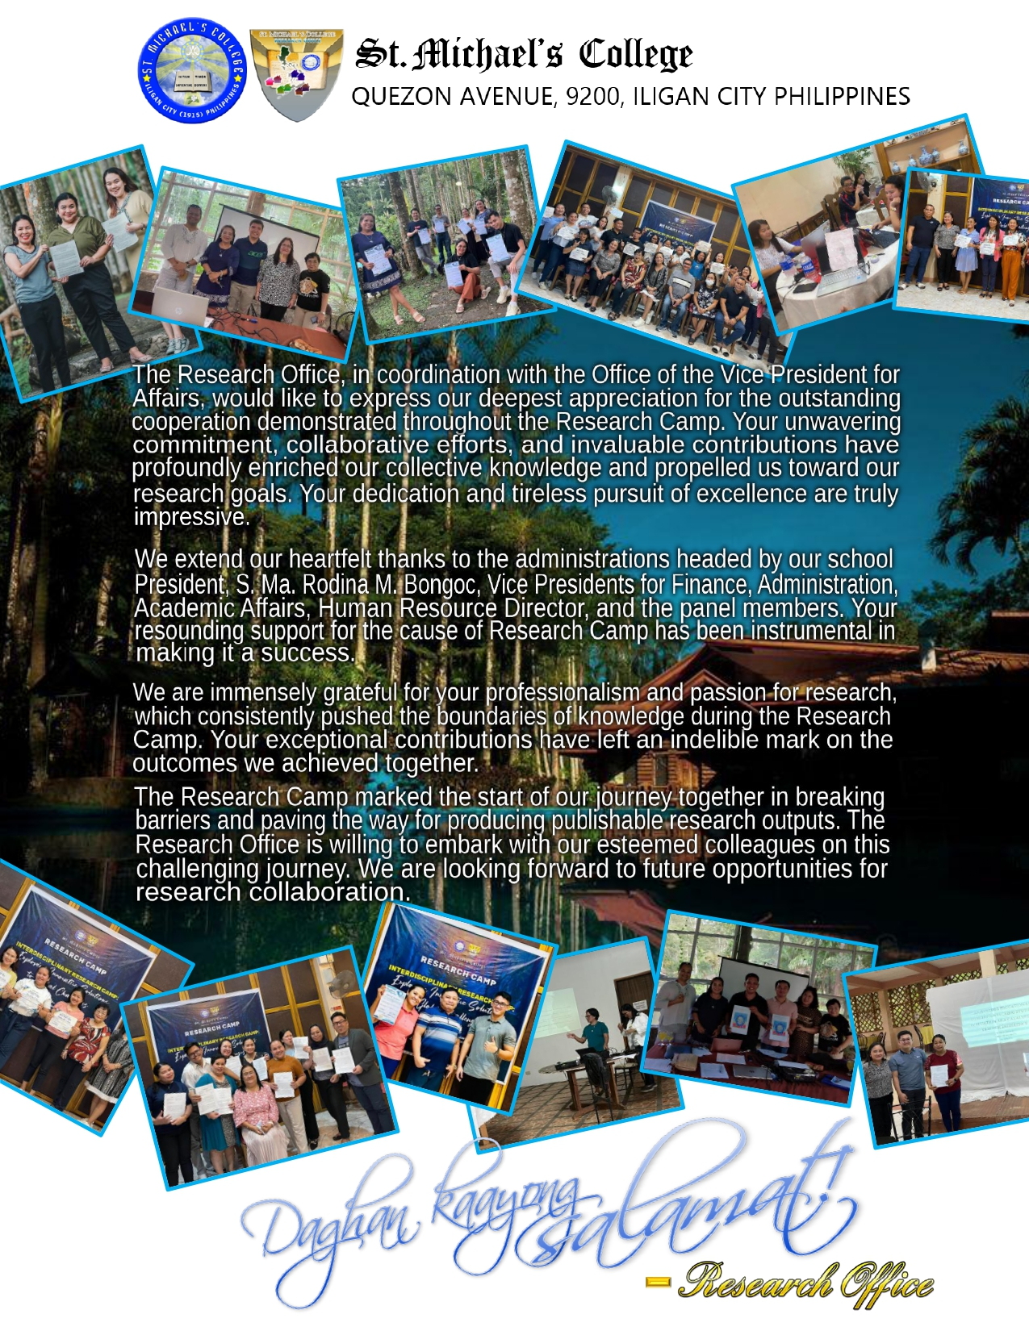

presenters receiving their certificates of recognition.



Submitted by:

STEPHANIE L. COLORADA, MAEd-ELT, TESOL
CAS FACULTY AND RESEARCH ASSOCIATE

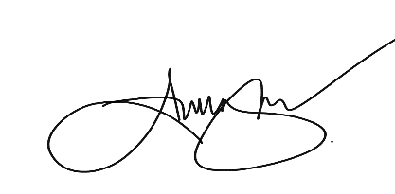
Noted by:

ANICETO B. NAVAL,Ph.D
Research Director

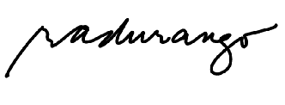

RITZCEN A. DURANGO, Ph.D
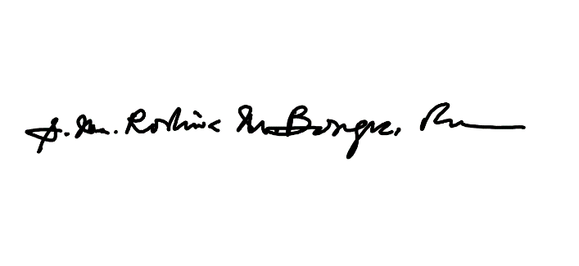
VP-ACADEMIC AFFAIRS

S. MA. RODINA BONGOC, RVM
President

