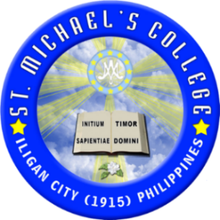

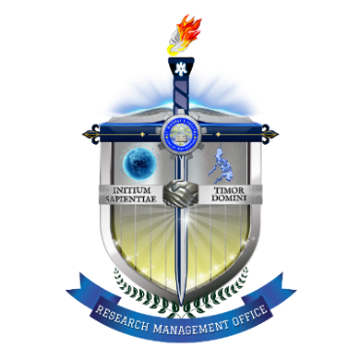

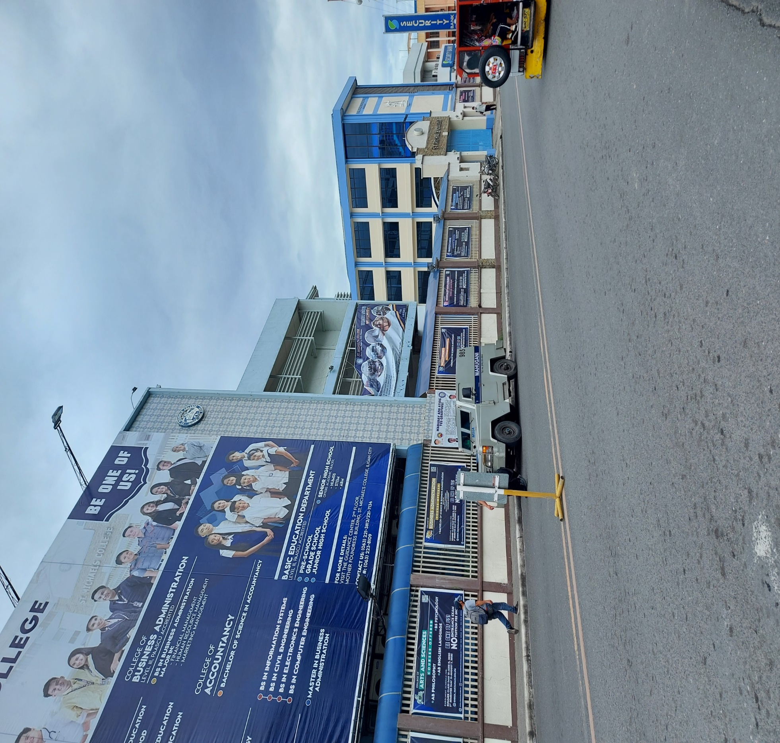

Nurturing Communities:

Innovating Nursing Practices for Comprehensive Care and Education

College of Nursing
Research camp
SMC HM Laboratory Hotel
ST. MICHAEL’S COLLEGE, ILIGAN CITY 9200
March 6 – 7, 2024

THE RESEARCH CAMP
The Research Management Office at St. Michael's College has developed a customized Research Capability Program to enhance the research skills of its academic members. This program, which is adapted to suit the specific needs of the faculty, addresses different competencies in research each academic year. The results have been encouraging, particularly in integrating research activities into teaching. Despite this progress, the faculty's performance in producing highly publishable research has been underwhelming. Notably, this is not because of a lack of research competency but a lack of time, which significantly impedes their research productivity.
To tackle this persistent issue, the concept of the Research Camp was introduced. This initiative is part of the Research Capability Program and is designed to meet the recommendations of PAASCU (Philippine Accrediting Association of Schools, Colleges, and Universities). These recommendations include sustaining the publication of the SMC Research Journal as a platform for disseminating research findings and increasing the participation of graduate faculty, including part-time graduate teachers, in research activities. The Research Camp aims to be an intensive, immersive event that fosters research productivity. It aims to bring together researchers from various disciplines to collaborate, exchange knowledge and ideas, and create highly publishable research outputs. The Camp not only aligns with the institutional goals but also promotes an interdisciplinary approach to research, enhancing the overall research landscape at St. Michael’s College.
Rationale

Building on the commendable success of the inaugural Research Camp at Montegelo Farms and the recent Graduate School Research Camp at Dream Residences, both in Manolo Fortich, Bukidnon, St. Michael's College of Iligan City has demonstrated a commendable commitment to enhancing the research capacities of its faculty members. These camps have not only facilitated the generation of high-quality research outputs, but have also nurtured a culture of collaboration and professional development among participants from various departments. Despite the formidable task of achieving a 100% publication rate, the camps have an undeniable influence on faculty knowledge, networking, and the cultivation of a thriving research culture.
In direct alignment with the Philippine Accrediting Association of Schools, Colleges, and Universities (PAASCU)'s recommendation, and in acknowledgment of the imperative to foster and disseminate collaborative research endeavors that not only enrich academic discourse but also tangibly benefit community extension initiatives, the Research Management Office (RMO) proposes another specialized Research Camp for the College of Nursing. This initiative is envisioned to serve as a catalyst in bridging the gap between academic research and community health needs, especially focusing on adopted community. This initiative, themed "Nurturing Communities: Innovating Nursing Practices for Comprehensive Care and Education," aims to foster the research activities of nursing faculty members, focusing on generating publishable research that addresses critical issues in community health, nursing education, and other related fields.
The objective of this specialized camp extends beyond merely expediting the production of research outputs. It seeks to create an environment for faculty members to enhance their research skills, foster innovative thinking, and deepen their understanding of research methodologies in nursing and healthcare. By integrating workshops, lectures, and hands-on training sessions, the camp will empower participants to conduct rigorous research that can significantly impact community health outcomes and education. This highlighted the importance of continued learning and adaptation in research practices for achieving meaningful results (Wenner & Rutherford, 2018).
Furthermore, this Research Camp will prioritize research that aligns with the theme of innovating nursing practices for comprehensive community care. However, it caters also research from other fields focusing on community extension and instruction. The camp will encourage research that not only advances nursing knowledge but also directly benefits local and global communities. Projects may include developing new healthcare delivery models, enhancing health literacy programs, and creating culturally competent care practices, all aimed at improving community health and wellbeing.
By emphasizing community-engaged research and the application of nursing innovations in real-world settings, the College of Nursing Research Camp will contribute significantly to the body of knowledge in nursing and healthcare. It will also reinforce the college's commitment to social responsibility and the well-being of communities it serves. This initiative represents a strategic step towards achieving excellence in nursing education and research, ultimately enhancing the quality of healthcare education and community services provided by St. Michael's College of Iligan City.

General Objective
The overarching goal of the Research Camp at St. Michael's College is to facilitate the creation of highly publishable research outputs by its academic community. Recognizing the challenges posed by limited time availability and the need for rapid production of quality research for publication, the camp is designed to address these specific issues.
It aims to gather researchers from a variety of disciplines, fostering an environment that encourages interdisciplinary collaboration and the sharing of knowledge and expertise. This initiative is crafted to not only expedite the research process but also to enhance the quality and impact of the research outputs, aligning with the institution’s commitment to advancing academic excellence and scholarly contribution.

Specific Objectives
By participating in workshops, lectures, and other training activities focused on research methods, data analysis, and academic writing, faculty researchers can improve their research skills and produce research outputs that meet the standards for publication in reputable academic journals. Specifically, it aims to:
- to provide an intensive and collaborative environment for researchers to enhance their research skills and knowledge;
- to develop innovative research ideas, and produce high-quality research outputs that are publishable in reputable academic journals;
- to provide opportunities for networking and collaboration with other researchers or colleagues in different fields; and
- to promote the dissemination and impact of research outputs through publication in academic journals.
Structure
The Research Camp at St. Michael’s College is strategically designed to cater to the specific needs of the graduate school members, aiming to enhance their research capabilities. This comprehensive program includes a series of workshops, lectures, and interactive discussions. Each workshop focuses on distinct research techniques and methodologies, offering a diverse range of topics.
These sessions, led by the Research Management Office in collaboration with experienced researchers from various disciplines, are structured to provide participants with in-depth, hands-on experience using a variety of research tools. This strategic approach not only fosters a practical understanding of different research methods but is also designed to augment the research productivity and output of the faculty members.

Participants
All full-time and part-time faculty members of the College of Nursing, faculty of other colleges as recommended by their respective Deans, personnel of Research Management Office, and pool of panel members from the Research Advisory Council (RAC) are required to attend the research camp unless prevented by inevitable circumstances (e.g. serious illness, injury, family emergencies, natural disasters, travel restrictions, and other unforeseeable events that are beyond the person's control). There are 15 faculty members of the College of Nursing, including the Dean, 2 CAS faculty, 8 members of RAC, 3 Research Management Office personnel, Vice President for Academic Affairs, and the School President. A total of 30 expected participants.

Logistics
The Nursing Research Camp at SMC HM Laboratory Hotel is scheduled to span two (2) consecutive days. This event will be held in the HM Laboratory Hotel, St. Michael’s College, Iligan City. To ensure a comfortable and focused experience for all attendees, the camp will include provisions for lodging and meals throughout its duration. This arrangement ensures that participants can fully immerse themselves in the research activities without the concern for logistical details, thus maximizing the productivity and effectiveness of the camp.

Expected Outcomes
The Nursing Research Camp is expected to foster the development of interdisciplinary research endeavors, establish new research collaborations, and enable the sharing of knowledge and expertise among different disciplines. A key requirement for participants is the presentation of their research outputs at the conclusion of the camp.
This is more than a mere obligation; it is a critical component of their participation. Failure to meet this expectation will cause sanctions, as determined and approved by the Research Advisory Council. This policy underscores the seriousness with which the administration regards the commitment of its participants to contribute actively to the camp's objectives.

Key features of this initiative include:
- Collaborative Research Design Workshop: Facilitating interdisciplinary collaboration among nursing faculty, community leaders, and other healthcare professionals to design research projects that address pressing community health issues.
- Skill Enhancement Sessions: Offering intensive training on contemporary research methodologies, data analysis techniques, and scholarly writing to enhance the quality and impact of research outputs.
- Community Engagement Platforms: Creating opportunities for direct interaction with the community to understand their health challenges, hence ensuring that research projects are grounded in real-world needs and can lead to practical interventions.
- Publication and Dissemination Support: Providing dedicated support for navigating the publication process, ensuring that research findings not only reach academic audiences but also inform policy and practice within the community and beyond.
- Sustainability and Impact Assessment: Integrating mechanisms for evaluating the long-term impact of research projects on community health outcomes, to develop sustainable health interventions.

Matrix of Schedule

Training | Schedule | Venue | Resource Speaker
Phase 1:  Research Tools Using Technology | March 6, 2024  8:30 - 10:00 | HM Laboratory Conference Hall | Research Management Office
Writeshop | March 6, 2024  10:00 - 12:00 | HM Laboratory Conference Hall | Research Management Office
Phase 2:  Thematic Analysis | March 6, 2024  1:30 - 3:00 | HM Laboratory Conference Hall | Research Management Office
Writeshop | March 6, 2024  3:00 - 5:00 | HM Laboratory Conference Hall | Research Management Office
Phase 3:  Article Writing | March 7, 2024  8:00 - 9:00 | HM Laboratory Conference Hall | Research Management Office
Writeshop  Writing Publishable Format | March 7, 2024  9:00 - 12:00 | HM Laboratory Conference Hall | Research Management Office
Phase 4:  Research Presentation | January 27, 2024  2:00 - 4:00 | HM Laboratory Conference Hall | Research Management Office

Pool of Panel Members
The pool of panel members for the Research Camp is comprising the members of the Research Advisory Council. These panelists bring a wealth of knowledge and experience, which will help to review the research outputs intended for publication. Their insights will play a vital role in ensuring the quality and rigor of the research produced during the camp, aligning to achieve publishable standards. This collaboration between institutions enhances the review process, providing diverse perspectives and expertise in the research's evaluation outputs.

Budget Proposal
Executive Summary:
The Research Office of St. Michael’s College is requesting funding of Php 36,242.50 to facilitate the proposed research camp. This camp is designed for 30 participants, including faculty members of the College of Nursing, 2 CAS faculty, 8 members of RAC, 3 Research Management Office personnel, Vice President for Academic Affairs, and the School President. The budget proposal encompasses all essential expenses, such as meals, snacks, accommodation, and materials required for the successful execution of the camp. To finance this initiative, the projected budget will be sourced from the annual budgets of the Research Management Office. This funding will ensure that all logistical and material needs are adequately met, allowing the participants to focus entirely on the research objectives of the camp.
Budget Breakdown:
Particulars | Total
Materials  Long bond paper: 5 reams x Php 315 = Php 1,575.00  Specialty Board for Certificate: Php 44.50 x 15 = Php 667.50  For presenters corsage Php 100 x 12 = Php 1,200 | Php 3, 442.50
Food and Accommodation  As quoted by the College of Hospitality and Tourism Management | Php 32,800.00
TOTAL | Php 36,242.50

Submitted for Approval,

Aniceto B. Naval
Director, Research Management Office

Recommending for Approval:

Ritzcen A. Durango, PhD Korsiney N. Cabasis, DBA
Vice President for Academic Affairs Vice President for Administration

Approved by:

S. Ma. Maricris B. Diaz, RVM
Vice President for Finance

S. Ma. Rodina M. Bongoc, RVM
President

