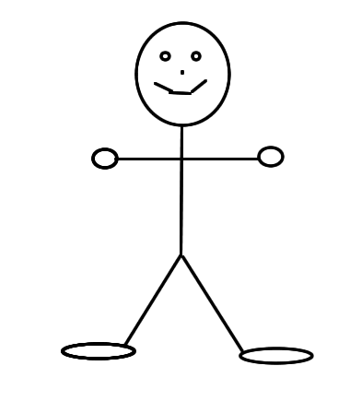
USE CASE DIAGRAM
View Reservation Log
Generate Report
Confirm Reservation
Add Reservation
Edit Reservation

View Equipment Status

Borrower IT Personnel
Delete Reservation
Inquire Reservation

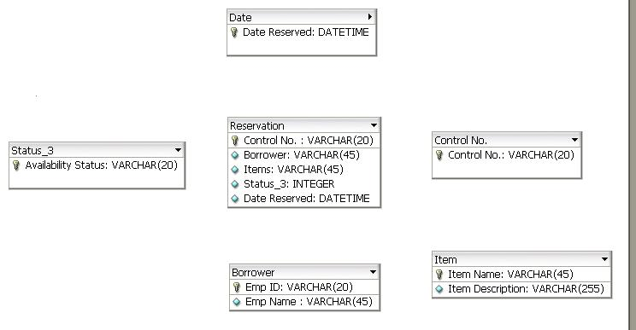
ERD

