Name :________________________________________________ Date:___________

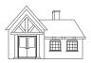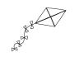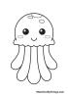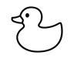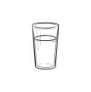fish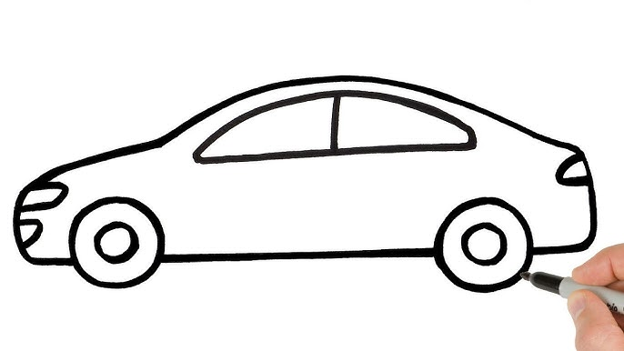

1 , 2 3 , 4 5 , 2 2 , 5 4 , 1

6 , 10 7 , 8 6 , 9 9 , 10

III. Count the objects and circle the correct answer.

1. Match the big and small letters.

B c  
C b  
D f  
F d  
H g  
H j  
J h  
K k

1. Match the beginning sound of the objects.

B

C  
  
D  
  
F  
  
G  
  
H  
  
J  
  
K