**ESM 212**

**Estimating forest carbon: a case study of oak woodlands at Sedgwick Ranch Reserve**

**Exercise 2, Spring 2023**

The purpose of this exercise is to acquaint you with the application of allometric equations for estimating forest carbon based on tree diameter measurements. You will use tree dbh data similar to what you collected during the second field trip. The data are provided in three files – one for each plot. The calculations can be readily performed in Excel or R (r script provided).

To estimate the amount of tree carbon in your plots, you need to do the following: *Double-check dbh data for consistency in data formatting for the 3 plots.

1) For each plot, calculate the total aboveground biomass of each tree. Apply the equation from table 1 in Jenkins et al. (2004), assuming that the allometric parameters for *Quercus douglasii* and *Q. agrifolia* are equivalent to those for “juniper/oak/mesquite.”

Eq: $bm=Exp(β_{0}+ β_{1}×\ln\left(dbh\right))$

Where $bm$ = total aboveground biomass; $Exp$ = exponential function; $β_{0}$ = -0.7152; $β_{1}$ = 1.7029; $ln⁡(dbh)$ = natural log base e of the diameter at breast height of the tree.

*Note: How do you handle multiple-trunked oaks? Calculate the total basal area by summing the calculated area of each trunk. Then calculate the equivalent DBH for a single-trunked tree with the same area. This has been done already in the data, but want you to take note of this.*

2) For comparison, produce an alternative estimate of aboveground tree biomass for each tree using equation 7 provided in Table 2 from Karlik and Chojnacky (2014).

Eq: $bm= β_{1}×{dbh}^{β_{2}}$

Where $bm$ = total aboveground biomass; $β_{1}$ = 0.068; $β_{2}$ = 2.569; $dbh$ = diameter at breast height of the tree.

3) Plot the dbh-biomass relationships for your different equations as illustrated in Jenkins et al. (2004), Figure 2 (pasted below). This will provide some sense of estimation uncertainty.

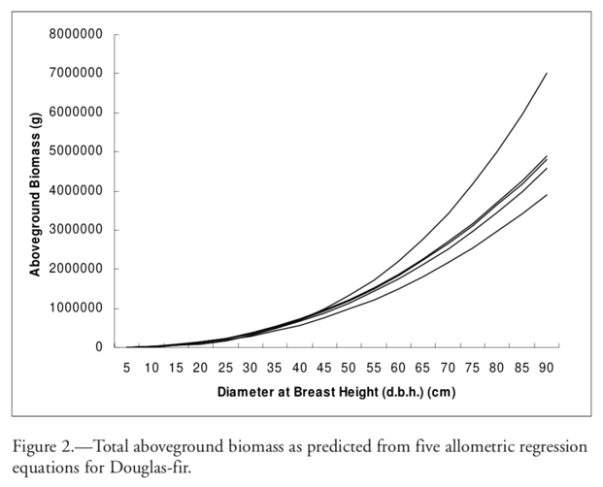

4) Based on the parameters from equation 7, Table 2, in Karlik and Chojnacky (2014), estimate the total tree biomass per plot by summing the biomass for all trees in the plots, and dividing by the total plot area (50m x 25m = 1250m2). Convert your estimate to tree carbon per hectare (see top of page 230 in Karlik and Chojnacky (2014), estimate of 45.85% of biomass is carbon, so (bm*0.4585)/(1250m2 * 0.0001) to get carbon per hectare).

5) Briefly discuss the major sources of uncertainty and error in your estimate of carbon in blue oak woodlands at Sedgwick Reserve, and how you might reduce the uncertainty in that estimate.