**BS. INFORMATION TECHNOLOGY**

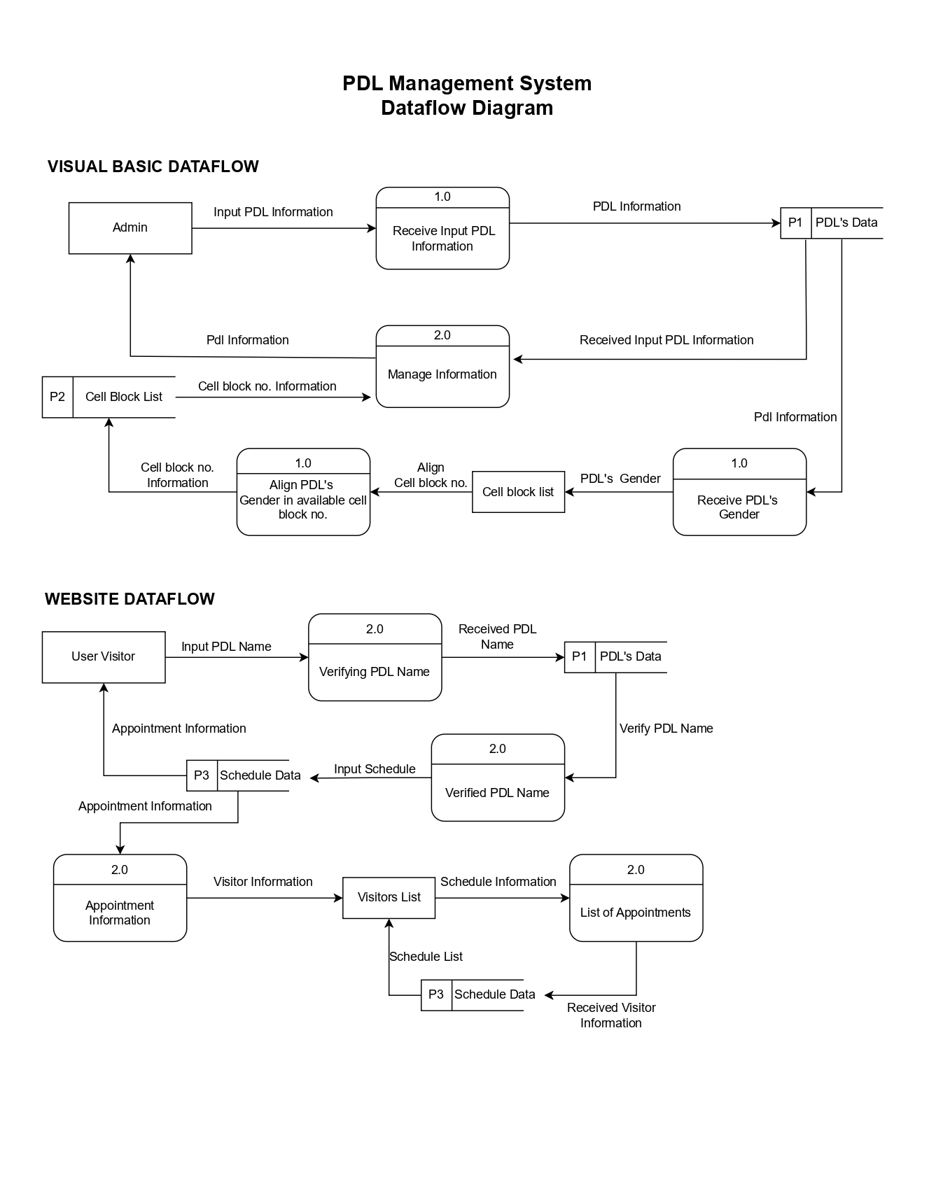**PDL MANAGEMENT SYSTEM DATAFLOW DIAGRAM**

Prepared by:

**Leader: JUSTINE NORIE B. DELA CRUZ**

**Group 2 – PDL Management System**

Checked by:

**RIZZA MAE BRAO**

**BS. INFORMATION TECHNOLOGY**

**PDL MANAGEMENT SYSTEM DATAFLOW DIAGRAM**

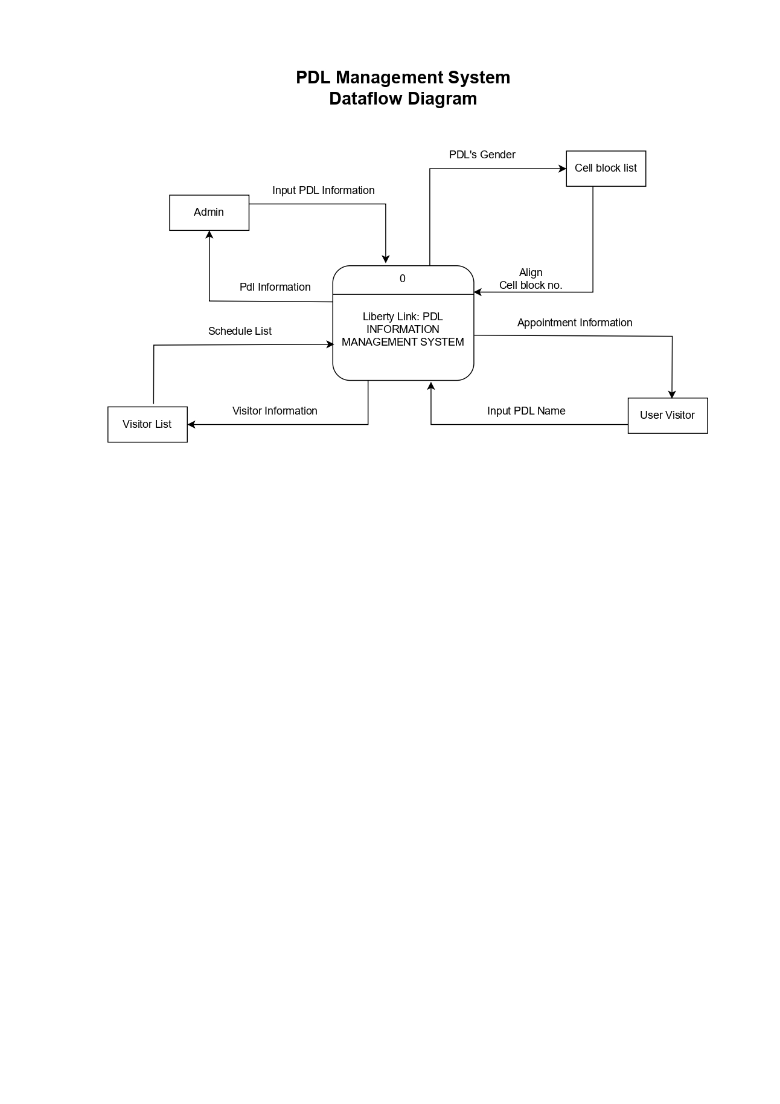

Prepared by:

**Leader: JUSTINE NORIE B. DELA CRUZ**

**Group 2 – PDL Management System**

Checked by:

**RIZZA MAE BRAO**