API Test 1:
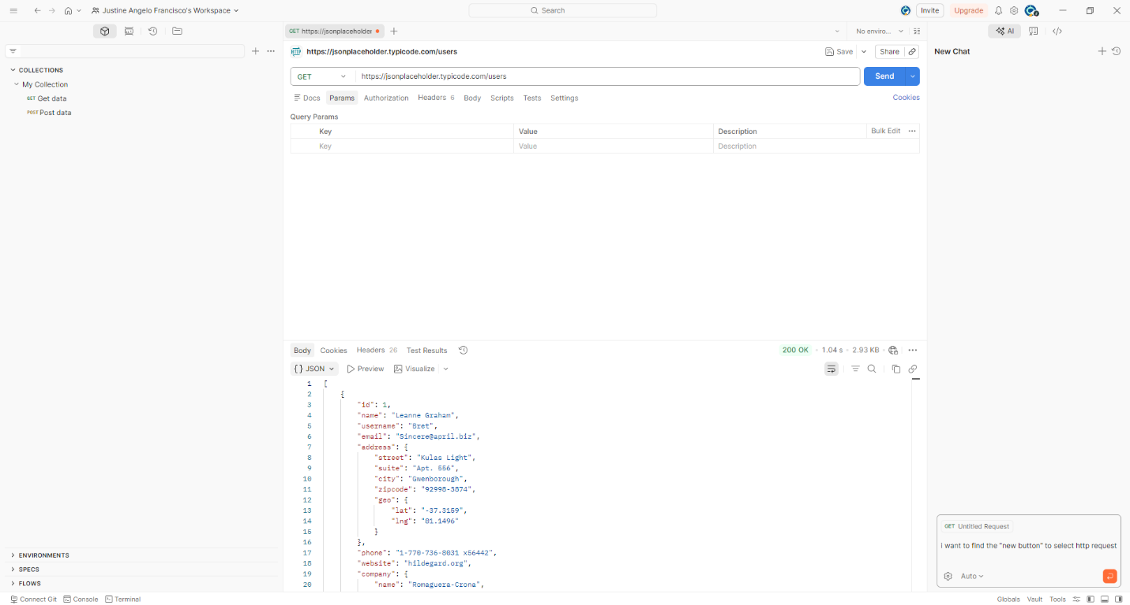
Full URL: https://jsonplaceholder.typicode.com/users
Endpoint: GET /users
Method: GET
Expected Result:
- API returns list of users.
Actual Result:
- API returned status 200 OK and returned user data in JSON format.
Analysis:
The API successfully retrieves all user records.

API Test 2:
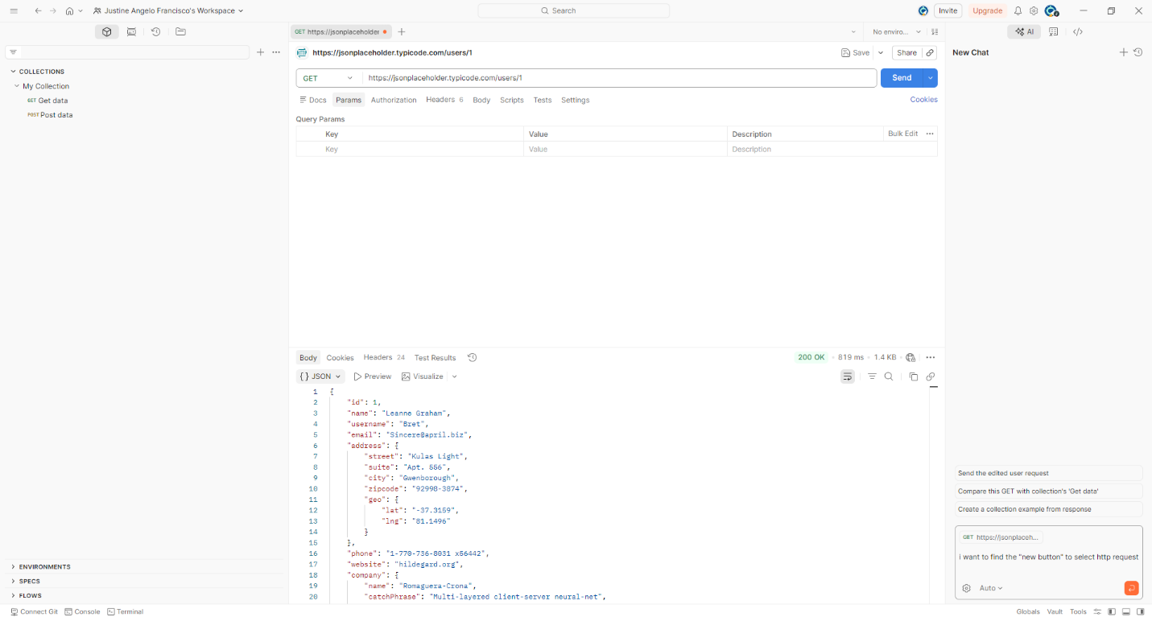
Endpoint: GET /users/1
Method: GET
Expected Result:
- Returns user information.
Actual Result:
- Status 200 OK and returned correct user details.
Analysis:
The endpoint correctly retrieves the requested user.

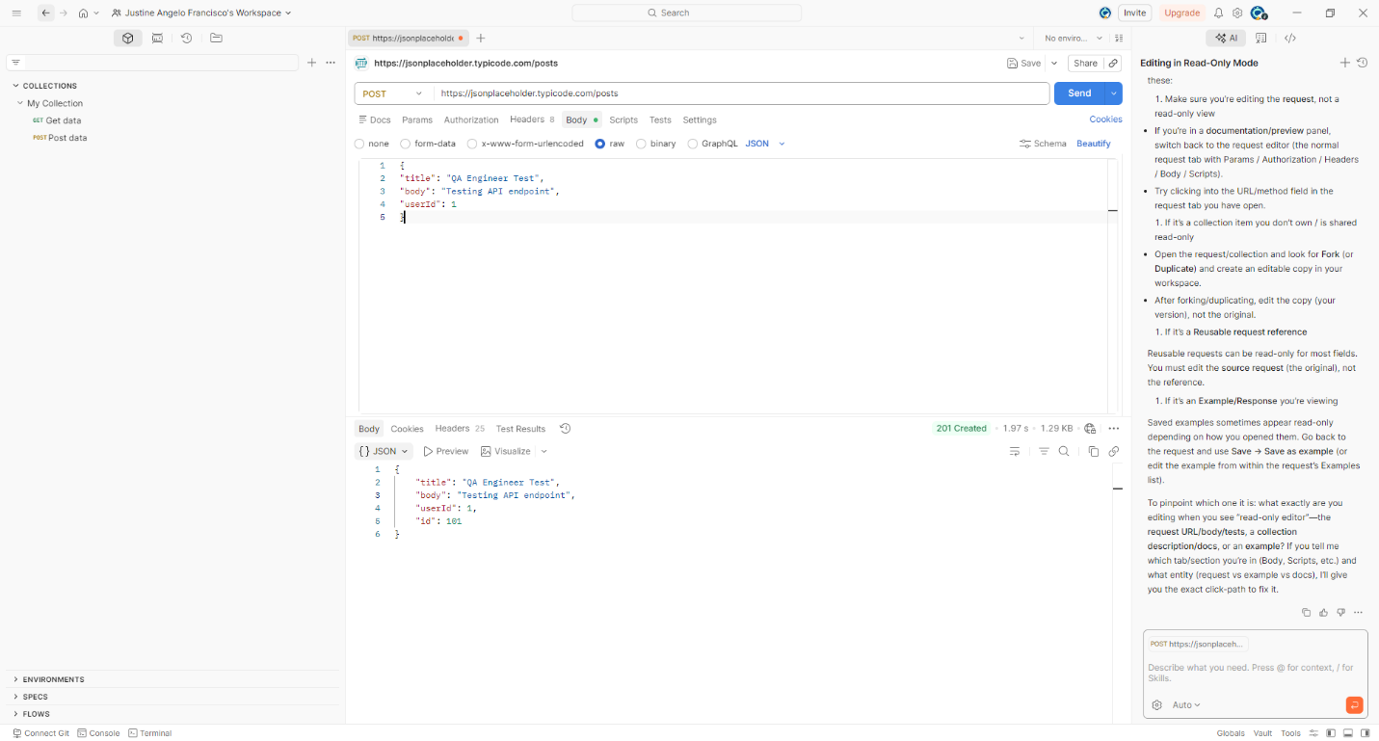
API Test 3:
Endpoint: POST /posts
Method: POST
Expected Result:
- Creates a new post.
Actual Result:
- Status 201 Created returned with new post object.
Analysis:
API successfully created a new resource.

API Test 4:
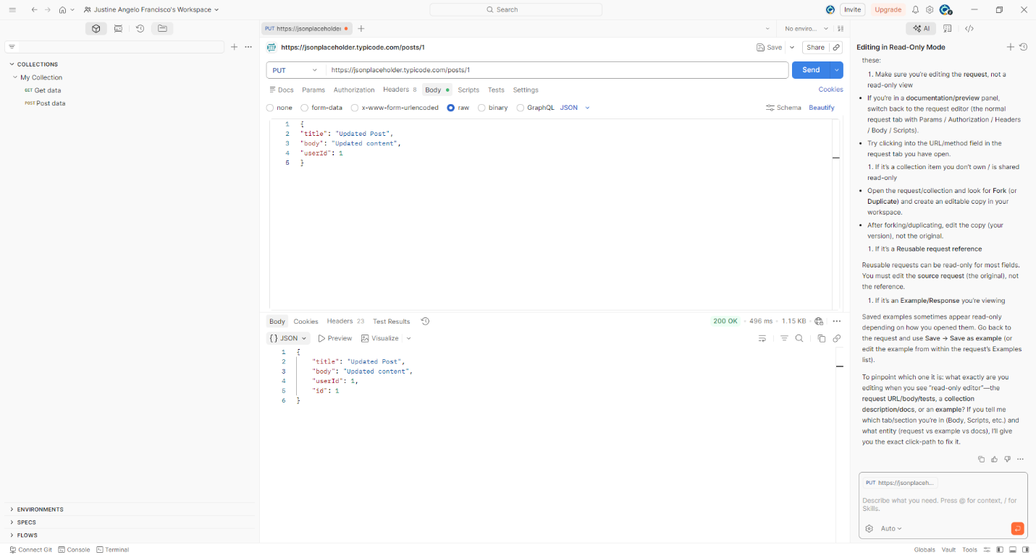
Endpoint: PUT /posts/1
Method: PUT
Expected Result:
- Updates post.
Actual Result:
- Status 200 OK returned with updated object.
Analysis:
API correctly updated the post resource.

