Justin Reid

April 10th 2016

Analysis of Yoyo Intermittent Recovery Test for Fall Training

The yoyo intermittent recovery test is a standardized measurement of the ability of an athlete to perform repeated interval runs over a period of time. The measurements are in meters and indicate how far an athlete ran given ever decreasing time between intervals. We analyzed the data from December 2014 to January 2016. We plotted player Id’s on the x axis and meters run on the y axis. The red circles are from December 2014 and the green triangles are from January 2016 (about a year later). The graph indicates that at the end of the year the athletes were not doing as well as they were at the beginning. We did a paired t test to confirm this. It showed an average decrease of **xxxx,** with a p-value of 0.00013.

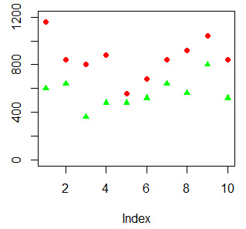

Red circles: December 2014

Green Triangles: January 2016

A decrease in the fitness level of all the athletes is surprising. It would be expected that the athletes would get stronger. When looking at the back squat data this expectation was met.