2

Transforming Shapes
Now that you know how to draw and combine the basic OpenSCAD 3D shapes, you're probably anxious to extend your creative capabilities. This chapter will introduce you to a collection of sophisticated operations that will allow you to transform your creations in any way that you can imagine. You'll learn how to move, rotate, reflect, and scale objects, as well as how to combine two objects by wrapping a tight, tent-like surface around them. 3D printing tips for the Big Projects in this chapter will help you think more creatively about how you place your objects on the build platform.

More on the OpenSCAD Environment
The OpenSCAD Toolbar provides you a collection of buttons that make switching your view very easy. You can also quickly access these operations by going to the View menu.

Views
Since OpenSCAD is a 3D design program, it's easy to wander around your object by using your mouse or trackpad. But what if you want to quickly reset or switch your viewpoint? These Toolbar buttons will come in very handy.

Zooming
View All
Zoom In
Zoom Out
Reset View

Orthogonal Views
Right
Top
Bottom
Left
Front
Back

Axes

The Axes Legend

Show Axes

OpenSCAD Shape Transformations
These OpenSCAD transformations will greatly expand your ability to create complex 3D designs. Each of the following commands is placed immediately before the object it is meant to transform. In this section I'll include a transparent grey outline to indicate where the original, untranslated object would have appeared.

Translating Shapes with translate
The translate command was first introduced last chapter. It allows you to move an object anywhere you'd like to place it within the Drawing window. I've included it again in this section to remind you that you already know how to transform a shape:
Insert 3translates.png

Rotating Shapes with rotate
Rotating a shape requires you to specify the both the angle of rotation (in degrees) and axis of rotation. You can rotate an object about any combination of the three axes, and the angle of rotation can be positive or negative. This example rotates a cuboid 90º about the x-axis:
rotate-x.scad  rotate([90,0,0])cube([30,20,10]); | Insert rotate-x.png  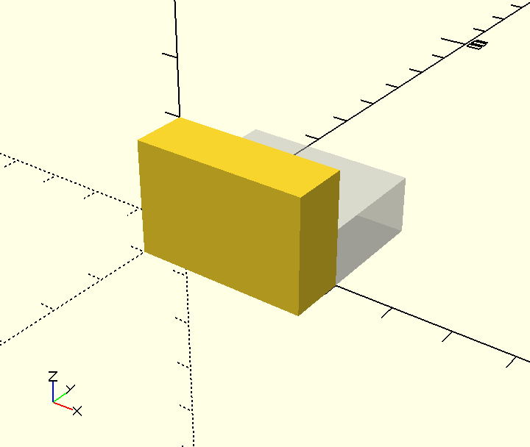

This code tells OpenSCAD to “rotate the cuboid 90º about the x-axis”. It's like someone made the YZ-plane into a wheel, then turned the wheel 90º in the positive direction. Because we're rotating about the X-axis, the X-axis stays fixed and the cuboid gets rotated into its' new position.
Here's how rotate works:
rotate([, , ]) cube([30,20,10]);
The ( )'s are used to modify the rotate command so that OpenSCAD knows how exactly how you want to rotate your shape about each of the three axes. The [ ]'s form a vector, grouping together the three axes of rotation:  is the amount of rotation about the x-axis,  is the amount of rotation about the y-axis, and  is the a amount of rotation about the z-axis. The ; is used to end the entire command.
Here are three more examples of rotate in action:

rotate-y.scad  rotate([0,180,0])cube([30,20,10]); | Insert rotate-y.png  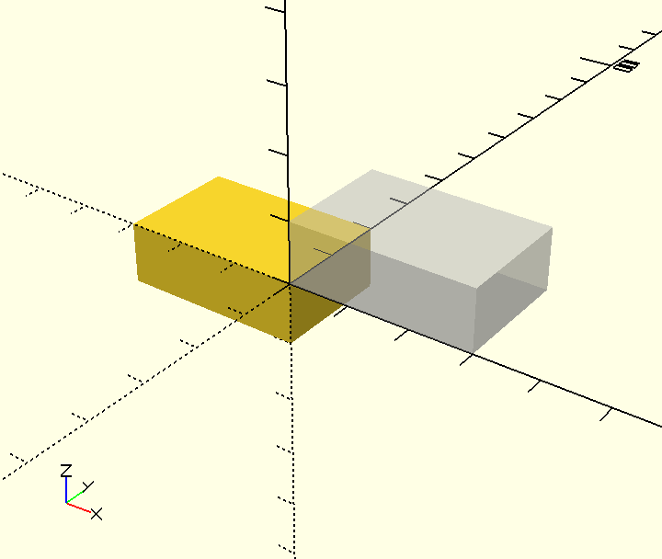

rotate-z.scad  rotate([0,0,45])cube([30,20,10]); | Insert rotate-z.png  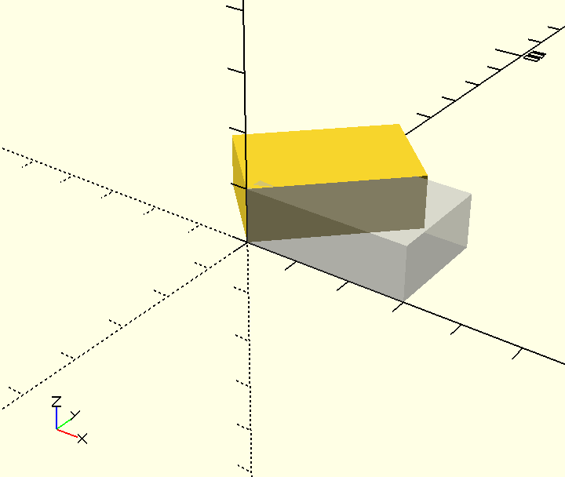

rotate-x-z.scad  rotate([-90,0,-90])cube([30,20,10]); | Insert rotate-x-z.png  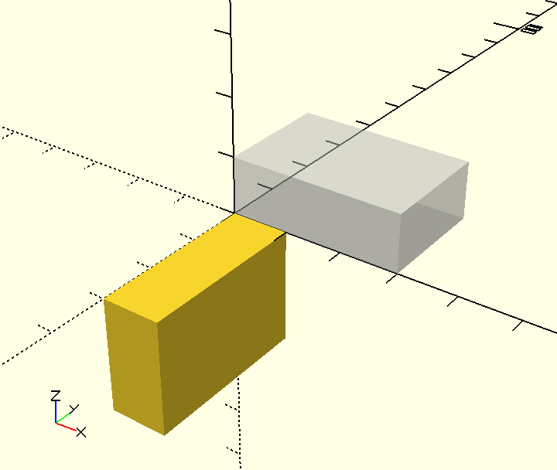

Reflecting Shapes with mirror
Reflecting a shape requires you to first imagine a 2D plane of reflection that passes through the origin (0, 0, 0). Then, plot an imaginary point that is perpendicular to that plane of reflection. This is the point that you use to tell the mirror command where your mirror is:

mirror-x.scad  mirror([10,0,0])cube([5,10,20]); | Insert mirror-x.png  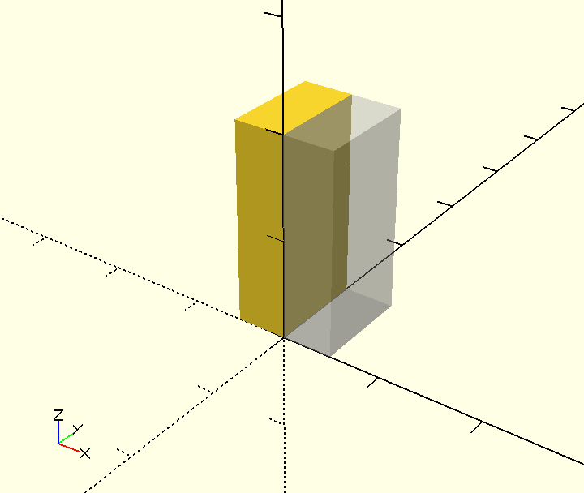

Notice that the vector [10, 0, 0] is used to tell the mirror command where the mirroring should occur. This code says “put a mirror centered around (0, 0, 0) that is perpendicular to the line connecting the origin to (10, 0, 0)”. Here's an illustration of what's happening behind the scenes with the mirror command:
Insert mirror-x-diagram.png
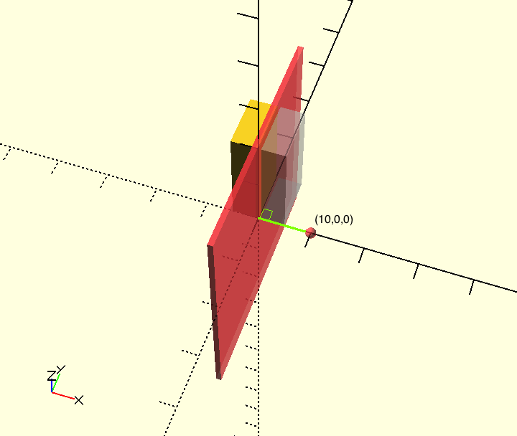
The red plane of reflection acts as the “mirror” because that is the 2D plane that is perpendicular to the line drawn from (0, 0, 0) to (10, 0 , 0).
Here's how mirror works:
mirror([, , ]) cube([5,10,20]);
The ( )'s are used to modify the mirror command so that OpenSCAD knows how exactly how you want to reflect your object. The [ ]'s form a vector, indicating the end point of the perpendicular line connected to the center of the plane of reflection:  is x-ordinate,  is the the y-ordinate, and  is the z-ordinate. The ; is used to end the entire command.
Here are two more examples of mirror in action:

mirror-z.scad  mirror([0,0,10]) cylinder(h=10, r1=2, r2=5); | 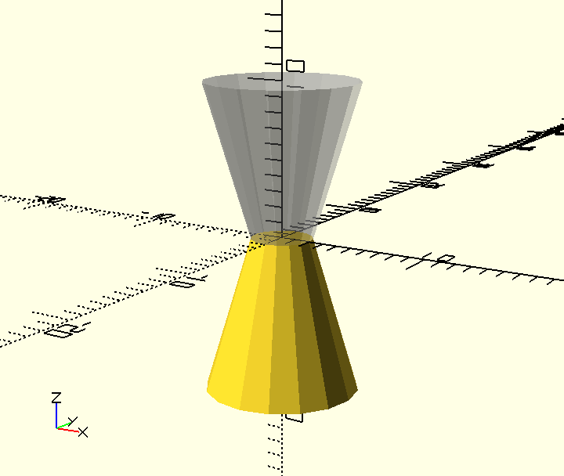  Insert mirror-z.png

mirror-y-z.scad  mirror([0,5,10]) cylinder(h=10, r1=2, r2=5); | Insert mirror-y-z.png  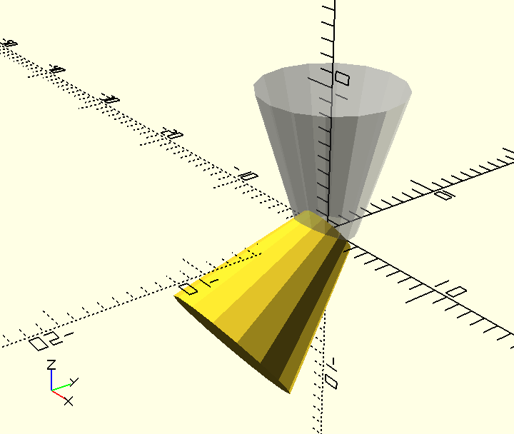

The mirror transformation is one of the most difficult OpenSCAD command to master. Don't worry if it's a little confusing at the moment. With practice, it will be a lot easier to see how one 3D point can indicate a 2D plane of reflection.

Scaling Shapes with resize
Luckily, resize is a pretty straight forward OpenSCAD command. This command allows you to stretch and shrink individual object dimensions. For instance, you can use resize to scale a sphere into an ellipsoid:

resize-sphere.scad  $fn =100;  resize([10,10,20]) sphere(1); | Insert resize-sphere.png  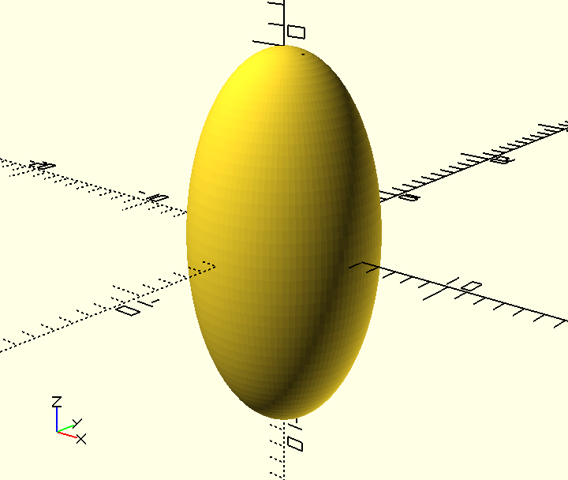

This example could be translated into English as “stretch a smooth sphere with radius of 1 so that it has a width along the x-axis of 10 units, a length along the y-axis of 10 units, and a height along the z-axis of 20 units.” The resize command uses a vector to specify each new dimension of the object. It's a very useful tool that you can use to expand the collection of basic shapes you have at your command.
Here's how resize works:
resize([, , ]) sphere(1);
The ( )'s are used to modify the resize command so that OpenSCAD knows how exactly how you want to scale your shape along each of the three axes. The [ ]'s form a vector, grouping together the three axes of rotation:  is the amount of rotation about the x-axis,  is the amount of rotation about the y-axis, and  is the a amount of rotation about the z-axis. The ; is used to end the entire command
Here is another example of resize in action. This time I'm scaling a basic cylinder into something more interesting:

resize-cylinder.scad  resize([10,5,20])cylinder(h=5, r1=5, r2=5); | Insert resize-cylinder.png  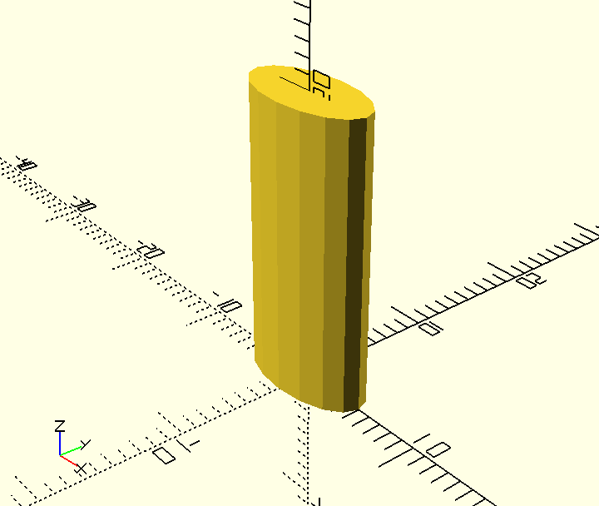

More Ways to Combine 3D Shapes
Last chapter you learned about three different boolean operations to combine 3D objects: union, difference, and intersection OpenSCAD gives you a couple more creative ways to combine two shape.

Combining Shapes with hull
Think of the hull operation as stretching a tight tent around two objects.

Combining Shapes with minikowski
Think of the minikowski operation as running one object about the entire perimeter of a second object.

Debugging Tips for Transforming Shapes

Order Matters

Write Comments with // and /* … */

Change the Color of Shapes with color

Understanding the decimal and hexadecimal versions of a color

Design Time – Transforming Shapes
Before you keep reading, practice the skills you learned in this chapter by building each of these complex objects.
  Heart  insert Heart.png here | 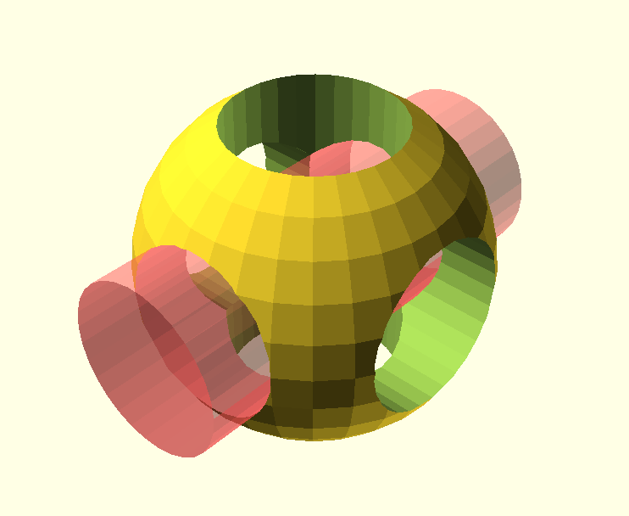  OpenScad Logo  insert OpenSCAD-Logo.png here
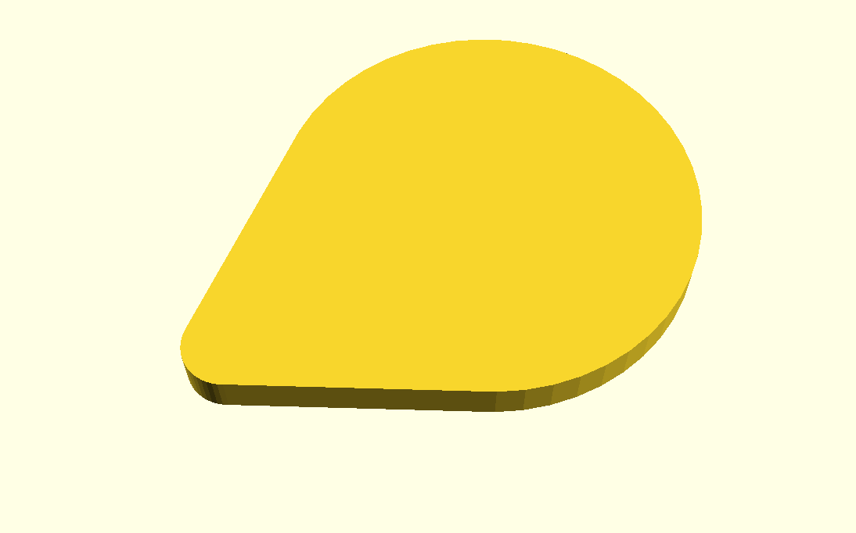  Guitar Pick  insert Guitar-Pick.png here | 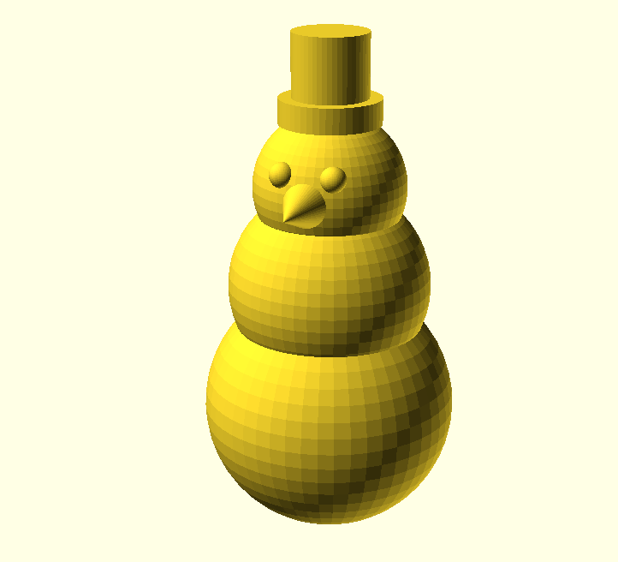  Snowman  insert Snowman.png here
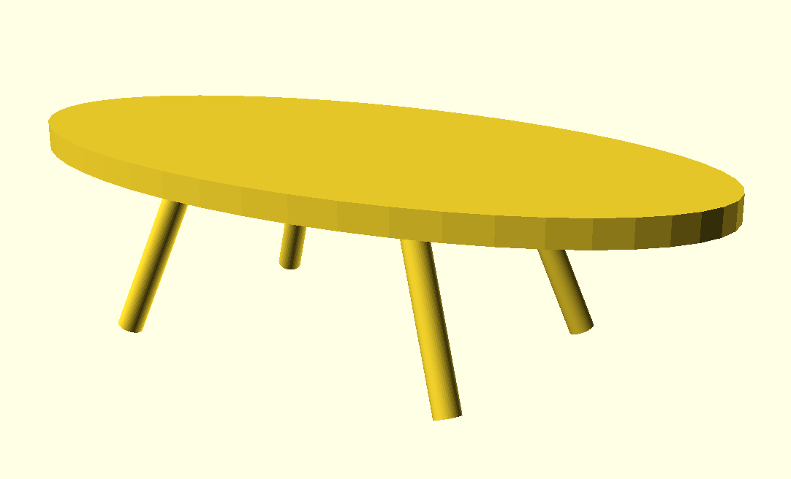  Modern Table  insert Modern-Table.png here | 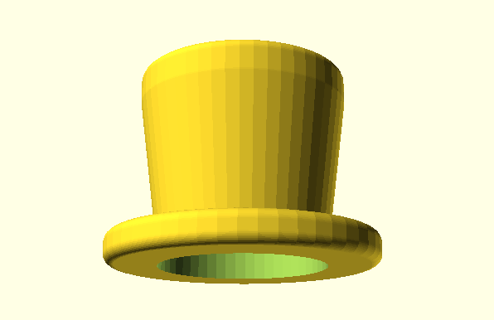  Top Hat  Insert Top-Hat.png here

Chapter Summary and Other Important Stuff
You now know how to:
type OpenSCAD code into the Editor window
preview objects in the Drawing window
draw cuboids, spheres, and cylinders in any size
import 3D objects in the .stl file format
smooth curves
move shapes to anywhere along the X, Y, and Z axes
group shapes
subtract and cutout overlapping shapes

Here are some important tips:
The name of a command tells you which type of shape you'd like to draw.
;'s are used is used to end a command.
Information inside of ( )'s are used to modify commands.
[ ]'s collect numbers together to form a vectors.
Boolean operations use { }'s to collect multiple shapes together .
( )'s, [ ]'s, and { }'s always come in pairs.
OpenSCAD is unit-less.
Set $fn at the beginning of your code to generate smooth curves.
Use the translate command to move your shapes.
Use indentation to help make your code readable and easy to understand.

Big Projects – Transforming Shapes

Calibration Pyramid
Building a calibration pyramid will help you determine whether you need to tweak the settings on your 3D printer. It will also help you practice using the cube and translate commands:
insert Calibration-Pyramid.png here
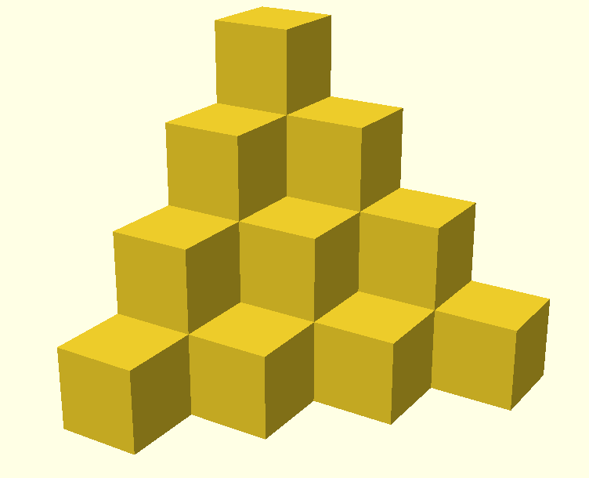
Figure Calibration Pyramid: A Calibration Pyramid
3D Printing Tips
Try printing this at different “resolutions”. Try Low, Medium, and High quality. Compare print times with results.
Try printing this pyramid at different sizes. Measure the pyramid after you print it. Does it match the measurement you expected it to be?
Do you have tight, straight lines at all corners?

Smiley Face Pendant
This project will get you thinking about using your 3D printer to print large, flat shapes. Flat shapes can be difficult to print because they tend to curl.
Insert Smiley-Face.png here

Figure smiley-face: A Smiley Face Pendant

3D Printing Tips
If you have a heated bed, use it. Vary the temperature of your heated bed to see which temperature works best for the type of filament you are using.
Inserting helper disks can help defend against curling. Helper disks are just 1 mm thick so they can easily be removed once your print is complete. Helper disks should be place around the perimeter of your object.

Hole and Pins Test
This project will get you thinking about using your 3D printer to print pieces that fit together. If you design this properly, the Pins portion of the project should fit snuggly inside the Holes portion.
insert Hole-and-Pin-Test.png here
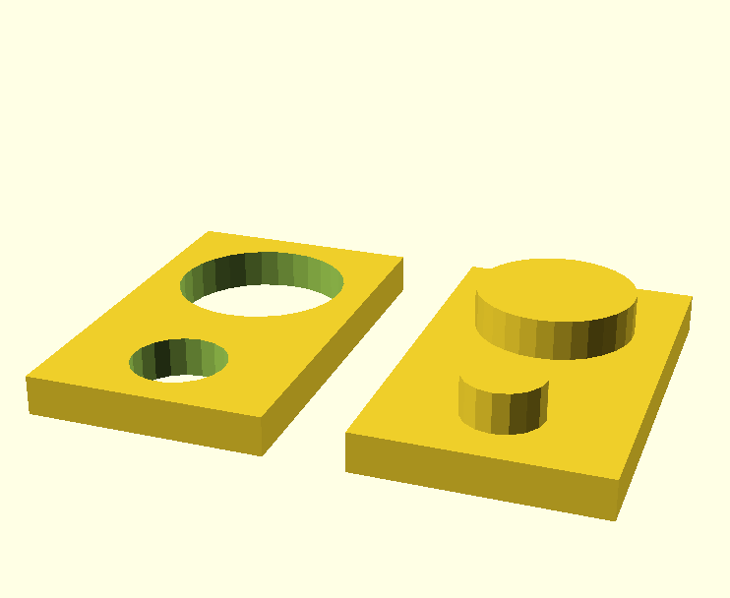
Figure hole and pin test: A Hole and Pin Test
3D Printing Tips
If you design the Pins to be exactly the same size as the Holes, the two pieces will not fit together. The Pins should be slightly smaller than the Holes.
How much smaller depends on the type of filament you are using. Both the brand and type of plastic will make a difference.
Space the two Pins far enough apart that you can test each one separately. Vary the difference in measurements for the small Pin and the large Pin so that you can complete the test faster.

