1

3D Shapes
In this chapter you will learn how to use the OpenSCAD programming language to draw basic 3D shapes. You will also learn how to move those shapes around in 3D space, as well as different ways methods for for combining multiple basic shapes into one complex object. Big projects from this section will ask you to apply these concepts as you design objects that are useful for getting to know your 3D printer.

OpenSCAD Environment Basics
OpenScad is a text-based programming language that makes 3D design very straight-forward and easy. Designing 3D objects with OpenSCAD is a two-step process:
  - Type a text-based code command to describe your object in the Editor window:
Insert Figure01-01.png here
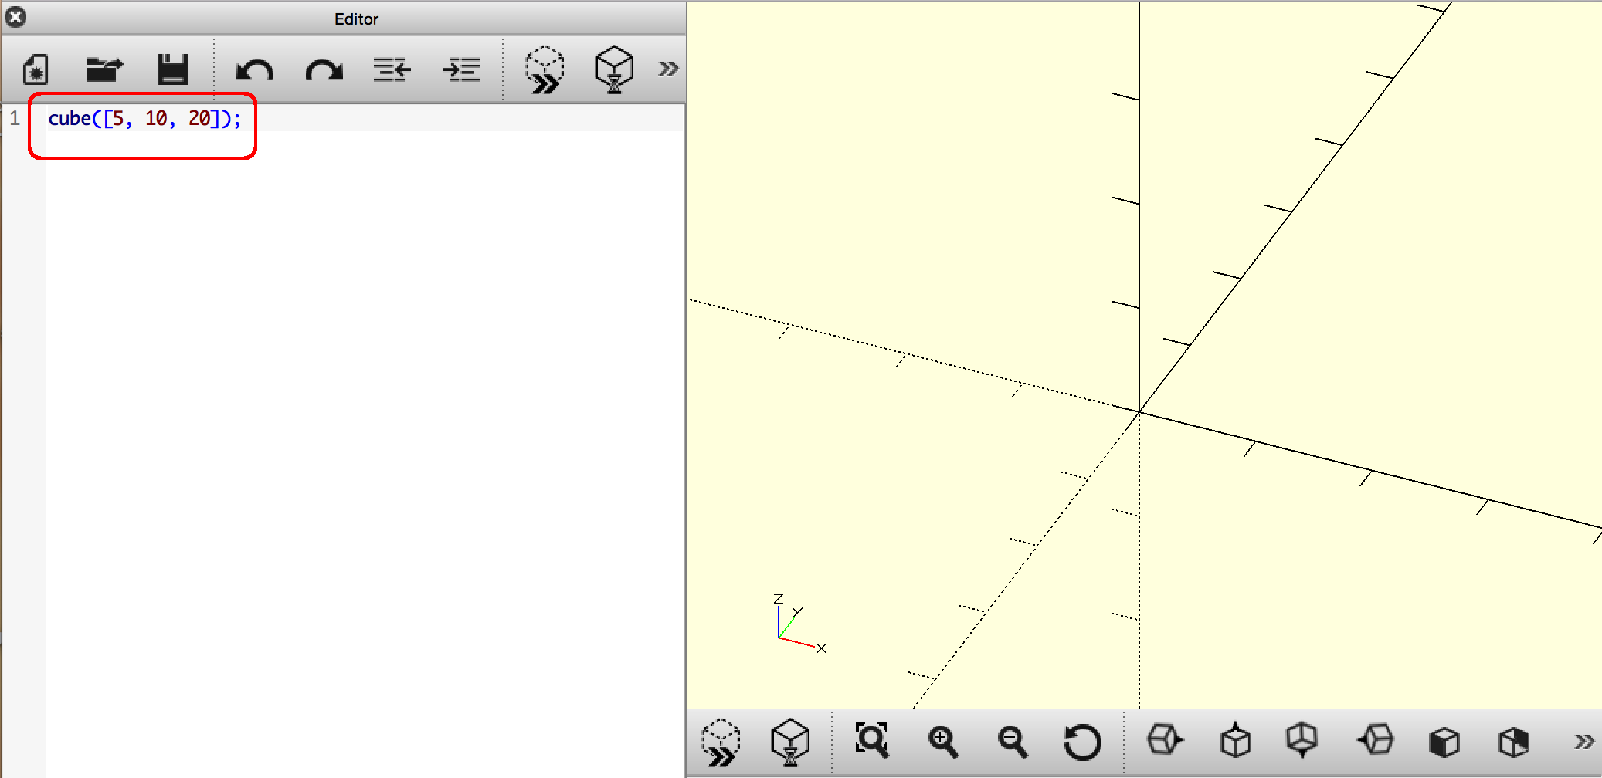
Figure 1-1: The Editor Window
  - Draw your object with the Preview button.
Insert Figure01-02.png here
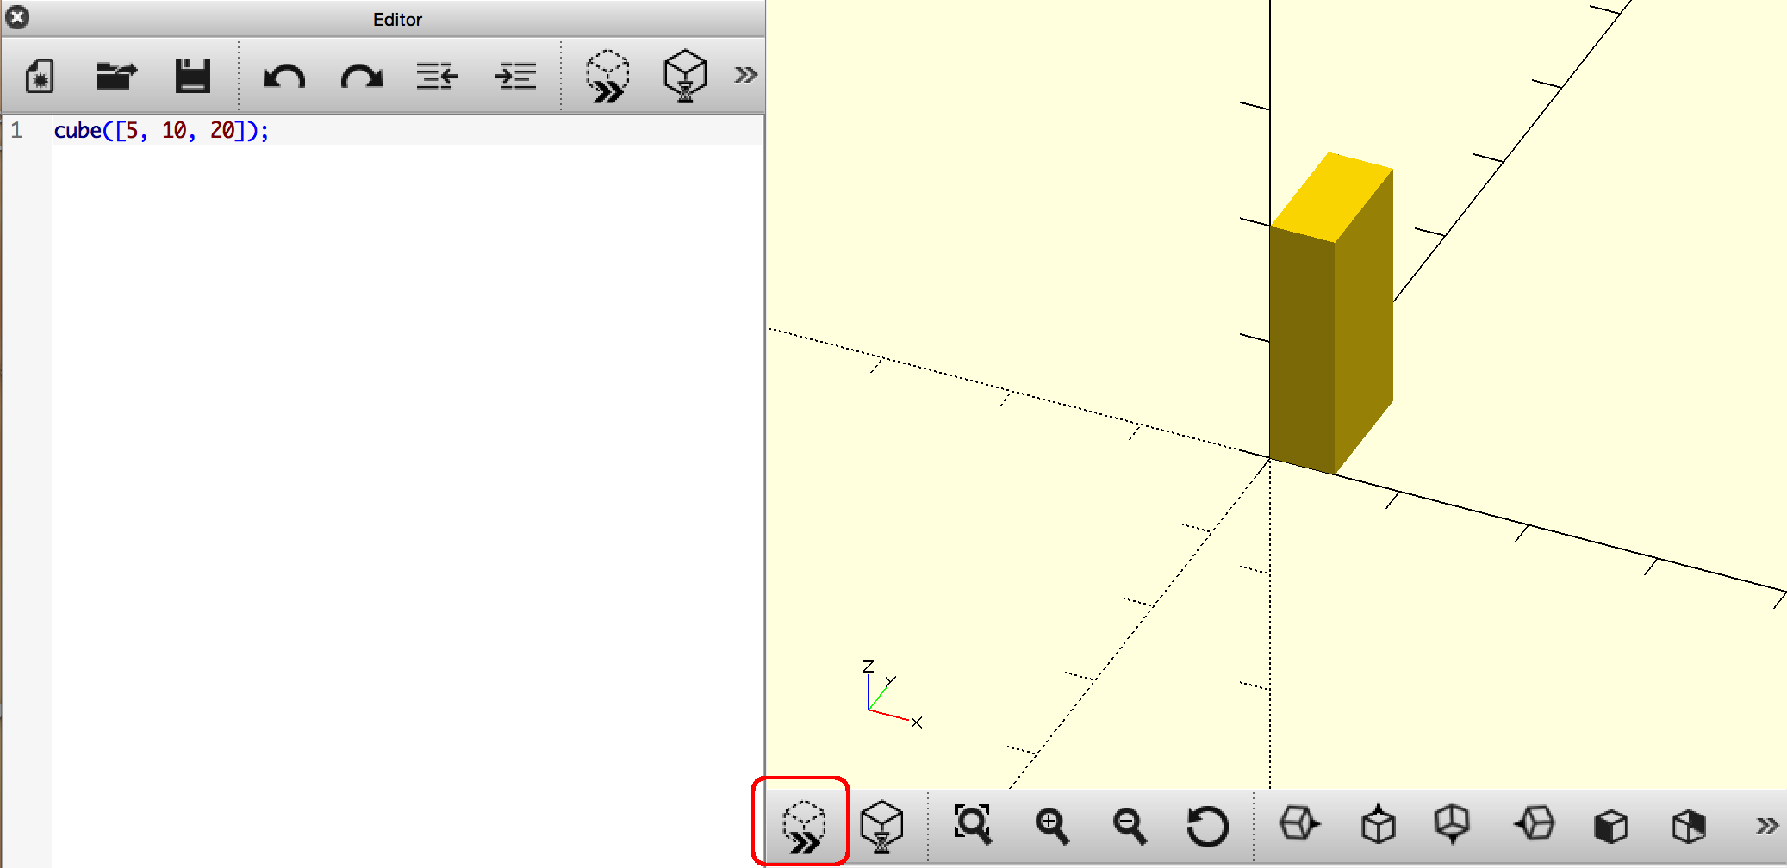
Figure 1-2: The Preview Button
There are many other useful buttons on this Toolbar, and those options will be introduced soon. For right now you can left-click-and-drag with your mouse to view your shapes from many different viewpoints.

Drawing Basic 3D Shapes
OpenSCAD code allows you to write instructions for your computer to draw basic 3D shapes. Commands to draw basic 3D shapes (cuboids, spheres, cylinders, cones, and imported models) are all quite similar. You have to indicate what type of shape you would like to see, then modify that command with numbers to indicate sizing.

Drawing Cuboids with cube
Let's take a closer look at the OpenSCAD code from above:
cube1.scad
cube([5, 10, 20]);
This OpenSCAD instruction can be translated into English as such: “Draw a cube that extends 5 units along the x-axis, 10 units along the y-axis, and 20 units along the z-axis.” As the sides are all different measures, this shape is more similar to a 3D rectangle than a cube. To help avoid confusion I'll call this type of shape a cuboid throughout the book. All cuboids have a width, length, and height; any of the three dimensions may be different or the same.
The OpenSCAD cube command allows you to create a cuboid of any size. It follows this format:
cube([, , ]);
cube is used to indicate that you want to draw a cuboid. The ( )'s are used to modify the cube command so that OpenSCAD knows how big you want your cuboid to be. The [ ]'s indicate a vector, which groups together the three dimensions of your cuboid:  is the width of the cuboid along the x-axis,  is the length of the cuboid along the y-axis, and  is the height of the cuboid along the z-axis. Finally, a ; is used as punctuation mark to end this command.
Here are two more examples of the cube command in action:
cube-2.scad  cube([30, 10, 5]); | Insert cube-2.png here  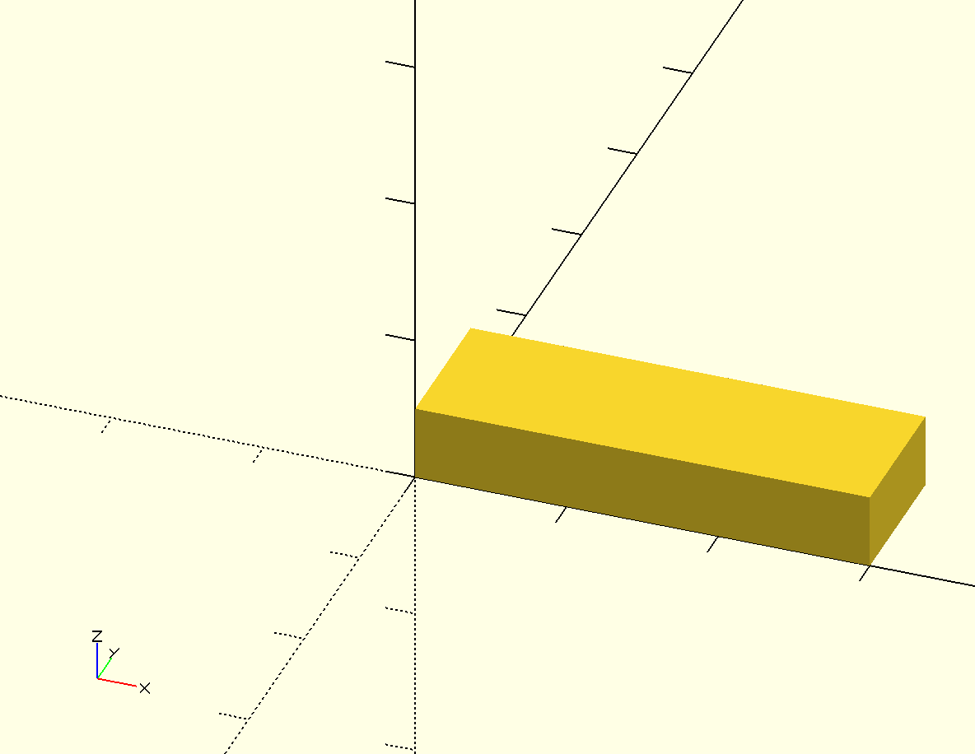  Figure cube-2: width - 30, length - 10, height – 5
cube-3.scad  cube([20, 20, 20]); | Insert cube-3.png here  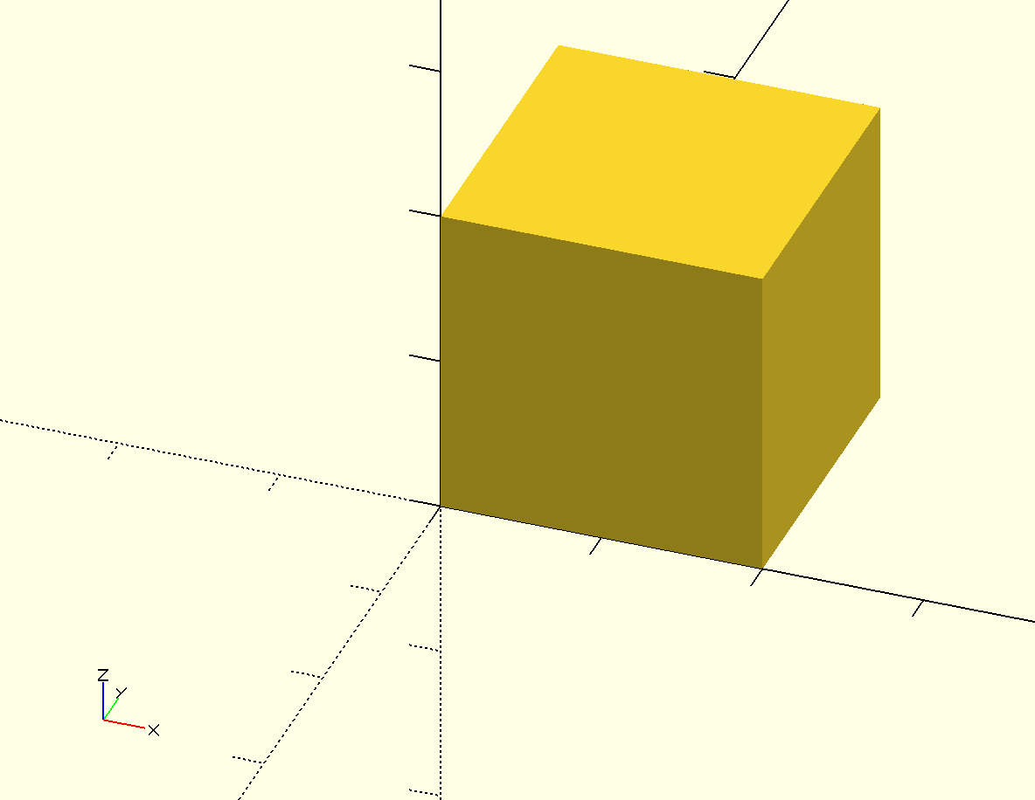  Figure cube-3: width – 20, length – 20, height – 20

Notice that each cuboid is positioned such that one corner touches the origin: (0, 0, 0)

Drawing Spheres with sphere
Drawing a sphere in OpenSCAD is even easier than drawing a cuboid:
sphere();
sphere is used to indicate that you want to draw a sphere. The ( )'s are used to modify the sphere command so that OpenSCAD knows how big you want your sphere to be:  is the radius of the sphere.
Here is an example of the sphere command in action:
sphere.scad  sphere(10); | Insert sphere.png here  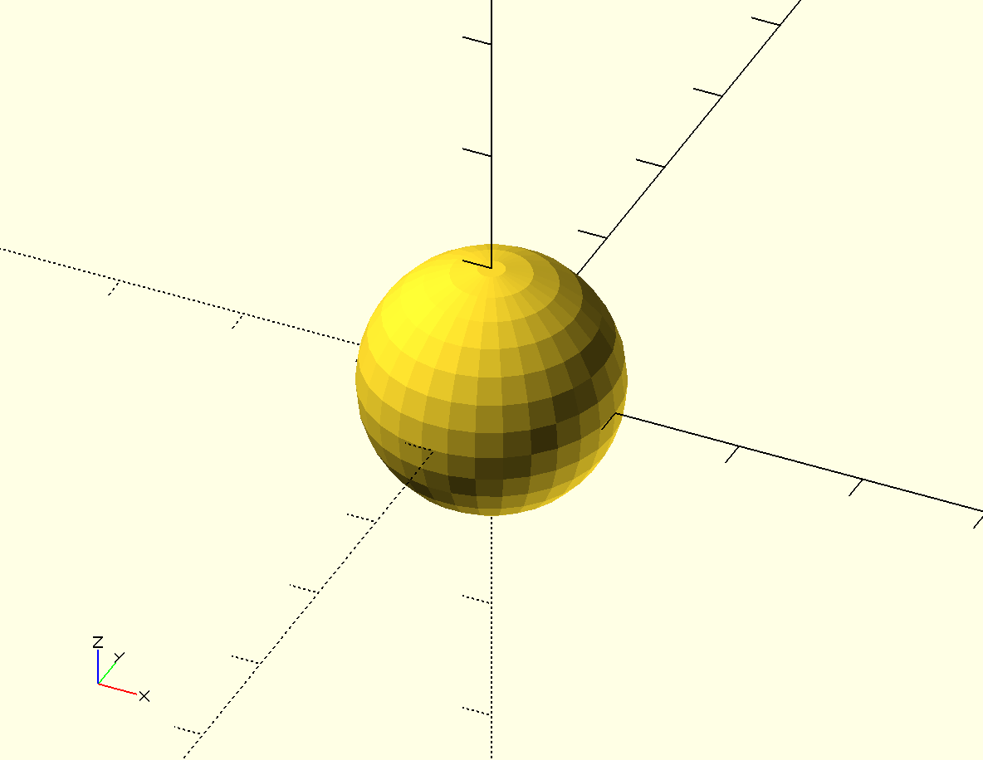  Figure sphere: radius – 10

Changing the size of the radius is the only one way you can change the shape of a sphere. That is why the basic sphere command only has one number inside of the ( )'s. As with the cube command, a ; is used as punctuation mark to end the command.
Notice also how the sphere is centered around the origin: (0, 0, 0). This is a bit different from the behavior of the cube command.

Drawing Cylinders and Cones with cylinder
To draw a cylinder in OpenSCAD, you must indicate the height of the cylinder and the two radii of the circles that form the top and bottoms of the cylinder:
cylinder.scad  cylinder(h=20, r1=5, r2=5); | Insert cylinder.png here  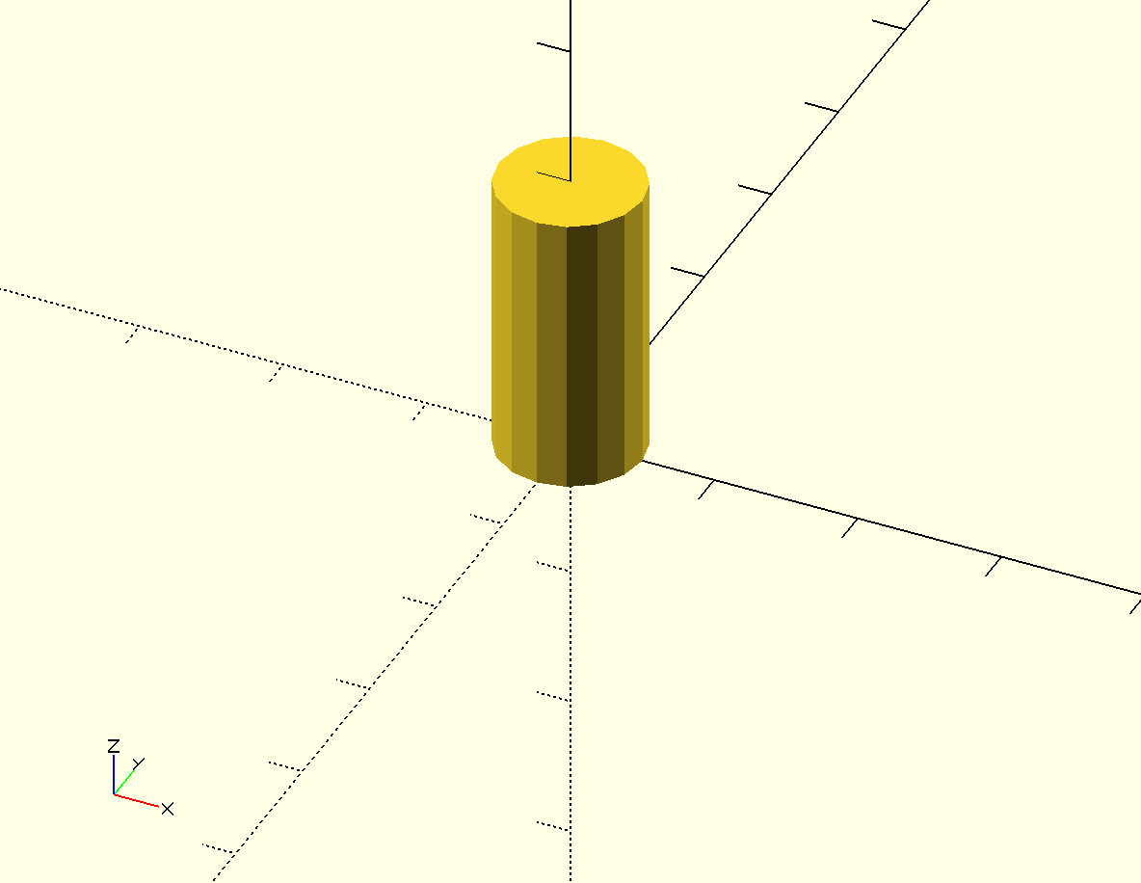  Figure cylinder:height = 20, bottom radius – 5, top radius – 5

The cylinder command follows this format:
cylinder(h=, r1= r2=);
The cylinder command is modified by indicating three values inside of the( )'s:  is the height of the cylinder along the z-axis,  is r1 - the radius of the bottom of the cylinder, and  is r2 - the radius of the top of the cylinder. Because it can be confusing keeping track of what the three numbers mean, OpenSCAD allows you to label the three values. As with the other two commands, a ; is used as punctuation mark to end the command.
Notice also how the cylinder is centered around the z-axis. This is different from both the sphere and cube commands.
The two radii do not have to be the same measurement. Here are two examples that demonstrate how you would use the cylinder command to draw a cone:
cone.scad  cylinder(h = 20, r1=5, r2=3); | Insert cone.png here  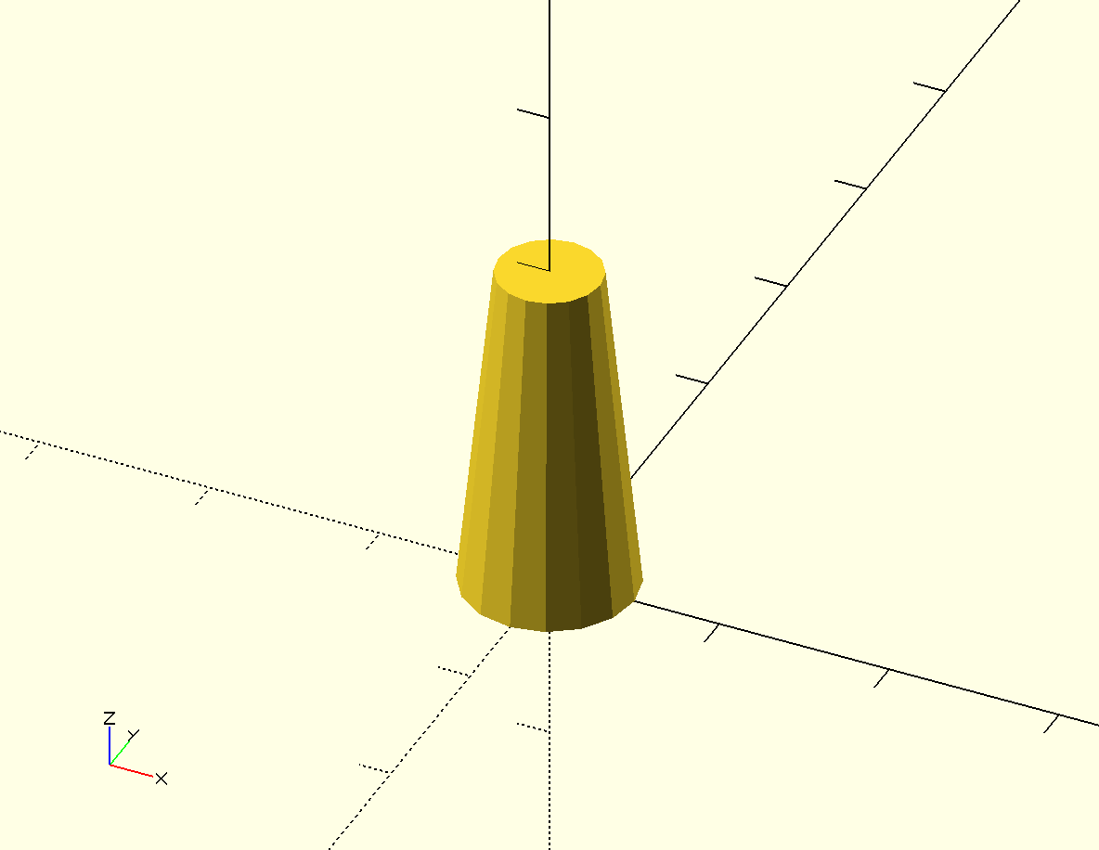  Figure cone:height = 20, bottom radius – 5, top radius – 3

cone-upside-down.scad  cylinder(h = 20, r1=0, r2=5); | 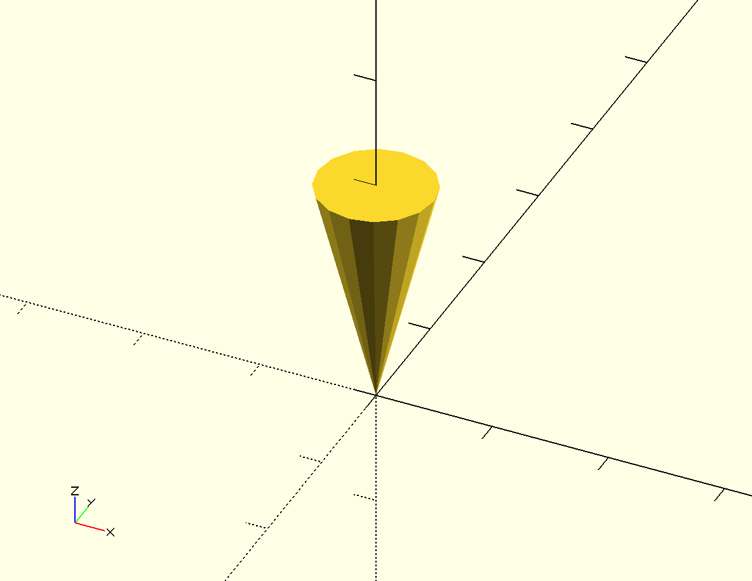  Insert cone-upside-down.png here  Figure cone-upside-down:height = 20, bottom radius – 0, top radius – 5

Importing 3D Models with import
Finally, OpenSCAD allows you to import 3D shapes saved in the .stl format from other 3D design programs. You can import these pre-existing 3D objects with the import command:

import.scad  import("3DBenchy.stl"); | Insert import.png here  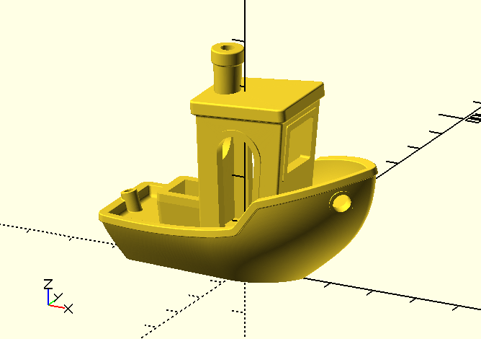  Figure import: An imported 3D image

Tell the import command which .stl file you'd like to import by including the name of the file inside of the( )'s. The .stl file you'd like to import should be saved in the same location/directory as your OpenSCAD program. As you might suspect, a ; is used to end the command.
Similar to the cylinder command, the import command centers the imported shape around the z-axis.

Basic Shape Modifications
In addition to changing the size of a shape, there are two other ways to make basic changes to the shapes you draw with OpenSCAD.

Moving Shapes
If the object you are creating has more than one shape, you'll definitely want to know how to move individual shapes around the Drawing window.

Centering Shapes with center=true
By default the sphere command draws a sphere centered about the origin; the cube,cylinder , and import commands do not. What if you want to draw theses other shapes so that they are also centered around the origin?
To draw a cuboid that's centered around the origin, modify the command to draw the shape with one extra component inside of the( )'s:
cube-1-centered.scad  cube([5, 10, 20], center=true); | Insert cube-1-centered.png here  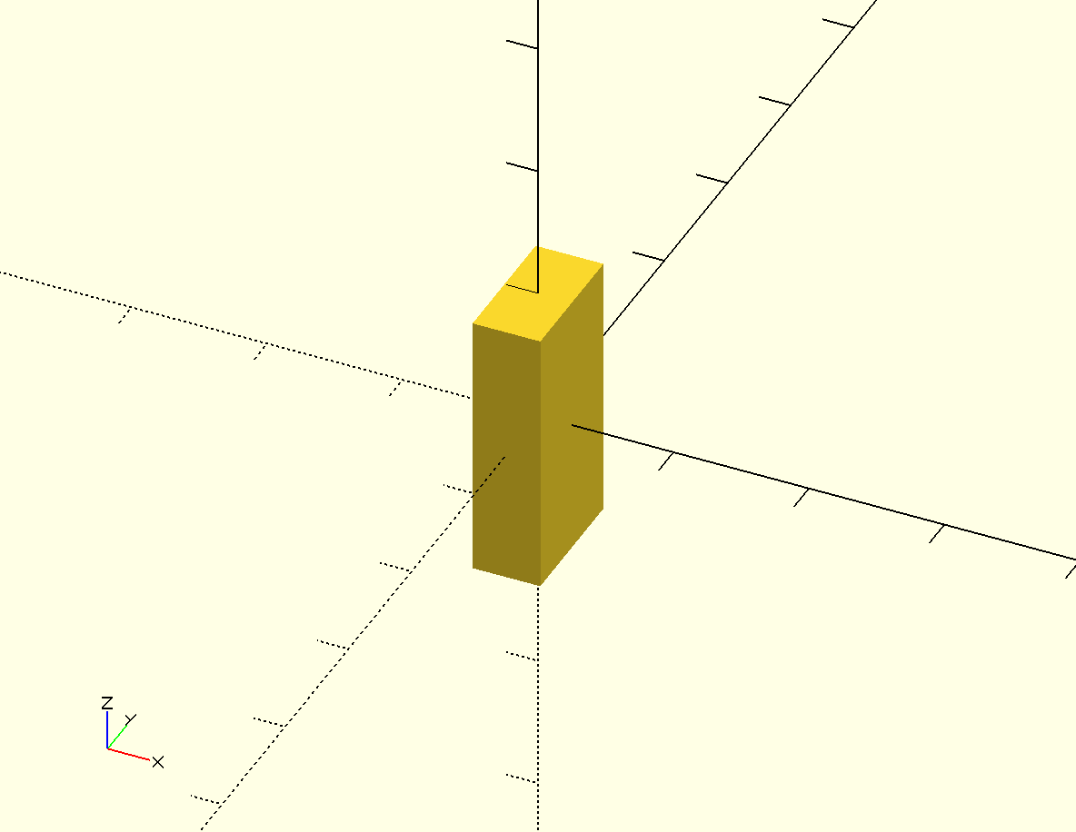  Figure cube-1-centered: A centered cuboid
Compare this centered cuboid to the first cuboid you drew:
cylinder-centered.scad  cylinder(h=20, r1=5, r2=5, center=true); | Insert cylinder-centerd.png here  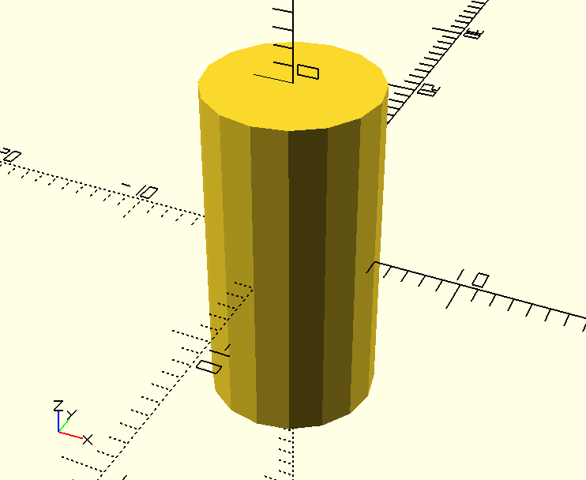  Figure cylinder-centered: A centered cylinder

Moving Shapes to a Specific Location with translate
As you learn to build complex objects by combining multiple primitive shapes, you will want to know how to move a shape to a specific spot in the Drawing window. This operation is called translate:
translate-cube.scad  translate([-10, 20, 0]) cube([20,10,10]); | Insert translate-cube.png here  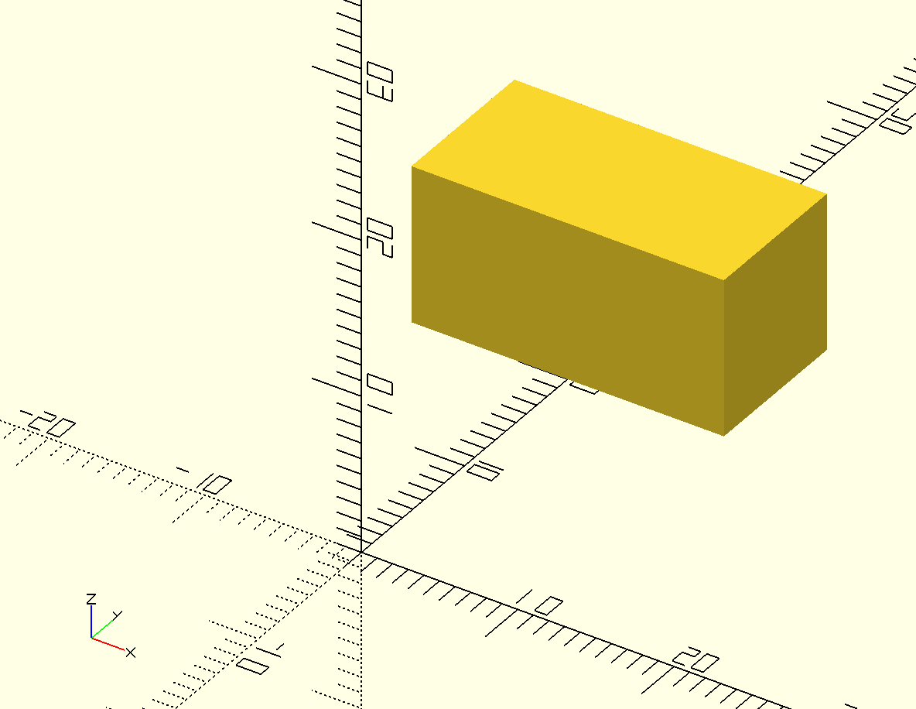  Figure translate-cube: A translated cuboid with a starting corner at (-10, 20, 0)

The translate command modifies a shape command, so is included just before the shape it is meant to modify. Notice how translate uses [ ]'s to group the three different dimensions of possible movement into a vector. The above example moves the cuboid 10 units in the negative direction along the x-axis, 20 units in the positive direction along the y-axis, and 0 units along the z-axis:
Insert translate-cube-diagram.png here
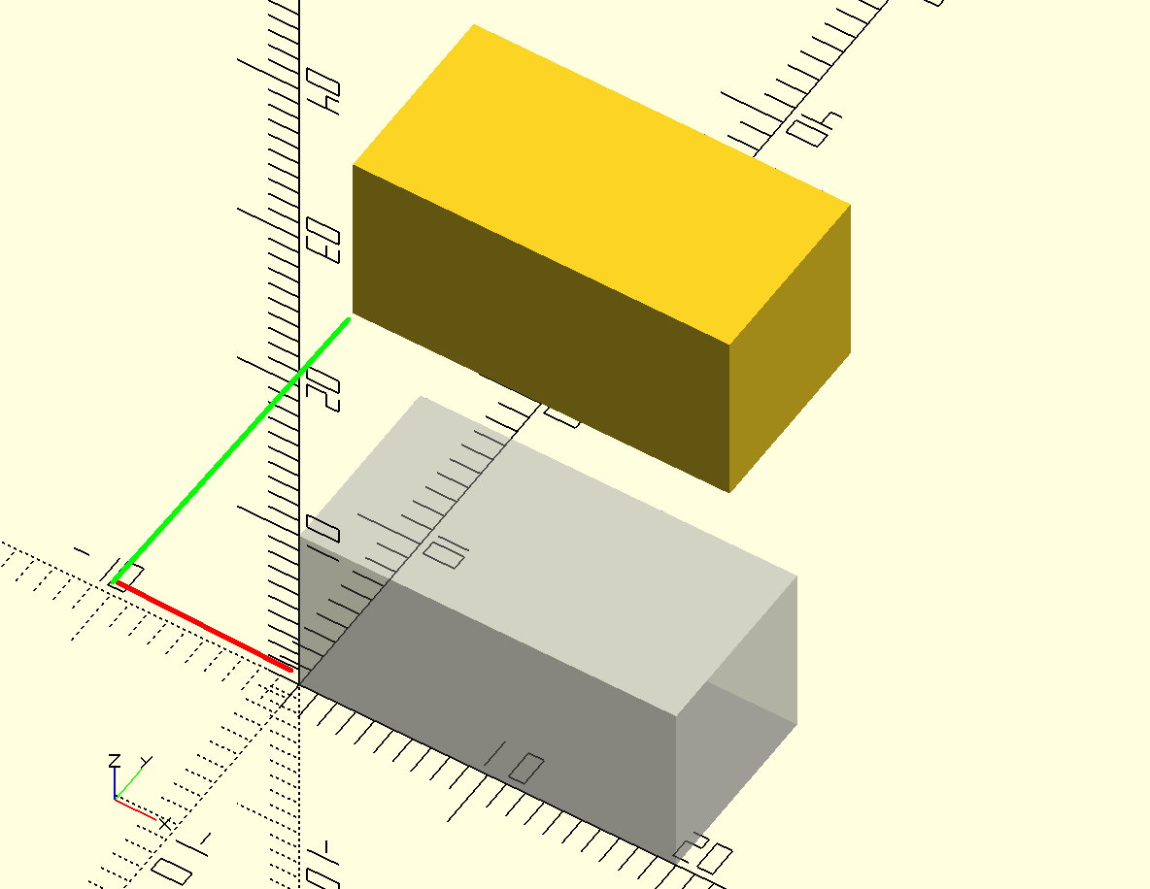
Figure translate-cube-diagram: A cuboid moved -10 units along the x-axis and 20 units along the y-axis
Here's how translate works:
translate([, , ]) cube([20,10,10]);
The ( )'s are used to modify the translate command so that OpenSCAD knows how far you want to move your shape along each of the three axes. The [ ]'s indicate a vector, and are used to group together the dimensions of the movement:  is the amount of movement along the x-axis,  is the amount of movement along the y-axis, and  is the amount of movement along the z-axis. Notice how the ; is used to end the entire command.
Include the translate command in front of each shape that you want to move:
translate-multiple.scad
translate([-10, 10, 0]) cube([20,10,10]);
translate([10, -10, 10]) sphere(5);
translate([0, 0, -10]) cylinder(h=30, r1=2, r2=2);
Insert translate-multiple.png here
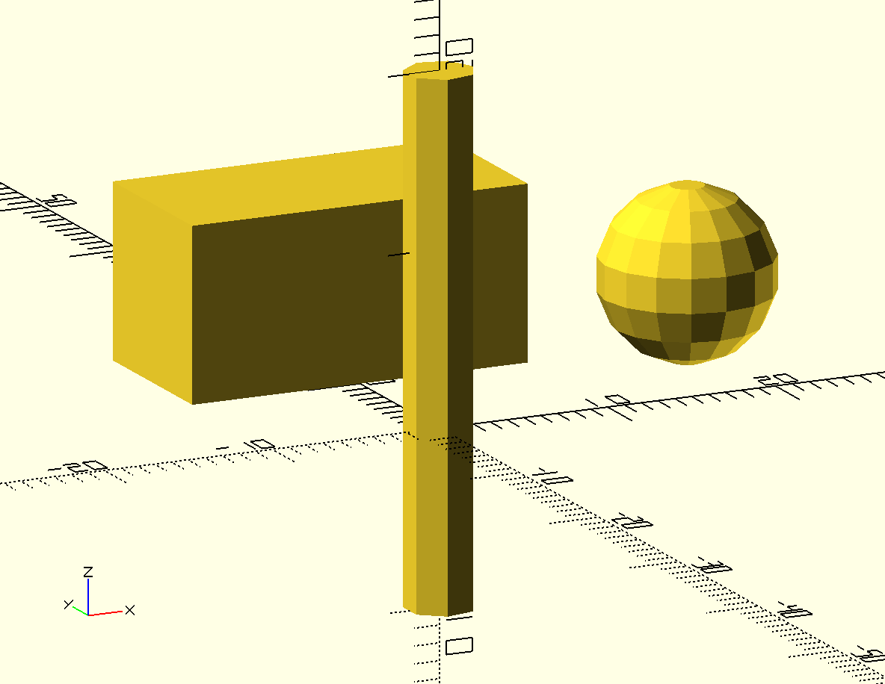
Figure translate-multiple: Three translated shapes
Notice how both the sphere and cylinder are moved according to their center point. That's because both of those shapes are centered by default.

Smoothing Curves with $fn
You might be wondering why the spheres and cylinders you've drawn so far don't appear to be “round”. The reason why is complicated, and is based on the fact that OpenSCAD (like most 3D design software) uses a collection of straight lines to approximate a curve. To save on memory and reduce the processing time required to draw complex shapes, by default OpenSCAD uses a relatively small number of lines to approximate curves. The cylinder in our last example is drawn using six line segments to approximate the curve of the circular faces of the cylinder.
OpenSCAD allows you to specify the number of line segments used to approximate a curve so that you can make your cylinders and spheres appear round. Use the $fn variable to set the number of line segments you'd like to use at the top of your OpenSCAD code:
smoothing-10-lines.scad  $fn=10;  cylinder(h=30, r1=2, r2=2); | Insert smoothing-10-lines.png here  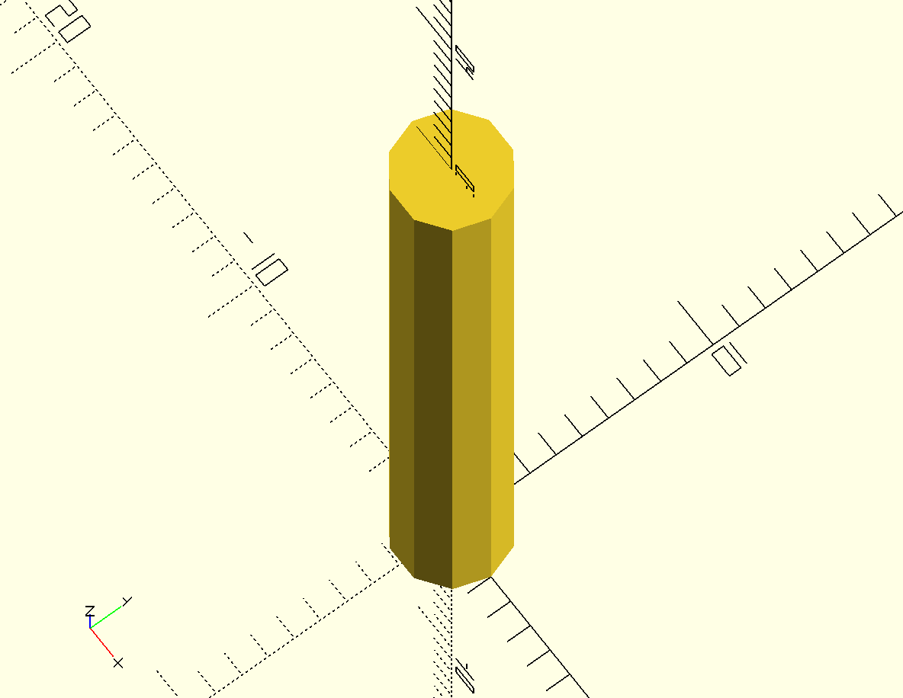  Figure smoothing-10-lines: 10 line segments to approximate a circle

This cylinder looks a bit more round because now OpenSCAD is using 10 line segments to draw the circular faces of the cylinder. Increase the $fn value to a large value to visibly increase the “roundness” of your shapes:

smoothing-50-lines.scad  $fn=50;  cylinder(h=30, r1=2, r2=2); | Insert smoothing-50-lines.png here  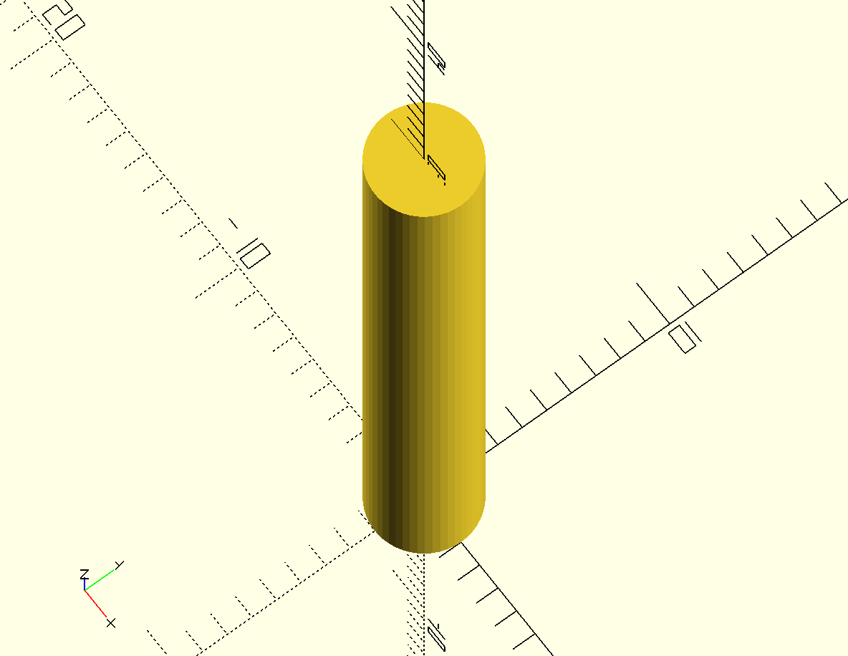  Figure smoothing-50-lines: 50 line segments to approximate a circle

This cylinder looks a lot smoother because OpenSCAD is now using 50 line segments to draw the circular faces of the shape.

Combining 3D Shapes with Boolean Operations
One of the most powerful features of 3D design is the ability to combine multiple basic shapes into one complex object. This can be done using three different boolean operations: union, difference, and intersection. These boolean operations can be quickly summarized with Venn diagrams:
Insert boolean-operations.png here
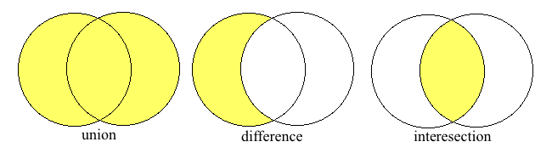
Figure boolean-operations: A visual illustration of three boolean operations
Combining two shapes with a union operations “adds” the two shapes together. Combining two shapes with a difference operations “subtracts” one shape from the other. Combining two shapes with an intersection operations results in everything getting carved away except for the the overlapping regions of the two shapes.

Grouping Shapes with union
Grouping multiple shapes together allows you to refer to the collection of shapes as one entity. To group shapes together, use the union operation:

union.scad  union(){  cube([10,10,10]);  sphere(5);  } | Insert union.png here  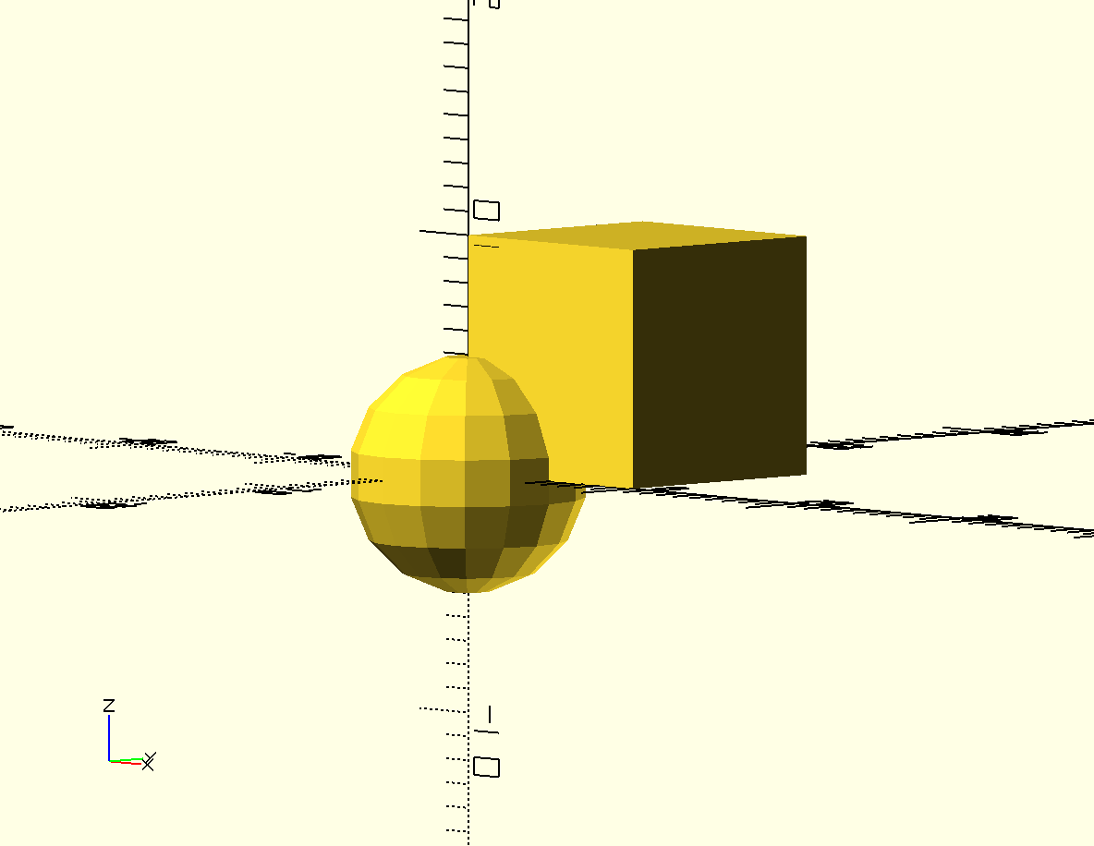  Figure union: A sphere and a cuboid grouped together

The union operation groups together all of the shapes that are inside of the{ }'s. There is no way to modify the union operation, so you will never need to put any extra information inside of the ( )'s.
Why would you want to do this? Why not just draw the two shapes on top of each other? Consider, for example, the need to move multiple shapes at once. You could translate each shape individually, or group all of the shapes together to move them all at once:
union-translated.scad  translate([5, 5, 5])  union(){  cube([10,10,10]);  sphere(5);  } | Insert union-translated.png here  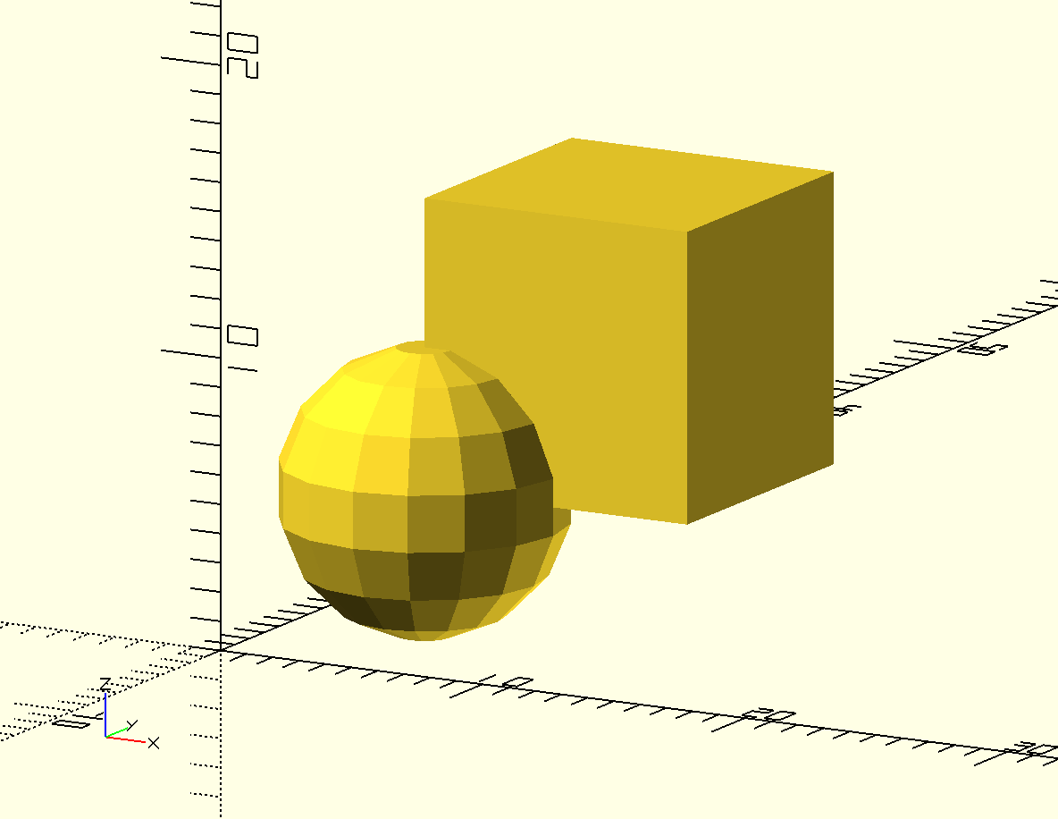  Figure union-translated: A sphere and a cuboid grouped together, then translated

The translate command modifies the entire grouped collection of shapes so that you can refer to both individual shapes as a single object. There is no need to write two translate commands.

Subtracting Shapes with difference
OpenSCAD allows you to subtract shapes with the difference command. When you apply the difference operation the first shape remains and the second shape gets subtracted away:

difference-1.scad  difference(){  cube([10,10,10]);  sphere(5);  } | Insert difference-1.png here  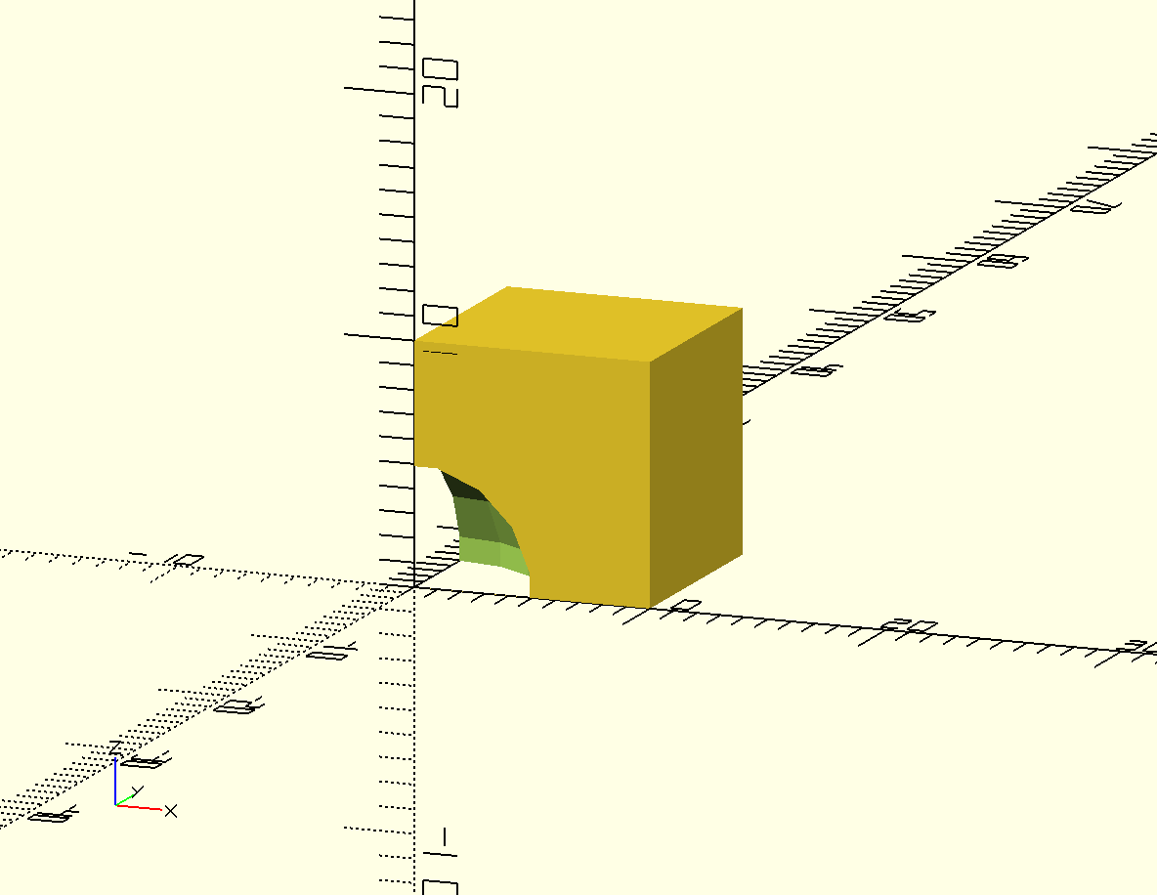  Figure difference-1: A sphere subtracted from a cuboid

Order matters when you use the difference operation. Notice what happens when I exchange the order of the two shapes that are being subtracted:
difference-2.scad  difference(){  sphere(5);  cube([10,10,10]);  } | Insert difference-2.png here  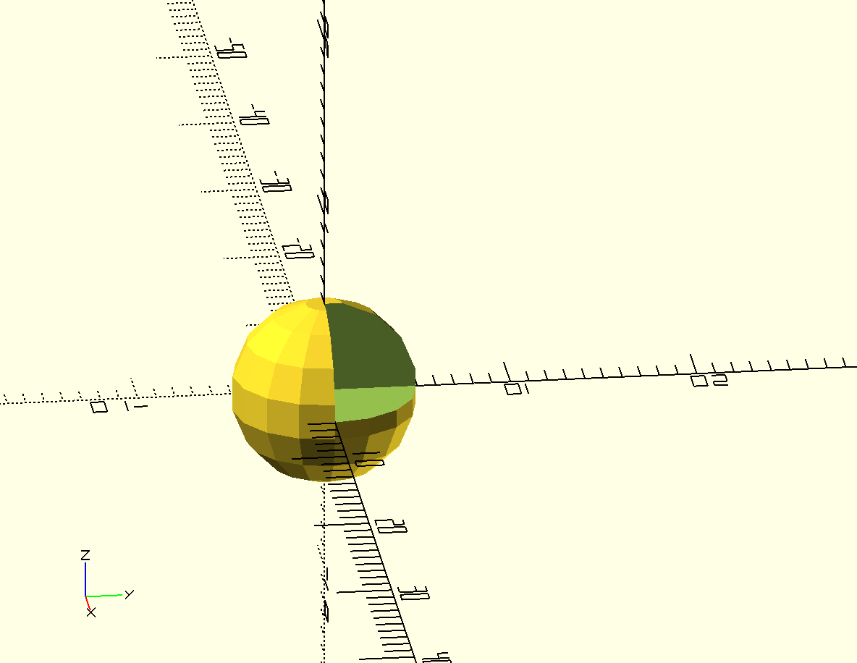  Figure difference-1: A cuboid subtracted from a sphere

Creating a Ghost Image of a Subtracted Shape with #
It is easy to lose sight of the object that you are subtracting. Place a # in front of a subtracted object to create a ghost version of the shape. Using the # will help you debug your designs:
ghost.scad  difference(){  cube([10,10,10]);  #sphere(5);  } | Insert ghost.png here  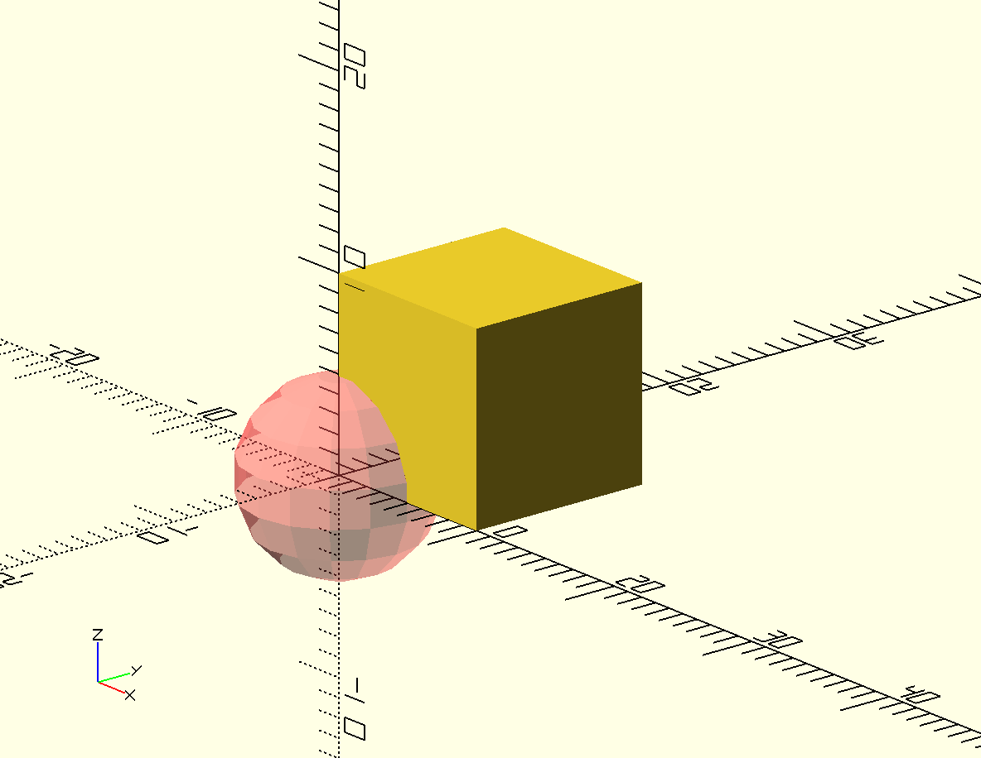  Figure ghost: A ghost-version of a subtracted sphere to help with problem solving

Carve-Out Overlapping Shapes with intersection
Finally, you may also carve away everything except for the overlapping portion of two shapes by using the intersection command:
intersection.scad  intersection(){  sphere(5);  cube([10,10,10]);  } | Insert intersection.png here  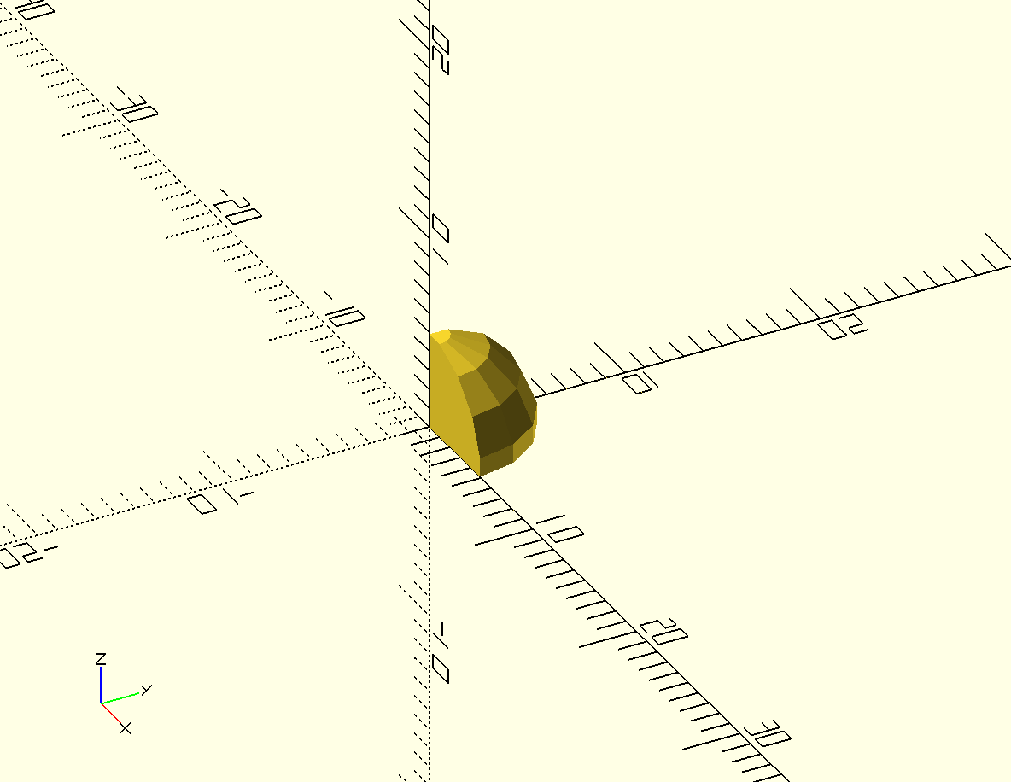  Figure intersection: The cutout of an overlapping sphere and cuboid

Notice how the shape left over from the intersection operation would fit perfectly into the “hole” left by the difference operation. This is true no matter what order you apply the difference operation.

Constructive Solid Geometry and Decomposition
This method of creating a complex object out of simple geometric primitives( like cuboids, spheres, cylinders, and cones) is called Constructive Solid Geometry. Because the formulas for determining the surface area and volume of these primitive shapes are are well-understood, it's easy for a computer to generate an accurate 3D model of your design. You can then print this complex 3D model on a 3D printer, or import it into a 3D virtual reality program.
With practice you will become very good at breaking a complex shape into geometric primitives. This sort of thinking is called decomposition. Decomposition is a very important problem solving skill to have. Decomposition helps you to redefine a complex problem into lots of little pieces that are each individually easy to understand.

Design Time
Before you keep reading, practice the skills you learned in this chapter by building each of these complex objects.
Mouse | 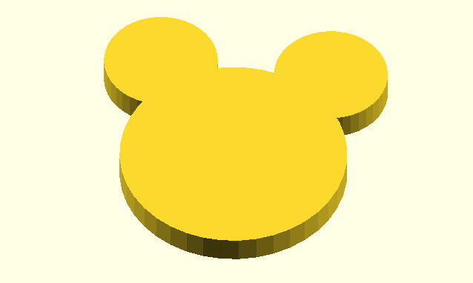  insert Mouse.png here  Figure mouse: A Simple Profile of a Mouse
Yo-Yo | insert Yo-Yo.png here  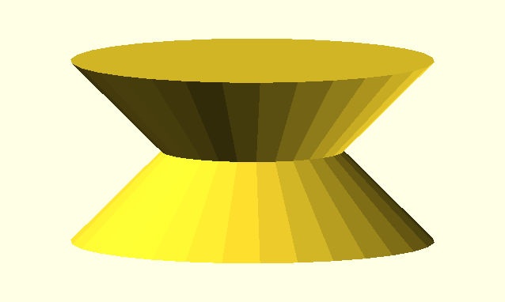  Figure mouse: A Simple Version of a Yo-Yo Toy
Spinner | insert Yo-Yo.png here  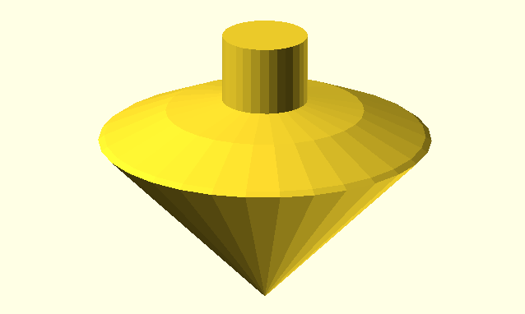  Figure mouse: A Spinner Toy

Epcot | insert Epcot.png here  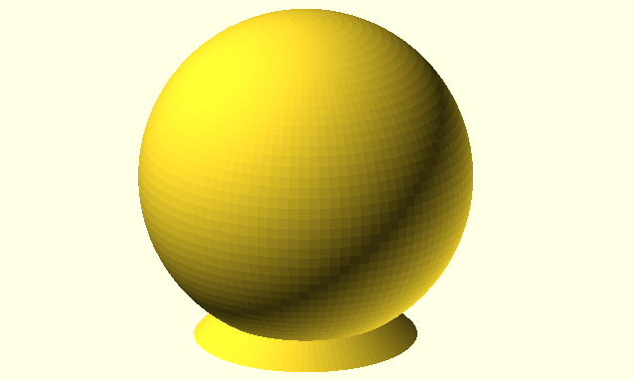  Figure epcot: A Simple Version of the Epcot Center
Halfpipe | 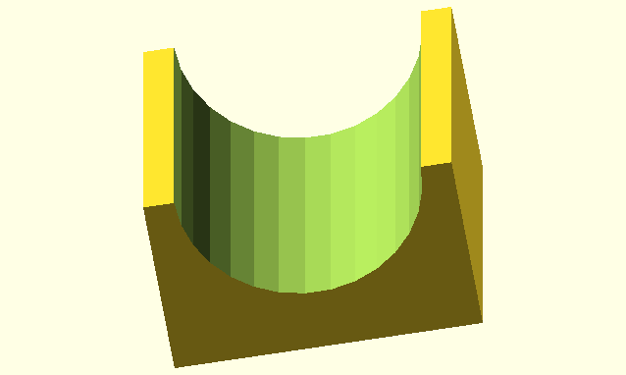  insert halfpipe.png here  Figure mouse: A Halfpipe Ramp
Ice Cream Cone | 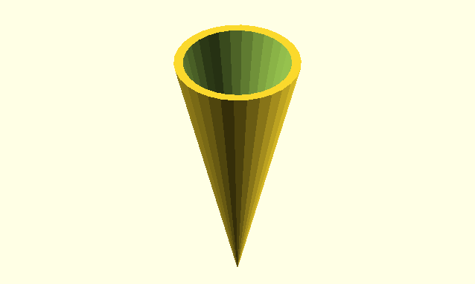  insert Ice-cream-cone.png here  Figure ice-cream-cone: An Ice Cream Cone

Chapter Summary and Other Important Stuff
You now know how to:
type OpenSCAD code into the Editor window
preview objects in the Drawing window
draw cuboids, spheres, and cylinders in any size
import 3D objects in the .stl file format
smooth curves
move shapes to anywhere along the X, Y, and Z axes
group shapes
subtract and cutout overlapping shapes

Here are some important tips:
The name of a command tells you which type of shape you'd like to draw.
;'s are used is used to end a command.
Information inside of ( )'s are used to modify commands.
[ ]'s collect numbers together to form a vectors.
Boolean operations use { }'s to collect multiple shapes together .
( )'s, [ ]'s, and { }'s always come in pairs.
OpenSCAD is unit-less.
Set $fn at the beginning of your code to generate smooth curves.
Use the translate command to move your shapes.
Use indentation to help make your code readable and easy to understand.

Big Projects

Calibration Pyramid
Building a calibration pyramid will help you determine whether you need to tweak the settings on your 3D printer. It will also help you practice using the cube and translate commands:
insert Calibration-Pyramid.png here
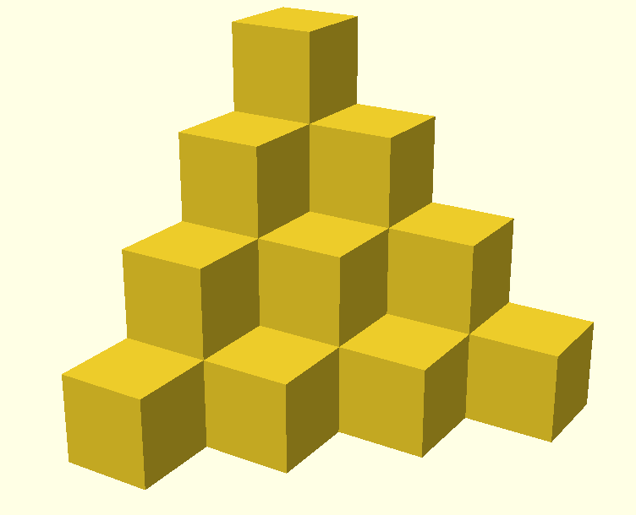
Figure Calibration Pyramid: A Calibration Pyramid
3D Printing Tips
Try printing this at different “resolutions”. Try Low, Medium, and High quality. Compare print times with results.
Try printing this pyramid at different sizes. Measure the pyramid after you print it. Does it match the measurement you expected it to be?
Do you have tight, straight lines at all corners?

Smiley Face Pendant
This project will get you thinking about using your 3D printer to print large, flat shapes. Flat shapes can be difficult to print because they tend to curl.
Insert Smiley-Face.png here

Figure smiley-face: A Smiley Face Pendant

3D Printing Tips
If you have a heated bed, use it. Vary the temperature of your heated bed to see which temperature works best for the type of filament you are using.
Inserting helper disks can help defend against curling. Helper disks are just 1 mm thick so they can easily be removed once your print is complete. Helper disks should be place around the perimeter of your object.

Hole and Pins Test
This project will get you thinking about using your 3D printer to print pieces that fit together. If you design this properly, the Pins portion of the project should fit snuggly inside the Holes portion.
insert Hole-and-Pin-Test.png here
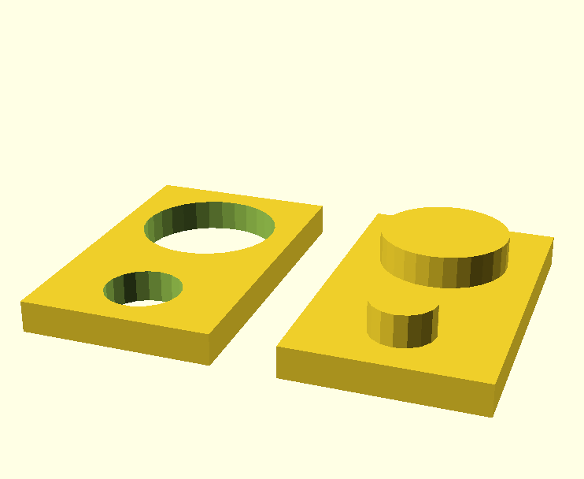
Figure hole and pin test: A Hole and Pin Test
3D Printing Tips
If you design the Pins to be exactly the same size as the Holes, the two pieces will not fit together. The Pins should be slightly smaller than the Holes.
How much smaller depends on the type of filament you are using. Both the brand and type of plastic will make a difference.
Space the two Pins far enough apart that you can test each one separately. Vary the difference in measurements for the small Pin and the large Pin so that you can complete the test faster.

