3

2D Shapes

2D Primitives

Drawing Ovals with circle

Drawing Rectangles with square

Drawing Polygons with polygon

Drawing Words with text

Advanced 2D Operations

Changing the Outline of a Shape with offset

Importing 2D Shapes with import

Going from 2D to 3D

Extruding Shapes with linear_extrude and rotate_extrude

linear_extrude

linear_extrude with a twist

inear_extrude with a scale

rotate_extrude

Data-driven Shapes with surface

Design Time – 2D Shapes
Before you keep reading, practice the skills you learned in this chapter by building each of these complex objects.
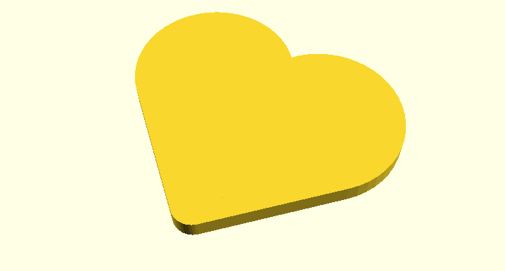  Heart  insert Heart.png here | 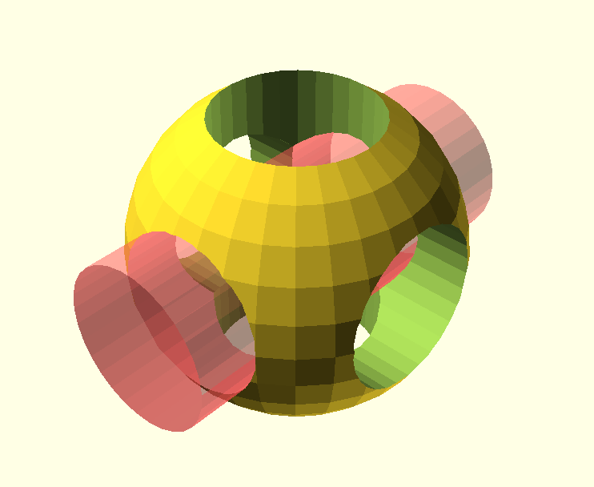  OpenScad Logo  insert OpenSCAD-Logo.png here
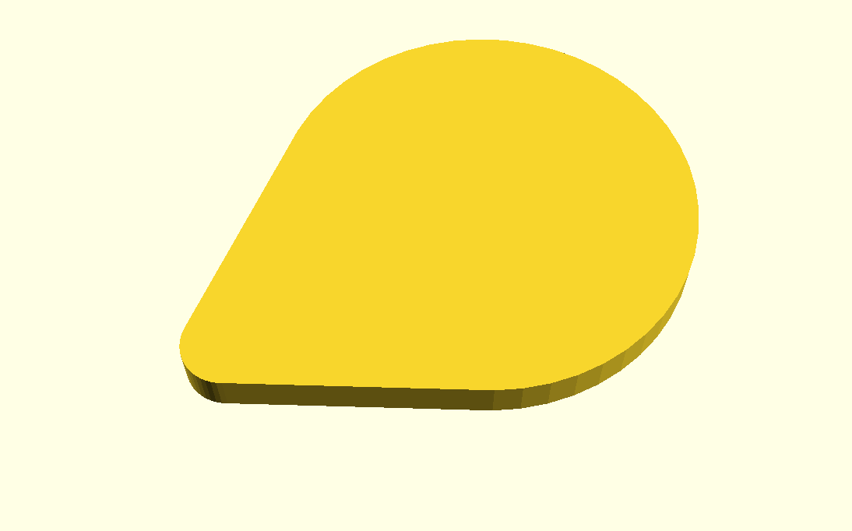  Guitar Pick  insert Guitar-Pick.png here | 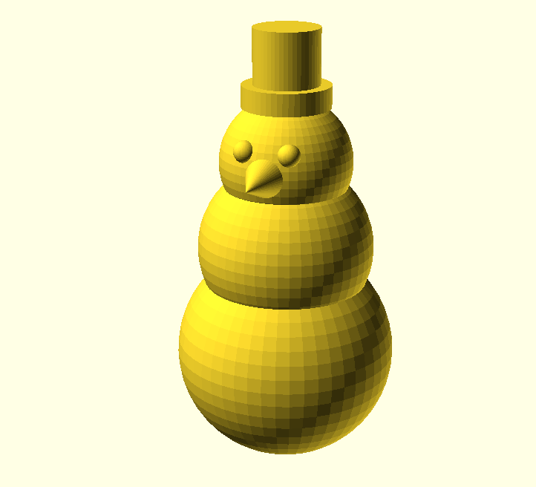  Snowman  insert Snowman.png here
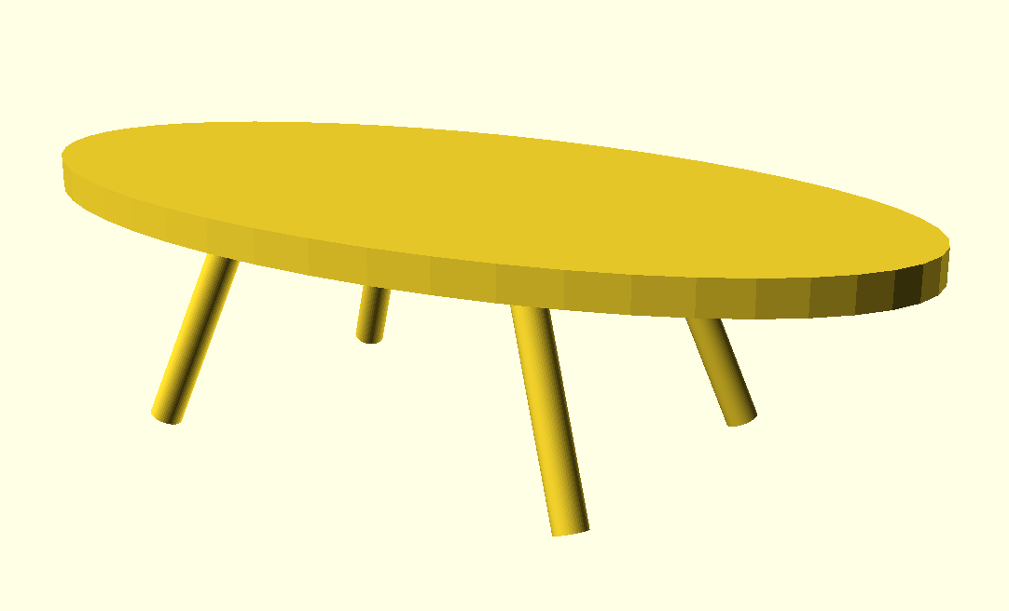  Modern Table  insert Modern-Table.png here | 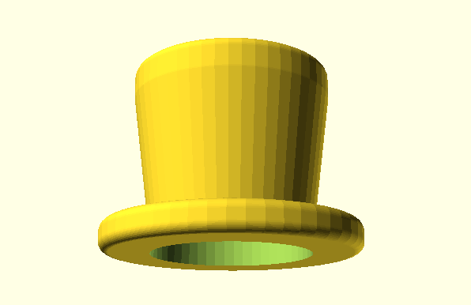  Top Hat  Insert Top-Hat.png here

Chapter Summary and Other Important Stuff
You now know how to:
type OpenSCAD code into the Editor window
preview objects in the Drawing window
draw cuboids, spheres, and cylinders in any size
import 3D objects in the .stl file format
smooth curves
move shapes to anywhere along the X, Y, and Z axes
group shapes
subtract and cutout overlapping shapes

Here are some important tips:
The name of a command tells you which type of shape you'd like to draw.
;'s are used is used to end a command.
Information inside of ( )'s are used to modify commands.
[ ]'s collect numbers together to form a vectors.
Boolean operations use { }'s to collect multiple shapes together .
( )'s, [ ]'s, and { }'s always come in pairs.
OpenSCAD is unit-less.
Set $fn at the beginning of your code to generate smooth curves.
Use the translate command to move your shapes.
Use indentation to help make your code readable and easy to understand.

Big Projects – 2D Shapes

Calibration Pyramid
Building a calibration pyramid will help you determine whether you need to tweak the settings on your 3D printer. It will also help you practice using the cube and translate commands:
insert Calibration-Pyramid.png here
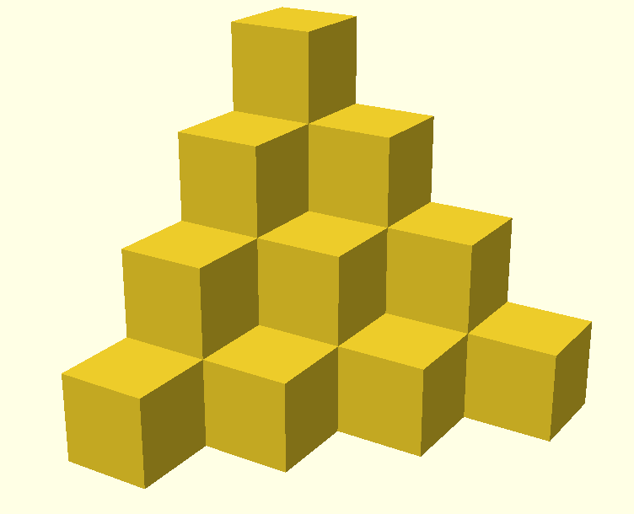
Figure Calibration Pyramid: A Calibration Pyramid
3D Printing Tips
Try printing this at different “resolutions”. Try Low, Medium, and High quality. Compare print times with results.
Try printing this pyramid at different sizes. Measure the pyramid after you print it. Does it match the measurement you expected it to be?
Do you have tight, straight lines at all corners?

Smiley Face Pendant
This project will get you thinking about using your 3D printer to print large, flat shapes. Flat shapes can be difficult to print because they tend to curl.
Insert Smiley-Face.png here

Figure smiley-face: A Smiley Face Pendant

3D Printing Tips
If you have a heated bed, use it. Vary the temperature of your heated bed to see which temperature works best for the type of filament you are using.
Inserting helper disks can help defend against curling. Helper disks are just 1 mm thick so they can easily be removed once your print is complete. Helper disks should be place around the perimeter of your object.

Hole and Pins Test
This project will get you thinking about using your 3D printer to print pieces that fit together. If you design this properly, the Pins portion of the project should fit snuggly inside the Holes portion.
insert Hole-and-Pin-Test.png here
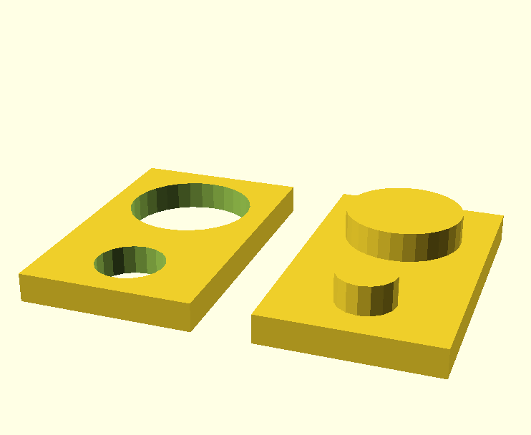
Figure hole and pin test: A Hole and Pin Test
3D Printing Tips
If you design the Pins to be exactly the same size as the Holes, the two pieces will not fit together. The Pins should be slightly smaller than the Holes.
How much smaller depends on the type of filament you are using. Both the brand and type of plastic will make a difference.
Space the two Pins far enough apart that you can test each one separately. Vary the difference in measurements for the small Pin and the large Pin so that you can complete the test faster.

