The Earnest Pirates

Vinit Todai, Shreyas Lele, Tejul Pandit

Checkpoint 2: Data Exploration

Introduction -

Our goal is to find the relationship between the characteristic features of police officers namely race and rank and the number of allegations against these police officers. Our main aim is to analyze if racial discrimination and the ranking of an officer plays any role in determining if the allegations against an officer is sustained or not.

Visualization Questions -

1. Identify relationship between rank of police officers and the number of complaints against him/her and number of complaints sustained.
2. Identify the relationship between the race of the police officer and the number of cases against him and the number of cases sustained.

Results -

**1. Identify relationship between rank of police officers and the number of complaints against him/her and number of complaints sustained.**

The objective behind this visualization was to identify the subtle relationship that may exist between the rank of a police officer and the allegations sustained out of the total number of allegations issued against him/her.

The first visualization as attached below provides a representation of the rank of the police officers against their respective total number of complaints registered. The bigger the bubble implies that there were a higher number of complaints.

Additionally, the top 3 ranks of officers against whom most complaints are registered are -

1. Police officers (Total allegation count: 150,977, Sustained allegation count: 12,843)
2. Sergeant of Police (Total allegation count: 40,677, Sustained allegation count: 2,373)
3. Police Officer as Detective (Total allegation count:28,062, Sustained allegation count:1,345)

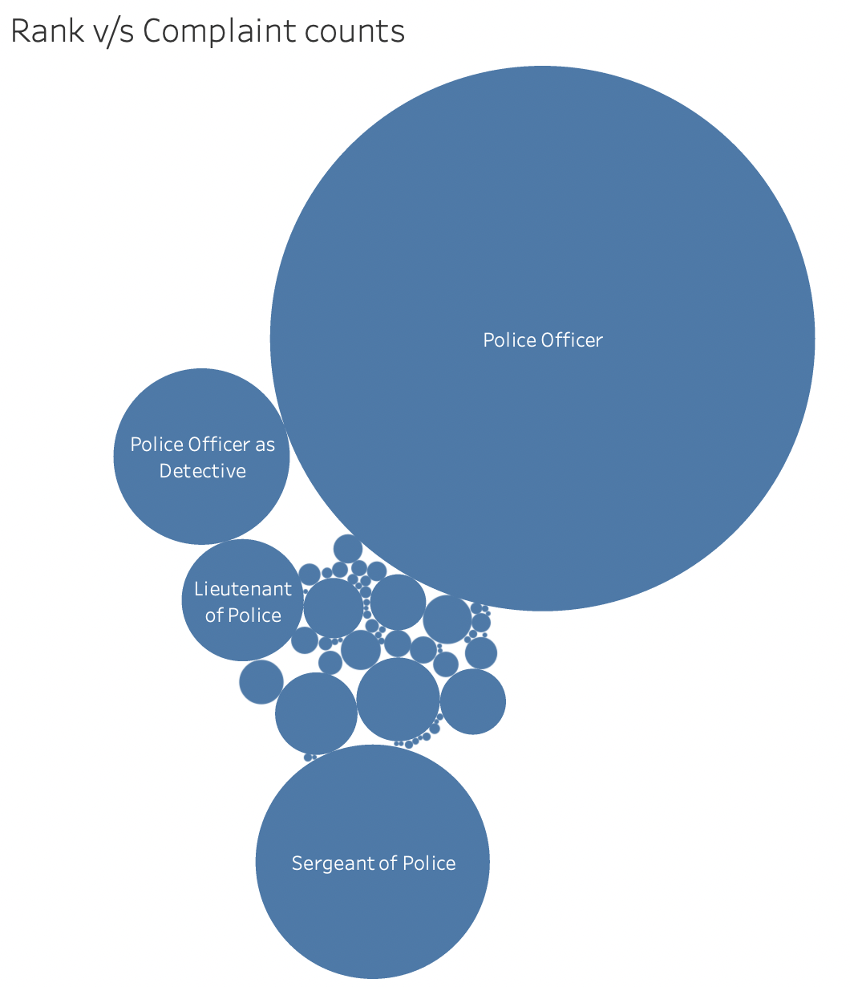

The second visualization dives deeper into the analysis by identifying individuals if any that get identified by their rank in terms of the count of allegations sustained against them.

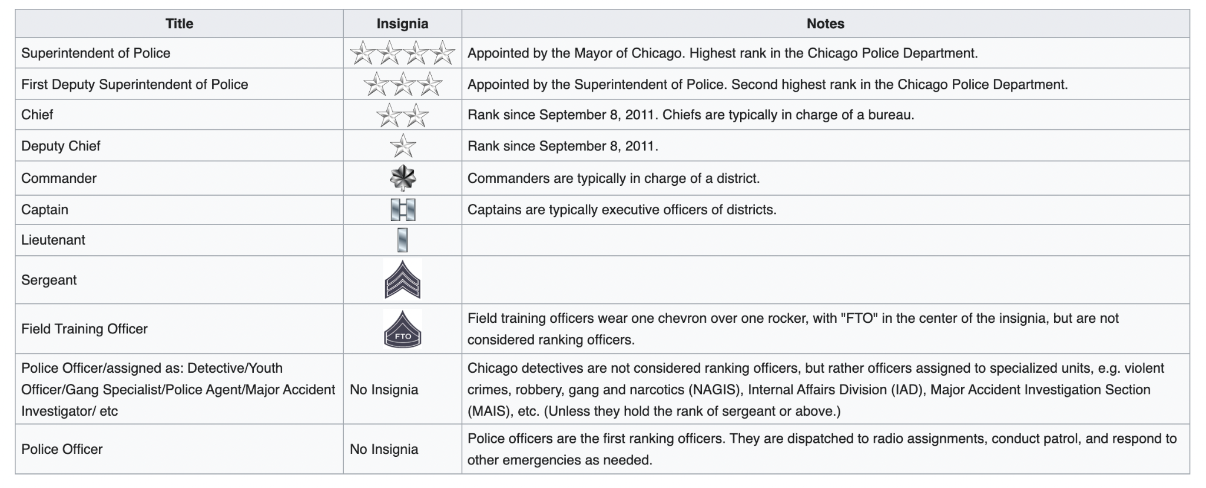

The above table from [1] provides a view regarding the ranking of police officers in Chicago police departments. Using the above image as reference we create a subset of the ranks to visualize the trend of ranks vs the percentage of allegations sustained.

The insights from the below graph falls in-line with the hypothesis that higher ranking officers leverage their rank. The index indicates that the brighter the colour, the higher the percentage of allegations not being sustained.

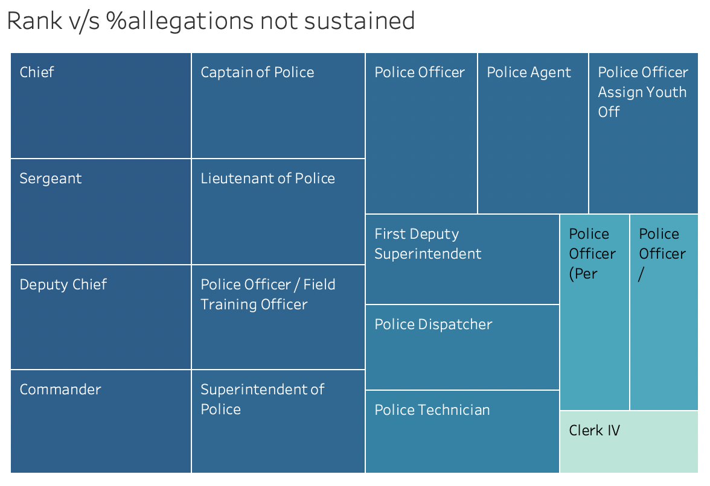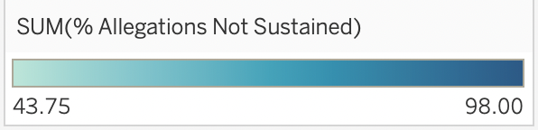

The table below is the information generated from the query based on which the above visualization was created.

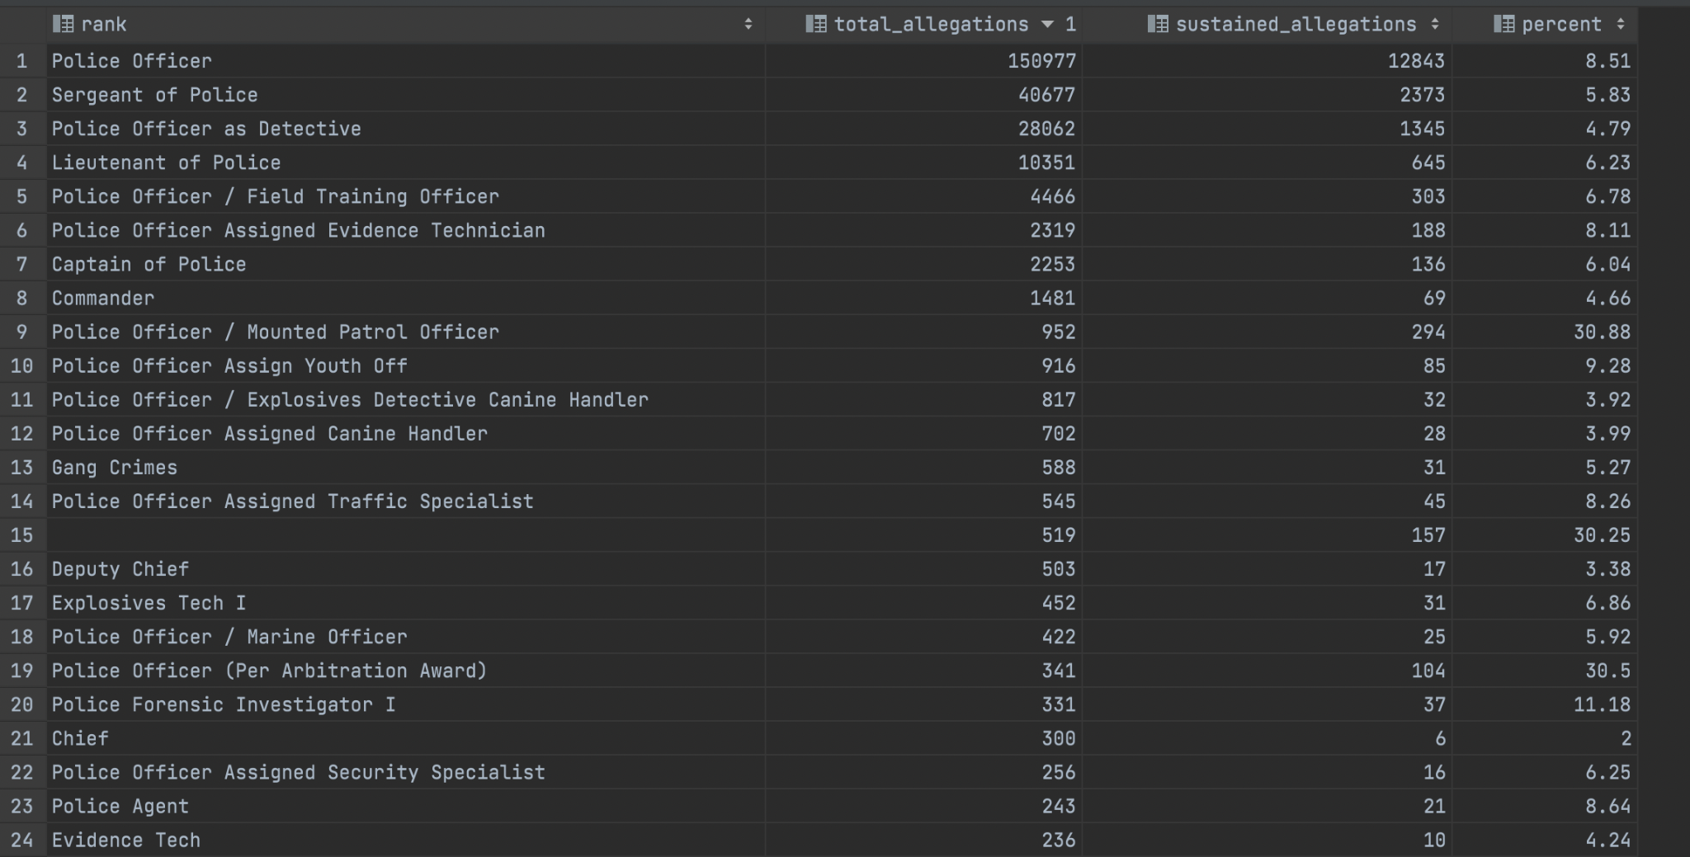

**2.Identify the relationship between the race of the police officer and the number of**

**cases against him and the number of cases sustained.**

This is basically to realise that is there any dependency of race on possibility of an allegation to be sustained.

It's seen from the graph that White officers have the maximum allegations against them nearing a total of 140k. However the number of allegations sustained is just around 8K. However for Black officers the number of allegations is 68K and the number of sustained allegations is 8K. Similarly for Hispanc the count of allegations is 40K and sustained count is 2.3K

Thus it is seen that for White Officers the ratio of sustained count to allegation count is very less. It is, however, double for Black Officers. Thus it is possible that the race of a police officer might be a factor that plays a role on whether an allegation against an officer will be sustained or not.

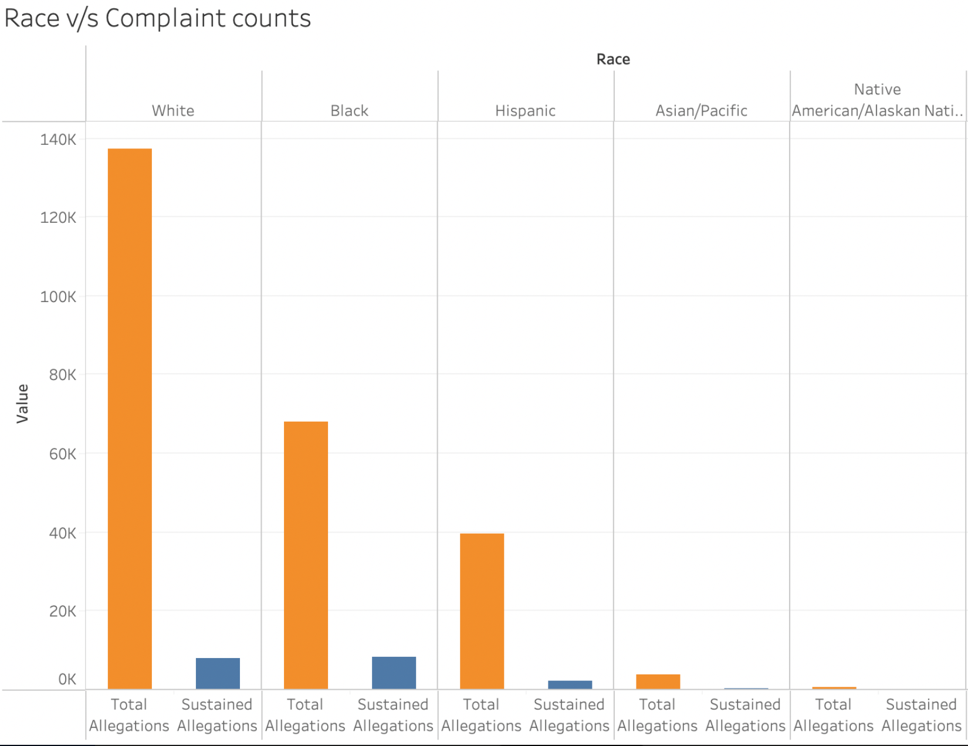

The table below is the information generated from the query based on which the above visualization was created.

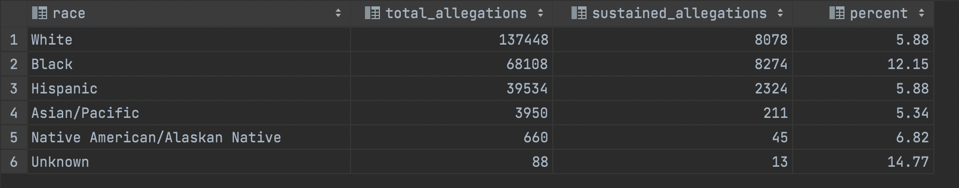

References -

[1] <https://en.wikipedia.org/wiki/Chicago_Police_Department>