Session 4: Quarto

Justin Lee

2024-04-12

Table of contents

## Notes:

* jl usually starts a Quarto doc with notes, to-dos, where i left off, etc
  + test

## Data source

* Data last downloaded on XXX
* Box directory: /Box-Box/jlee/QSU_RWorkshop/data/baseball_gamelogs2023.rds

## Table 1

### USING GTSUMMARY ###  
require(gtsummary)  
## note on require -- does the same as library() but will continue executing submitted code if package does not exist; not really useful in this case, but can be useful if its within an Rscript or function where you still want the code to run  
  
### try using gtsummary --   
reset_gtsummary_theme()  
# theme_gtsummary_journal(journal = "jama")  
theme_gtsummary_compact()  
  
dput(names(tab1))

c("Name", "Team", "GS", "G", "IP", "W", "L", "QS", "SV", "HLD",   
"H", "ER", "HR", "SO", "BB", "K.9", "BB.9", "K.BB", "HR.9", "AVG",   
"WHIP", "BABIP", "LOB.", "ERA", "FIP", "ADP", "division", "POS"  
)

vars_tab1 <- c("Team", "IP", "W", "L", "SV", "K.9", "BB.9", "K.BB", "ERA", "WHIP")  
  
tab1 %>%  
 dplyr::select(vars_tab1) %>%  
 gtsummary::tbl_summary(by=Team,  
 type = list(c("IP", "W", "L", "SV", "K.9", "BB.9", "K.BB", "ERA", "WHIP") ~ "continuous"),  
 # statistic = list(c("ConnectivityZscore") ~ "{median} [{p25}, {p75}]"  
 # ),  
 missing_text = "Missing",  
 label = list(IP ~ "Innings Pitched",  
 W ~ "Wins",  
 L ~ "Losses",  
 SV ~ "Saves",  
 K.9 ~ "Strikeouts per 9 innings",  
 BB.9 ~ "Walks per 9 innings",  
 K.BB ~ "Strikeouts per walk",  
 ERA ~ "Earned Run Average",  
 WHIP ~ "Walks + Hits per inning pitched"  
 )  
 ) %>%  
 add_stat_label() %>%  
 modify_spanning_header(all_stat_cols() ~ "**Team**") %>%  
 add_difference(everything() ~ "smd") %>%  
 modify_column_hide(columns=ci)

| **Characteristic** | **LAD**, N = 12 | **SFG**, N = 6 | **Difference** |
| --- | --- | --- | --- |
| Innings Pitched, Median (IQR) | 112 (91, 123) | 86 (66, 129) | 0.07 |
| Wins, Median (IQR) | 8 (6, 10) | 6 (4, 7) | 0.43 |
| Losses, Median (IQR) | 5 (4, 6) | 4 (4, 6) | -0.13 |
| Saves, Median (IQR) | 0 (0, 1) | 1 (0, 2) | -0.29 |
| Strikeouts per 9 innings, Median (IQR) | 9.29 (8.72, 10.16) | 9.38 (7.84, 11.14) | 0.00 |
| Walks per 9 innings, Median (IQR) | 2.90 (2.52, 3.29) | 3.18 (2.28, 3.90) | -0.20 |
| Strikeouts per walk, Median (IQR) | 3.24 (2.67, 3.66) | 3.09 (2.71, 3.41) | 0.24 |
| Earned Run Average, Median (IQR) | 3.72 (3.57, 4.38) | 3.90 (3.71, 3.97) | 0.22 |
| Walks + Hits per inning pitched, Median (IQR) | 1.17 (1.15, 1.30) | 1.27 (1.24, 1.33) | -0.81 |

## Create separate tabs for different tables/figures/text

* set up function for plots
  + jl steal what we did in session3_advancedR.qmd

## Tab 1: Mookie Betts

### Plot BA and OBP

## now call the function with my parameters of choice:  
plot.stat(data=df_gamelog_long, player_var = c("bettsmo"), stat_var = c("BA", "OBP"))

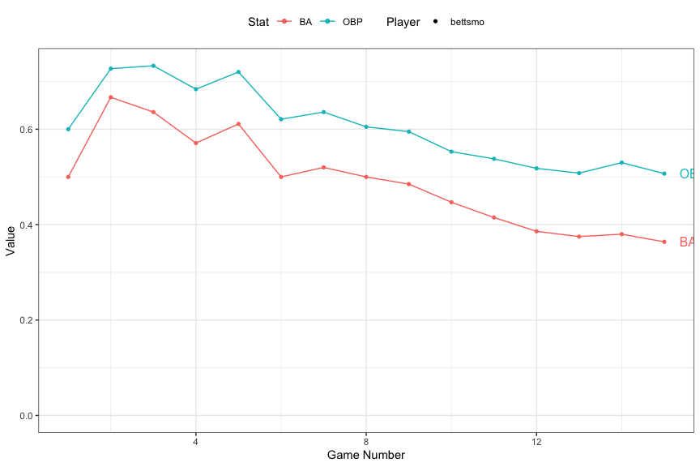

### Plot R and RBI

* fdsajiopgwjp

## now call the function with my parameters of choice:  
plot.stat(data=df_gamelog_long, player_var = c("bettsmo"), stat_var = c("R", "RBI"))

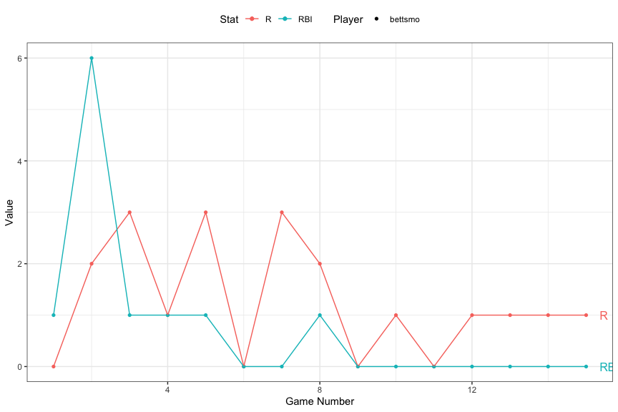

## Tab 2: Mookie Betts and Shohei Ohtani

### Plot BA and OBP

* jl note direct label getting cut off, up the fig-width for this code chunk

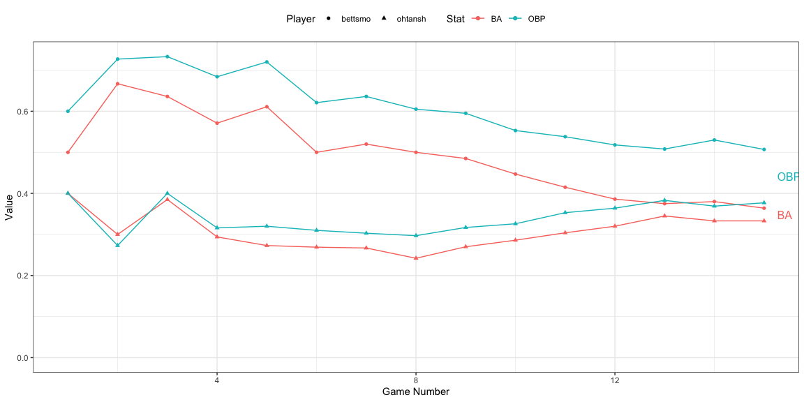

### Something other than the plot.stat function

* turn this into a plotly
  + plotly::ggplotly()
* 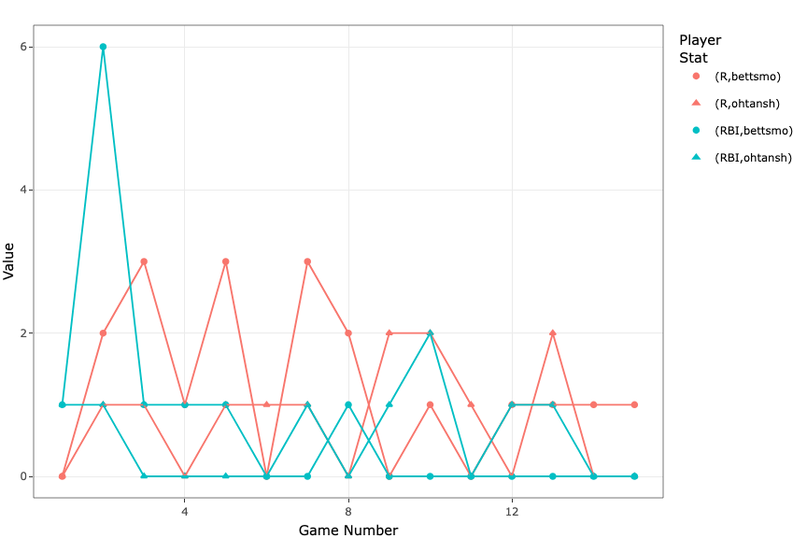

## try to get a Shiny plot to filter by any id? – in progress

* jl this works in Viewer, but Shiny code needs to be hosted somewhere so won’t show up in the html output
* in YAML need to set server: shiny

## jl testing iframe to sneak in Shiny app into Quarto html file?

## Quarto

Quarto enables you to weave together content and executable code into a finished document. To learn more about Quarto see <https://quarto.org>.