Digital Interface Electronics: Basic Circuits and Concepts you should know

Ohm’s Law: V = I x R (Voltage = Current x Resistance)
Source, ground, potential – w/o a circuit will have potential but no current. We have control over the resistance and the potential. Divide both sides by “R” to get v=i. As voltage increase, current increases.

Example 1: Current Limiting Resistors:

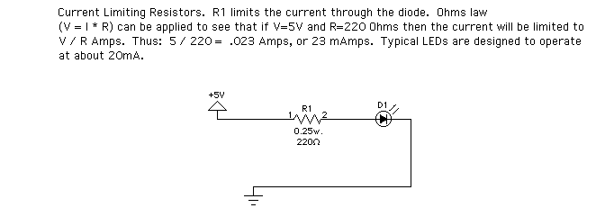

Example 2: pull-up and pull-down resistors

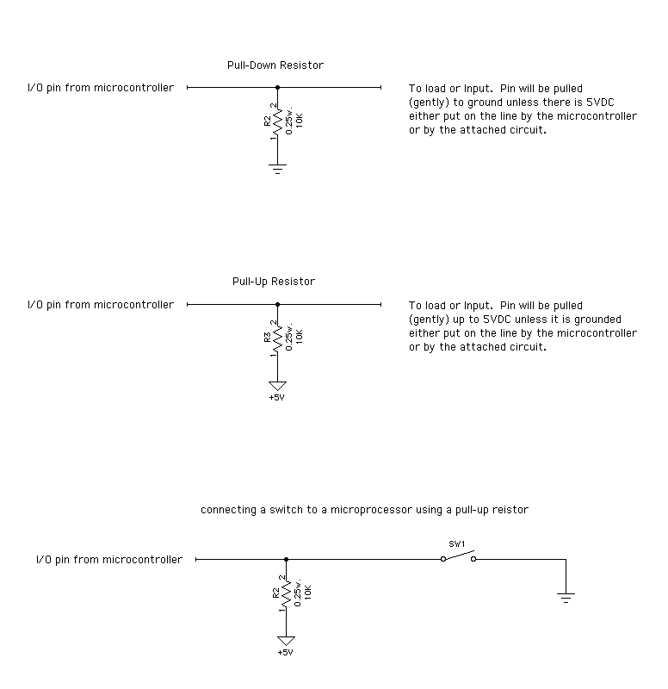

Example 3: Voltage Dividers

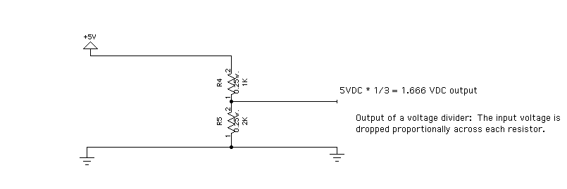

Example 4: Using Voltage Regulators

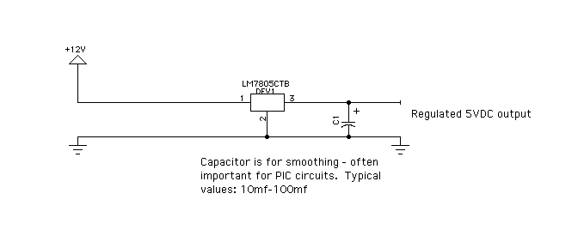

Example 5: Basic Transistor Switches

