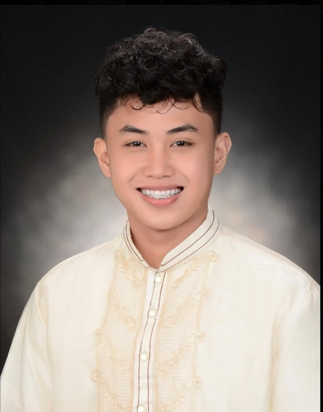

**PERSONAL INFORMATION:**

**Date of Birth:** July 27, 1999 **Place of Birth:**  Manila (PGH) **Nationality:** Filipino **Civil Status:** Single **Religion:** Roman Catholic

* Proficient in Microsoft Office Applications
* Proficient in Computer-aided design (CAD) skills
* Proficient in Computer Hardware
* Knowledgeable in C++ Programming

**EDUCATIONAL BACKGROUND:**

**Bachelor of Science in Electronics Engineering Polytechnic University of the Philippines – Taguig Branch** *2018-2022*

**Senior High School** **STEM** **Pasig Catholic College** *2016-2018*

**Junior High School HSL-Braille College** *2012-2016*

**AWARDS AND AFFILIATIONS:**

No Attitude Freedivers **Safety** **Coach**

Institute of Electronics Engineers of the Philippines **Member**

Association of Electronics Engineering Students **Member**

AECES Men’s Volleyball Team **Team Captain**

**Seasons MVP** – Quest for the BEST PUP- Taguig

**Molchanov’s Certified Freediver** Wave 1

**JUSTIN JAYCE S. MOTA block 5 lot 1 dreamland sbdv. brgy. hagonoy taguig city** [**motajustinjayce@gmail.com**](mailto:motajustinjayce@gmail.com) **/ +639277892417**

**HIGHLIGHTS OF QUALIFICATION:**

Graduated Bachelor of Science in Electronics Engineering. **HIGHLY-DRIVEN** and seeking for new opportunities to share my Leadership and Analytical skills in the field of Information Technology.

**TECHNICAL SKILLS:**

**SOFT SKILLS:**

* Team Player
* Experienced in Leadership
* Can work with Minimal Supervision
* Highly Analytical
* Highly Adaptive
* Good Inter/Intrapersonal skills
* Critical Thinker

**TRAININGS AND SEMINARS:**

|  |  |  |
| --- | --- | --- |
| **Engineering your Finances** | February 5, 2021 | Webinar  Polytechnic University of the Philippines |
| **Technology Driven Career in Industry 4.0 for Electronics Engineering** | May 12, 2020 | Webinar  Polytechnic University of the Philippines |
| **Occupational Safety** | March 30, 2019 | Webinar  Polytechnic University of the Philippines |
| **BILAD (Building Interactive Life in Accordance with Development)** | March 29, 2019 | Webinar  Polytechnic University of the Philippines |

**CHARACTER REFERENCES:**

Accenture Inc.

Software Engineer

Fujitsu Philippines

Cloud and MS Business Head

**Gerardo Onate**

+639604281313

**Engr. Joseph Raniel Rosales**

+639989716141