**BCI: Drowsy Driving Detection**

| **Justin Lukas**  University of Alabama  Tuscaloosa, AL, USA  Jjlukas@crimson.ua.edu | **Elliott Miller**  University of Alabama  Tuscaloosa, AL, USA  Eemiller1@crimson.ua.edu | **Logan Skinner**  University of Alabama  Tuscaloosa, AL, USA  Laskinner@crimson.ua.edu |
| --- | --- | --- |

# ABSTRACT

This paper discusses our approach to improving road safety by tackling the problem of drowsy driving. Our application uses EEG data to detect driver drowsiness and provide stimuli to drivers.

## Author Keywords

Brain computer interface, drowsy-driving

# INTRODUCTION

Drowsy driving is often an underappreciated danger to driving conditions. Other roadway distractions such as cell phones and driving while intoxicated often top people’s list of road dangers, but drowsy driving is not to be overlooked. The CDC reports 72,000 accidents per year that are the result of drowsy driving including up to 6,000 fatalities [1]. Drowsy drivers exhibit a decline in concentration and danger recognition. This problem extends beyond automobiles however, as people who operate heavy machinery, especially over long shifts, and any other type of motor vehicle or equipment could be under some of the same risks of injury or death.

Previous attempts at detecting drowsy driving have been made both with and without using BCI devices. These previous implementations have room to improve though. By utilizing beta and theta waves, an accurate reading of normal alert consciousness and drowsiness can be measured. Using this data, we can initiate different responses and stimuli to keep drowsy drivers alert and increase road safety. Things such as visual stimuli, sounds, trivia questions, math problems, changes in temperature, and changes in music should be tested to determine the best option for keeping drivers focused for long enough to get to a safe place to stop. Our implementation will be focused on using a smartphone to engage drivers by asking verbal questions when drowsiness or lack of focus is detected by the system.

By taking advantage of technology available, we can provide an accurate and comfortable tool for users to monitor their state of awareness to help improve driving conditions. This technology will not require any effort on the part of the user but will provide potentially lifesaving features while driving long trips or in conditions conducive to drowsy driving such as lack of sleep due to long working shifts, users with sleep apnea, and commercial vehicle drivers.

# previous work

An IEEE paper from 2010 proposes a similar approach that tracks EEG data in real time and produces a warning tone when drivers become drowsy. They use a headband style BCI headset with a built in Bluetooth transmitter that sends data to a separate device. The device receiving the transmission has a speaker that produces a warning tone under the right conditions (see Figure 1) [2].

The system uses a signal processing module that compares the first few minutes of driving data with future data to detect drowsiness. Their approach assumes that the driver is alert for the first few minutes of driving time and uses that as a basis for the rest of the trip. If the driver’s theta and alpha rhythm deviates too much, the system will detect that the driver is drowsy [2].

While our projects have a lot of similarities, we are able to improve upon this earlier approach to BCI in cars by using smartphones for our stimulus device. The smartphone provides a more user-friendly approach and gives us more room to grow with future stimuli.

# our approach

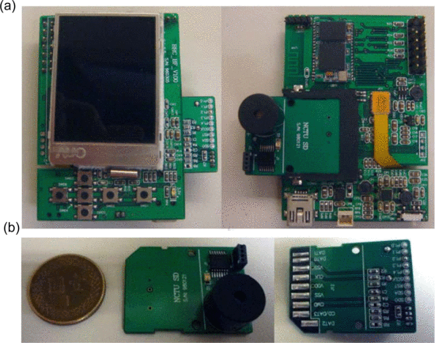Our approach has involved several iterations of research and some changes to our original design before we were ready to start developing. Finally, we were able to take a passive BCI approach by using an EEG to read brain waves and determine the drowsiness or alertness of the user. Our process is as follows: We place electrodes on the user’s head in the locations FP1, FP2, A1, and A2 from the international 10-20 system (see Figure 2). We then store the data in our FireBase database in order to be able to track the received signals in real time. If a user’s theta waves are between 4 and 8 Hz, the system determines that the user is

Figure 1. Warning tone device

Figure 2. BCI Headband for tracking EEG data

drowsy, triggering a signal to our application that elicits some sort of stimulation to bring the user back to a state of alertness. While the user’s beta waves are between 14 and 30 Hz, the system continues to function as normal, monitoring the brain waves of the user until a drowsy state is reached.

Ultimately, we chose our stimulation to be a set of trivia questions, prompting the user to consciously and actively think critically. It was our intention that such a stimulation would increase the alertness of the user, and this is indeed the observed user behavior in response to our stimulations. This supports the premise and goal of our project, which is to enhance the neurophysiological feature of alertness in our users.

# system design

Our project’s design was closely modeled after the BCI Cycle (see Figure 3). Signal acquisition is accomplished through the OpenBCI GUI while feature extraction and translation occur using node.js which constantly writes to a real-time FireBase database. Our mobile application has a listener for changes to the database, and when Beta or Theta waves drop below a certain threshold, a response is triggered to help stimulate brain activity for the user.

# challenges

Over the course of our project, several challenges have stuck out in relation to the data collection and translation. It took several failed attempts in order to stumble upon FireBase as the ideal way to gather and store our data. However, using FireBase has caused other concerns when it came to responsiveness of our implementation. FireBase allows for event listeners that trigger when any change is detected to the data referenced, however, this causes concerns since the data is updated so frequently, several quick fires all at once effectively disallowed the trivia questions to be asked to completion.

# Summary

Our project was conceptualized to counter a prevalent problem of drowsy-driving. With advancements in BCI technology, we are on the cusp of cost-effective, user-friendly solutions to monitor and respond to brain activity that could effectively negate drowsy-driving. Past research has been done on this topic, however, there has not been any research into the best way to stimulate users back to alertness. Our project looks to build on past research and focus on ways to help alert drivers when they are feeling drowsy in order to counter the negative effects of drowsy-driving.

# FUTURE WORK

There are various opportunities for us to expand our project scope, both in the functionality of our project and its applications. We have identified several areas for potential future work that, given the time and resources, we would prioritize focusing on. The first feature to implement would be a weighted system for the response stimulations. This means that, upon receiving a signal that the user is drowsy, the behavior of the application would differ based on a calculated weight. This weight would be the result of the measured effectiveness of different response techniques; i.e. reading a math problem out loud, playing a song, etc. If a certain response is determined to be more effective than another, then this would be the first stimulation exhibited by the application.

As an extension of this functionality, we would also like to tailor this experience to individual users, eliciting the most effective stimulation per their specific profile. We theorize that some people respond to various stimulations differently, and therefore would ideally like our application to give each user a custom experience that is most effective for them, as opposed to just the average user.

Another area we would like to see our project improved is in its hardware. Our current implementation involves using a laptop computer as a “middleman” to transfer data from the OpenBCI GUI to a database and then to our frontend android application. This is not an ideal set up for someone riding in the car, nor is the tangle of bulky wires the most comfortable thing to be wearing while driving. For future work, we would like to simplify the hardware involved, including the headset and use of a laptop computer.

Lastly, we would like to eventually incorporate third-party applications into our project, such as Spotify. This would allow the user to choose their favorites songs to be played, or trivia from their favorite subject. Our application, of course, would still determine the most successful out of the set of predetermined stimulation methods.

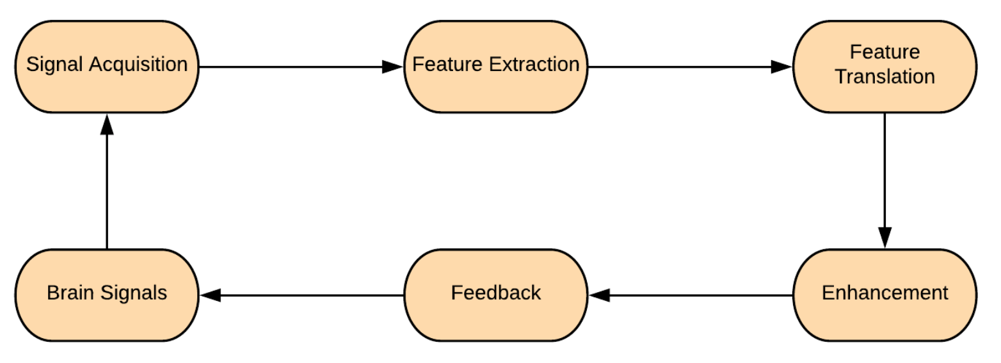

Figure 3. The BCI Cycle

# REFERENCES

1. Drowsy Driving: Asleep at the Wheel. (2017, November 7). Retrieved February 11, 2018, from CDC:<https://www.cdc.gov/features/dsdrowsydriving/index.html>
2. Chin-Teng Lin, Che-Jui Chang, Bor-Shyh Lin, Shao-Hang Hung, Chih-Feng Chao, and I-Jan Wang. 2010. A Real-Time Wireless Brain-Computer Interface System for Drowsiness Detection. *J. IEEE Transactions on Biomedical Circuits and Systems,* vol. 4, no. 4 (August 2010).