Inverted index builder using state machine

Problem statement

Given: Incoming documents, from web, in different time, speed, volume and format. (# of documents is of the order of millions)
Task: Build a fast inverted index, which facilitates faster query search on it.
System should manage incoming flow of documents and distribute them wisely to parallel threads.
Queries should be done in up to date inverted index. The query time should be as small as possible.
Black box overview of the system:

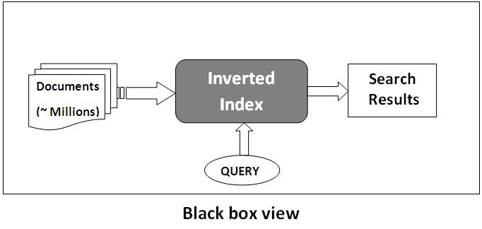

Detailed process:-

Corpus
Index Builder

Index Builder

Index Builder
Index Builder

Inverted Index
∆∆I
∆I
Crawler
∆I
∆I
Query
State Machine
Dictionary
Copy?

Overview of the conception

Here is the class diagram of our project. The idea is to separate the software into 4 layers:
- Software layer that contains all the algorithms
- Data layer that contains the java classes of data from the database
- Database access layer that build the data classes with the information taken from the database
- The Database layer

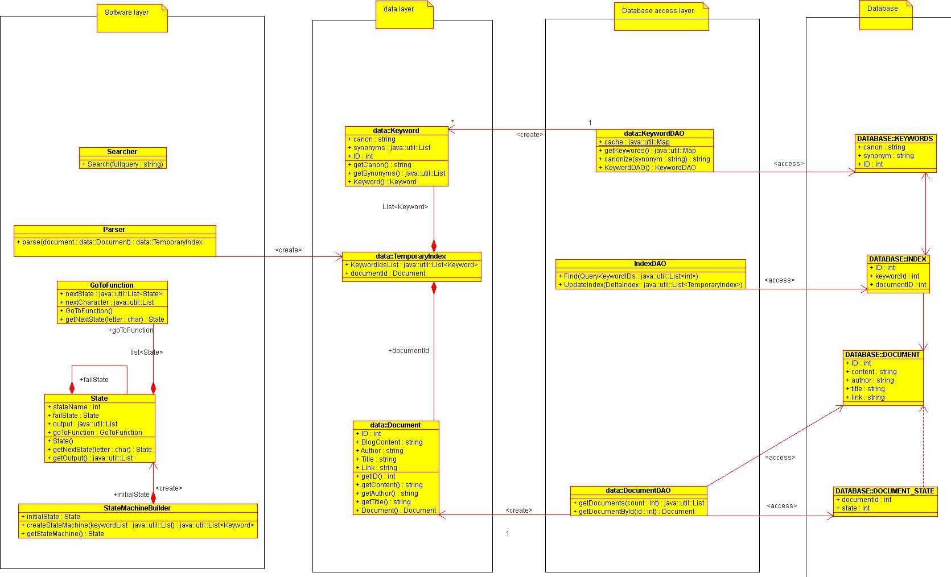

Here is the global sequence diagram of our conception (more details are given later on):

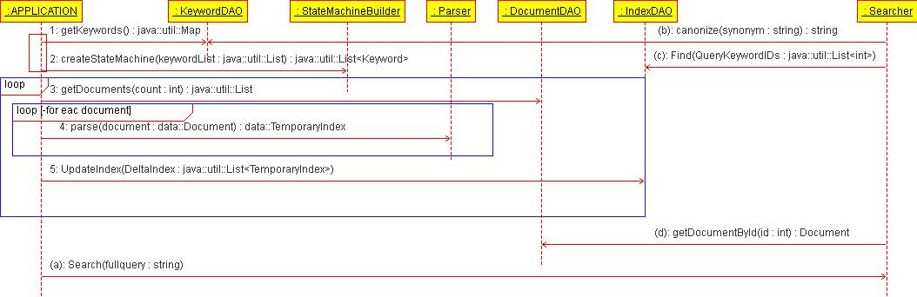

Let’s describe all parts independently with more details. First we will detail the data access part and then the software part.

Data Access: DAO, Data classes, Database architecture
Access to persistent storage is via objects of the data access layer. Confining data access to a logical grouping of classes insulates the other application components from changes in database schema.

Document
The DocumentDAO singleton class provides methods for retrieving Document objects from the document database:
List <Document> getDocuments (int count): retrieve a specified number of unprocessed documents from the database. The documents retrieved will be atomically marked as processed so that processing is not duplicated on other nodes. In this scheme, a document is considered processed to all other processes once retrieved from the database. This may cause problems from a fault recovery perspective if the processing node fails. A proposed enhancement to this scheme is to use another state, processing, to indicate that the document has been retrieved and to update the state to a processed state once processing is actually complete. For the initial implementation we will use the processed state only.
Document getDocumentById (int id): retrieve a specific document from the database, referenced by its ID.
Int getID (): accessor method.
String getContent (): accessor method.
String getAuthor (): accessor method.
String getTitle (): accessor method
String getLink(): accessor method.
The Document class encapsulates the BLOG database table, with the addition of a state field that tracks whether a document has been processed or not. This field will be implemented as a new field on the BLOG table or as a new reference table DOCUMENT_STATE.
and show UML class and sequence diagrams respectively for non-trivial classes and methods involved in the implementation of the Document data access layer.

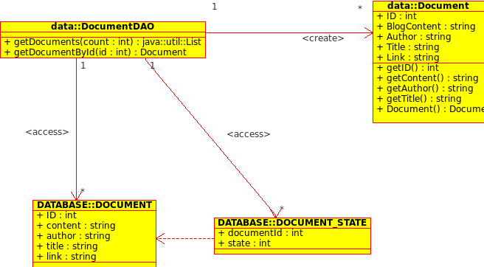

Figure 1: Document class diagram

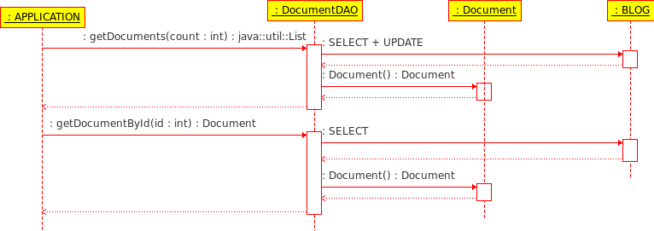

Figure 2: Document sequence diagram

Keyword
The KeywordDAO singleton class provides methods for retrieving Keyword objects from the document database. It also provides methods for converting search terms to their canonical form which will be recognized by the document parser:
Map<String, List<String>> getKeywords (): this method will returns a map of string lists. The map keys are the canonical keywords and the lists are synonyms for the associated canon. The keywords will be loaded from the database and cached when the class initializes. Subsequent queries will draw from the cache.
String getCanon (String synonym): given a synomyn, returns the canonical form of the keyword.

The Keyword field encapsulates a new table that will be created to store keywords, KEYWORDS. This table will contain a denormalized mapping of canons to synonyms. Figure and Figure show UML class and sequence diagrams respectively for non-trivial classes and methods involved in the implementation of the Keyword data access layer.

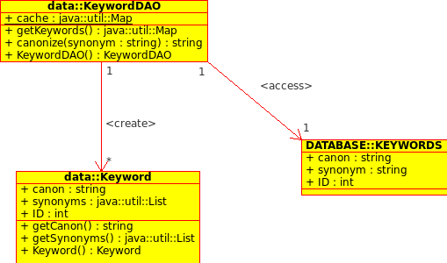
Figure 3: Keyword class diagram

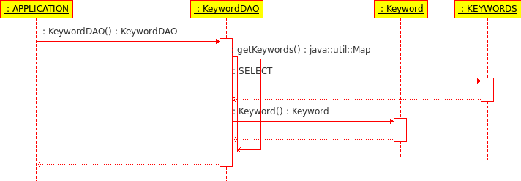

Figure 4: Keyword Initialization Sequence

IndexDAO

IndexDAO class provides methods for updating and searching the Inverted index table stored in SQL Database. There are two methods defined in this class:

1. Void Update Index (List<TempIndex> input)
This method takes input of type List<TempIndex> (Note: Temporary index is a user defined data class, which contains Document ID and List of <keyword ids> as its attributes) and generates an SQL query which updates the INDEX table in the Database.

2. List<Integer> Find (List<Integer> QueryKeywordIds)
This method takes a list of <int> (which corresponds to mapped String query into keyword ids) as input and searches the INDEX table in DB to find all the document ids which are common between for the given query keywords.

Figure 5 and Figure 6 shows the UML class and sequence diagrams respectively for classes and methods involved in the implementation of the IndexDAO.
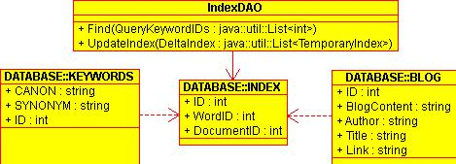
Figure 5: Index DAO class diagram

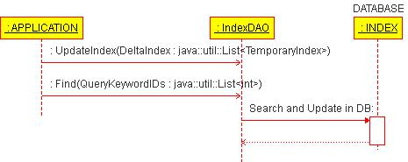
Figure 6: IndexDAO Sequence Diagram

Software layer

Searcher
This class is designed to perform search for a query entered by the user. It contains a method named search () which is responsible for finding all the documents which contained all query keywords.

1. List<Document> Search (String)

It takes query entered by the user in string type and returns the list of documents in which all the keywords of the query occurred together.

This method First calls, List<int> KeywordDAO.canonize(string), to map string query keywords into corresponding list of keyword IDs.
Note: - We are assuming that the query will be formed with the set of keywords, which will be a subset of Original keyword set, with which state machine is built.

Then it calls, List<Integer> IndexDAO.Find (List<querykeywordIDs>), which will searches in INDEX DB for a list of Common DOC_IDs corresponding to given query keywords.

In the end, it calls List<Document> DocumentDAO.getDocById(DOC_Id). This will map DOC_id into Document from BLOG table in the database.
Note: - Document is a user defined data class, which have its attributes id, content, author, link and title.

Figure 7 and Figure 8 shows the UML class and sequence diagrams respectively for classes and methods involved in the implementation of the Searcher.

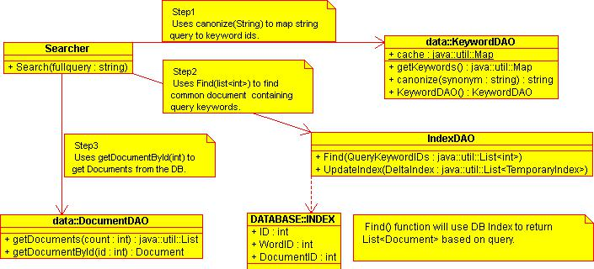

Figure 7: Searcher class diagram

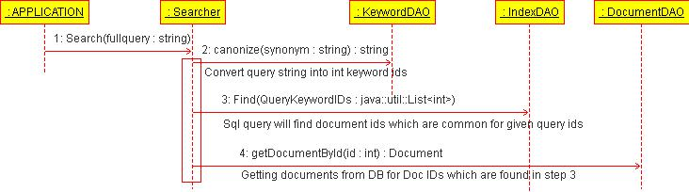
Figure 8: Searcher Sequence Diagram

StateMachineBuilder
This class is designed to build the state machine from the list of keywords that is an attribute of KeywordDAO. This class has a static attribute initialState that is the first state of the state machine built by the function createStateMachine (initializes with the value null). The first state gives us the whole state machine thanks to the architecture of a state. Once the state machine is built, the function getStateMachine is there to access the initial state stored in the class.

Figure 9 and Figure 10 shows the UML class and sequence diagrams respectively for classes and methods involved in the implementation of the StateMachineBuilder.

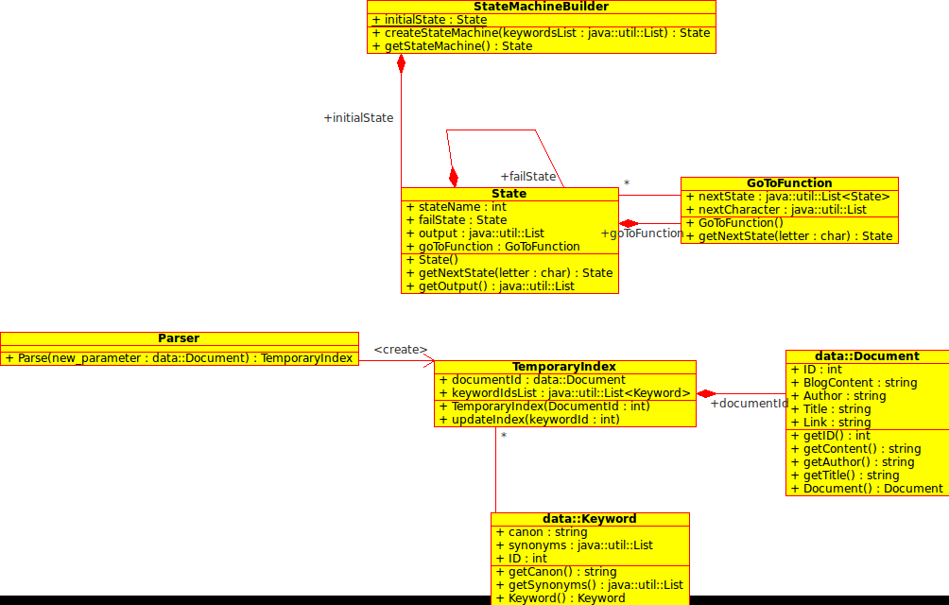
Figure 9

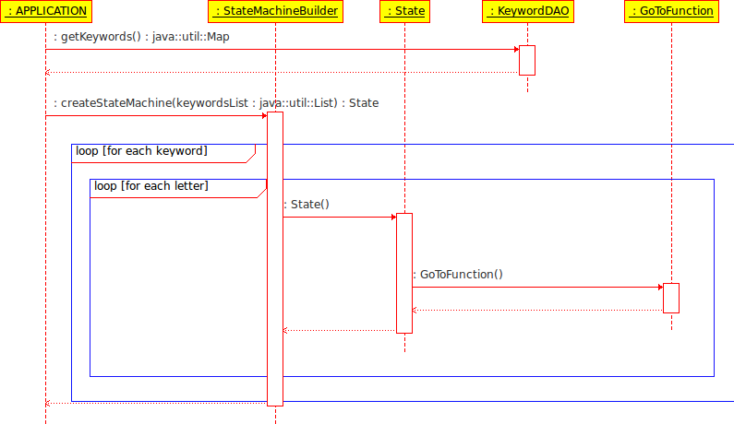
Figure 10

Parser

The parser is designed to have the algorithm that makes us able to parse a document inside the state machine. It is by default using the state machine contained in the static attribute of StateMachineBuilder. To parse a document we need to call the function parse inside this class and to give it as attribute the document we want to parse. This class returns the temporary index which is of type TemporaryIndex (Note: TemporaryIndex is a user defined data class, which contains Document ID and List of <keyword ids> as its attributes).

Figure 11 and Figure 12 shows the UML class and sequence diagrams respectively for classes and methods involved in the implementation of the Parser.
Figure 11

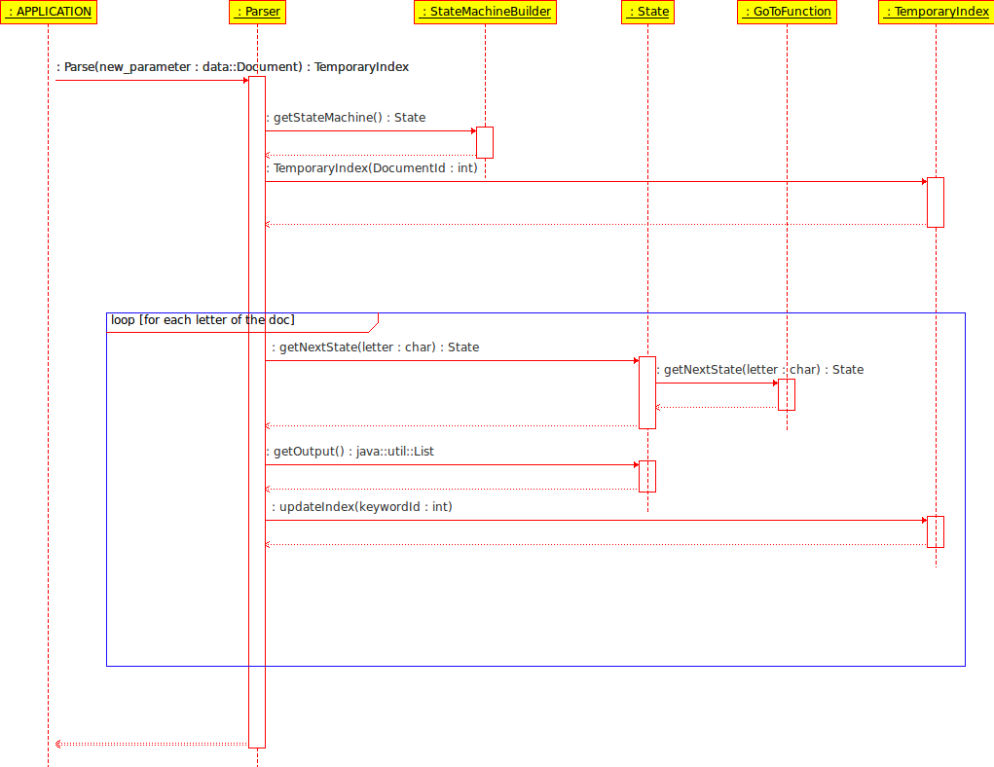
Figure 12

Implementation Effort Estimates

Activity | Subtask | Effort (hours)
Data Access Development | DocumentDAO | 20
 | KeywordDAO | 20
Integration
System Testing
Total

