**DANA MES Tester**

**Final Project Report**

Submitted as partial fulfillment of the requirements for

ENGT 4050

Senior Technology Capstone

Prof. Richard Springman

**Apex Solutions**

**Project Team B-1**

Andrew Elec, Team Leader

Justin Keating

Matthew Szych

Marco Zaragoza

Chris Yowpp

Nick Fryer

**Faculty Advisor**

Mr. Scott Brahaney

**Sponsor**

DANA Incorporated

April 30th, 2020

The University of Toledo

College of Engineering

Engineering Technology Department

This page intentionally left blank

An Abstract of

**DANA MES Tester**

by

Team B-1

Andrew Elec, Team Leader

Justin Keating

Matthew Szych

Marco Zaragoza

Chris Yowpp

Nick Fryer

for

ENGT 4050

Senior Technology Capstone

Spring Semester 2020

The University of Toledo

In abstract DANA produces two sets of the same data type, but in two different formats.The Data collected then needs to be formatted into a standard format that is then used to generate reports.An application is needed to take the reported data and send it to be stored. A MySQL database can be used to ensure this is done correctly. There needs to be a way to interact with the data while being expandable with a front end .ASP web application.

**Acknowledgments**

Mr. Byron Solheim, DANA Gear Lab Manager

Mr. Chris Hannigan, DANA Service Technician

Mr. Scott Brahaney, UT Faculty Advisor

**Table of Contents**

Abstract…………………………………………………….……………………………….……..3 Acknowledgments……………………………………………..…………………………………..4

Table of Contents...…………………………………………..…………………..………………..5

Introduction…………………………………………………………..…….………………..…….6

Background………………………………………………………………….……………..……...6

Project Description…………………………………………………………..………...…………...7

Project Team…………………………………………………………….……………….………...8

Design and Analysis Process ………………………………………………...…………..…………8

Java Team…………………………………………………………..………………..……..8

MySQL Team…………………………………………………..…………………..………9

ASP Team…………………………………………………………….…………………..10

Results……………………………………………………………….…………………………....11

Figure 1…………………………………………………….……………………………..11

Figure2……………………………………………………………………………………11

Discussion & Conclusion……………………………………………………………………..……12

Appendices………………………………………………………………….…………………….13

Appendix A……………………………………………………………………….………13

**Introduction**

The motivation for this project is to create a system that increases the efficiency of the current practice of data transfer via some automation. Current practice relies on data validation and transformation via personnel. Such data is then used to create reports; this leads to time that could be spent on other business activities. The proposed system is to take the company data, transform it into a compatible format that can be entered automatically into a MySQL database. In addition, the system will validate the imported data and be able to generate reports from the data.

The following sections will delve more into detail of the design objectives and tasks completed. In addition, describing the circumstances we dealt with and struggles of COVID-19 interfering with our project

**Background**

The problem is that DANA produces two sets of the same data type but in two different formats. Data then needs to be formatted into a standard format that is then used to generate reports, or have the ability to filter out data that is not needed. These needs make the project interesting because three components are needed to solve the problem. A way to import the data, store the data, and the ability to interact with the data while being expandable.

Our motivation for the project was to show off our talents we have acquired during the undergrad years of college. We took classes and life experiences learned to accomplish something that could be used in the real world.

**Project Description**

In the early stages of our project we knew that the project incorporates the use of breaking down given compiled machine data into a MySQL database for DANA. The data being collected is measurements from automobile gears, this is important information that needs to be stored to look at for future reference and calculations. We Planned on making sure this was going to be done with C#, MySQL, and .ASP.NET.

Though during the mid stages of our project we realized we had to make a few adjustments to make sure criteria was met with DANA. We met with DANA weekly to make sure everyone was on the same page and started to make goals. Preparations have also been made to design this project with Java, MySQL Server, and .ASP.NET. We changed to JAVA because it was able to give more functionality to our project as a whole.

COVID-19 was just starting to get very serious as well. In preparation for it getting worse, the team decided to make sure everyone was on the same page and working hard by doing weekly check-ins. We also decided to make sure we were doing daily communication just to keep in touch.

Lastly, in the creation/ending stages of the project we needed to start incorporating everything together, we divided work to people’s strengths and gave it a go to begin a very successful project. COVID-19 now has gotten worse and the only thing the team wanted to do was make sure everyone was safe and that the project was also being completed according to our goals/gantt chart schedule. We began having multiple meetings a week, even with DANA to make sure the project was on the right track to completion before May.

**Project Team**

In order to make sure the deadline of our project was met we needed to split the team up into 3 seperate groups. The first group was in charge of creation of Application using JAVA, the second team was in charge of creation of MySQL Server, and thirdly the last team was in charge of the .ASP.NET front end website.

The JAVA team consisted of Andrew Elek and Marco Zaragoza. They both have had previous experience with JAVA and C# so this was an easy decision to make.

The MySQL team consisted of Chris Yowpp and Mathew Szych. They both took this role to learn more about SQL and also because they too have had past experience.

The .ASP team consisted of Justin Keating and Nick Fryer. Both did not have any experience with .ASP, but have had experience with HTML designing. They took this job to also learn more about front end website creations with .ASP.NET.

**Design and Analysis Process**

**JAVA Team:**

* Import data from multiple excel sheets
* Easier to format data via application rather than on database
* Created Java app that exports filtered data to database server
* Uses Java 1.8 for Long Term Support
* JavaFX for the GUI
* SQL Driver for database connection

Overall, the JAVA team was designated to design a friendly user interface application that takes DANA’s acquired excel data, formats it, and stores it onto the SQL Server. The application was done by using JAVA coding and JAVAFx for the graphical-user-interface. Once the data was pushed the SQL team needed to make sure it was being stored correctly and ready to then be pushed out to the front end .ASP website.

**MySQL Team:**

* Uses Microsoft SQL Server Management
* Open Source
* Entails a Data Management System
* Relational Database
* Fast, Scalable, Easy to Use
* Makes uses of procedures for .ASP access
* Creates multiple tables for expandability
* Uses insert statements to get the data from Java application

Overall, the MySQL team did a very good job handling the imported data and making sure it was being correctly pushed out to the .ASP team. In order to accomplish their goals they created well-oriented tables to hold/sort data. After the tables were created the .ASP team needed stored procedures to be created within the database to push the queried data to the .ASP website.

**ASP Team:**

* Uses .ASP Framework
* Open Source Web-App
* Query Database
* Expandability for longevity
* Created within Visual Studio 2019
* Configured to successfully connect to SQL Database
* Multiple Objects/Methods to connect GUI together
* Boot-strapped was used to create style sheet of GUI
* Takes SQL Data and transforms it into a gridview on front end website
* Allows user to query from gridview
* Can be deployed over DANA’s network so it can be used over LAN

Overallt the ASP team was able to create the perfect website for DANA to query search data that has been obtained through their machines. The ASP website is set up to connect to the SQL database through stored procedures and allow users to search the whole database to find exactly what is needed.

Together all three teams were able to blend their creations into one to form a fully functional application, SQL Database, and front end website. Every part of the project successfully connects to one another and allows the passing of the data files to flow smoothly for searchable data.

**Results**

The GUI for the Java applications (Figure 1) was created using JavaFX to give the user a simple and nice looking interface to interact with. This application allows the user to select an Excel file to upload to the database.

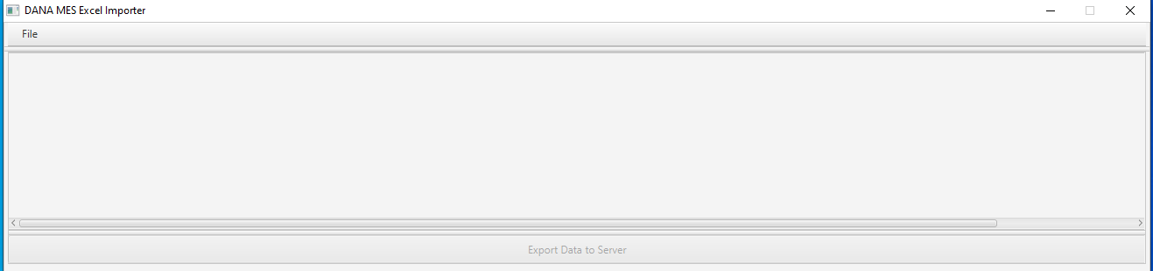

Figure 1: Java Application

The front end website (Figure 2) is what DANA employee’s will use to query machine data that is being stored via LAN (Local Area Connection) connection.

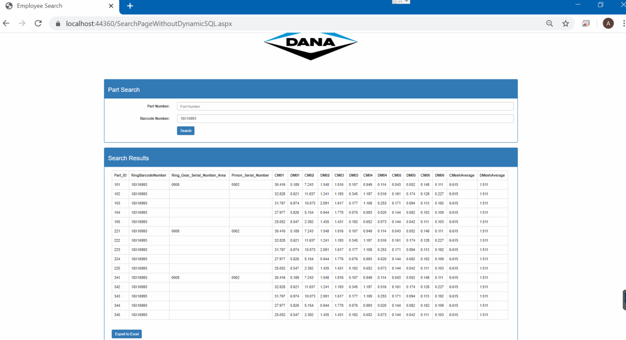

Figure 2: .ASP Web Application

Our Senior Capstone turned out to be a very well rounded project that gave DANA more than they ever wanted. All parts of the creation of the projects have been stress tested and tested to make sure there are no faults. The project will be handed down to DANA for them to take as theirs in the first week of May. They were very pleased to see the outcome we have created for them.

**Discussion and Conclusions**

This project required the creation of a database that will allow for the automatic entry and formatting of two sets of data. To access the SQL Server database a website built with ASP.NET to display, query, and export the data to a standardized Excel spreadsheet. A Java application was created to take the data from the Excel file and upload it to the database. This project was created with the intention of being a fully functioning, scalable foundation that will immediately be put into practical use within the company. For this reason, the project followed a “complete then polish” format. In order to meet this deadline and provide a product with the requested functionality the work was split between three separate groups each having their own milestones.

These milestones included every required project detail from “obtaining data” to “testing the database”. Upon reviewing these milestones, the completion deadline matched the timeline for the workload. The project was fully completed in time for the April deadline and ready for presentation to the client in May.

**Appendices**

**Appendix A:**

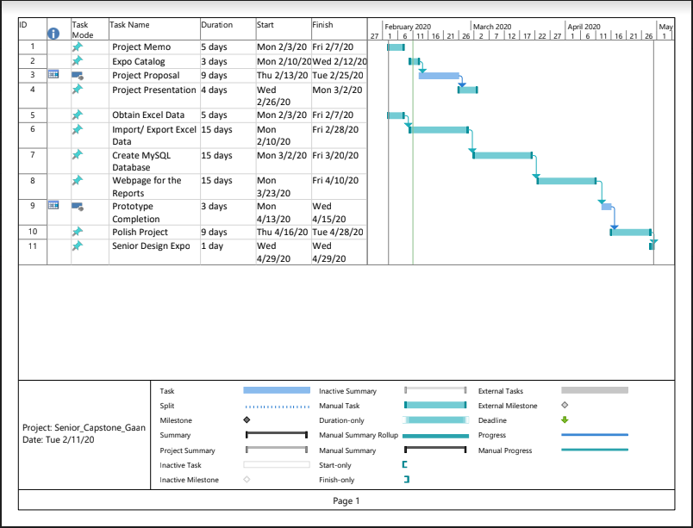

Figure 3 : Gantt Chart