EEL 5606 - Assignment 2
Requirements Document
Simulation-Based Autonomous UGV for Indoor Shipyard Maintenance Corridor Inspection
Justin Kwarteng

1. Introduction
This project defines a simulation-based autonomous unmanned ground vehicle (UGV) for remote inspection of an indoor shipyard maintenance corridor after a reported obstruction, alarm, or suspected hazard. The UGV is intended to enter a defined route before personnel, identify blocked or unsafe paths, avoid obstacles when possible, and report mission status to an operator station. The purpose is to reduce unnecessary human exposure while improving the speed and repeatability of initial inspections.
The course prototype will be implemented entirely in software. ROS 2 will run the autonomy logic, command interface, and telemetry logging. Gazebo will simulate the UGV, corridor environment, drivetrain, sensor outputs, and obstacles. RViz may be used as an optional visualization tool. The baseline rover uses a two-wheel differential-drive configuration with one caster wheel, encoder-style odometry, an IMU, and front/side range sensing. The route will be predefined; full SLAM-based mapping is reserved for future work.

1.1 Baseline Design Assumptions
Design Item | Baseline Decision
Primary customer | Shipyard or naval-facility maintenance and safety team
Reference environment | Indoor maintenance corridor or warehouse-style aisle with a known inspection route
Prototype type | Simulation-only prototype on an existing laptop
Core software | ROS 2 and Gazebo; RViz is optional for visualization
Mobility | 2WD differential drive with one caster wheel
Sensors | Encoder-style odometry, simulated IMU, and simulated front/side range sensors
Out of scope | Physical build, onboard camera vision, manipulator arm, and SLAM-based mapping

1.2 Planning Estimate for an Equivalent Physical Prototype
The course deliverable is virtual, but the following planning estimate provides a realistic hardware-equivalent cost with contingency. It is not a vendor quotation.
Cost Element | Planning Range
2WD chassis, caster, and encoder motors | $80-$160
Embedded controller and motor driver | $30-$90
IMU and range sensors | $60-$180
Battery, charger, and power regulation | $70-$160
Wiring, mounting hardware, and enclosure materials | $80-$180
Integration contingency (approximately 25%) | $100-$180
Recommended physical prototype planning budget | $600-$900

2. Design Reference Mission
Following a storm, alarm, or maintenance report, facility personnel suspect that an indoor shipyard maintenance corridor may contain an obstruction or unsafe condition. The operator places the simulated UGV at the corridor entrance and issues a single start command. The UGV follows a predefined route, monitors simulated odometry, IMU, and range-sensor data, and records mission events. When an obstacle is detected, the UGV attempts a simple avoidance maneuver. If no safe route is available, or if sensor data become unreliable, the UGV stops and reports the condition to the operator. Under nominal conditions, the UGV reaches the inspection endpoint and transmits a mission summary and is expected to take no more than six minutes. During the mission, the UGV will transmit route progress, current mission state, detected-obstacle events, estimated obstacle locations, sensor-health status, simulated battery status, and elapsed mission time to the operator station.

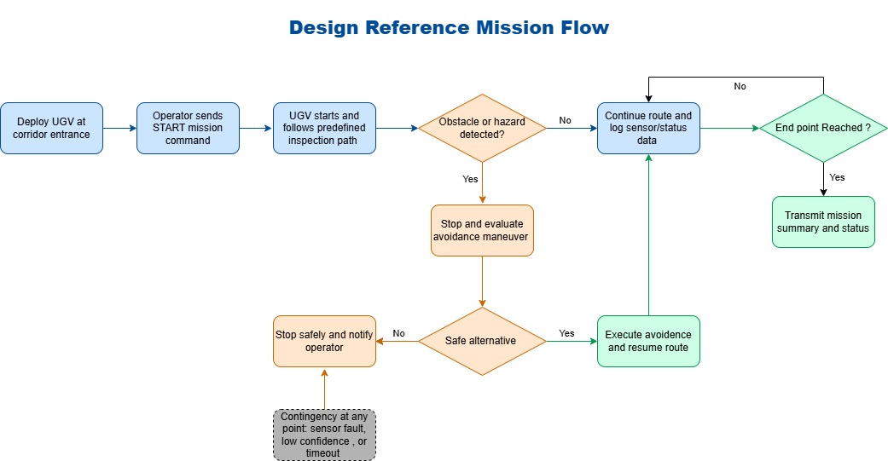

Figure 1. Design Reference Mission flow for the indoor shipyard maintenance corridor inspection scenario.
Approx. Time (minutes:seconds) | Phase | Expected Behavior
0:00 | Deployment | UGV is positioned at the corridor entrance. Operator confirms the simulation world and telemetry interface are active.
0:15 | Mission initiation | Operator issues one START command. UGV begins autonomous inspection route.
0:15-4:30 | Route inspection | UGV follows the predefined route while monitoring odometry, IMU, and range-sensor data.
As needed | Obstacle response | UGV slows or stops, attempts an avoidance maneuver, and logs the event.
As needed | Contingency response | If no safe route is available, sensor data are invalid, or mission timeout occurs, UGV stops and notifies the operator.
By 6:00 | Mission completion | UGV reaches the endpoint or stops safely and transmits a mission summary.

2.1 Likely Contingencies
Condition | Trigger | Required Response
Blocked route | UGV cannot identify a safe avoidance maneuver within the allowed response time. | Stop, report blocked path, and wait for operator action.
Sensor-data loss | Range, IMU, or odometry data become unavailable or invalid. | Enter safe-stop state and report the affected sensor stream.
Localization uncertainty | Estimated position confidence falls below the acceptable threshold. | Stop and report the current estimated pose and fault status.
Mission timeout | UGV does not reach the endpoint within the required duration. | Stop, report timeout, and transmit the recorded mission log.

3. Measures of Effectiveness (MOEs)
The MOEs measure whether the simulated system provides useful value to the customer during the reference mission.
ID | Measure | Definition | Target
MOE-1 | Inspection mission success rate | Percentage of standardized test runs in which the UGV reaches the endpoint or enters a safe-stop state without collision. | >= 90%
MOE-2 | Obstacle-response effectiveness | Percentage of route obstacles that are detected and handled without collision. | >= 95%
MOE-3 | Inspection completion time | Elapsed time from START command to endpoint arrival or safe-stop report. | <= 6 minutes
MOE-4 | Inspection-data reporting completeness | Percentage of standardized test runs in which the operator receives a complete mission record containing route progress, obstacle events, estimated obstacle locations, system-health status, elapsed mission time, and final mission outcome. | >= 95%

4. Measures of Performance (MOPs)
The MOPs are measurable system characteristics that directly support the MOEs and function as key performance parameters for the simulation.
ID | Measure | Definition | Target | Trace
MOP-1 | Nominal travel speed | UGV commanded forward speed during route inspection. | 0.20-0.35 m/s | MOE-1, MOE-3
MOP-2 | Obstacle-detection range | Minimum range at which an obstacle in the planned path is detected. | >= 0.75 m | MOE-2
MOP-3 | Stopping distance | Maximum distance traveled after a stop condition is issued at 0.30 m/s. | <= 0.35 m | MOE-2
MOP-4 | Endpoint accuracy | Distance between final reported pose and the defined endpoint. | <= 0.50 m | MOE-1
MOP-5 | Telemetry update rate | Frequency at which route progress, current mission state, detected-obstacle events, sensor-health status, and simulated battery status are sent to the operator interface. | >= 1 Hz | MOE-1,MOE-4
MOP-6 | Obstacle-response time | Time between obstacle detection and stop or avoidance action. | <= 2 seconds | MOE-2

4.1 Standardized Verification Scenarios
The following scenarios will be used repeatedly to verify nominal behavior and contingency handling in Gazebo.
ID | Scenario | Setup | Expected Result
SCN-1 | Nominal route | Clear corridor with the planned endpoint reachable. | UGV completes route within the required time and reports mission success.
SCN-2 | Avoidable obstacle | Single solid obstacle placed in the planned path with room to maneuver around it. | UGV detects the obstacle, initiates an avoidance response, and resumes the mission without collision.
SCN-3 | Blocked route | Obstacle configuration prevents a safe alternate path. | UGV enters a safe-stop state and notifies the operator.
SCN-4 | Sensor or timeout contingency | A simulated sensor stream is disabled or the mission exceeds the allowed duration. | UGV stops safely, reports the fault, and records the event in the mission summary.

5. Formal Requirements
Each requirement is written as a verifiable “shall” statement and allocated to the primary subsystem responsible for implementation.
Requirement ID | Allocated Subsystem | Formal Requirement | Rationale | Traced From | Verification
REQ-SYS-001 | Mission Management | The UGV shall begin autonomous corridor inspection after receiving a single operator START command. | Limits operator workload and establishes autonomous mission execution. | MOE-1 | Demonstration
REQ-SYS-002 | Mission Management | The UGV shall complete the defined reference mission within 6 minutes under nominal simulation conditions. | Supports timely inspection following an alarm or reported obstruction. | MOE-3 | Test
REQ-MOB-001 | Mobility Controller | The UGV shall support commanded forward travel between 0.20 m/s and 0.35 m/s during route inspection. | Balances mission time with safe indoor operation. | MOP-1 | Test
REQ-NAV-001 | Navigation / Odometry | The UGV shall publish encoder-style odometry at a rate of at least 10 Hz while the robot is moving. | Provides sufficient feedback for route tracking and logging. | MOP-4 | Test
REQ-NAV-002 | Navigation / Odometry | The UGV shall finish the nominal mission within 0.50 m of the defined inspection endpoint. | Ensures that the planned corridor route is followed with useful accuracy. | MOP-4, MOE-1 | Test
REQ-SEN-001 | Range Sensor Suite | The UGV shall detect a solid obstacle in the planned path at a distance of at least 0.75 m. | Provides time to stop or begin an avoidance maneuver. | MOP-2, MOE-2 | Test
REQ-SEN-002 | IMU Sensor | The UGV shall publish simulated IMU orientation data at a rate of at least 10 Hz during mission execution. | Supports heading monitoring and future sensor fusion. | MOE-1 | Inspection / Test
REQ-SAF-001 | Safety Manager | The UGV shall stop within 0.35 m after an unsafe-path condition is issued while traveling at 0.30 m/s. | Reduces collision risk in the corridor environment. | MOP-3, MOE-2 | Test
REQ-AUT-001 | Obstacle-Avoidance Software | The UGV shall initiate a stop or avoidance maneuver within 2 seconds after detecting an obstacle in its planned path. | Ensures timely reaction to unexpected obstructions. | MOP-6, MOE-2 | Test
REQ-AUT-002 | Obstacle-Avoidance Software | The UGV shall enter a safe-stop state and notify the operator if no safe alternate route is identified within 10 seconds of detecting an obstacle. | Prevents unsafe or indefinite autonomous behavior. | MOE-1, MOE-2 | Demonstration
REQ-COM-001 | Telemetry Interface | The UGV shall report route progress, current mission state, detected-obstacle events, sensor-health status, and simulated battery status to the operator interface at least once per second during mission execution. | Maintains operator awareness of mission progress and faults. | MOP-5, MOE-1,MOE-4 | Test
REQ-LOG-001 | Telemetry / Logging | The UGV shall generate a mission summary containing elapsed mission time, final mission outcome, route progress, detected-obstacle events, estimated obstacle locations, sensor-health status, simulated battery status, and safe-stop events. | Provides repeatable inspection documentation for the customer. | MOE-1, MOE-3, MOE-4 | Inspection

6. Traceability Summary
The requirements trace from customer-valued outcomes to measurable system performance and then to subsystem-level verification activities.
Customer Outcome (MOE) | Contributing Performance Measures | Formal Requirements
MOE-1: Mission success rate | MOP-4 endpoint accuracy; MOP-5 telemetry rate | REQ-SYS-001, REQ-NAV-002, REQ-AUT-002, REQ-COM-001, REQ-LOG-001
MOE-2: Obstacle-response effectiveness | MOP-2 detection range; MOP-3 stopping distance; MOP-6 response time | REQ-SEN-001, REQ-SAF-001, REQ-AUT-001, REQ-AUT-002
MOE-3: Inspection completion time | MOP-1 travel speed | REQ-SYS-002, REQ-MOB-001, REQ-LOG-001
MOE-4: Inspection-data reporting completeness | MOP-5 telemetry update rate | REQ-COM-001, REQ-LOG-001

7. Future Work
The baseline course project intentionally uses a predefined route and a simplified simulated UGV. Future extensions may evaluate SLAM-based mapping, more advanced path planning, onboard vision, dynamic obstacles, 4WD or tracked mobility, and a physical hardware implementation. These features are not required for the initial design reference mission.

8. Technical Notes
ROS 2 is used as the software framework for autonomy logic and telemetry exchange. Gazebo is used as the physics and sensor simulator. Gazebo supports simulated sensor streams and can introduce sensor noise, while ROS-Gazebo integration supports bridging actuator and sensor messages. RViz is optional and may be used to visualize odometry and sensor data during development. The simulation is intended to validate mission behavior and requirements.

