Assignment 5 - Risk Management through T&E
Simulation-Based Autonomous UGV for Indoor Shipyard Maintenance Corridor Inspection
Justin Kwarteng | EEL 5606 | Due July 7, 2026
Item | Plan Summary
Project focus | Burn down technical risk through staged test and evaluation for the ROS 2/Gazebo UGV autonomy stack.
Continuity with A2-A4 | Uses the Assignment 2 requirements baseline, the Assignment 3 2D LiDAR sensing decision, and the Assignment 4 four-node software architecture.
Custom ROS 2 nodes | mission_manager_node, route_follower_node, obstacle_avoidance_node, telemetry_logger_node. ros_gz_bridge is supporting middleware, not a custom autonomy node.
Primary T&E environment | Software-in-the-loop testing on the existing Pop!_OS/Linux laptop using ROS 2 Humble, Gazebo/Ignition, ros_gz_bridge, corridor worlds, and timestamped mission logs.
Top risk areas | LiDAR detection/tuning, obstacle avoidance behavior, bridge/topic stability, final /cmd_vel safety gating, waypoint route completion, and repeatable mission evidence.

1. Project Description
This project develops a simulation-based autonomous unmanned ground vehicle (UGV) for indoor shipyard or port maintenance-corridor inspection after a reported obstruction, alarm, storm-related issue, or suspected hazard. The robot is a two-wheel differential-drive rover with a caster wheel, simulated encoder-style odometry, IMU, 2D LiDAR/range sensing, and simulated battery/system-health reporting. The mission is to start from a single operator command, follow a predefined corridor inspection route using odometry-based waypoints, detect and respond to obstacles with 2D LiDAR, enter safe-stop when a path is blocked or sensor data become invalid, and report progress, health, events, and final mission outcome to an operator/logging interface. The baseline remains simulation-only in ROS 2 Humble and Gazebo/Ignition; physical hardware, camera vision, SLAM, and full Nav2 autonomy are future work rather than current baseline scope.
The risk-management strategy is to reduce technical uncertainty through repeatable test events instead of waiting until the final demonstration. Each major risk is tied to one or more formal requirements, then burned down through simulation checks, topic-rate tests, node integration tests, scenario tests, and final regression runs in the nominal, avoidable-obstacle, blocked-route, and sensor/timeout contingency worlds.

2. Requirements
The table below reuses the top twelve Assignment 2 requirements and updates them to reflect the current Assignment 3 and Assignment 4 baseline: 2D LiDAR is the primary obstacle-detection sensor, the route follower uses odometry-based waypoints, and the custom software architecture consists of four ROS 2 nodes.
Req ID | Subsystem | Updated Requirement | T&E Verification / Evidence
REQ-SYS-001 | Mission Management | The UGV shall begin autonomous corridor inspection after receiving a single operator START command. | Demonstrate /start_mission service transition from IDLE to INSPECTING in the nominal world.
REQ-SYS-002 | Mission Management | The UGV shall complete the defined nominal reference mission within 6 minutes under simulation conditions. | Timed nominal-route test with mission summary showing elapsed time and COMPLETE outcome.
REQ-MOB-001 | Mobility Controller | The UGV shall support commanded forward travel between 0.20 m/s and 0.35 m/s during route inspection. | Record /nominal_cmd_vel and final /cmd_vel during nominal and obstacle tests.
REQ-NAV-001 | Navigation / Odometry | The UGV shall publish encoder-style odometry at a rate of at least 10 Hz while the robot is moving. | ros2 topic hz /odom during motion; logger records odometry in CSV.
REQ-NAV-002 | Navigation / Route Following | The UGV shall finish the nominal mission within 0.50 m of the defined inspection endpoint using the predefined route or odometry-based waypoints. | Endpoint measurement from odometry/final pose and mission summary.
REQ-SEN-001 | Range Sensor Suite | The UGV shall detect a solid obstacle in the planned path at a distance of at least 0.75 m using the selected 2D LiDAR/range-sensing baseline. | LiDAR characterization and obstacle-distance logs in the avoidable and blocked scenarios.
REQ-SEN-002 | IMU Sensor | The UGV shall publish simulated IMU orientation data at a rate of at least 10 Hz during mission execution. | ros2 topic hz /imu and sensor-health status during integrated tests.
REQ-SAF-001 | Safety Manager / Obstacle Avoidance | The UGV shall stop within 0.35 m after an unsafe-path condition is issued while traveling at 0.30 m/s. | Stopping-distance test using obstacle trigger and final /cmd_vel zero command.
REQ-AUT-001 | Obstacle-Avoidance Software | The UGV shall initiate a stop or avoidance maneuver within 2 seconds after detecting an obstacle in its planned path. | Timestamp detection, command response, and obstacle status transitions in mission log.
REQ-AUT-002 | Obstacle-Avoidance Software | The UGV shall enter a safe-stop state and notify the operator if no safe alternate route is identified within 10 seconds of detecting an obstacle. | Blocked-route test with BLOCKED/SAFE_STOP mission event and final zero /cmd_vel.
REQ-COM-001 | Telemetry Interface | The UGV shall report route progress, current mission state, detected-obstacle events, sensor-health status, and simulated battery status to the operator interface at least once per second during mission execution. | ros2 topic hz /ugv/status and inspection of mission log fields.
REQ-LOG-001 | Telemetry / Logging | The UGV shall generate a mission summary containing elapsed mission time, final outcome, progress, obstacle events, estimated obstacle locations, sensor-health status, simulated battery status, and safe-stop events. | Verify timestamped CSV and mission_summary text files under the project logs directory.

3. Risk Register
Risk scoring uses a 1-5 likelihood scale and a 1-5 consequence scale. The initial score is Likelihood x Consequence. Ratings are interpreted as Low = 1-4, Medium = 5-9, High = 10-16, and Critical = 17-25. Consequence is measured against the ability to meet the formal requirements and produce convincing test evidence.
Risk ID | Risk Statement | Primary Requirement Trace | L | C | Score | Initial Rating
R1 | ROS/Gazebo bridge or topic instability prevents reliable /cmd_vel, /odom, /scan, /imu, or log evidence. | REQ-NAV-001, REQ-SEN-001, REQ-SEN-002, REQ-COM-001 | 3 | 5 | 15 | High
R2 | 2D LiDAR scan configuration, sector thresholds, or range filtering fails to detect obstacles at >=0.75 m or produces false decisions. | REQ-SEN-001, REQ-AUT-001, REQ-SAF-001 | 4 | 5 | 20 | Critical
R3 | Final /cmd_vel safety gating is not controlled by a single owner, causing duplicate publishers or unsafe motion. | REQ-MOB-001, REQ-SAF-001, REQ-AUT-001 | 3 | 5 | 15 | High
R4 | Odometry-based waypoint route follower drifts, turns late, or fails to reach the endpoint within 0.50 m. | REQ-NAV-001, REQ-NAV-002, REQ-SYS-002 | 3 | 4 | 12 | High
R5 | Obstacle-avoidance behavior collides, oscillates near clutter, chooses an unsafe side, or fails to resume route after avoidance. | REQ-SAF-001, REQ-AUT-001, REQ-AUT-002 | 4 | 4 | 16 | High
R6 | Sensor-health watchdog, blocked-path timer, or mission timeout fails to trigger safe-stop when data are stale or route is blocked. | REQ-AUT-002, REQ-SYS-002, REQ-COM-001 | 2 | 5 | 10 | High
R7 | Telemetry/logger does not publish at 1 Hz or misses required fields in the final mission summary. | REQ-COM-001, REQ-LOG-001 | 3 | 3 | 9 | Medium
R8 | Gazebo world geometry or obstacle placement is not repeatable enough to support fair nominal, avoidable, and blocked-route testing. | REQ-SEN-001, REQ-AUT-002, REQ-NAV-002 | 3 | 4 | 12 | High
R9 | Single-developer schedule pressure leaves insufficient time for regression after route or obstacle-avoidance changes. | All verification scenarios | 3 | 3 | 9 | Medium
R10 | Final documentation and evidence do not match the implemented four-node architecture or actual simulation results. | REQ-LOG-001 and final acceptance | 2 | 4 | 8 | Medium

3.1 Risk Triggers, Mitigation, and Residual Targets
Risk ID | Trigger / Leading Indicator | Mitigation and T&E Burn-Down Action | Residual Target
R1 | ros2 topic list missing expected topics; topic hz unstable; bridge process exits; commands work in Gazebo but not ROS. | Create startup script, verify bridge direction for each topic, run topic echo/hz checks before every system test, and save a known-good bridge command set. | Residual <=6 after repeated topic checks pass.
R2 | /scan ranges are infinite/invalid, front-sector distance disagrees with obstacle location, or detection occurs too late. | Run LiDAR characterization in clear and obstacle worlds; tune min/max range, field of view, front sector, stale timeout, and obstacle thresholds. | Residual <=6 after >=0.75 m detection is repeatable.
R3 | ros2 topic info -v /cmd_vel shows multiple unexpected publishers or robot moves after unsafe event. | Use /nominal_cmd_vel for route intent and make obstacle_avoidance_node the only autonomy publisher to final /cmd_vel in integrated tests. | Residual <=4 after no duplicate final publishers remain.
R4 | Mission progress stalls, robot cuts corners, endpoint error exceeds 0.50 m, or route cannot recover after avoidance. | Start with straight-corridor route, then add odometry waypoints; test each waypoint segment separately and tune tolerances. | Residual <=6 after nominal endpoint criteria pass.
R5 | Robot contacts wall/obstacle, wiggles indefinitely, or never resumes route. | Use conservative speeds, sector-based left/right clearance checks, blocked timer, and safe-stop fallback if bypass is not clean. | Residual <=6 after avoidable and blocked tests pass.
R6 | Robot continues motion with stale /scan, /odom, or /imu; no timeout event appears in log. | Inject or simulate stale sensor conditions; verify SENSOR_INVALID/TIMEOUT event and final zero /cmd_vel. | Residual <=4 after contingency test passes.
R7 | /ugv/status below 1 Hz, mission_summary missing fields, or CSV has inconsistent column names. | Standardize log fields, run ros2 topic hz /ugv/status, and inspect summary after each scenario. | Residual <=4 after log checklist passes.
R8 | Different runs produce different obstacle distances or route behavior due to world naming, spawn pose, or obstacle placement. | Freeze normal and blocked worlds, document spawn pose, and keep screenshots of scenario setups. | Residual <=6 after worlds are repeatable.
R9 | Late feature changes break previously passing tests or consume final documentation time. | Use small increments, back up working nodes, preserve fallback straight-corridor demo, and keep a manual issue list. | Residual <=4 before final acceptance.
R10 | Report mentions old node names, missing logs, or evidence not tied to requirements. | Use the four-node architecture consistently and build final evidence table directly from mission logs. | Residual <=4 after final traceability review.

4. Risk Matrix
The matrix sorts each risk by likelihood and consequence. The color of each cell represents the risk score range. Risks in the orange and red regions receive the earliest and most repeated T&E activity because they can prevent the robot from meeting safety, obstacle-response, or demonstration requirements.
Consequence \ Likelihood | 1 | 2 | 3 | 4 | 5
5 |  | R6 | R1, R3 | R2
4 |  | R10 | R4, R8 | R5
3 |  |  | R7, R9
2
1
Figure 1. Risk matrix using 1-5 likelihood and 1-5 consequence. Green = low, yellow = medium, orange = high, red = critical.
Matrix interpretation: R2 is the only critical starting risk because the LiDAR configuration directly controls obstacle detection, response timing, and stopping behavior. R1, R3, R4, R5, R6, and R8 are high risks because any one of them could prevent a clean final demonstration or invalidate the test evidence. R7, R9, and R10 are medium risks that mainly affect schedule, reporting, and documentation quality.

5. Risk Burn-Down Strategies
The top four risk-burn-down efforts focus on the risks that most directly affect collision avoidance and requirement verification: R2 LiDAR detection/tuning, R5 obstacle-avoidance behavior, R1 bridge/topic stability, and R3 final /cmd_vel safety gating. Risk scores are expected to decrease only when test evidence is produced, not merely when code is written. Figure 2 provides a combined burn-down chart for the top four technical risks, while the table below describes the specific test and evaluation actions used to reduce each risk over time.
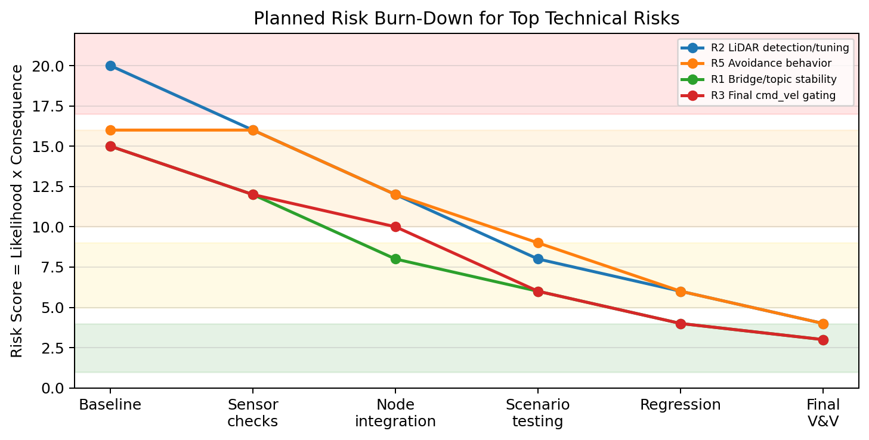
Figure 2. Planned risk score reduction as simulation evidence accumulates.
Risk | Early Test / Analysis | Integration Burn-Down | Scenario Burn-Down | Exit Criteria
R2 LiDAR detection/tuning | Run clear-world and obstacle-world /scan checks. Confirm valid finite ranges and front-sector minimum distance. | Tune front sector, min/max range, update rate, stale-data timeout, and obstacle threshold. | Pass avoidable and blocked scenarios with detection before 0.75 m and response within 2 seconds. | Detection repeatable in logs; residual score <=6.
R5 Obstacle-avoidance behavior | Verify obstacle_avoidance_node can stop on close obstacle without wall contact. | Add left/right clearance decision, conservative turn speed, and blocked timer. | Pass avoidable obstacle and blocked route without collision or indefinite oscillation. | Avoid/resume or safe-stop behavior repeatable; residual score <=6.
R1 Bridge/topic stability | Verify startup script, topic names, bridge directions, and required topic rates. | Create pre-test checklist for /cmd_vel, /odom, /scan, /imu, /mission/state, and /ugv/status. | Repeat checks before each scenario; store output/logs as evidence. | No missing topic in final regression; residual score <=6.
R3 Final /cmd_vel safety gating | Confirm route_follower_node publishes /nominal_cmd_vel only. | Confirm obstacle_avoidance_node is the only autonomy publisher to final /cmd_vel using ros2 topic info -v. | Inject blocked/sensor-invalid event and verify final /cmd_vel goes to zero. | No conflicting publishers; residual score <=4.

6. Test and Evaluation Schedule
All baseline T&E occurs in software-in-the-loop simulation on the existing Linux development laptop. The major test events are sequenced so that low-level topic and sensor risks are reduced before full mission scenarios are used for acceptance evidence.
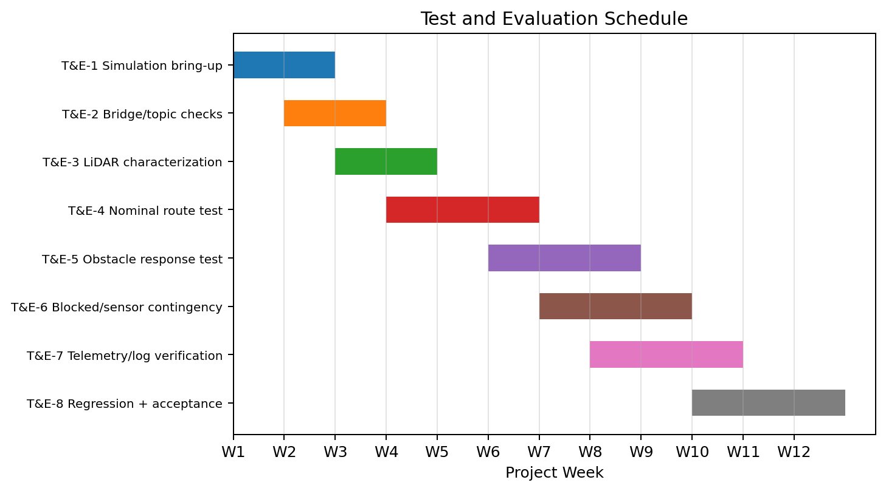
Figure 3. Gantt-style sequence for test and evaluation events over the project timeline.
Test Event | Schedule | Where Held | Major Objective
T&E-1 Simulation bring-up | Weeks 1-2 | Gazebo/Ignition normal corridor world on local laptop. | Verify rover spawns, differential-drive plugin works, and /cmd_vel can move the robot under controlled conditions.
T&E-2 Bridge/topic checks | Weeks 2-3 | ROS 2 terminal and ros_gz_bridge with the rover loaded. | Verify /cmd_vel, /odom, /scan, and /imu are available, bridged correctly, and stable enough for later autonomy testing.
T&E-3 LiDAR characterization | Weeks 3-4 | Clear, avoidable-obstacle, and blocked corridor setups. | Measure front-sector range behavior, invalid values, detection distance, and threshold settings for the selected 2D LiDAR baseline.
T&E-4 Nominal route test | Weeks 4-6 | Normal corridor route with no blocking hazard. | Verify single START command, mission-state transitions, waypoint route progress, endpoint completion, and completion within 6 minutes.
T&E-5 Obstacle response test | Weeks 6-8 | Avoidable obstacle world with clearance around the obstacle. | Verify obstacle detection, response within 2 seconds, conservative stopping/turning, route resumption, and obstacle-event logging.
T&E-6 Blocked/sensor contingency | Weeks 7-9 | Blocked corridor world and simulated stale sensor/timeout conditions. | Verify safe-stop, BLOCKED/SENSOR_INVALID/TIMEOUT events, and final zero /cmd_vel when the path or sensor data are unsafe.
T&E-7 Telemetry/log verification | Weeks 8-10 | Integrated mission stack with telemetry_logger_node enabled. | Verify /ugv/status at >=1 Hz, battery/health fields, CSV mission log, and mission_summary text output for each scenario.
T&E-8 Regression and acceptance | Weeks 10-12 | Final normal, avoidable-obstacle, blocked, and sensor/timeout scenario set. | Rerun the complete scenario set after final code changes and collect the evidence used for final requirements verification.

7. Conclusion
This risk-management plan connects the project requirements to a staged T&E strategy. The highest starting risks are not documentation risks; they are the technical functions that can prevent the simulated UGV from safely completing the mission: reliable LiDAR data, clean obstacle response, stable ROS/Gazebo bridging, and a single final /cmd_vel safety gate. By burning those risks down through early topic checks, sensor characterization, node integration, scenario testing, and final regression, the project can show traceable evidence that the UGV starts on command, follows the corridor route, detects obstacles, avoids or safe-stops when needed, monitors health, and produces a complete mission record.

