**Balance Code:**

* Open the file “BalanceCode_XXX” for your system – it should automatically load the parameters
  + Some models you will have to specify the COM port
* Click the “Deploy to Hardware button” or press Ctrl+B
* Verify the motor is connected a shown: 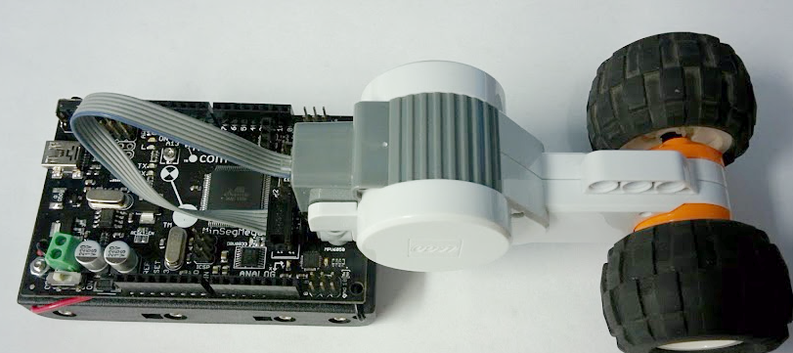
* Follow the balance instructions:
  + Check batteries are properly installed
  + Turn switch on
  + Press and hold reset button (top left for M2V3.2, On Mega for M1V3.0, On Side for MinSegMega)
  + Place MinSeg in upright position (while holding reset button)
  + Release reset button (continue to hold upright)
  + Hold upright for approximately 1 second
  + MinSeg should try to balance - Release
  + - Enjoy!

**MinSegShield M1V4:**

* Verify the motor is connected a shown:

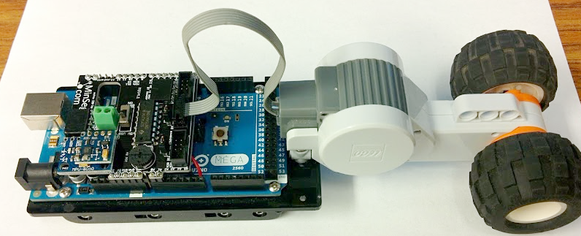

* Follow the balance instructions:
  + Check batteries are properly installed
  + Turn switch on
  + Press and hold reset button (top left for M2V3.2, On Mega for M1V3.0, On Side for MinSegMega)
  + Place MinSeg in upright position (while holding reset button)
  + Release reset button (continue to hold upright)
  + Hold upright for approximately 1 second
  + MinSeg should try to balance - Release
  + - Enjoy!