UNIVERSITY OF SAN CARLOS

SCHOOL OF ARTS AND SCIENCES 

DEPARTMENT OF COMPUTER AND INFORMATION SCIENCES

# Hospital Information Management System

A PROTOTYPE

FINAL PROJECT OUTPUT

IT 2202

Database Systems

By:

Salazar, Mark Eleazer

Manigo, Justin Graig

I. Introduction

University of Cebu Medical Center

**Since**: 2015

**Owner:** Atty. Augosto Go

**Branches/Location:**   
  
Ouano Avenue, Subangdaku, Mandaue City 6014

**Industry**: Healthcare Facility / Hospital **Employees:** 5,000

**Company History**

The Company has been established to deliver high quality clinical care and affordable and efficient patient-centered services through its state-of -the-art medical facilities and excellent medical staff. UCMed is envisioned to be a tertiary hospital with 300-be capacity. An Affiliate of the University of Cebu (the largest privately-held educational institution in the country) and the University of Cebu School of Medicine, UCMed aspires to be a training hospital for the students and medical practitioners in the field of Medicine, Nursing and Allied Medical Services.

Business Process

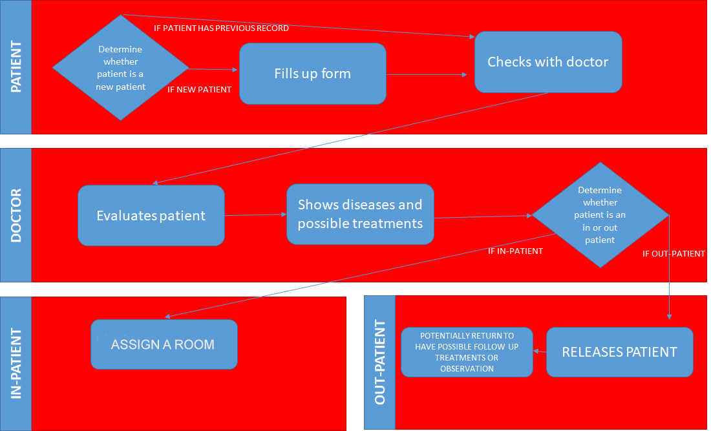

**UCMed Business Process**

UPDATED ENTITY RELATIONSHIP DIAGRAM

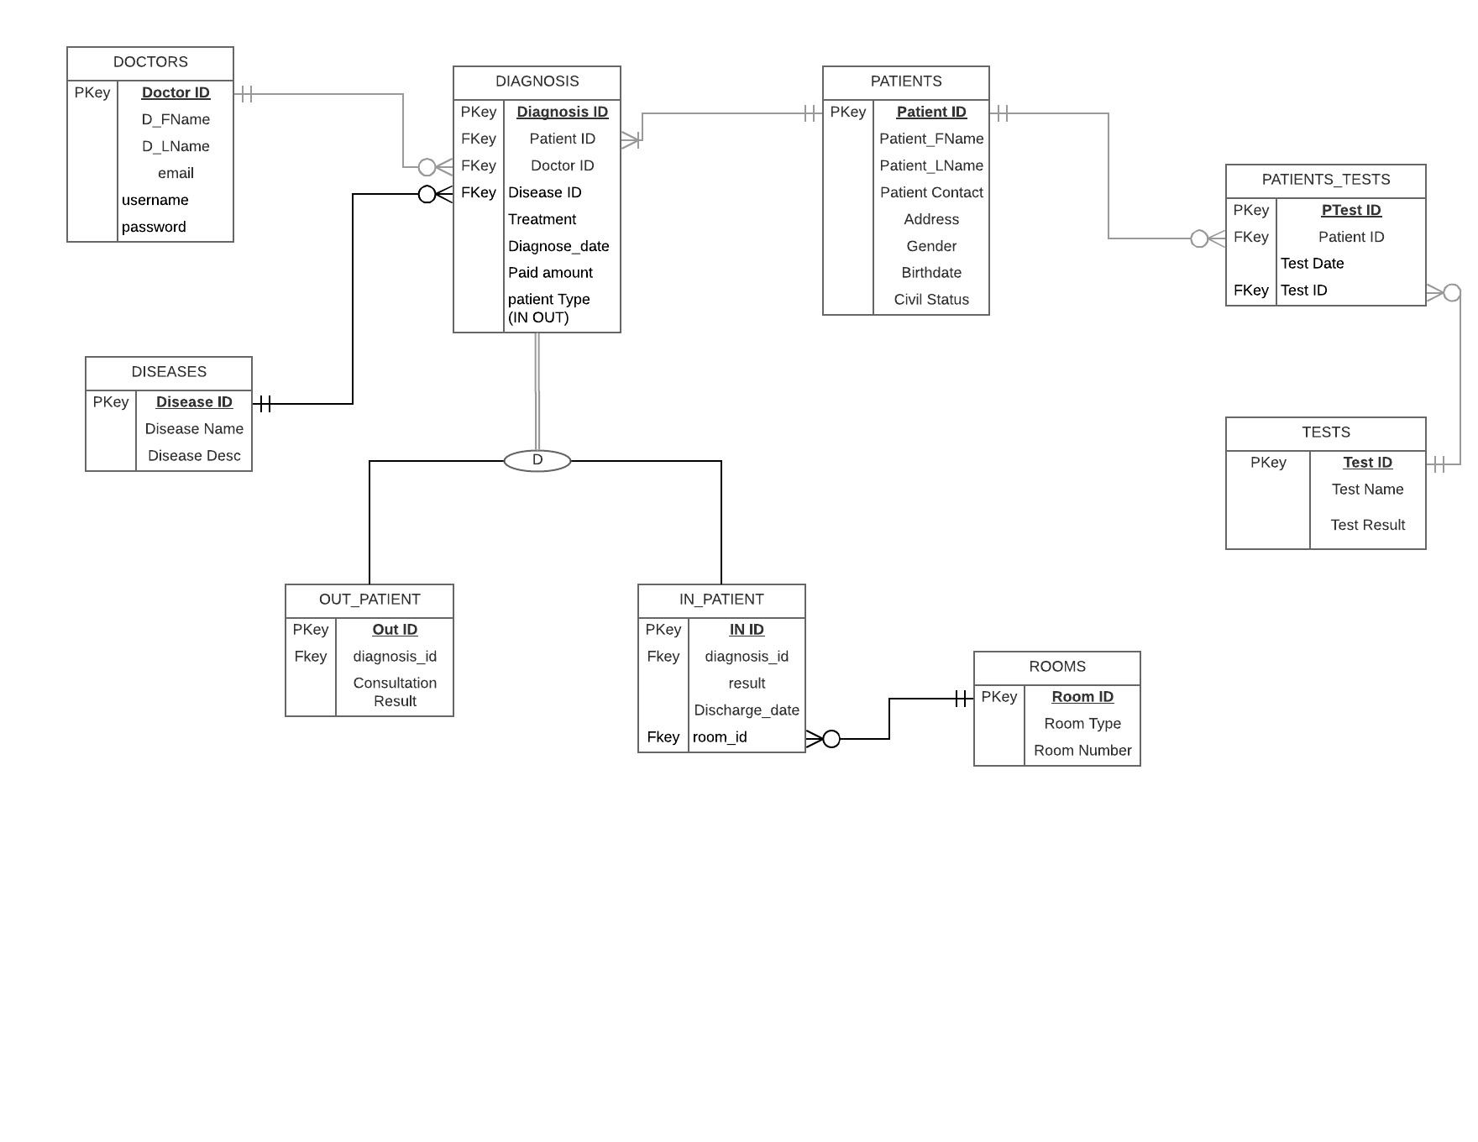

MODULES AND ROLES

|  |  |  |  |  |  |
| --- | --- | --- | --- | --- | --- |
| **Module Name:** | **C** | **R** | **U** | **D** | **Done By:** |
| Doctors Registration Module | Y | N | N | N | Justin Manigo |
| Login Module | N | Y | N | N | Justin Manigo |
| View chart of doctors patient visited per month | N | Y | N | N | Mark Salazar |

|  |  |  |  |  |  |
| --- | --- | --- | --- | --- | --- |
| **Module Name:** | **C** | **R** | **U** | **D** | **Done By:** |
| View all patients of specific doctor | N | Y | N | N | Justin Manigo |
| View patients medical record | N | Y | N | N | Mark Salazar |
| Add patients medical record | Y | Y | N | N | Mark salazar |

|  |  |  |  |  |  |
| --- | --- | --- | --- | --- | --- |
| **Module Name:** | **C** | **R** | **U** | **D** | **Done By:** |
| Edit patient medical record | Y | Y | Y | N | Mark Salazar and Justin Manigo |
| Add medical record | Y | Y | Y | N | Mark Salazar and Justin Manigo |
| View chart disease | N | Y | N | N | Mark Salazar and Justin Manigo |

|  |  |  |  |  |  |
| --- | --- | --- | --- | --- | --- |
| **User Level: Administrator** | **C** | **R** | **U** | **D** | **Module Name:** |
| ADMIN(Doctor) | Y | N | Y | N | Doctors Registration |
| Y | N | Y | N | Patient registration |
| N | Y | N | N | Patients visited per month |
| N | Y | N | N | Most disease of patient |

|  |  |  |  |  |  |
| --- | --- | --- | --- | --- | --- |
| **User Level: Administrator** | **C** | **R** | **U** | **D** | **Module Name:** |
| ADMIN(Doctor) | Y | N | Y | N | Doctors Registration |
| Y | N | Y | N | Patient registration |
| N | Y | N | N | Patients visited per month |
| N | Y | N | N | Most disease of patient |

|  |  |  |  |  |  |
| --- | --- | --- | --- | --- | --- |
| **User Level: Administrator** | **C** | **R** | **U** | **D** | **Module Name:** |
| ADMIN(Doctor) | Y | N | Y | N | Doctors Registration |
| Y | N | Y | N | Patient registration |
| N | Y | N | N | Patients visited per month |
| N | Y | N | N | Most disease of patient |

|  |  |  |  |  |  |
| --- | --- | --- | --- | --- | --- |
| **User Level: Administrator** | **C** | **R** | **U** | **D** | **Module Name:** |
| ADMIN(Doctor) | Y | N | Y | N | Add medical record |
| Y | N | Y | N | Patient registration |
| N | Y | N | N | Patients visited per month |
| N | Y | N | N | Most disease of patient |

|  |  |  |  |  |  |
| --- | --- | --- | --- | --- | --- |
| **User Level: Administrator** | **C** | **R** | **U** | **D** | **Module Name:** |
| ADMIN(Doctor) | N | Y | N | N | All patients of specific doctor |
| Y | N | Y | N | View patients medical record |
| N | Y | N | N | Add patients medical record |
| N | Y | N | N | Edit patient medical record |

|  |  |  |
| --- | --- | --- |
| SELECT ds.disease_name,ds.disease_desc, d.patient_type,d.diagnose_date,  d.paid_amount,r.room_type,r.room_number,  ip.discharge_date,ip.result,op.consultation_result,d.treatment  FROM diagnosis d  JOIN patients p ON p.patient_id=d.patient_id  JOIN diseases ds ON d.disease_id=ds.disease_id  LEFT JOIN out_patients op ON op.diagnosis_id=d.diagnosis_id  LEFT JOIN in_patients ip ON ip.diagnosis_id=d.diagnosis_id  LEFT JOIN rooms r ON r.room_id = ip.room_id  WHERE d.diagnosis_id =".$_GET['diagid']; | | |
| **From**: viewpatients.php | **Expected Rows**: Many | **Output**: HTML |

V. SQL Queries

|  |  |  |
| --- | --- | --- |
| "SELECT ds.disease_name,ds.disease_desc, d.patient_type,d.diagnose_date,d.paid_amount,r.room_type,r.room_number,  ip.discharge_date,ip.result,op.consultation_result,d.treatment  FROM diagnosis d JOIN patients p ON p.patient_id=d.patient_id  JOIN diseases ds ON d.disease_id=ds.disease_id  LEFT JOIN out_patients op ON op.diagnosis_id=d.diagnosis_id  LEFT JOIN in_patients ip ON ip.diagnosis_id=d.diagnosis_id  LEFT JOIN rooms r ON r.room_id = ip.room_id  WHERE d.diagnosis_id =".$_GET['diagid']; | | |
| **From**: patitentz.php | **Expected Rows**: Many | **Output**: DataTable |

|  |  |  |
| --- | --- | --- |
| SELECT COUNT(orderNumber), SUM(amount) FROM payments WHERE paymentDate = <PHP_VARIABLE> | | |
| **From**: dashboard.php | **Expected Rows**: One | **Output**: Chart |

|  |  |  |
| --- | --- | --- |
|  | | |
| **From**: | **Expected Rows**: | **Output**: |

|  |  |  |
| --- | --- | --- |
|  | | |
| **From**: | **Expected Row** | **Output**: |

|  |  |  |
| --- | --- | --- |
|  | | |
| **From**: | **Expected Rows**: | **Output**: |

|  |  |  |
| --- | --- | --- |
| **Presentation and Documentation** | |  |
| **Criteria** | **Weight** | **Score** |
| Mastery and Believability | 20% |  |
| Participation in Team Presentation | 20% |  |
| Content Development | 20% |  |
| Context and Purpose | 40% |  |

|  |  |  |
| --- | --- | --- |
| **Database System** |  |  |
| **Criteria** | **Weight** | **Score** |
| Queries | 40% |  |
| Functions /Features | 40% |  |
| Data Presentation | 10% |  |
| Readability | 10% |  |