

UNIVERSITY OF SAN CARLOS

SCHOOL OF ARTS AND SCIENCES DEPARTMENT OF COMPUTER AND INFORMATION SCIENCES

# Hospital Information Management System

A PROTOTYPE

FINAL PROJECT OUTPUT

IT 2202

Database Systems

By:

Salazar, Mark Eleazer

Manigo, Justin Graig

I. Introduction

University of Cebu Medical Center

**Since**: 2015

**Owner:** Atty. Augusto Go

**Branches/Location:**   
  
Ouano Avenue, Subangdaku, Mandaue City 6014

**Industry**: Healthcare Facility / Hospital **Employees:** 5,000

**Company History**

The Company has been established to deliver high quality clinical care and affordable and efficient patient-centered services through its state-of -the-art medical facilities and excellent medical staff. UCMed is envisioned to be a tertiary hospital with 300-be capacity. An Affiliate of the University of Cebu (the largest privately-held educational institution in the country) and the University of Cebu School of Medicine, UCMed aspires to be a training hospital for the students and medical practitioners in the field of Medicine, Nursing and Allied Medical Services.

Business Process

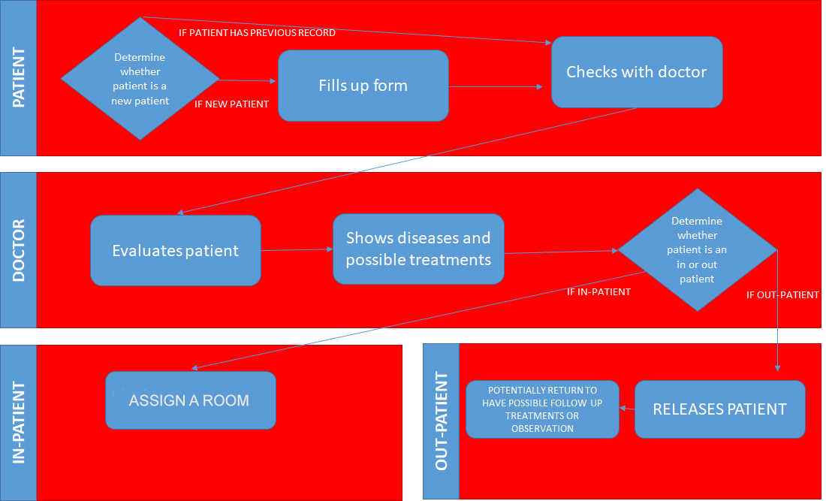

**UCMed Business Process**

UPDATED ENTITY RELATIONSHIP DIAGRAM

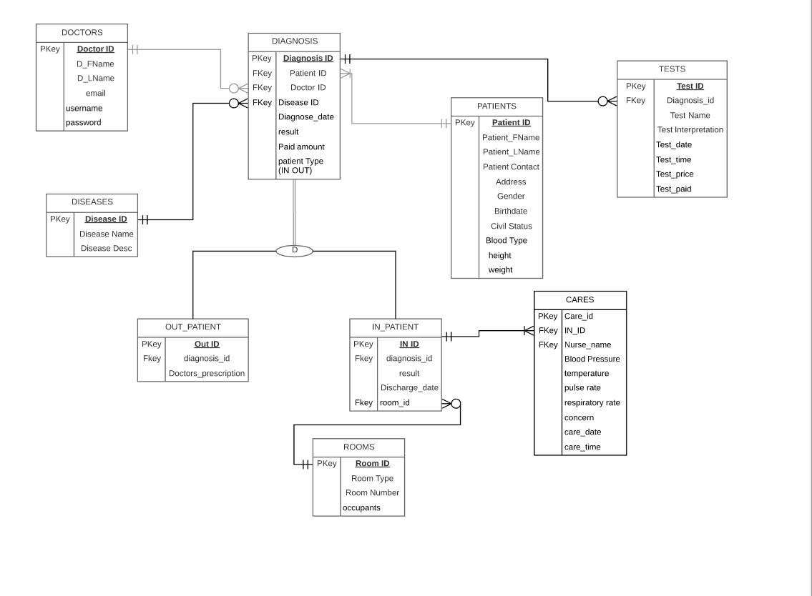

MODULES AND ROLES

|  |  |  |  |  |  |
| --- | --- | --- | --- | --- | --- |
| **Module Name:** | **C** | **R** | **U** | **D** | **Done By:** |
| Doctors Registration Module | Y | N | N | N | Justin Manigo |
| Login Module | N | Y | N | N | Justin Manigo |
| View chart of doctors patient visited per month | N | Y | N | N | Mark Salazar |

|  |  |  |  |  |  |
| --- | --- | --- | --- | --- | --- |
| **Module Name:** | **C** | **R** | **U** | **D** | **Done By:** |
| View all patients of specific doctor | N | Y | N | N | Justin Manigo |
| View patients medical record | N | Y | N | N | Mark Salazar |
| Add patients medical record | Y | Y | N | N | Mark salazar |

|  |  |  |  |  |  |
| --- | --- | --- | --- | --- | --- |
| **Module Name:** | **C** | **R** | **U** | **D** | **Done By:** |
| Add New Patient | Y | Y | Y | N | Mark Salazar and Justin Manigo |
| Add Disease | Y | Y | N | N | Mark Salazar and Justin Manigo |
| View chart disease | N | Y | N | N | Mark Salazar and Justin Manigo |

|  |  |  |  |  |  |
| --- | --- | --- | --- | --- | --- |
| **Module Name:** | **C** | **R** | **U** | **D** | **Done By:** |
| Delete Diagnosis | N | N | N | Y | Mark Salazar |
| Update patient info | Y | Y | Y | N | Mark Salazar |
| View In Care Patient Record | Y | Y | N | N | Mark Salazar and Justin Manigo |

|  |  |  |  |  |  |
| --- | --- | --- | --- | --- | --- |
| **User Level: Administrator** | **C** | **R** | **U** | **D** | **Module Name:** |
| ADMIN(Doctor) | N | Y | N | N | Profit Per Year |
| Y | N | Y | N |  |
| N | Y | N | N | Patients visited per month |
| N | Y | N | N | Most disease of patient |

|  |  |  |  |  |  |
| --- | --- | --- | --- | --- | --- |
| **User Level: Administrator** | **C** | **R** | **U** | **D** | **Module Name:** |
| ADMIN(Doctor) | Y | N | Y | N | Doctors Registration |
| Y | N | Y | N | Patient registration |
| N | Y | N | N | Patients visited per month |
| N | Y | N | N | Most disease of patient |

|  |  |  |  |  |  |
| --- | --- | --- | --- | --- | --- |
| **User Level: Administrator** | **C** | **R** | **U** | **D** | **Module Name:** |
| ADMIN(Doctor) | Y | N | Y | N | Add medical record |
| Y | N | Y | N | Patient registration |
| N | Y | N | N | Patients visited per month |
| N | Y | N | N | Most disease of patient |

|  |  |  |  |  |  |
| --- | --- | --- | --- | --- | --- |
| **User Level: Administrator** | **C** | **R** | **U** | **D** | **Module Name:** |
| ADMIN(Doctor) | Y | N | Y | N | Doctors Registration |
| Y | N | Y | N | Patient registration |
| N | Y | N | N | Patients visited per month |
| N | Y | N | N | Most disease of patient |

|  |  |  |  |  |  |
| --- | --- | --- | --- | --- | --- |
| **User Level: Administrator** | **C** | **R** | **U** | **D** | **Module Name:** |
| ADMIN(Doctor) | N | N | N | Y | Delete Diagnosis |
| Y | Y | N | N | View Test Patient |
| Y | Y | N | N | VIEW In Patient Care |
| N | Y | N | Y | Discharge |

|  |  |  |  |  |  |
| --- | --- | --- | --- | --- | --- |
| **User Level: Administrator** | **C** | **R** | **U** | **D** | **Module Name:** |
| ADMIN(Doctor) | N | Y | N | N | All patients of specific doctor |
| Y | N | Y | N | View patients medical record |
| N | Y | N | N | Add patients medical record |
| N | Y | N | N | Edit patient medical record |

|  |  |  |  |  |  |
| --- | --- | --- | --- | --- | --- |
| **Module Name:** | **C** | **R** | **U** | **D** | **Done By:** |
| Discharge In Patient | N | Y | Y | Y | Mark Salazar |
| View Patient Test | Y | Y | N | N | Mark Salazar |
| View In Care Patient Record | Y | Y | N | N | Mark Salazar and Justin Manigo |

V. SQL Queries

|  |  |  |
| --- | --- | --- |
| "SELECT ddiseases.disease_name as mostdis, patient_id as patient FROM diagnosis JOIN diseases ON diseases.disease_id = diagnosis.disease_id GROUP BY mostdis" | | |
| **From**: index.php | **Expected Row: many** | **Output**: chart |

|  |  |  |
| --- | --- | --- |
| $sql= "SELECT diseases.disease_name as mostdis, patient_id as patient FROM diagnosis JOIN diseases ON diseases.disease_id = diagnosis.disease_id GROUP BY mostdis" | | |
| **From**: index.php | **Expected Rows**: many | **Output**: chart |

|  |  |  |
| --- | --- | --- |
| $sql= "SELECT date_format(d.diagnose_date,'%M')as month, SUM(paid_amount) as total FROM diagnosis d GROUP BY month ORDER BY month ASC;" | | |
| **From**: index.php | **Expected Rows**: many | **Output**: chart |

|  |  |  |
| --- | --- | --- |
| $sql="SELECT `doc_Fname`,`doc_Lname`, `doctor_id` FROM doctors WHERE username='$username'"; | | |
| **From**: index.php | **Expected Rows**: many | **Output**: HTML |

|  |  |  |
| --- | --- | --- |
| $sql="SELECT * FROM patients JOIN diagnosis ON patients.patient_id = diagnosis.patient_id  WHERE diagnosis.doctor_id = $did GROUP BY diagnosis.patient_id"; | | |
| **From**: patientz.php | **Expected Rows**: many | **Output**: Datatable |
| $querypatient = "SELECT * FROM patients WHERE patient_id = ".$_GET['pid']; | | |
| **From**: updatepatient.php | **Expected Rows**: 1 | **Output**: HTML |

|  |  |  |
| --- | --- | --- |
| $queryroom = "SELECT * FROM rooms WHERE room_type='$hey'"; | | |
| **From**: updatepatient.php | **Expected Rows**: many | **Output**: HTML |

|  |  |  |
| --- | --- | --- |
| $querydisease = "SELECT disease_id, disease_name FROM diseases"; | | |
| **From**: updatepatient.php | **Expected Rows**: many | **Output**: HTML |

|  |  |  |
| --- | --- | --- |
| $querypatient = "SELECT patient_Fname, patient_Lname, patient_contact, address, gender, birthdate, civil_status FROM patients WHERE patient_id =".$_GET['pid']; | | |
| **From**: viewpatient.php | **Expected Rows**: 1 | **Output**: HTML |

|  |  |  |
| --- | --- | --- |
| "SELECT diagnosis.diagnose_date,disease_name,patient_type,diagnosis.diagnosis_id  FROM diagnosis  JOIN patients ON diagnosis.patient_id= patients.patient_id  JOIN diseases ON diagnosis.disease_id=diseases.disease_id  WHERE patients.patient_id=".$_GET['pid'];  $resultpre = mysqli_query($conn, $viewpatient); | | |
| **From**: viewpatient.php | **Expected Rows**: many | **Output**: Datatable |

|  |  |  |
| --- | --- | --- |
| "SELECT ds.disease_name,d.results, d.patient_type,d.diagnose_date,d.paid_amount,r.room_type,r.room_number,ip.discharge_date,  op.doctors_prescription  FROM diagnosis d  JOIN patients p ON p.patient_id=d.patient_id  JOIN diseases ds ON d.disease_id=ds.disease_id  LEFT JOIN out_patients op ON op.diagnosis_id=d.diagnosis_id  LEFT JOIN in_patients ip ON ip.diagnosis_id=d.diagnosis_id  LEFT JOIN rooms r ON r.room_id = ip.room_id  WHERE d.diagnosis_id =".$_GET['diagid']; | | |
| **From**: updatepatientdiagnosis.php | **Expected Rows**: 1 | **Output**: HTML |

|  |  |  |
| --- | --- | --- |
| $querypatient = "SELECT ds.disease_name,d.results, d.patient_type,d.diagnose_date,d.paid_amount,r.room_type,r.room_number,ip.discharge_date,  op.doctors_prescription  FROM diagnosis d  JOIN patients p ON p.patient_id=d.patient_id  JOIN diseases ds ON d.disease_id=ds.disease_id  LEFT JOIN out_patients op ON op.diagnosis_id=d.diagnosis_id  LEFT JOIN in_patients ip ON ip.diagnosis_id=d.diagnosis_id  LEFT JOIN rooms r ON r.room_id = ip.room_id  WHERE d.diagnosis_id =".$_GET['diagid']; | | |
| **From**: viewspecpatientz.php | **Expected Rows**: 1 | **Output**: HTML |

|  |  |  |
| --- | --- | --- |
| $viewpost = "SELECT * FROM `test` WHERE diagnosis_id = ".$_GET['diagid']; | | |
| **From**: viewspecpatientz.php | **Expected Rows**: many | **Output**: Datatable |

|  |  |  |
| --- | --- | --- |
| $viewpre = "SELECT care_date,care_time,nurse_name,care_id FROM cares  JOIN in_patients ON cares.in_id = in_patients.in_id  WHERE in_patients.diagnosis_id=".$_GET['diagid']." ORDER BY care_date DESC"; | | |
| **From**: viewspecpatientz.php | **Expected Rows**: many | **Output**: Datatable |
| $querypatient = "SELECT * FROM test WHERE test_id=".$tid;  $result=mysqli_query($conn,$querypatient); | | |
| **From**: viewtestrecord.php | **Expected Rows**: 1 | **Output**: HTML |

|  |  |  |
| --- | --- | --- |
| $sql= "SELECT * FROM patients  JOIN diagnosis ON patients.patient_id = diagnosis.patient_id  JOIN in_patients ON diagnosis.diagnosis_id = in_patients.diagnosis_id  WHERE diagnosis.doctor_id = $did AND diagnosis.patient_type= 'in' AND in_patients.discharge_date = $nul  GROUP BY diagnosis.patient_id"; | | |
| **From**: dischcharge.php | **Expected Rows**: many | **Output**: Datatable |

|  |  |  |
| --- | --- | --- |
| $querypatient = "SELECT patient_Fname, patient_Lname, patient_contact, address, gender, birthdate, civil_status, patient_BloodType,patient_height, patient_weight,diagnosis.diagnosis_id FROM diagnosis JOIN patients ON diagnosis.patient_id = patients.patient_id WHERE diagnosis.diagnosis_id = ".$_GET['did']; | | |
| **From**: dischargeme.php | **Expected Rows**: 1 | **Output**: HTML |

|  |  |  |
| --- | --- | --- |
| $querypatient = "SELECT * FROM patients WHERE patient_id =".$_GET['pid']; | | |
| **From**: updatepatientinfo.php | **Expected Rows**: 1 | **Output**: HTML |

|  |  |  |
| --- | --- | --- |
| **Presentation and Documentation** | |  |
| **Criteria** | **Weight** | **Score** |
| Mastery and Believability | 20% |  |
| Participation in Team Presentation | 20% |  |
| Content Development | 20% |  |
| Context and Purpose | 40% |  |

|  |  |  |
| --- | --- | --- |
| **Database System** |  |  |
| **Criteria** | **Weight** | **Score** |
| Queries | 40% |  |
| Functions /Features | 40% |  |
| Data Presentation | 10% |  |
| Readability | 10% |  |