Task 2 Latin Hypercube Sampling in 2D 1
Part (a): Equilibrium Analysis 1
Part (b): Equilibrium Values 1
Part (c): Equilibrium Values 1
Functions 2
clear; close all; clc;

Task 2 Latin Hypercube Sampling in 2D

Part (a): Equilibrium Analysis
For the system of equations:
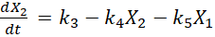​
The equilibrium points and are found by setting the derivatives to zero:
Solving the equation, we have:
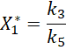
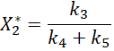

Part (b): Equilibrium Values
Solving these equations with , , and , we get:
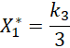
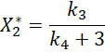

Part (c): Equilibrium Values
%Define Constants
k1 = 1;
k2 = 2;
k5 = 3;
T = 20;
Tol = 0.1;
[successful_k3, successful_k4,Unsuccessful_k3, Unsuccessful_k4] = latinHypercubeSampling(k1,k2,k5,T,Tol);
%2D Visualization
figure;
scatter(successful_k3, successful_k4, 'filled','b');
hold on
scatter(Unsuccessful_k3, Unsuccessful_k4, 'filled','r');
xlabel('k_3');
ylabel('k_4');
legend('Successful','Unsuccessful')
title('Latin Hypercube Sampling in 2D Parameter Space');
grid on;

Functions
%Main function for Latin Hypercube Sampling
function [successful_k3, successful_k4,Unsuccessful_k3, Unsuccessful_k4] = latinHypercubeSampling(k1,k2,k5,T,Tol)
% Define constants
X1_initial = 1; % Initial value for state variable X1
X2_initial = 1; % Initial value for state variable X2
num_trials = 1000; % Number of trials for Latin Hypercube Sampling
mesh_size = 10; % Mesh size for visualization (not used in this version)
% Initialize arrays to store successful parameter pairs
successful_k3 = []; % Array to store successful k3 values
successful_k4 = []; % Array to store successful k4 values
% Initialize arrays to store successful parameter pairs
Unsuccessful_k3 = []; % Array to store unsuccessful k3 values
Unsuccessful_k4 = []; % Array to store unsuccessful k4 values
% Perform Latin Hypercube Sampling
range = [0, 50; 0, 50]; % Range for k3 and k4
samples = custom_lhsdesign(num_trials, 2, range); % Custom LHS function
sample_k3 = samples(:, 1); % Extract k3 samples
sample_k4 = samples(:, 2); % Extract k4 samples
% Loop through each trial
for i = 1:num_trials
k3 = sample_k3(i); % Current k3 value
k4 = sample_k4(i); % Current k4 value
% Solve the system of equations using ode45
[time, X] = ode45(@(t, X) yourModel(t, X, k1, k2, k3, k4, k5), [0, T], [X1_initial, X2_initial]);
% Apply constraints to filter successful parameter combinations
if (0 <= X(end, 1) && X(end, 1) <= 0 + Tol) || (2 - Tol <= X(end, 2) && X(end, 2) <= 2 + Tol)
if all(X(:, 1) >= 0) && all(X(:, 2) >= 0)
successful_k3 = [successful_k3; k3]; % Store successful k3
successful_k4 = [successful_k4; k4]; % Store successful k4
end
else
Unsuccessful_k3 = [Unsuccessful_k3; k3]; % Store successful k3
Unsuccessful_k4 = [Unsuccessful_k4; k4]; % Store successful k4
end
end
end
% Function to define the system of ODEs
function dX = yourModel(t, X, k1, k2, k3, k4, k5)
% Extract state variables
X1 = X(1); % State variable X1
X2 = X(2); % State variable X2
% Define your model equations here
dX1_dt = k1 * X1 * X2 - k2 * X1; % Equation for dX1/dt
dX2_dt = k3 - k4 * X2 - k5 * X1; % Equation for dX2/dt
% Return derivatives
dX = [dX1_dt; dX2_dt]; % Return the derivatives as a vector
end
function samples = custom_lhsdesign(n, d, range)
% n: number of samples
% d: dimension
% range: [min, max] for each dimension
samples = zeros(n, d);
for i = 1:d
p = randperm(n)';
samples(:, i) = (p - 1) / (n - 1);
samples(:, i) = samples(:, i) * (range(i, 2) - range(i, 1)) + range(i, 1);
end
samples = samples(randperm(n), :);
end
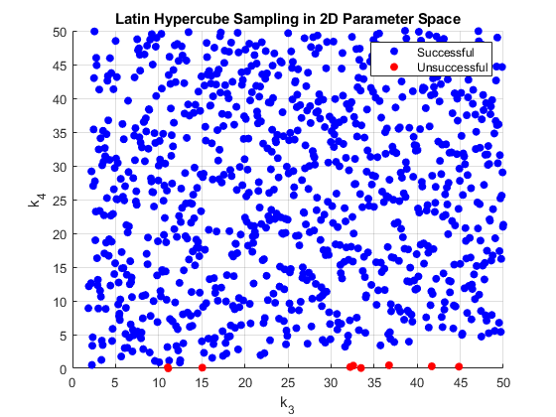
Published with MATLAB® R2021a

