Manual

To start the game or reset to a new game, press the Start/Reset button

 This is you. A young green square with an unlimited amount of red squares to collect.

 This is a juicy red square. You want to collect as many of these as possible.

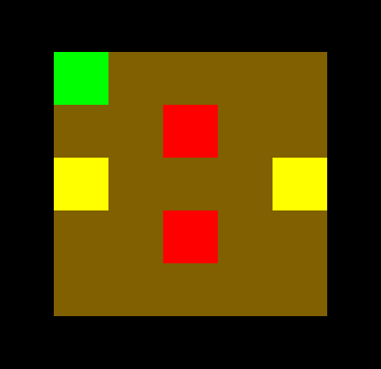

A basic level will have a couple doors. Doors are marked by the yellow light coming from the room next door. When on a yellow square, simple walk into the door.

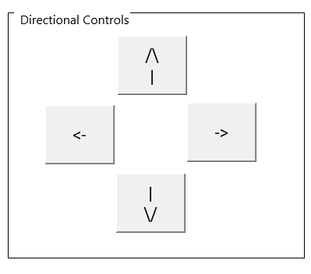

The directional controls are the only way of moving around the level.



Finally, the counters on top of the level tell you what your progress is. 1 point is awarded for every red square. You may only move 90 times.