A Letter to the Future

CP212 is an peculiar course. If taken at face value, CP212 feel like a very useless course since most of it’s applications seem to be better served by other languages without the overhead and restrictions due to Excel. Where the course excels (pun intended) is in teaching how to handle and analyse large amounts of data. VBA in combination with Excel offers a stable and solid environment to quickly implement your analysis; from input gathering, to data manipulation, and finally to outputting your results. Being able to execute on the above has been the greatest skill I’ve gained from CP212.

Before Entering the course, I had a computer science friend who tried the course in the previous semester. This taught me that the course was not about creating windows’ applications as its title, “Windows Application Programming” may suggest. Without this inside perspective into the course I would not have gone into CP212 with the expectation of learning how to process data through VBA.

Having a small introduction to Visual Basic.NET and a strong foundation for transitioning into it is my second most valuable skill. I recently discovered that Visual Basic is slowly eclipsing C# as the preferred programming language for developing applications for the windows platform. I think that having Visual Basic as a tool to use will be beneficial for me in future job prospects.

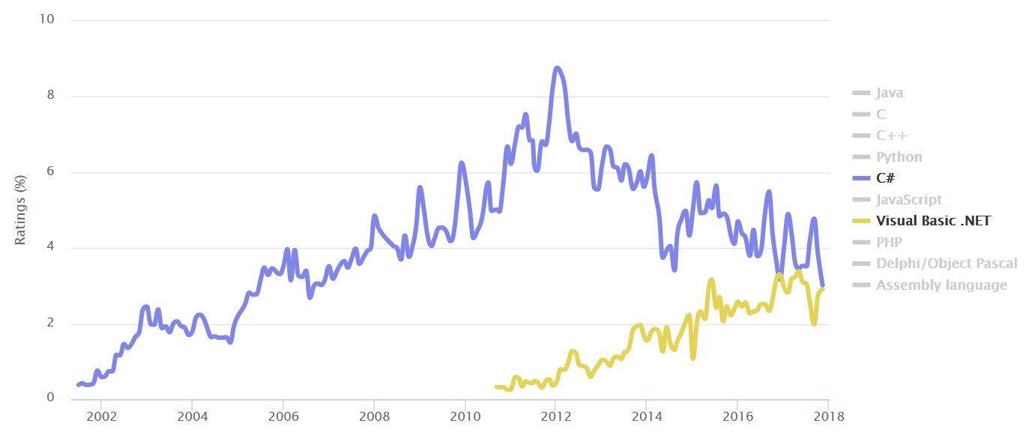

<https://www.tiobe.com/tiobe-index/>