CS 255 System Design Document Template

This template lays out all the different sections that you need to complete for Project Two. Each section has guidance to prompt your thinking. You will need to continually reference the interview transcript as you work to make sure that you are addressing your client’s needs. There is no required length for the final document. Instead the goal is to complete each section based on what your client’s needs are. Remove this note when you are finished, and replace all bracketed text with the relevant information.

UML Diagrams

UML Use Case Diagram
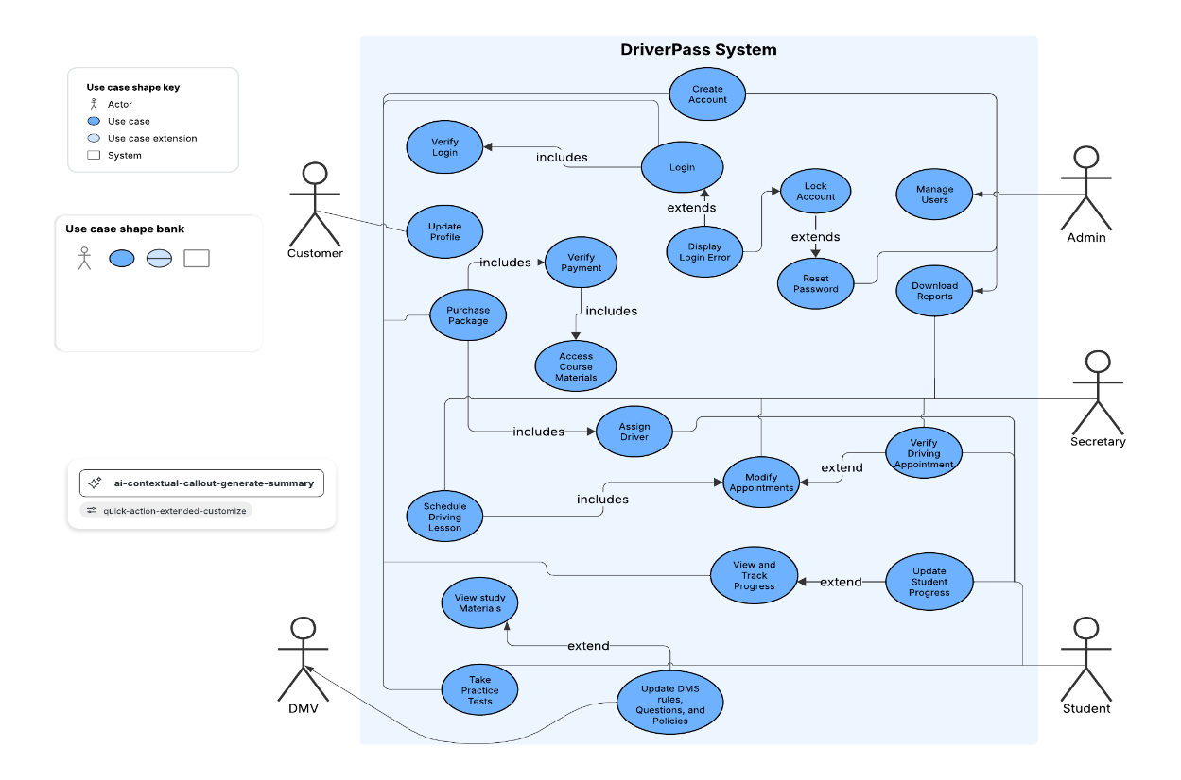

UML Activity Diagrams
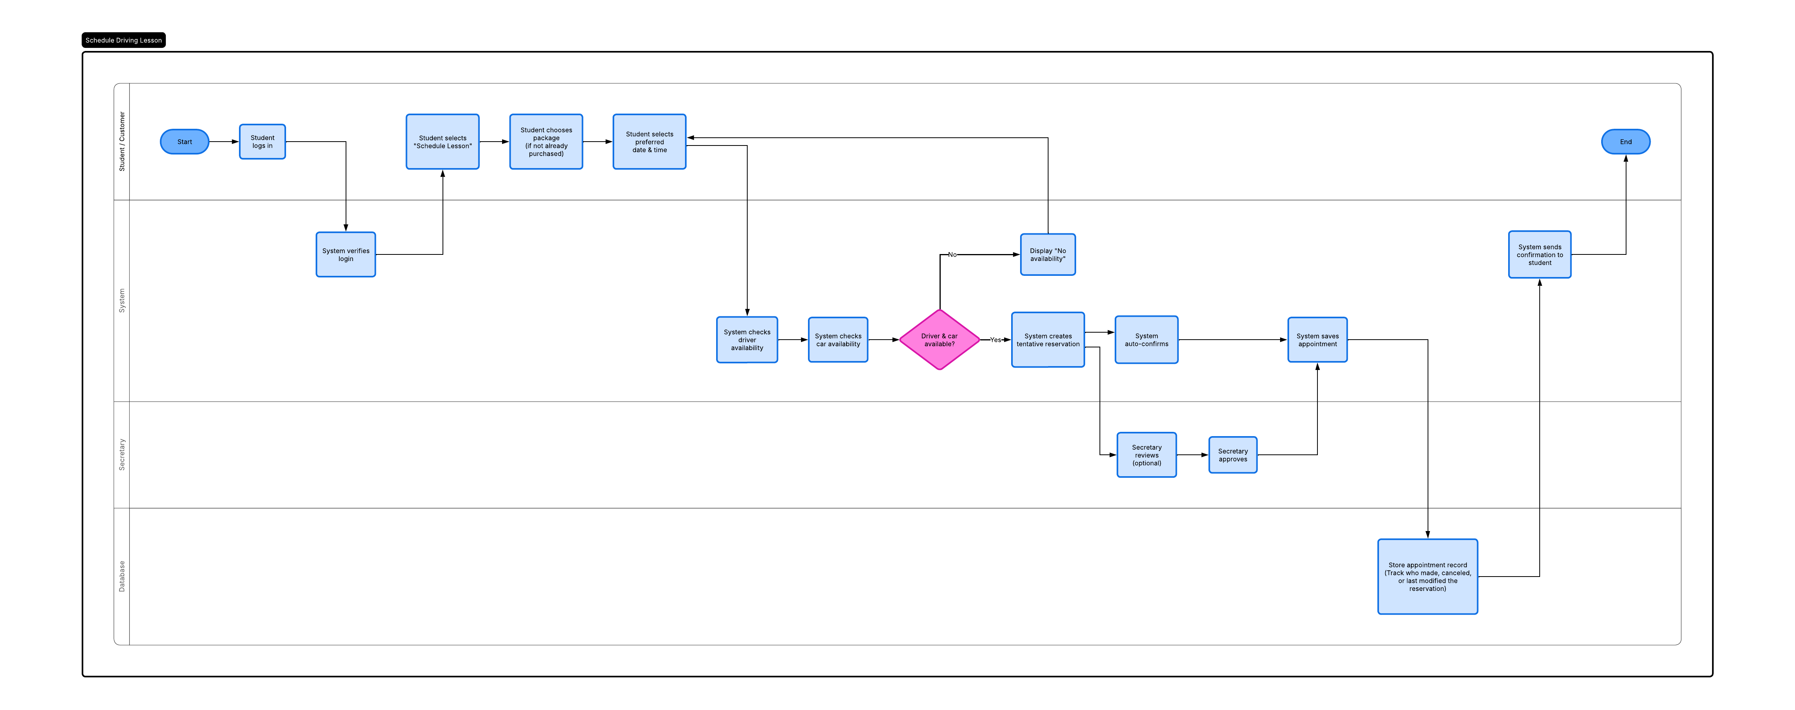
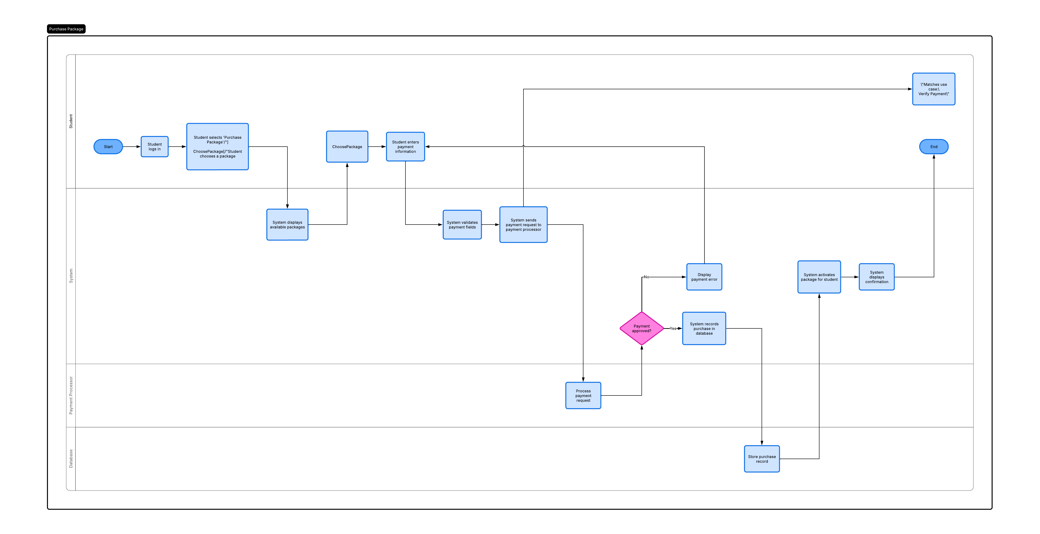

UML Sequence Diagram
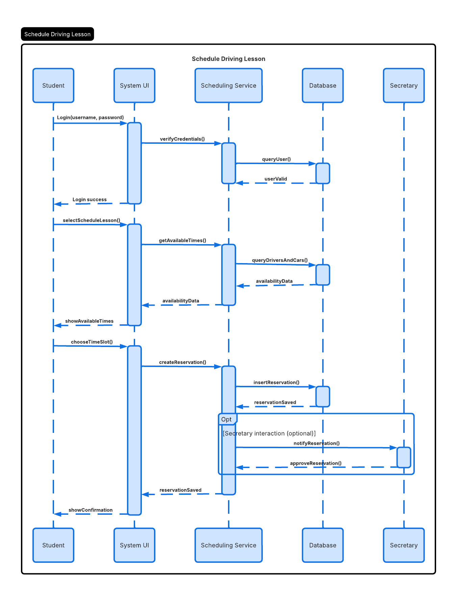

UML Class Diagram
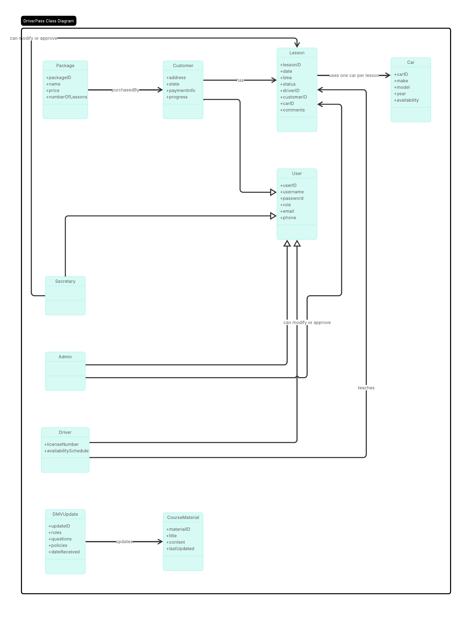

Technical Requirements
The technical requirements for the DriverPass system describe the hardware, software, tools, and infrastructure needed to make the system work safely and efficiently. On the user side, people only need a basic computer, laptop, smartphone, or tablet with internet access and a modern web browser. Nothing needs to be installed on their device. On the server side, the system needs cloud-based virtual machines or containers to run the web application, plus scalable storage for user accounts, lesson schedules, payments, DMV updates, and activity logs. Backup storage is also required in case data needs to be recovered.
For software, the user interface is built with standard web technologies like HTML5, CSS, and JavaScript. The server uses a web application framework such as Java/Spring Boot or .NET to handle business logic, and a relational database like MySQL or PostgreSQL to store users, lessons, packages, progress, and DMV updates. The system must connect to a secure payment processor and include login and access controls based on user roles. Security features like HTTPS/TLS encryption, password hashing, account lockouts after repeated failed logins, and automated password resets are also required.
Developers will use tools such as an IDE (Eclipse, IntelliJ, or Visual Studio), Git for version control, and standard testing and debugging tools. UML tools like Lucidchart, Draw.io, or Visual Paradigm are needed to create system diagrams. Logging and monitoring tools are also important for tracking reservations, system errors, and admin actions.
The system’s infrastructure must run on a cloud platform that can host the application and database, automatically back up data, and scale resources as needed. Security protections like HTTPS, firewalls, and intrusion detection systems are required. The system must also connect to external services, including a payment gateway and a DMV update service. To perform well, the system must stay available, respond quickly to logins, scheduling, and lesson changes, and update driver and car availability in real time. Finally, the system needs centralized data management for user profiles, reservations, schedules, packages, and DMV updates, along with detailed logs showing who created, changed, or canceled each reservation. Sensitive data, such as payment information, must be stored securely following industry best practices.

