Justin Morales xek275

Daniel Bringhurst ais755

Server scripts should be run with python3 or higher.

1. You can run the client.py in an ide or in on the command line using the following commands.

In terminal type “python3 client.py” and hit Enter or run the file or run it in an IDE like PyCharm.

2. The text sent to the terminal is already been preset so you do not have to worry about it.

3. There are two port numbers you can use; however you will need to set them in the code with the variable labeled serverAddress to hit the specific ports. The example of the code is below.

#Non Forced Losseless Server

#serveraddress = ("69.61.103.44", 7851)

#Forced Lossy Server

serveraddress = ("69.61.103.44", 8591)

4. The program is set to run 10000 pings (This will take a few minutes) to the server. The output should look like the following when pinging the forced lossy port 8591.

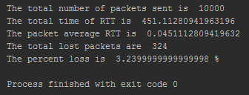

As you can see from the data above, when sending 10000 packets there was a loss of 324 packets, which came out to a percent loss of about 3.24%.

If you ping the lossless port 7851 then you will get the following results.

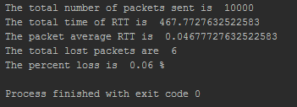

As you can see out of 10000 packets there was 6 packets that were actually lost which resulted in a .06% loss.