How to use the Logistics UK Technical Assessment API

The API is set up using the Laravel Sanctum package, https://packagist.org/packages/laravel/sanctum.

Please follow the following instructions to test the API.

1. Use the /api/register endpoint to create a new user with 3 parameters. Name, email and password.
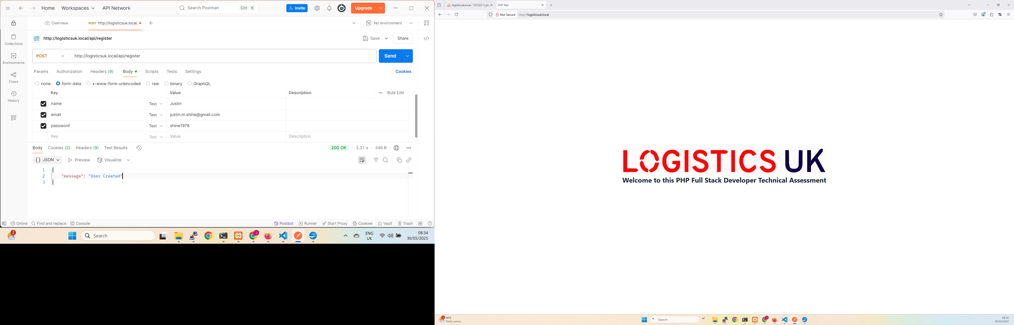
2. Use the /login endpoint to login and receive the user accounts API token.
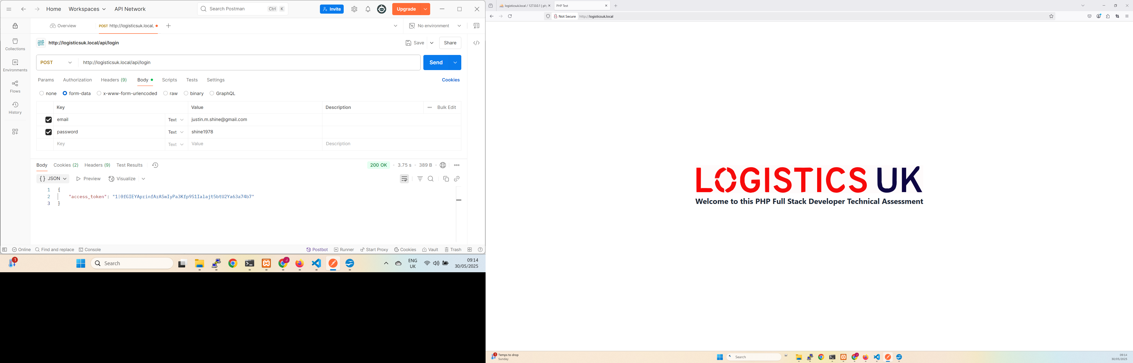
3. Add a new task using the POST request /tasks
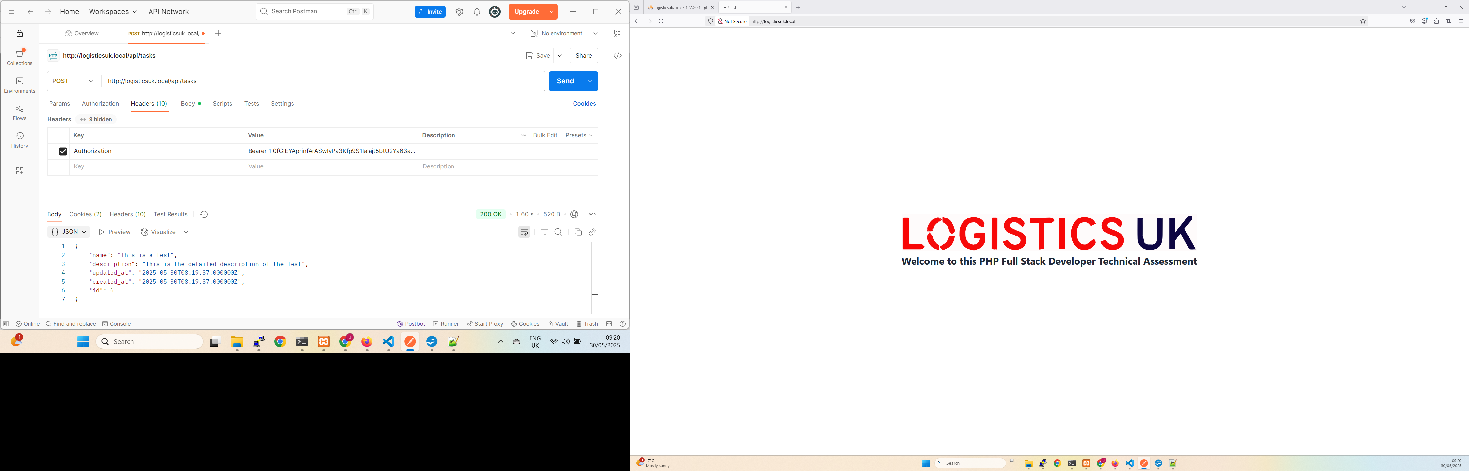
A new task with id 6 has been added to the tasks model.

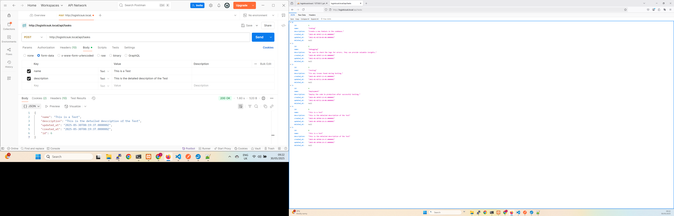
4. Edit this new task using the PUT request /tasks/{id} and use x-www-form-urlencoded in the Postman body. You can now see the updated task in the browser.

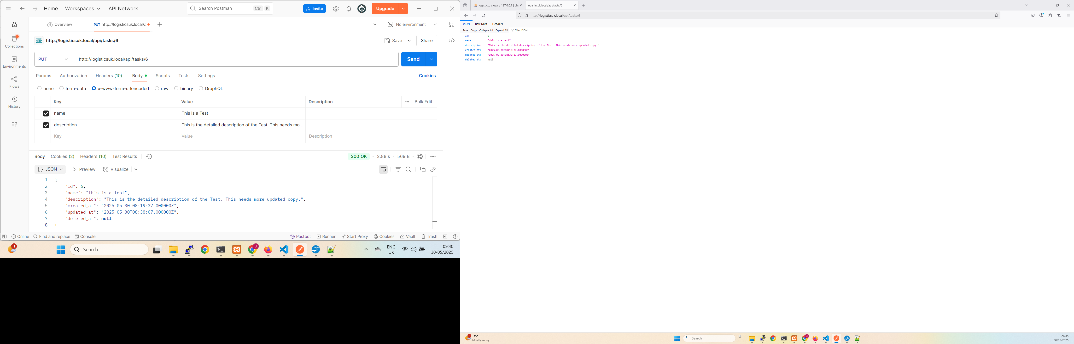
5. Finally we check the DELETE request /tasks/{id}. You can not see in the browser that task id 6 has been deleted.

