**JUSTIN OBSEÑARES**

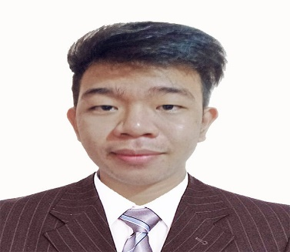 

2022

Web Developer / Helpdesk - Internship Staff

**E D U C A T I O N**

**E X P E R I E N C E**

**C E R T I F I C A T E**

Introduction to Careers in Cybersecurity

(August 26, 2021)

**ELEMENTARY**

Imelda Elementary School (2011-2012)

**HIGH SCHOOL**

M.B. ASISITIO SR. HIGH SCHOOL UNIT-1 (2018)

**COLLEGE**

Global Reciprocal Colleges (2018)

**bA**

**SOFT SKILLS**

* Leadership
* Planning
* Organization Skills
* Problem Solving

**Magellan E-Support Services Inc.**

Caloocan City

09163461677

justinobsenares@gmail.com

My goal is to become associated with a company where I can utilize my skills and gain further experience while enhancing the company’s productivity and reputation. Ready to develop new skills and grow knowledge by gaining practical experience. Quick learner familiar with common software applications.

* HTML5
* HTML CSS Proficiency
* JavaScript
* Visual Basic
* C#
* Java
* MySQL
* PHP
* Adobe Photoshop

**S K I L L S**

* Watching Anime
* Listening Music
* Computer Games
* Drawing

**HOBBIES**

**P R O F I L E**