We Rate Dogs

Once our data was clean and tidy, we were finally able to utilize it to gather some insights. Here is a list of questions that we were trying to answer:

* What are the most common breeds reviewed?
* What percentage of the dataset falls in the top 10 breeds?
* What is the distribution of dog stages?
* Do dog stages have an impact on rating?
* What is the distribution of dog ratings?

**What are the most common breeds reviewed?**



As illustrated in our bar chart the Golden Retriever, Labrador Retriever and Pembroke are the top 3 reviewed dogs in this dataset. What is unclear is why these dogs happen to be reviewed so often.

**What percentage of the dataset falls in the top 10 breeds?**

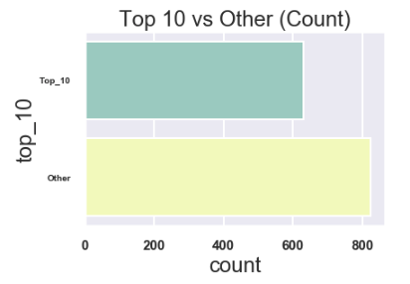

What I found to be quite interesting is that dogs that fall in the top 10 breeds were reviewed a staggering 43% of the time, even though they only represent 9% of all the unique breeds that are found to be in this data set. While the top dog (Golden Retriever) was reviewed 9.3% of the time. I’m not exactly sure as to why this is. Maybe the content creators have a bias towards these dogs, maybe these dog owners are more eager to have their dogs reviewed than others. In either case we don’t have a concrete answer at this point it’s all speculation.

**What is the distribution of dog stages?**

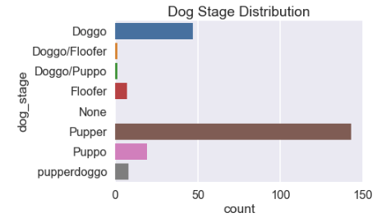

We have a very uneven distribution when it comes to dog stages, Pupper is far and away the most reviewed dog stage, Doggo in 2nd and Puppo in 3rd. Of course, we need to take this information with a grain of salt considering how few dogs were actually given a dog stage in this data set.

**Do dog stages have an impact on rating?**

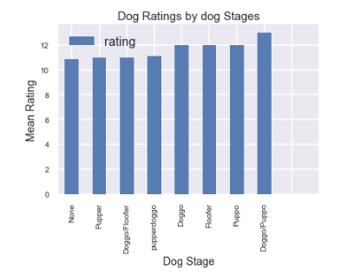

So as a whole our ratings across all stages are quite similar, Doggo/Puppo seems to be the leader, however as previously mentioned this portion of data is quite small and therefore it might not be wise to jump to conclusions due to the small sample size. But what should be noted is that on average all dogs with dog stages seem to be ranked consistently higher (on average) than dogs with the value “None” for the dog stage category.

**What is the distribution of dog ratings?**

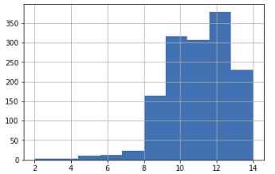

Our rating column is a left skewed distribution with a median of 11, mean of 10.92 and a mode of 12. As we can see the majority of our dog ratings lie in the 10-12 area. However, we do have a small portion of dogs with some very low ratings.