

**School of Computing & Creative Media**

**Department of Computing**

**Bachelor of Computer Science (Hons)**

**XBMC 3024: Mobile Programming and Screen Design 2**

**May 2020 Semester**

**Assignment**

**Prepared by:**

**Ong Kha Hong (0118500)**

**Nicholas Lim Eng Han (0118436)**

Table of Contents

1.0 Login and Sign Up Screen 3

1.1 Sign Up Page 4

2.0 Main Menu Screen 5

2.1 Daily Temperature Scanning Screen 6

2.2 Graph Analytics 7

2.3 Social Distance Screen 8

2.4 Covid-19 Information 9

2.4.1 Link to Browser Screen 10

2.5 QR Code Scanning Screen 11

2.6 Hospital Info Screen 12

2.6.1 Phone Dialer Screen 13

2.6.2 Direct to Map Screen 14

3.0 Side menu bar 15

3.1 About Screen 16

# 1.0 Login and Sign Up Screen

This is the first screen when you run the Covid-19 App

Default Login is [kdu123@gmail.com](mailto:kdu123@gmail.com) and password is kdu123

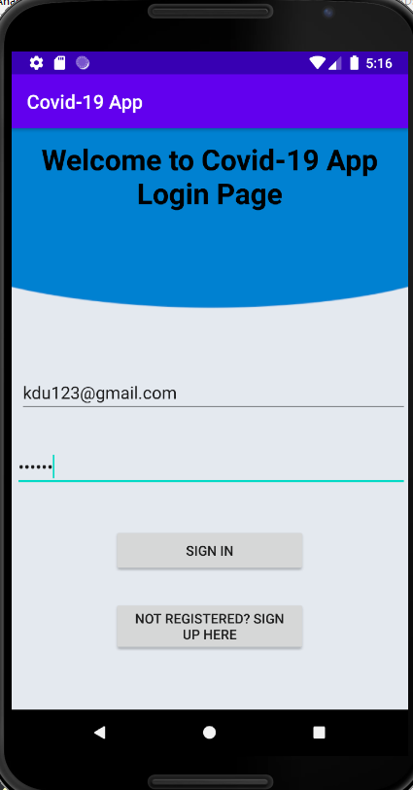

## 1.1 Sign Up Page

If you are not registered, you can click on Not Registered? Sign Up Here button and it will navigate you to the sign-up page.

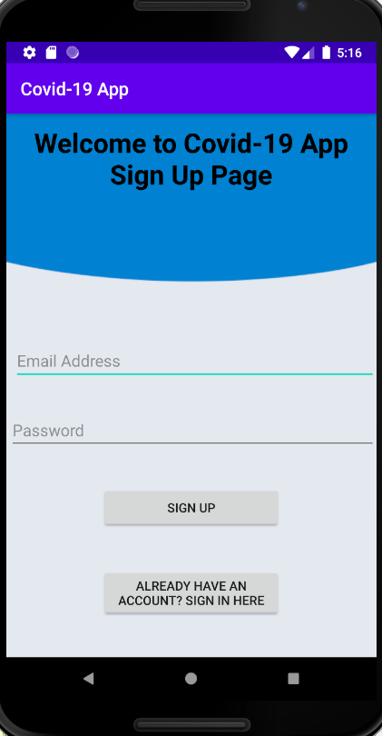

# 2.0 Main Menu Screen

After sign-in you are then navigated to the main menu screen

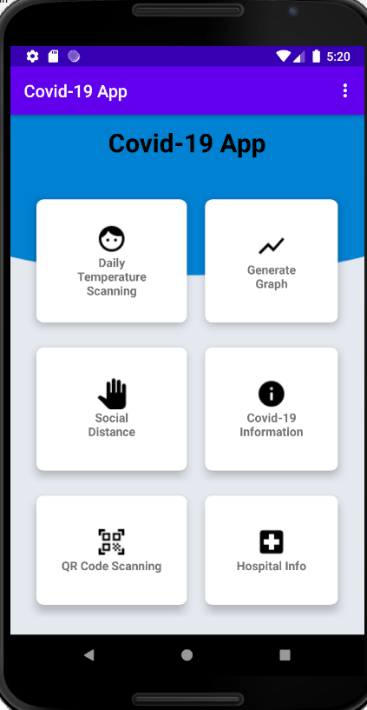

## 2.1 Daily Temperature Scanning Screen

By clicking the daily temperature scanning you are then navigated to the temperature scanning screen, Entering your temperature and date will be saved into the database.

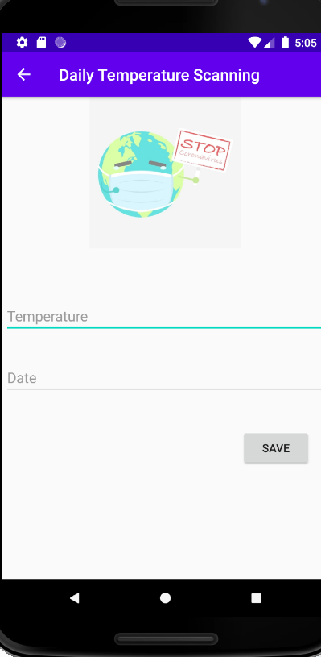

## 2.2 Graph Analytics

By clicking generate graph button you are navigated to the graph screen. Which previews the analytics of Malaysia’s Covid-19 cases every month.

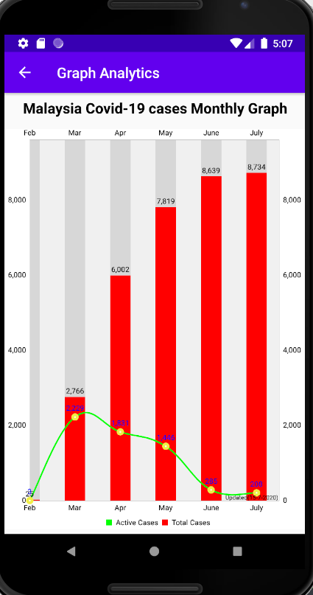

## 2.3 Social Distance Screen

By clicking the social distance button, you are then navigated to the Social distance camera function which can identify whether user is practicing social distancing. It uses two points of the camera to measure the distance between one point to another.

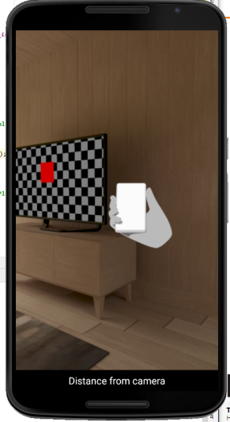

## 2.4 Covid-19 Information

By clicking on Covid-19 Information you will be navigated to Covid-19’s information it has a video that shows user what to avoid to reduce the chances of getting

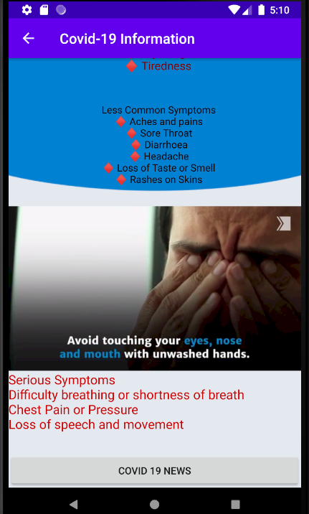

## 2.4.1 Link to Browser Screen

Covid-19 it also has a button that if clicked it will lead the user to Covid-19 news happening in Malaysia.

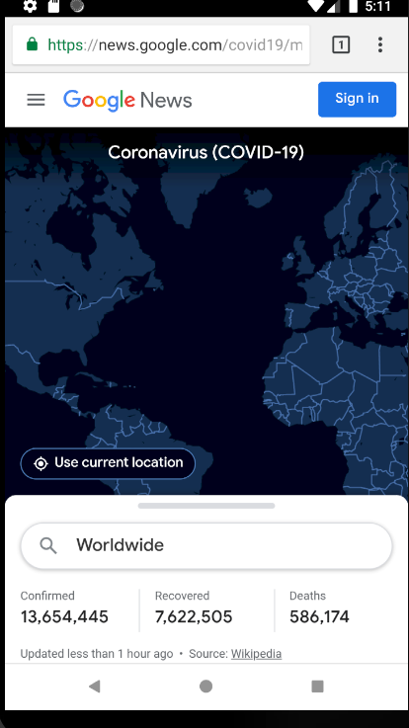

## 2.5 QR Code Scanning Screen

By clicking QR scanning, it will navigate user to the QR scanner which prompts user’s camera to scan QR codes

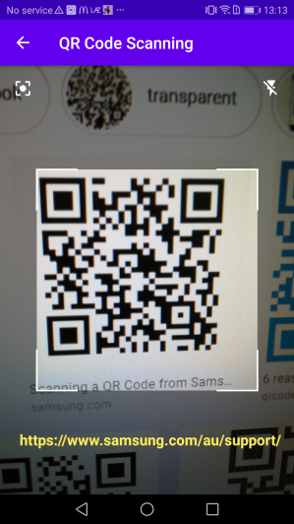

## 2.6 Hospital Info Screen

By clicking hospital info button, it will navigate user to the Hospital info screen which has information of hospital that has treatment for Covid-19. It has addresses and contact number inside this page.

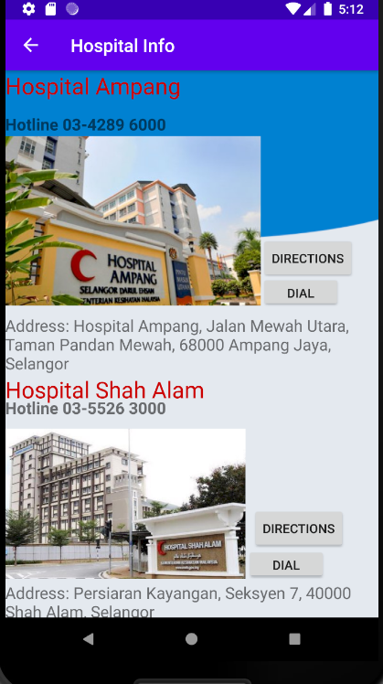

## 2.6.1 Phone Dialer Screen

The button dial will prompt user’s phone dialer the number of the hospital selected.

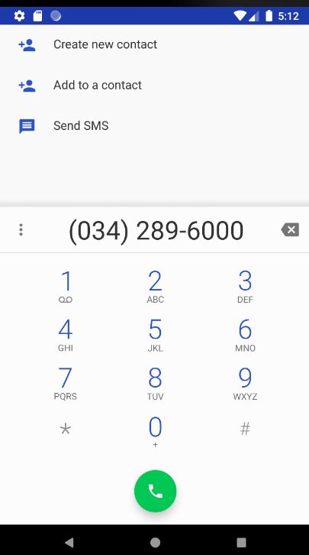

## 2.6.2 Direct to Map Screen

The button directions lead users to google map which gives the directions to the hospital selected.

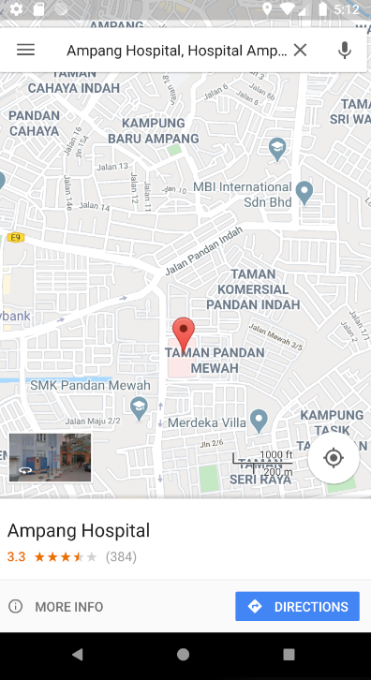

# 3.0 Side menu bar

By clicking the side menu bar, you can have two choices, about and logout. The about button leads you to the page where it shows the team information and the logout button will logout the user from the current session.

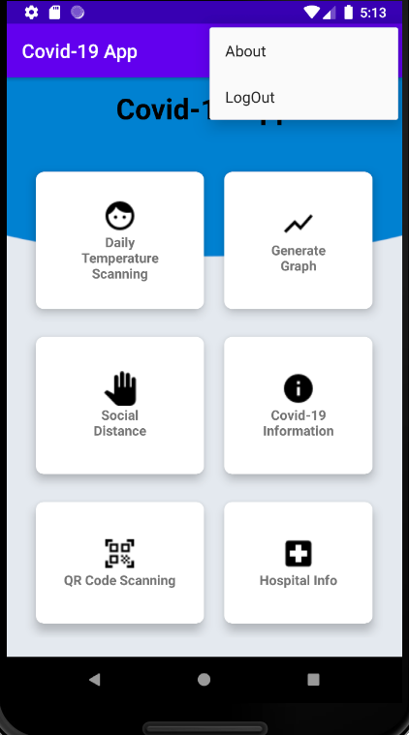

## 3.1 About Screen

