Laracasts via Jeffrey Way

\\Casts 41-60

41_Say no to implicit routing: Back from the code igniter days came implicit routing. You may recognize it when using the Route::controller option.

The Route::controller option was used to implicitly expressed routes. This relied on a form of magic for your routes to handle request. Now you may like using such implicit routes but they leave room to too much magic and guessing on Laravel's part. That is, if you were to express a controller within your routes page, you will notice that only the method you've defined within the controller will be used. The parameters of such a request are left to Laravel's interpretation. Although it does a very good job in implicitly expressing the routes, it still fails to express all options.

Notice the problem => Route::controller

Let's fix this by using a resource => Route::resource
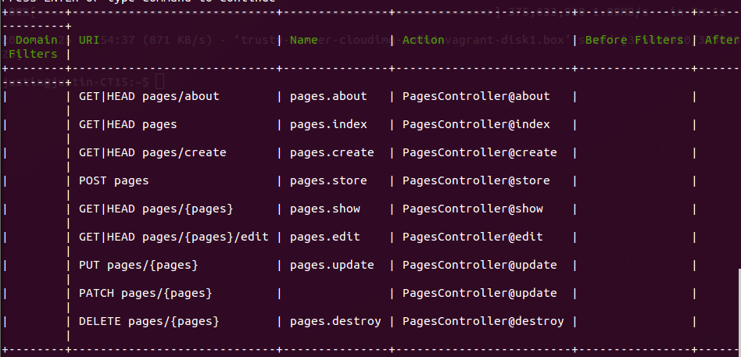

We no longer have to rely on an implicit assumption from our controllers for proper route URI names. It all explicitly states each route. Our controllers can then follow a pattern of index, create, store, show, edit, update, and destroy. All these routes are RESTful. They rely on a similar CRUD methodology but give way to proper RESTful design. This allows us to also explicitly define specific routes of our choice. The routes that come before a resource have higher precedence that what the resource defines.

42_Vagrant and Laravel: We went ahead and used Jeffrey Way's install script. This allowed us to installed all the provisions we needed to develop in Laravel.

One thing to note, when actually creating your provisions, we are creating the install shell script and the Vagrant file inside our Laravel project. Also, whenever we vagrant up, we removing the original Apache web root and symbolically linking the vagrant folder to our var/www/html folder.

This is important to view our Laravel application within a particular address and root.

In my opinion, Vagrant can be used for production virtualization. Basically simulating a production environment for our own needs of testing. But for our own projects, using LAMP or an extension of such, is alright in my opinion.

43_Form Model Bindingt: What if you are editing a table of orders and wanted to list the current values in a form field. That is, show all the current values that are editable in an update form submission. You may replace each input field with an orders model elements. But did you know you can bind a form with a model and thus show its current instance variables?

To do this, we went ahead and mocked up a complete order table with three video game consoles. We used a seeder to seed the database. Next, we went ahead and created an Orders Controller that followed a REST pattern. After adjusting all the settings for our page, we can view all orders and single items. Everything from this point has been replicated from an earlier example, therefore, no example will be demonstrated.

Within our edit order page, we have the ability to bind a model to a form. We can do this easily through the Form model bind method. It works exactly the same as a Form open, we just have to define the model it will use. The form inside the call will grab each attribute from within our form and auto complete each field with the appropriate fields.

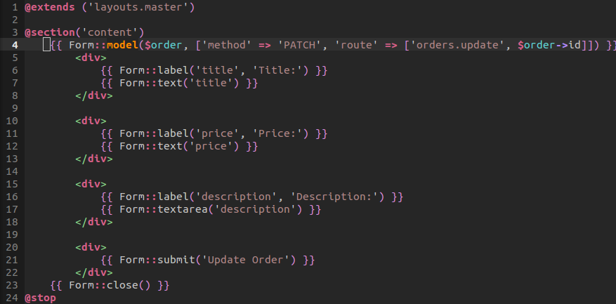

From this point, when we submit the form update, a PATCH request will be made. From within the update order we will find the current order, fill in the attributes with the current input, save the results, and redirect back to the home page. As always, this allows us to easily edit.

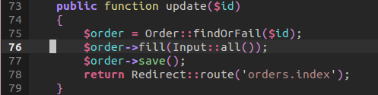

44_Intended redirections: When heading on over to an administrator section of a page or somewhere on a page where login is required. We may direct the user to login. But afterwards, how can we redirect them back to their originally intended location. To do this, we will take advantage of the Redirector object found in the illuminate class.

Within our routes, we will create a sessions resource. This means that the sessions/create path and that of login will both allow a user to login. The point of this is to show that we are using the sessions object. We explicitly express two methods for our login and logout –working as intended.

The biggest point to notice is that we are applying a before filter to our admin route. If the filter returns true, or we are indeed logged in, then we can return back to a fictitious administrator page to welcome the authenticated user.

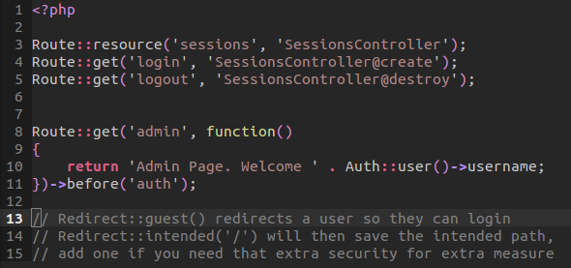

The filter itself will check if the user is a guest, if so, then redirect them back to the login page. When this happens, the Redirect guest method will call and redirect to login. When this happens, the session will save a particular variable. That is, it will put a URL intended variable inside the session. We can see this in redirector object's method of guest.
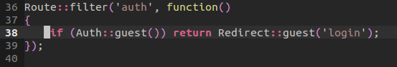

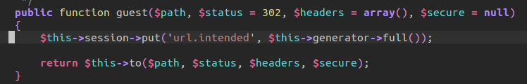

When we login a user with their credentials, we can grab their input and attempt to authenticate the user. Remember, when attempting to authenticate, Laravel will automatically hash the password. If the attempt was successful, then it will use that intended variable –using admin string as a backup. Else it will redirect back with the errors.

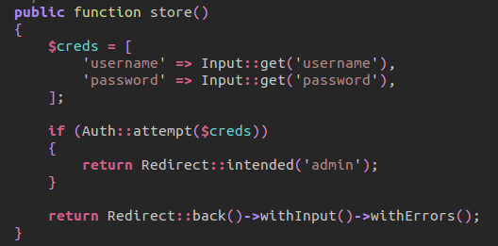

Destroying a session as usual:

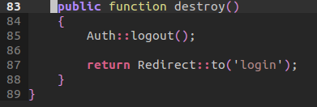

45_Mass Assignment Explained: Mass assignment allows you to easily bind data, consisting of, for example, an associative array, that can be assigned to a model in order for a database transaction. There is, however, a large vulnerability to this process. Specifically, if we do not guard nor protect what can or cannot be fillable as data, then anyone could edit a form element and add additional input that can be mass assigned and thus alter the database in an untruthful manner. Mass assignment was an issue for the Rails community as manipulating data as input was extremely easy. What made rails so awesome, also open the way of using mass assignment correctly and how to avoid its promiscuous vulnerability.

In this example, we will take a look at how to protect against mass assignment. To activate mass assignment, we must comment out the fillable array. We need to add a guarded array as some form of guard or fillable is needed. Next, we will create a simple mass assignment:

User::create(Input::all());

Just like that, we could add a hidden input field inside our user creation page, and add a field of data that is available in the database but should not be accessed by the user. For example, an active member on a website may have a boolean of true as a paid member. Well, with mass assignment vulnerability, we could give ourselves a paid membership without actually paying for it.

Thankfully, there are a few ways to combat this situation. Specifically, we could discretely grab the desired input and save them to an instance:

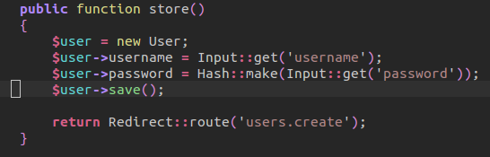

However, Laravel does offer the first example as a solution to a real-world problem. Imagine if a user had fifty fields to fill out, mass assignment could easily grab all the necessary fields and assign them properly to the respected model. However, to guard or give fillable permission for what fields can and cannot be assigned, we turn to the model.

Generally, there are two options when protecting fields. You can define a black list of fields that cannot be mass assigned. In this example, the field 'active' would be black listed in a guarded array –we would never want that field to be automatically mass assigned. Or, we can define a white list. A white list of fillable will be an array of fields that can be mass assigned. In this example, the username and password would be fillable fields.

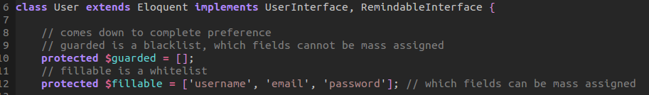
What instance of protection you choose is up to you. There is a time and place for mass assignment –just make sure you guard yourself to any vulnerability.

46_password resets: In this lesson, we take a look at how to create a password reset feature for our users. Laravel makes it extremely easy to setup a password reset system as the majority of the grunt work is done via the Password Broker object. This means that all we have to do is create a few routes to handle a user's request for a reset and for the creation of a new password. The controller, migration, and the object itself are readily available for the user to generate.

To start out, we grab the logic from a previous chapter that worked with redirect. Specifically, we created a user login view and functionality. The user logs in with their credentials and can then access and admin route. They can logout by visiting the respected logout URI.

To begin, we will add a couple routes to handle a few request. Our GET route of remind will handle the creation of a request for a new password. This will occupy a remind URI. Within this route, we will display a view for a user to submit an email for a password reset token. When the user submits their password, then we will handle that POST request through the POST remind method within the Password Reset Controller.

The other two routes will handle the respective GET and POST of receiving and available token, injecting a hidden field that represents its value and receiving new credentials for a new password reset. That same form will POST to itself and thus reset and redirect the user back to the login. But for now, we can see that we explicitly define the four methods we will be primarily using when resetting a password. Keep in mind that the implementation below will reflect Laravel 4.1 and not Laravel 4.0 that differentiates slightly on the Password Broker implementation.

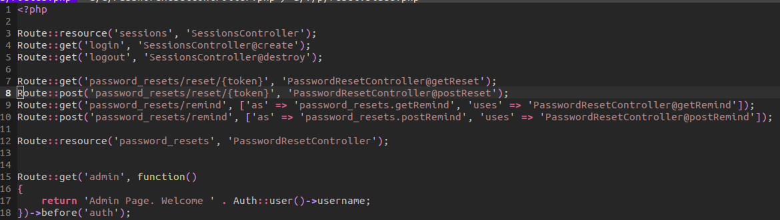

Our reminder view that will get the ball rolling in requesting that the user adds an email address. Behind the scenes, as we will shortly see, such email input is not required but must be valid as the method handling the post request will check to see if the email exists as an entity within the database.

As we notice, our POST remind will grab the input of the email, use a closure to setup a message, and then check if the email has been sent or is an invalid user. In the case of an invalid user, we will redirect back to the page with an error status of why the email was not sent. Please keep in mind that you do set up your mail.php configuration.
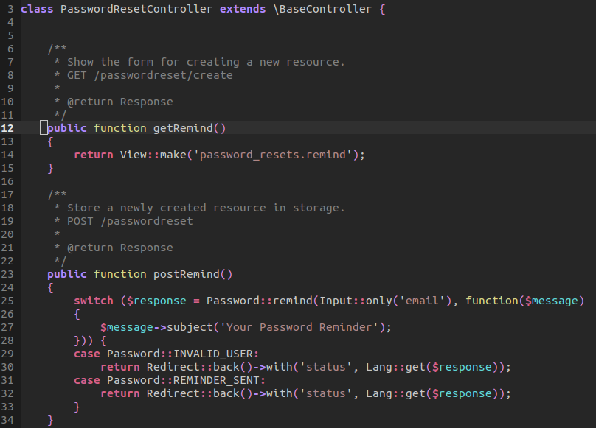

If everything goes well, then Laravel will send an email to the requested reset. You will receive an email with a token. That token, in itself, is actually stored in the generated migration. When the user finally uses the token to reset their credentials, the available token will be deleted from persistence.

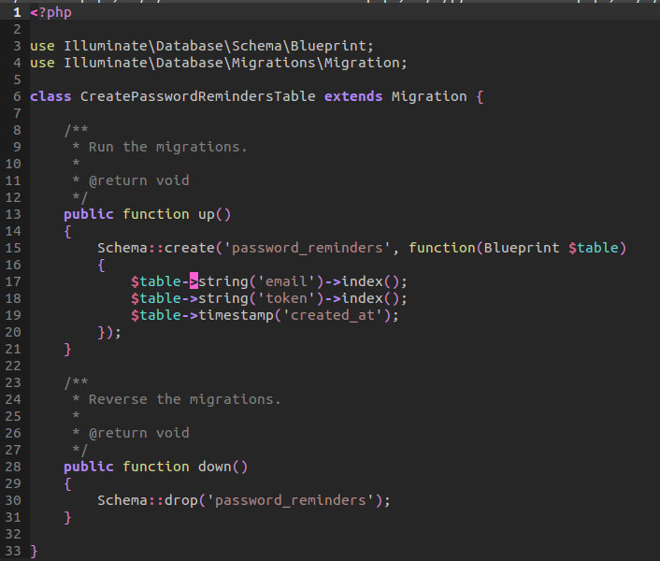

In the email, a URL will be provided with the addition of a token. That token will be used in the get Rest method. We check to make sure a token is provided. If not, then we will 404. Else, we will make the view with the appropriate credential:

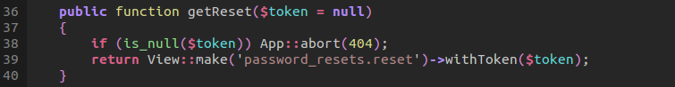

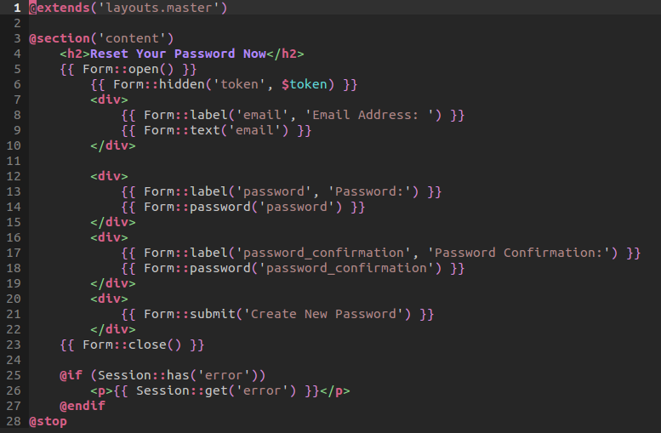

Notice how our token is hidden away in a field. This will be used again when we validate our credentials.

When the user has entered their appropriate email, password, password confirmation, they will submit to a POST reset.

Within this method, we will grab the required fields. Then we will send over the credentials to the password reset method. We then process the instance of the current user and their password within the closure. We hash the newly create password and save. We then check against our cases for any sort of exception that may have been thrown. This includes an invalid password, token, or user. Else, we will redirect the user back to the login to use their newly register credentials.

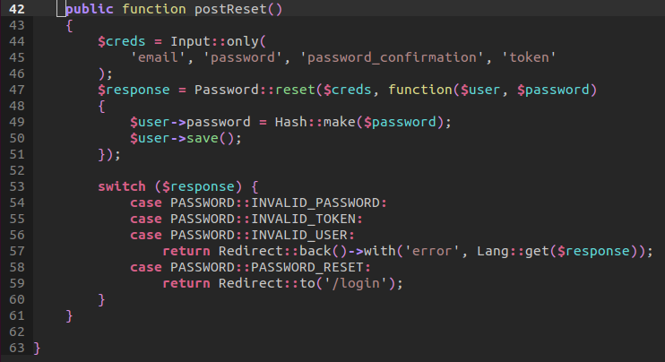

47_Controller Cleanup: When working with Laravel, we may feel tempted to cloud our controllers with far too much logic. If we start asking ourselves if we can call a controller with over twenty lines of logic from another, stop and think to yourself how this may be a code smell. In the soon-to-follow example, we will notice that our validation services are being used directly in the controller to validate that an input matches a related model. Does this validation rule belong here? No. Can the validation be used somewhere else inside our controller? Yes. This is a sign of major refactoring. Specifically, taking advantage of Hexagonal Design.

A bit of a walk through of the original design, we grab the input –all of it. And then we call our Validation facade to then check to see if all credentials where passed. We then check to see if the validation has failed, and if so, then redirect back with the errors. We then use Mass Assignment to create the new Project –keep in mind that are model has a fillable array in which guards against Mass Assignment Vulnerability. This is of course done through a fillable array. Next, we create new instance of a mailer object and then notify the project owner that a new project has been assigned. We, again, create a new table entity through mass assignment by using a User Event object that would be responsible for logging a user event.

We redirect the user back once we are finished.

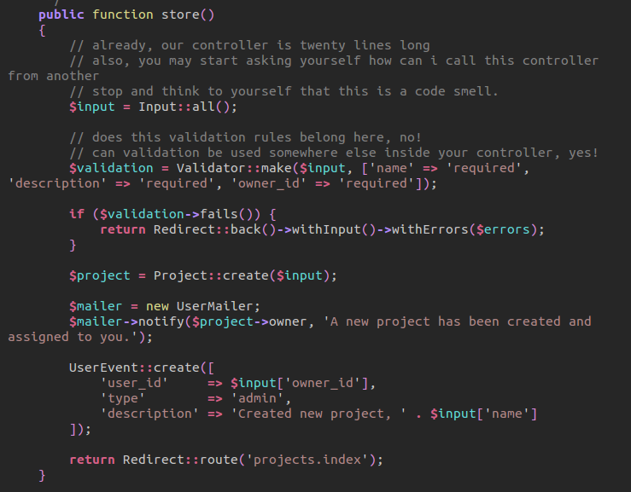
Now let's refactor this entire project so we are using a service object. By doing so, we are separating our entire logic away from our controller. That is, we are making an HTTP layer.

Within our store method, we will create new instance of the Creator object. Now in a real world project, I would inject this as another dependency. But, for example sake, we will just create a new instance, passing through a reference to the current controller via this. We then will return a call of the creator object to create with the Input from the current project being made. That's it! All the logic is taking away from our controllers.

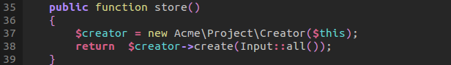

Now let's jump into the service object. Our creator object will store a protected reference of the listener inside the constructor. This reference, again, is the constructor. When we call the create method, we pass through a reference of Input and within the controller, we call a static reference of the Project model rules:
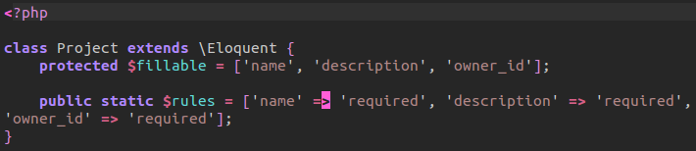

Within the create method, we first call our Validation object. Now we could separate the validation to its own service and simply inject a validation interface that we later bind with an implementation. But, again, for simplicity, this is fine. We then check if it fails. Now why did we pass through a reference of the controller itself? We did this because we are going to respond to when the validator fails. But when this is done, the HTTP layer, or the controller will react to this. We have a separate method in the controller that will respond to failure. We return the call to this method with the validation messages being passed through.

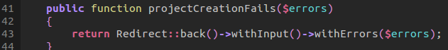
As we can see, we react carefully to this error by returning a redirection! This call will be returned back to the original call with the store method –if you trace where the final return is in the stack call.

Next, we create a new project. We could resolve the User Mailer object by injecting it as a dependency or we can resolve it our of the IoC container. We do relatively the same thing as the original code, the only difference is we react differently to a successful project that is created! Notice we respond to a project creation. Our listener object, which is the controller, will react in a very similar way. We respond with a redirect back to the project index:
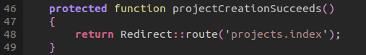

The main point here is we are not stuck implementing one solution. We could easily wrap everything in a try-catch method and be done. Or we can implement a Hexagonal solution. The summary? Try and keep your controller clean. As hard as it may be, the logic should not live within our controller. It would be harder to test and therefore more difficult to assert when building our entire architecture.

48_Dependency Injection Containers: Dependency Injection Containers allow us to build more maintainable code and testable features. We need to inject classes inside our controllers and service providers. However, to meet the needs of maintainability, we can house our instantiations inside a dependency injection container.

In the commented out section, we call the Facade of Application. The closure will allow us to create a new instance of Foo that contains a new reference of Bar. When we are ready to grab that instance of Foo that houses Bar as a property, then we would make the instance:

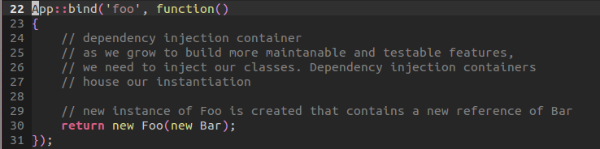
But how does the IoC container work in resolving an instance or binding a call to instance in order to house an object that injects another dependency?

To demonstrate what is happening behind the scenes, let us take a look at two methods that we are using: the bind and make methods. Our bind method will take the name of the object we are instantiating. We pass through a closure to be Type Hinted as Callable. We then register the named of the object we are trying to instantiate and pass through a reference of how to instantiate it along with whatever dependencies it may contain.

When we call the make method we grab the name of the object we are trying to instantiate or make. We check to see if the name is registered inside the static protected property that is registry. We then resolve by moving the instance of the registry name onto a variable property. We finally return that instance by directly calling the closure. This will resolve the instance that we called when we App::make.

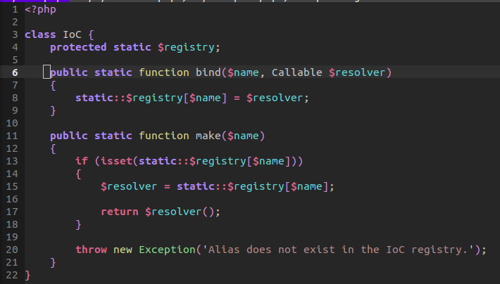

Now to take this a step further, in our original example, we will have a class that will expect an instance of Bar as a dependency. When we call the IoC bind method, we pass through the closure as to how this is resolved. Finally, when we finally call make, a new instance of foo is returned along with the expected inner Bar object as a protected property instance –pretty neat? We could even create singleton instance as well as other type of references. The point to take away is that dependency injection containers can house how our instances are handled and instantiated.
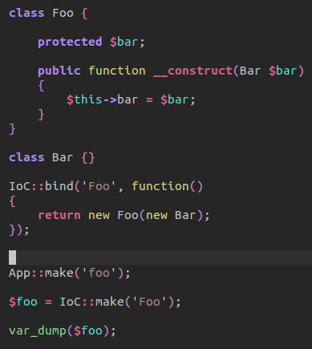
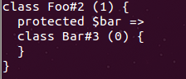

49_Commands 101: In this lesson, we take a look at creating our very own custom commands. Laravel offers us the option of creating custom commands that can handle repetitious task. In this example, we will be creating a user create command to create a username and password.

First, we need to register our command. We can do this by:

artisan command:make UserCreatorCommand

This will create a new file within our application's command folder. Inside this folder, we will be able to customize how our user will be created.

The User Create Command has a few protected properties that will help us define our object. This includes a name of the command and a description.

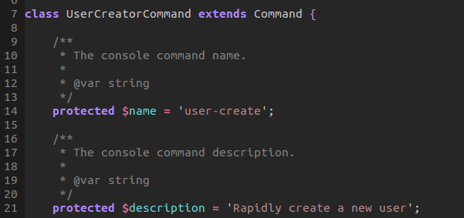

We have the possibility of accepting both arguments and options. But for now, we will accept arguments. Our getter will grab the required arguments that must be provided along with an associated description of each.

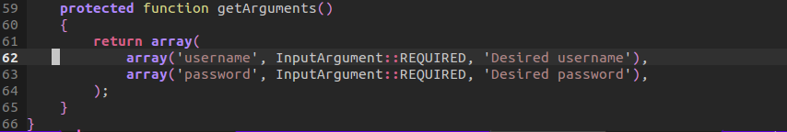

Now for this example, we are not going to accept automatic arguments. That is, we are not going to require them for our command. Now if we did, then we would expect two arguments to follow our command in the fire method, as demonstrated in what is commented out. But in this example, we will prompt the user for a username and password. We use the secret method to accept a prompt that doesn't display password input. In either case, we create a new user object, fill in its attributes and save. We report back that the user has been created.

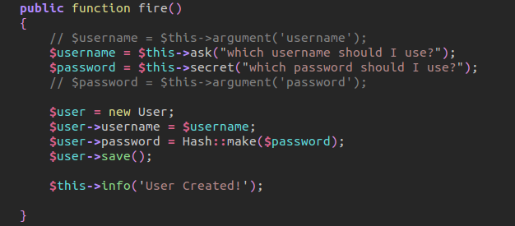

We have successfully created a user with one command! Now we should imagine fire as a transport layer, something that helps us get from one destination to the next. It shouldn't be concern with persisting the database nor the logic for creating data. In our next lesson we will create a more abstract form of our command so that we are breaking single responsibility.

50_Commands 201: In this example, we improve upon the understand of commands by moving the logic of generating a file away from the generator command. Like any other form of single responsibility, our primary concern is that the fire method will take the arguments and options provided, generate the file, and return our information back to us. It is in no way concern with how a file is generated. And this is actually healthy code because it's testable, but more importantly for this case, maintainable.

Our Model Generator Command will contain a name and description as usual. However, where things start to differentiate is how we Type Hint a dependency injection. Laravel will automatically resolve any dependency injections through the IoC container. We can resolve any dependencies necessary by calling the Artisan resolve method.

Thus our Model Generator controller can now have access to the dependency injected Model Generator as its own instance property.

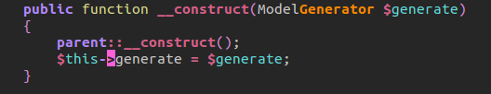

Moving onto our fire method, we can grab the argument as before, Remember we are defining our argument property as required:

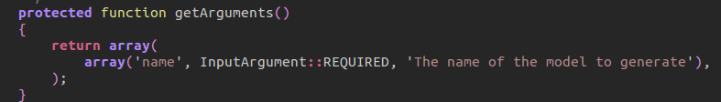

However, our second variable is path –this is optional. An optional path means that we can grab command options but not have them set as required. Of course, an option could be required, but for this instance, we will provide a default path as the last index of the array created. We provide the application path concatenated with our models folder. This will be our default option if no options are provided.

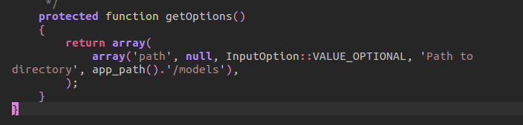

So far our goal is to provide the opportunity to use both commands:

artisan g:model Foo
artisan g:model Foo –path=”app/Acme”

Next within our fire method, we will call the instance of our generator and pass through a reference of both the model and the path. Afterwards, we will output the information that the file/path has been created.

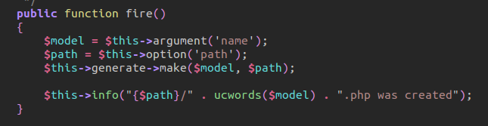

Dissecting the Model Generator, our constructor will inject a File system object which will allow us to add new files to our existing code base.

The first method called is the make method. We grab the model and path. We then generate a full path with the provided path and the name of the file. We uppercase the model as models are generally uppercased.

We then grab the current template. Our method will pass through the model as a string name. We get the file from the instance of the file system object and then replace the template name, with the available model name. So, to reiterate, we grab the template, find the handlebars as our custom template, search-and-replace our model name, return entire file back to our template variable in the make method.

We then take the generated path and generated template to then put the file in our code base.

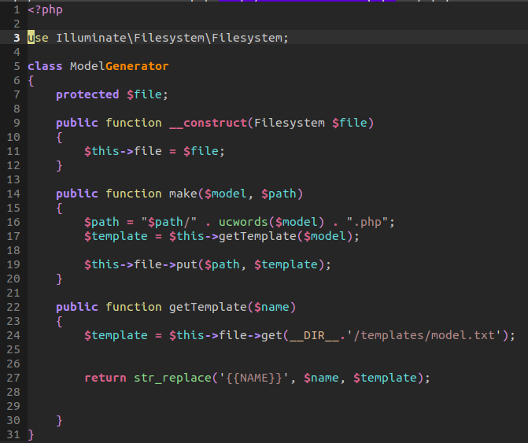

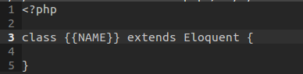

The biggest idea to take away from this screen cast is the idea that single responsibility is absolutely important. Why? Because it allows our command to be testable and maintainable. But for our example, it cleans up our fire method because it should not be concern wit the logic of how a file is generated.

51_Acceptance testing with Behat: In this lesson, we take a crash course in acceptance testing. Acceptance testing revolves around Behavior Driven Development. Development that revolves around Test Driven Development and Domain Driven Design. Behat is similar to Rails Cucumber. It combines a domain specific language that allows both software developers and business analyst to work together and collaborate on software development. The appeal of Behat is its super easy to understand language and process of helping a developer write new features with accompanying test.

The first process in getting started with Behat in Laravel 4.2 is to install all the appropriate packages:
Mink will be used to simulate a browser like experience through code.

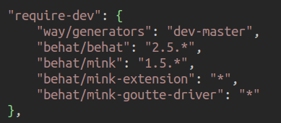

Next we will create a Behat YAML file that will contain our Behat settings. Our default will define a default path where all our tests will live. We include the Mink Extension with a base URL for proper browser simulation:

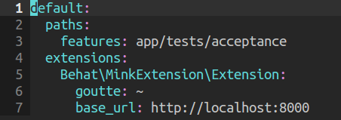

Once you have these enabled, you can call behat init. This will get the ball rolling in creating the necessary files for your use.

The first thing we will do is write a test for a feature. This feature will be creating a Guest Book. We list the feature information. Giving it a name and description. Next we will define two scenarios.

Our first scenario will fill out a guest book with a name and message, it will submit the form, and expect that it should then see the input it sent in as a request to the server.

Our second scenario will submit a form incorrectly. That is, try to submit a form with empty fields. We will expect that the browser should see a message indicating the browser to ill in all fields.

As you can see by the domain-specific language, Behat is extremely easy to understand. We write a feature, testing two scenarios, doing so with cucumber language syntax.
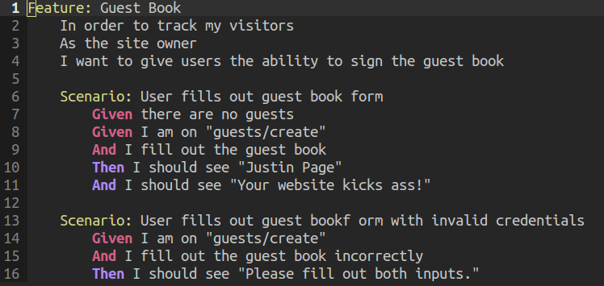

However, Notice that we define two custom behaviors. That is filling out a guest book and filling out a guest book incorrectly. These behaviors are not recognize by Behat. We can see this by calling:

behat -dl # This will list all possible commands available for our scenario. But what if we wanted to create our own features?
To do this, we edit our Feature Context file adding in the logic for our custom commands. But first, we must call behat –appends-snippets. This will allow us to append custom methods that would be specific for calling them out in our cucumber file.

Let's talk about scenario one. Scenario ones goal is to fill out a parameter and submit the form. We default a name and message variable. We then call both fields to be filled with a value. We then call the methods to press the button. These, and many other methods, can be found in the Mink Context file that was used in the Behat Extension.

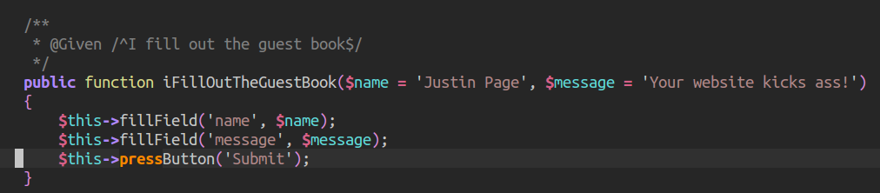
Interestingly, you'll notice that we assume there are no guests in the guests table. To support this we must truncate the table each time a test is ran so only one entity needs to be entered. When we provide that custom “given there are no guests.” Then we would call the append snippets, which in turn, will allow us to correctly truncate our table:
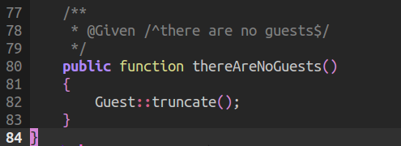

In order to use the Guest Model at all, we need access to Laravel. We can do this by calling a method bootstrap and description. We set unit testing to true, testing environment, and we then require the bootstrap start file. This will give us an instance of the application. We then boot up the application in Mink and thus have access to a proper instance of Laravel.

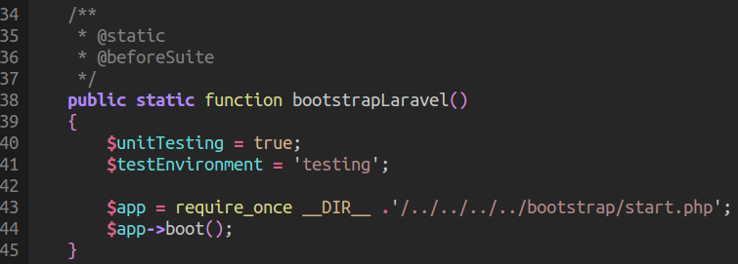

Our second method is filling out a field incorrectly, instead of repeating ourselves, we call the instance property of filling out a guest book, but with available empty string parameters,

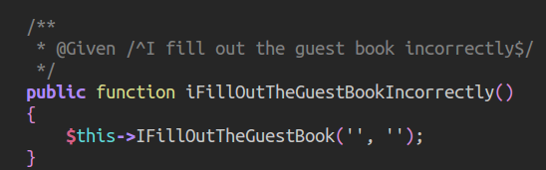

Our form will then display a flash message on response and thus Behat will pass. The main benefits is that Behavior Driven Development provides an easy layer of communication between the business side and engineering. We can clearly develop a test to reflect browser behavior and do simple acceptance testing to make sure that what we input will be returned. However, what was the process in developing code to pass these test?

We have four routes. Our guests index will display all guest book entries. The guests create will return a view to create a new entry into our guests table. The guests store will validate the data, and unless it fails, will create a new Guest entry and then redirect back to the index. On fail, it will redirect back to the guests create route with a flash message. Notice that we are handling both the submission of a proper field input and an incorrectly filled guest book.

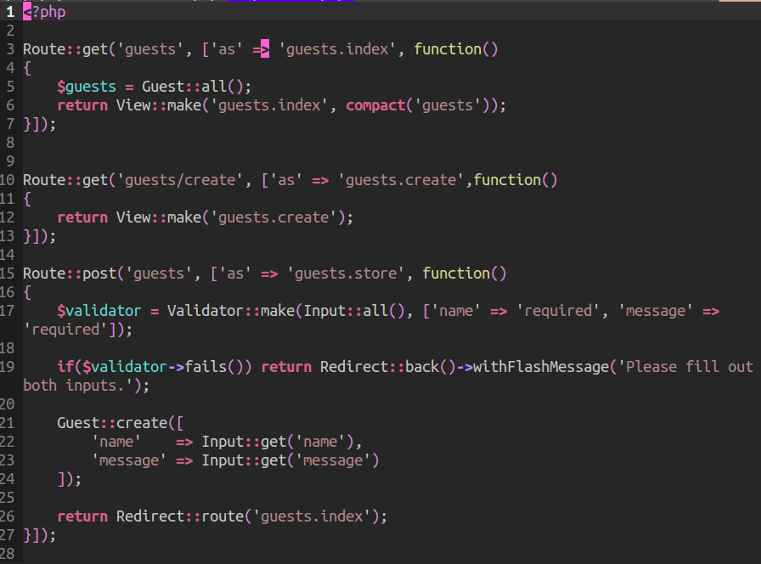

In order to use mass assignment, we make sure our model is protecting itself by including a fillable array property:
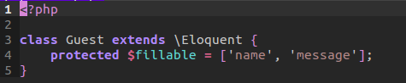

Lastly, our views are quite simple: notice our label and text inputs are similar to what is expected in Behat testing:

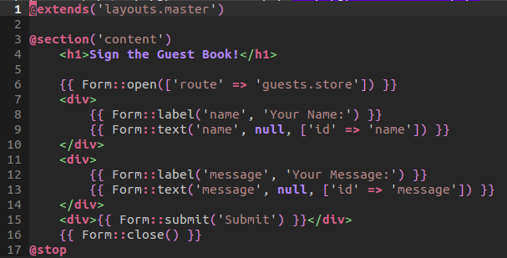
// create

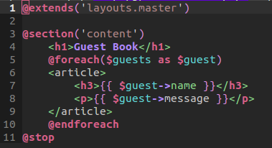

// index

52_When to app make: In this lesson, we take a look at an integrated test, that uses dependency injection, in order to test the action of a user whose charged has failed. That is, a user with a current account that has proven delinquent. And moving it to a single isolated unit test that does not persist the database.

I will first explain the functionality of the object, how it is resolving its current bindings, and then jump into our current isolated unit test.

When a user subscription is scheduled to make a payment, it will either succeed or fail. If in the even it fails, it will call a fire method on a charged failed object. That is, a listener will will listen for when a user fails to make a payment. When this occurs, a charge fail object will fire and thus deactivate the delinquent user. Our fire method works as normal in that it accepts a customer, it then calls an instance method of to deactivate the user.

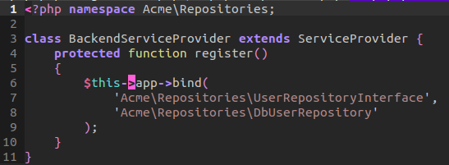
Normally within our object, we would inject a dependency. This would then be resolved out of the IoC container. Specifically, it would take advantage of a Back-end service provider who would bind an injected interface with a concrete example. We've seen this before in our IoC lesson:

However, dependency injection is wise for when we need to use an instance of an object in multiple methods. If, however, we only need to use the dependency once in one method. Maybe we can use the Application's make method. This will return a concrete object instance. The Back end service provider will recognize the bind and return the instance. We then call the repository's billing identifier. This will return the correct user object. We then deactivate the user base on the object. We finally log the user deactivation as an array within a log. By embracing a repository and using an interface, we are taking advantage of Liskov substitution principle. That is objects should be replaceable with instances of their subtypes without altering the correctness of that program.

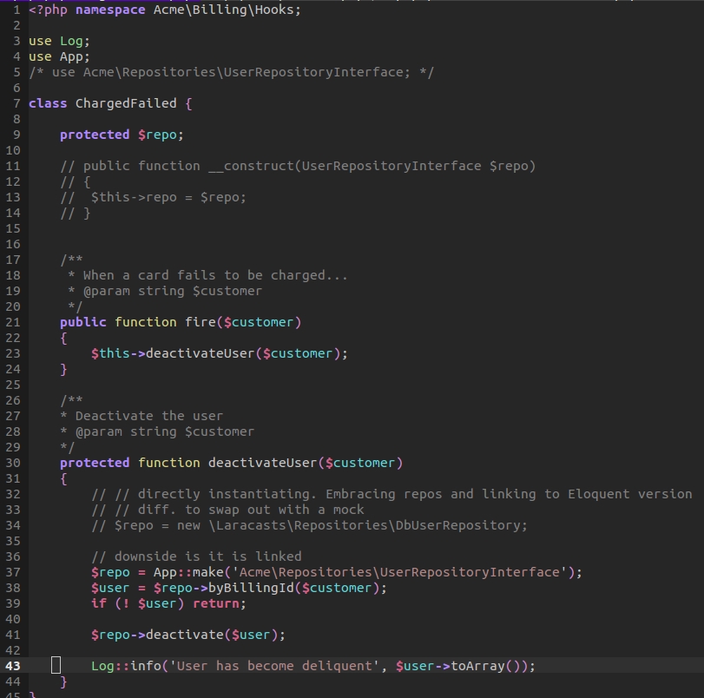

Our goal is for us to develop a test that moves from an integration test to an isolated unit test. This will allow us to not touch the database and thus save us time in running our test. Integration test are concern with the actual process of data. Data in which is integrated throughout the test. We will not concern ourselves with an actual user object. Instead, we will mock a user object who has one method property that returns a blank array. Remember, our unit test is not concern with the actual information returned but, instead, with the action of deactivating a user.

Our metric for testing an object is no longer dependent on accessing the database because we mocked the object. We do not need to verify if these are updated. Our metric is if those methods are called. We can assume a separate test will be dedicated to the repository. We don't have to double our testing.

To mock an object, we define an object in which will be mocked. Not an actual instance of an object but a mock of it. Something that would appear to represent a DB User Repository. We define two methods to be called within the mock. That is finding a user by billing id. And we will deactivate the user with the user object once. We then create the instance by providing the mock. Therefore, when we call fire on our object. The repository will use the mock object for the current instance, not the back end service provider.

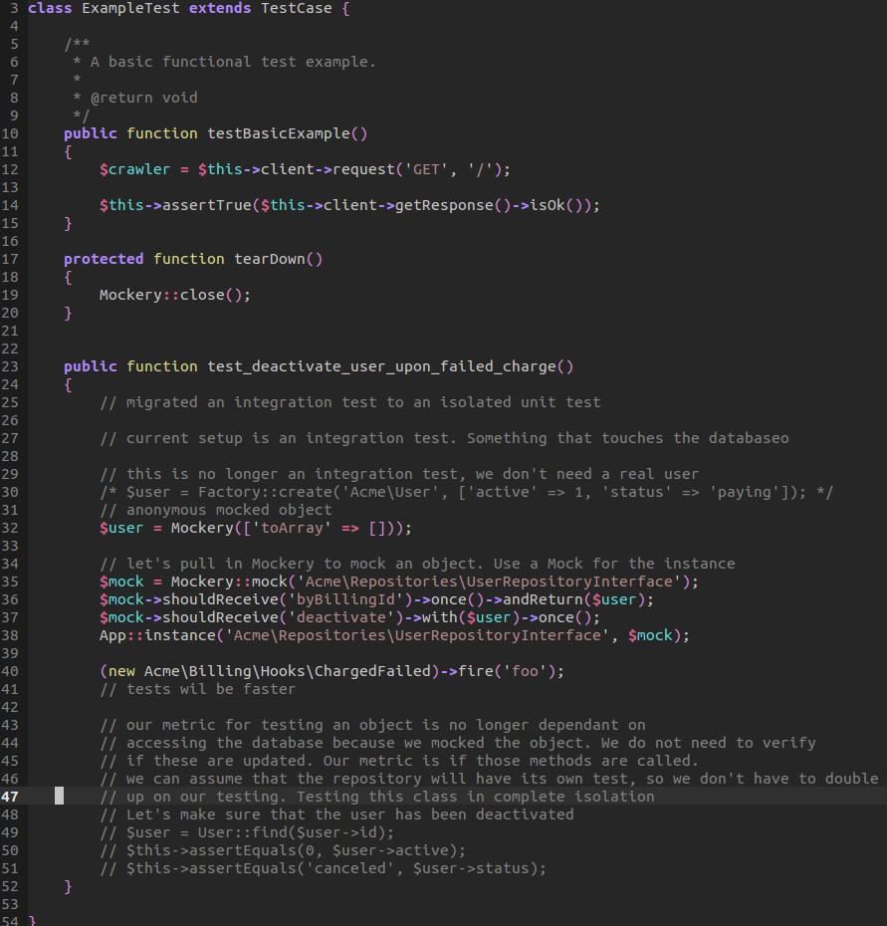

53_reports with graphs: In thi

