Laracasts via Jeffrey Way

\Casts 21-40

21_Workers with fortrabbit: Laravel makes it extremely easy to work with queues.

Queues, as we discussed in the previous lesson, are process that we want to put in the background and then to listen to a request of that queue to then launch later. In a way, we are pushing jobs on a desk and having a worker or a queue center handle all the actual processes. The difference between this lesson and the previous lesson on queues is that this discusses pushing a queue and registering a listener on fortrabbit via a worker.

We make sure that we install iron MQ within our composer file and register a demo product on iron MQ website. We then make sure that we pop in the correct credentials from within our app/config/queue.php file. In here, we would indicate whether we would use sync –sync being the local option for listening to queues –and a remote service, such as iron.

We will demonstrate our simple use through pushing one job on the queue. We first call a push of a class to launch when the queue is processed. That is, we push the class itself along with a second parameter for extra data. That class will be called when the queue is handled. We return a done string to indicate that our first statement ran successfully.

Our class of do something is really simple, it contains a single method of fire. Fire, as you may guess it, will fire when the queue is processed. That is, the job itself will continue. We show a dynamic process by grabbing the current applicaton path and then appending the time to the queue.txt file. Because this isn't a push queue that is handled by a marshal, we need to kill the job once it's finished. To do this, we we simply call the delete method on job.

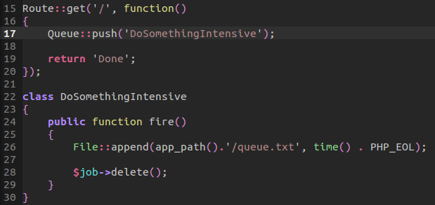

We then push our changes to our remote server and go to the index of our page. It will then return a status of Done.

In the background, we have pushed all these jobs to iron MQ however nothing is processing them. This is where our workers from fortrabbit would come into play. We can then call:

php artisan queue:listen
This will cause our server to continuously listen for jobs to process. Once it needs to work, it will then call the proper jobs to process. Alternatively, we would need scheduler via workers from fortrabbit for this to run automatically. That is, scheduler would run this listen script continuously listening for job it needs to handle. We can do this via a YAML file. For more information, we need to first purchase a worker for our fortrabbit product.

22_You must use composer: Composer give us a powerful set of tools for working with packages as well as multiple files. We install composer through PHP's package compression file system via Composer website. We can then go ahead and install this application globally.

We call composer simply through its name: Composer

We can then go ahead and call the initializer that composer has available to us: Composer init
Here, we can go ahead and give a name to our composer package name, a description, and a simple author email. We can give a description for what minimum stability we like –such as dev.

We can then define any dependencies we like. For this instance, we will create a composer.json file. This JSON file will allow us to insert packages either through our required object or required developer object. We can browse packagist for more packages we would like to use within our PHP file system.

An alternative to searching the packagist center for a certain package is for us to call composer require.
This will add packages to our JSON file automatically setting up our file and downloading any dependencies it may have.

Now we can use the packages from within our project. We have our vendor folder which makes available all our files to be used. We installed mono log as well as a generator. We can then use this files directly from the vendor folder.

Now another huge addition to composer is its use of name spaces and the separation of development vs. production tools available to us.

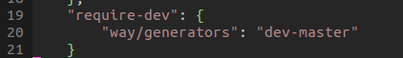
We can include a require-dev object in our JSON that allows us to indicate certain packages to only be available or required to be use during development. Here, we are including our way generator inside our require-dev environment:

Now, we can include autoload arrays that indicate which files and class maps of Objects we would like to include inside our project. However, this is actually a bit more work than necessary. Composer will automatically include a helper function that will autoload all files within our root. Therefore, any files within our root do not need a files array. Also, we could include this class map array with a list of all our files. But this is actually more work than necessary:
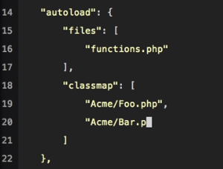

To lessen your load, why not take advantage of PSR-0. PSR-0 follows a list of PHP figurations that are community voted. One of them, the very first, is the way names paces are processed. Composer respects this auto-loading by including all name spaces inside a particular folder. The array key will reflect the name of the folder itself and the value is where it is located –in this instance, the root of the project tree.

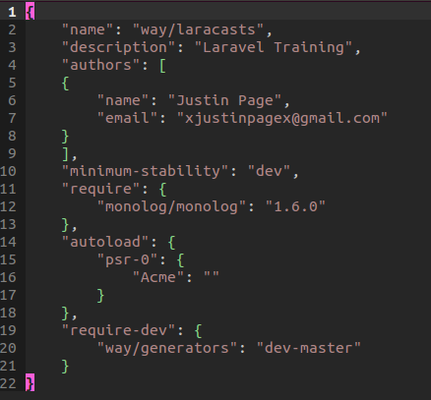

By importing the autoload file that composer already provides us, we can go ahead and load up all our name spaces. Here, we are calling new to the Stripe Billing class.

Remember to always composer dump when we decide to reload all name space paths. Once we have done so, we can load up root functions. Such as a function of dying and dumping a value.
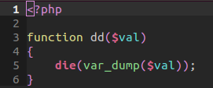

For this example, we went ahead and created a name space for Acme Billing. We create a class that will call the die and dump function. And just like that, our file is available to us because we auto loaded its path.
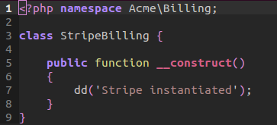

We can then simply call a new instance of the class without having to load a direct use of the namespace:
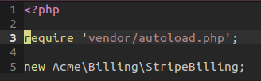

23_flash-messages: If you want to flash a message for your session -so you can have access to data from another page –we can use the power of flashing a message for Session Storage. This allows us to easily pass values from page to page.

Our goal here is to flash a message when a user would store an item or make a change to our database –this would involve a more complicated process, but we will simulate it via a GET request.

First, our routers. We create a route resource for all our routes to be used. This allows us to process all our request through REST. We overwrite out store method to be used as a get request -because POST is what usually calls the store method. We then create an index route that will return the home view.

Our auto loader handles all the configuration for us!

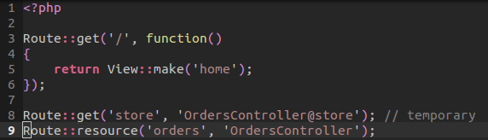

Within our controller, we flash a message via the with method. The 'with' method will store the current value we would like to pass through to our next page. We can either send in an array of values or the syntax of with. We use underscore to represent PHP array values and dashes to represent CSS classes.

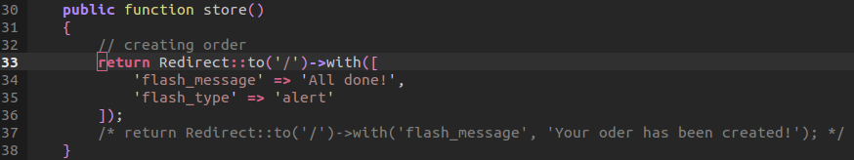

We redirect to the index or home page. Our home page @extends('layouts.master')
Here, it will check to see if a flash message value exists. This value will contain a message and flash type.

We include some simple styling for each flash type. We then include the partial of our layout. In addition, we target that flash message div to slide up after four seconds of appearance via jQuery.

The magic happens within our blade partials template. We check to see if the session has a flash message. If it does, then it will check to see if a flash type exists. If it does, then it will render a div of flash message with alert –remember, this means red background with white text. Else, this isn't an alert, and thus we can style it normally with the flash info class.
Lastly, we process the last bit by outputting the Session flash message bit to output our message. Notice that this partial will not render unless there is a session storage of flash message. This means that if we where to visit the index from the start, we wouldn't see a flash message because the session data is only available when we simulate the store method –by viewing the store route.
// partial:
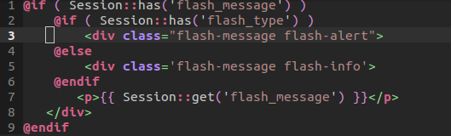
// master layout:
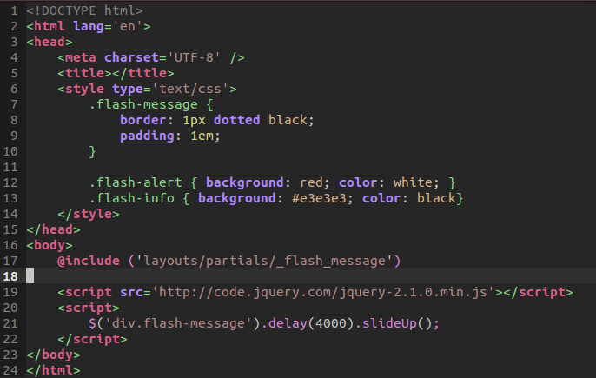

24_responsibility: The controller should attribute to the principle of Single Responsibility. This means each method from within the controller should be responsible for one action. Easily, the most popular and advocated principle, is Single Responsibility. A class should have one reason to change. If it is doing too much, you should abstract that logic out. Some notice that their controller is doing too much. We may login a user, route the user, and even email the user from the controller. The controller may be responsible for validation. Here, we may also specify view content as well as emailing users. This is not a good idea because basic stuff in the controller violates the principle of Single Responsibility. Although this is not an odd controller, it does too much.

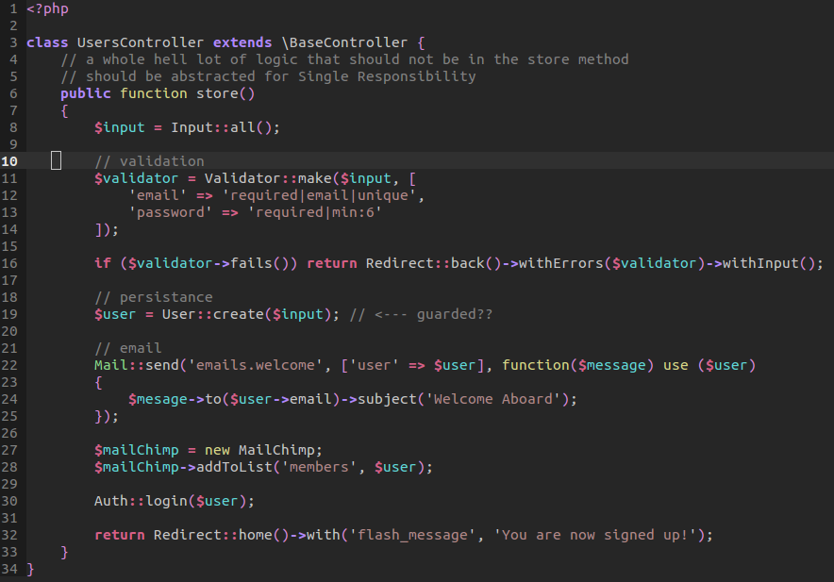

The controller is responsible for a lot but not this much!

Would another part of my application benefit from a particular logic? We may need to validate a user with other methods. Chances are, a controller is doing too much. The controller is a transport layer.

An easier way to stick to the single responsibility principle is for us to abstract all the logic away from the controller to a repository pattern as well as a service provider.

In our fixed example, we injected an instance of the user class so we can call the method that is located in the user object. That user object will use a validation method that is inherited from a validation abstract class. We can then send in the input and then immediately check to make sure that it is true. If not, then we will redirect the user back with the errors from a method that gets all the errors that are returned from the validation class. This will also return with any input they may have passed.

For our next instance, we created a repository pattern that is responsible for creating a user. That involves sending in the input. That repository will then handle the creation of the user. We can then use dependency injection to then send through a welcome email to the user that is returned from the repository pattern. We can also dependency inject a news letter item for a list to be emailed. From all these abstractions, we notice that we are improving our controller. We then authenticate the user and then redirect them back with a flash message. However, we face another issue. Our controller is still doing too much! We can abstract this further, so we are not violating the single responsibility principle, as heavily as before, by using a service provider. The service provider allows us to easily abstract all our method away to the model so we can create the user. This allow us to mock the creation of a user and makes testing the controller significantly easier to do.
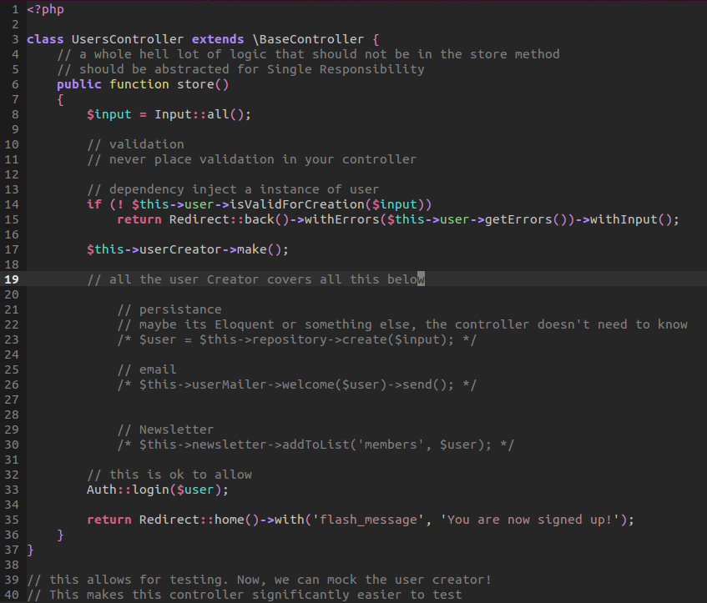

25_route model binding: Route model binding is beneficial because it allows us to grab a query of, say task, and automatically assume a way to bind an instance of a task from the database to the request we make through query.

For this example, we created an example that grabs a task from a request of tasks. It takes this task in a closure and returns that object. That object is automatically binded through the call of the Route bind. We match that query of task to the binding and each closure contains the value and the route in which it came from. We make a constraint of finding a slug, or also known as the URI to a particular path, and grabbing the first value. By doing so, we return the JSON of our current query.

Please note that we must associate the model of task request with Task. This way, our URI request will be match to the Task model. The task model is automatically associated with the table tasks.

The above may not be true, I probably don't need to include the model if I'm just binding a query through GET
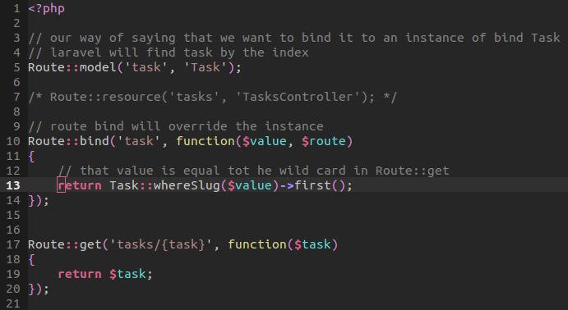
What if we wanted to use a controller instead of having our routes contain all the logic? We can simply make the switch by first binding our tasks table to the Task model. Thus we have that glue between the two. Now all our resources that request a route of tasks will be handled by the resource of Task Controller.

Now, within our task controller, we can handle the show route of our controller to display a JSON of our query as well as calling a view to die and dump our current task that we would like to edit.

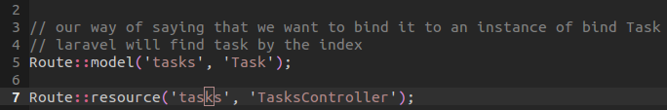

When we call: php artisan routes

We will notice that our edit method is called. Our edit method will take that model of task and then send it as an object array, That is, an object within an array to be used by our view. By doing so, we can return a very simple method of displaying our object without having to send it directly through. Our route model binding will automatically tie the two. This makes it easy for creating an API.

// from within the controller
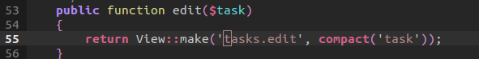

// view will grab the task object as well as dump the object to display its full view:

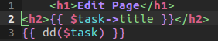

26_Caching Essentials: Caching is the process of storing data so that future requests for that data can be served faster. Laravel makes this ridiculously easy! Laravel, by default, will contain a cache.php file within the config folder. By default, the driver will be the device in which the data will be stored. It can be on file, a database, or even redis.

Now we only have to concern ourselves with three main Cache calls:
- Cache put
- Cache get
- Cache has
Together, these Eloquent methods can store data, retrieve it, and even verify of its existence.

In our first example, we went ahead put a key of foo with a value of bar that would last ten minutes. We can then return the cache value by getting it through the key and also provide a default value. Now we could very well remember a query that we conduct by calling it through eloquent. By doing so, we can retrieve data from the database once and then store it. This is demonstrated as we listen for an event to occur, which is the query call. This query call will call once! Then, we will return the query of the task. The query builder will not dump the query and instead the original eloquent remember to grab the key value and return the JSON –no query was done!

// have no fear! This is at the bottom of the routes file.

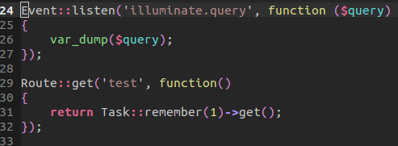

Now let us take a more constructive approach to our development. In this instance, we will create a cache filter that will apply before and after. Specifically, we will be creating a checker to see if a key exists, and if so, return those result. If not, then create a new key and store the value for later reference.

Before we jump into actually creating the cache filter, we need to register the filter. This could be done in the filters.php file, but for brevity, we will elaborate our entire filter within the process of the route. To do this, we name the filter cache fetch and cache put. This is a name to sort of follow a name spacing pattern. Although it could just be name fetch and put. Now we link the reaction of those filters to a name spaced Cache Filter object –specifically tying together those methods.
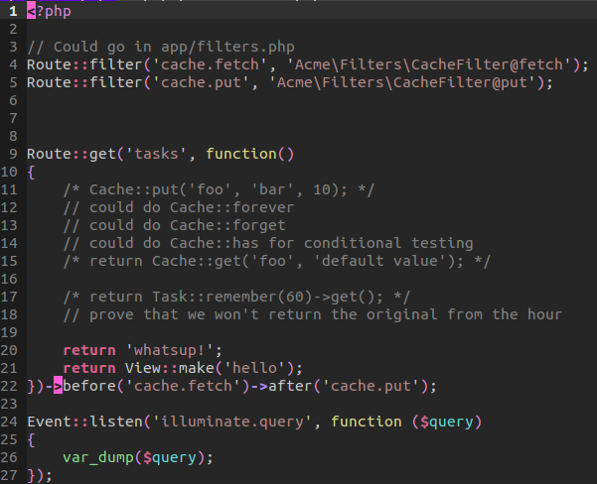

Now within the Cache Filter, we have a few things happening. First, the before filter will call fetch. The fetch method will type hint to make sure that it receives a type of route and type of request. The request will contain a URL, which will be used to generate a new cache key. That generation of the cache key simply returns a string of route concatenated with a string that is URL friendly

Now the key here (pun intended) is that we will check to see if the Cache has an associative value for this key. If it does, return that data by getting it through the key.

If the data does not exist, then whatever logic was in our route, will launch. But notice we are using an after method that will cache the result. This is done with cache put. Our cache put method will take the type of route object we are using, a type of request, and a type of response. Remember, data is available after a request not before! We generate the keys the same way. The only difference is that we verify the key does not exist. And therefore, we put the key with the content of our response value for a total of sixty minutes.

We of course use the name space of Illuminate and other values. We register our own name space within our composer file following psr-0 standards.
Now jumping real quickly back to our routes, we can see that our original view will be made once. And then it is cached. That cached value will now be grab for the next hour until a new key is made. This will occur every time a request is made and therefore saves substantial amount of time!

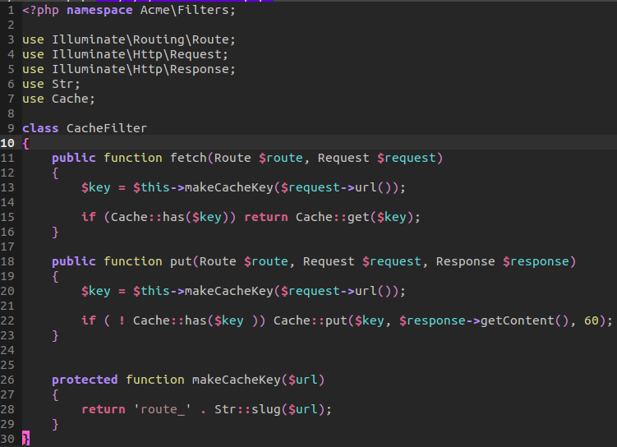

27_Event driven code: There are three ways in order for us to listen for events to fire. In this lesson, we take a look at our single responsibility pattern and implementing a slightly different approach. Instead of having to create a service provider, we can use events to signal something should happen. For our first approach, we will digress both an email service and adding a user to a mailing list –two events that must fire after a user is validated.

We first grab the input as usual, we would then validate the user with their credentials, our repository pattern would create and persist the data of our user. However, the two events of emailing and adding the user to a mailing list will happen thanks to event listeners.

Our first approach will take advantage of an observer file. This observer file will directly listen to an event that must fire. This event will be when a user is signed up. Before using this custom observer we must add it to our application path:

require app_path() . '/observers.php'

By including this path, we now have the file available. Another option would be to use composer.json to load as well.

Now our two listeners can now listen for an event. Notice we delegate such actions to a specific object and method.

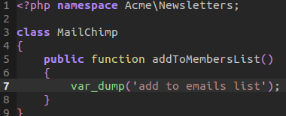
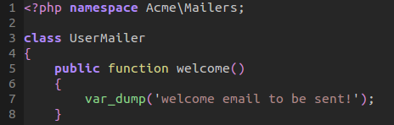

Both of these events fire and thus demonstrate how we can launch these events.

The second option is using a subscriber. The subscriber will allow us to contain all listeners in the object that we want to use when the event is fired. Within our observer file, we subscribe the User Mailer object. Within the User Mailer object, we create a subscribe method that will grab any events and listen for user sign-up –associating the welcome method within it.

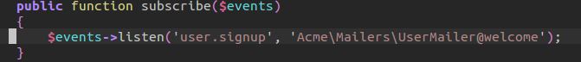
The last approach involves using the constructor to setup the listener events. This will allow all listeners associated with an object that may be used to directly be listed. In a way, it makes it very easy for a junior developer to understand where this listener is registered. Firing the method itself is the same –within the store method.

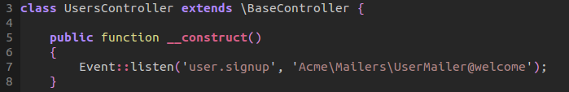
Which of the three implementations you choose is up to you. The biggest thing to consider is which is most understandable within your team? Relying too heavily on magic events and subscriptions may create a rabbit hole of trying to figure out where something happens. The observer object, at the moment, maintains separation while also maintaining understandability.

28_git workflow: There

- git log –oneline : display commits and shortened hash values.
- git checkout <name_of_file> : revert back to last commit or you can use dot for all rollbacks
- git reset <commit_hash> : Let's say that you had two commits that basically did the same thing. What if only one of them really applied. We can apply a soft reset. This soft reset will revert back to an earlier commit while maintaining the most recent commit. This is good if you don't want to clutter your commits
- git reset –hard <commit_hash> : a hard commit is reverting all changes to a file that is just like the commit –not maintaining the most recent commit.

29_polymorphic huh: Polymorphism is the ability to present the same interface for different underlying data types or entities. This is a very complicated explanation for it to mean that one type of data can be present under different types of data. A comment can be present under a Lesson or an Episode. Now we could go about creating a has many and belongs to method for both lesson and comment. But this would interfere with episodes. That is, a Lesson can have many comments and comments can belong to a Lesson. But a comment can also belong to an episode. How do we represent this relationship. Thanks to Laravel, this is quite easy.

Both our Episode and Lesson table share the same description –a title and nothing else.
However, for polymorphism to work, we need to indicate in the comment section how one entity may belong to an Episode or Lesson. To do this, we will indicate a commentable identifier and commentable type. The identifier will identify whether the id belongs to lesson_id or episode_id. That is, when we search for lesson one, then we would find a comment belonging to lesson one. This identifier shows the relationship. The second is identifying the type. Because both Episode and Lesson have numerical identifiers, Laravel needs to know what Model to use in association. That is where commentable_type comes into play. Commentable_type will indicate whether a comment belongs to a Lesson or Comment.

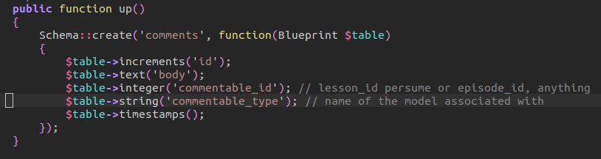
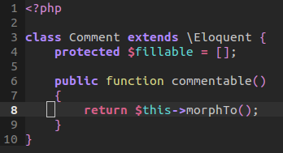
Now within our Comment class, we will indicate that the commetable method will morph comment to belong to a certain model. This method alone will look at both our commentable_type and commentable_id.

For both Lesson and Episode, this polymorphism pattern will apply. Both models will use the same comments method. This comments method will return a relationship that morphs the model to have many Comments base on the commentable identifier and type. Notice how commentable, the word itself, is used as a parameter for Laravel to understand where to look.

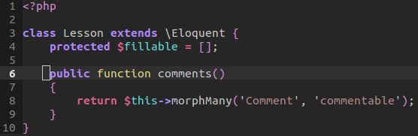

The best way to demonstrate this is through a few queries within our artisan tinker:

Let's say you want to find a lesson one and all it's comments. Remember that comments method above? Yeah! That's where this comes in:
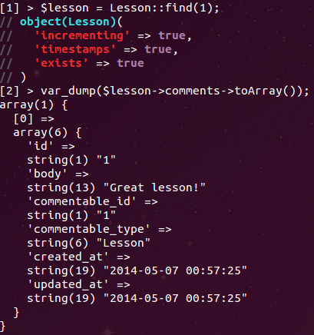

Episode is the same format, we just fund find an episode with an id of one.

But what if we wanted to find a comment with an identifier, what Lesson or Episode does it belong to?

Here we are finding a comment of one and returning the commentable method that will morph the comment model to belong to a Lesson or Episode depending on its data.

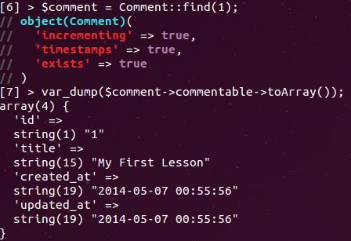

The same thing applies to finding a comment belonging to a Episode –it would be finding a comment with an identifier of two.

But what if we wanted to create comment under a certain lesson or episode? Well, we would first find the lesson we would like to comment. Next, we will find all comments that Lesson has and then chain a create method. Notice we are not indicating an identifier nor any other custom information beside the body comment. Laravel is intelligent enough to know that you want to create comment under the Lesson model with a commentable_id of one! I will provide an extra bit to demonstrate the output for adding a comment to Episode.

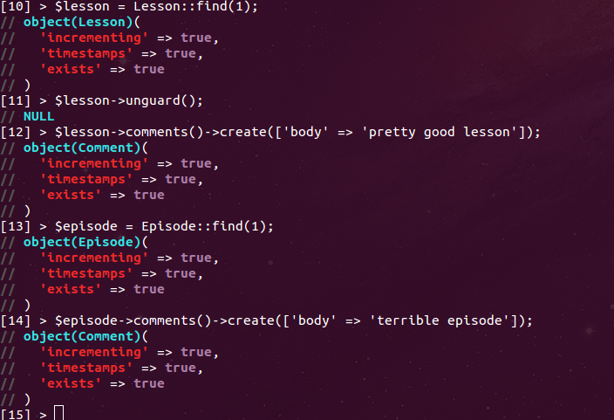

Thus, when we look at our database for comments, we will see that our appropriate entity was inserted –keeping in mind that we are inserting a comment for Lesson or Episode.
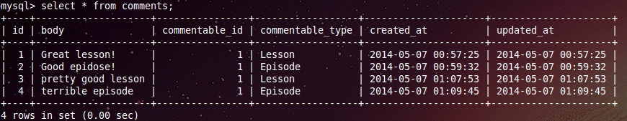

30_iterate anything: In this lesson, we take a look at a primer episode that talks about how Laravel handles iterations. Are you ever curious how Laravel implements itself to loop through an object collection? The ability to do this lies in the Collection object's ability to implement a few classes that allow it to implement a few abstract methods for custom output.

Here, we will be iterating through a library full of books. Our Library class implements two classes: Iterator Aggregate and Countable. Within our constructor, we maintain a reference of an array of books –each book iteration is an object itself. We then implement two must-use abstract methods. The get iterator is used in order to indicate to the for-each loop that it will handle the iteration through the object it must iterate. In this instance, the books that where injected. The count method, on the other hand, will return a count of the array of books –count method is abstract and therefore provides a means for us to count an objects properties.

Our Book class does not implement any classes and only offers a reference of a title and a getter for such title.

Through our sequential code, we create a books array, pushing a new Book object onto the stack. We pass the array to Library for reference. When we use the for-each loop, we are using the get iterator method to return an iteration of the book reference. We then call title for each iteration of book. We also echo the total books through count. This all adds up to us understanding how Laravel iterates through objects. Its done through PHP5 Classes and features.
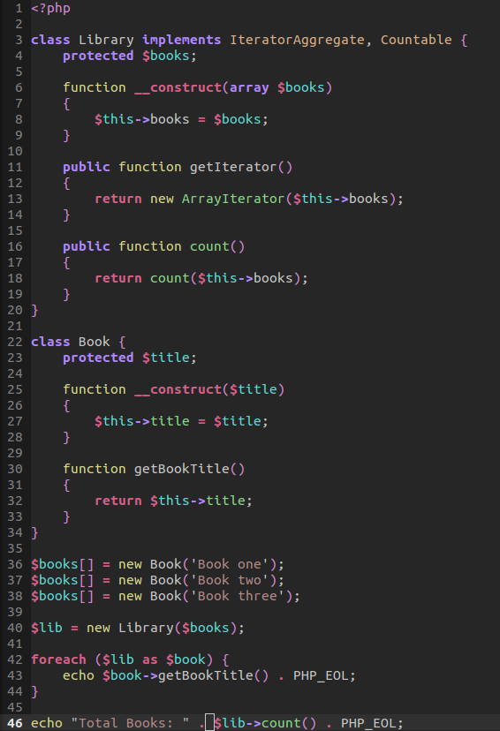

31_testing crash course: In this lesson, we had our first crash course in testing. One of the most popular testing packages we can use is PHPunit. PHP unit offers its own package via composer. We can install the package and then call PHPunit from:

vendor/bin/phpunit

I believe there is an available way to install PHPunit over aptitude. But for now, I'll just leave it in here.

We can take advantage of testing our routes, what data is returned, to even asserting if a certain status is returned. In these cases, we will register a controller that will demonstrate some of our work.

Our route will have the following routes. Notice that we are using the main index request as home and we are using the index method call from the Pages Controller.

We are also going to call our controller in order to use our controller as pages. Lastly, we will create a post request that will be known as buy for the pattern and the closure will return a redirect back to the home route where we will send a flash message with Foo data.

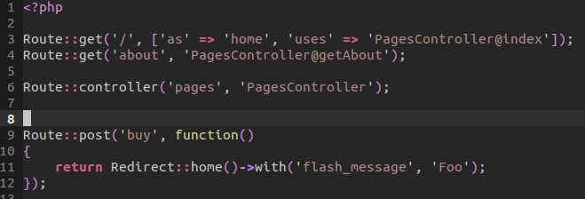

In our controller, we have two methods. One is an index that returns a message and the other will return a view with tags. These tags I assume are referring to cache tag values –I checked the API and couldn't find the direct reference. Look this up with ctags.

Now to the magic of our testing. We have test folder in which we have a Test Case and an Example Test. The Test Case class will create the application, put the application into testing mode, and then require the start PHP file to which gets the ball rolling.

Now we will focus on testing with the Example Test class that extends the Test Case Object.

We first create a test index method that will call a GET request to the index and then assert that the response is OK –that is, a status of 200. This, along with tons of other helper methods are available from within:
/var/www/Laracasts/vendor/laravel/framework/src/Illuminate/Foundation/Testing
We can see how we can assert what are response should be and compare the results. In a way, these test cases are very similar to what we did at tally24.

Another test we written I a basic test that will make a POST request to the buy route. We then assert that the post request will redirect our header to home with a flash message. We make sure that both the redirection occurs along with the data that is passed through. More specifically, we are making sure that the data that is passed equals that of the data we expect. This is important when comparing large amounts of data.

We can even assert that a view has tags. In our last test method, we are checking that exact instance.

All of these are kinda scattered but it demonstrates how we can test our code to make sure that it works correctly for our use.

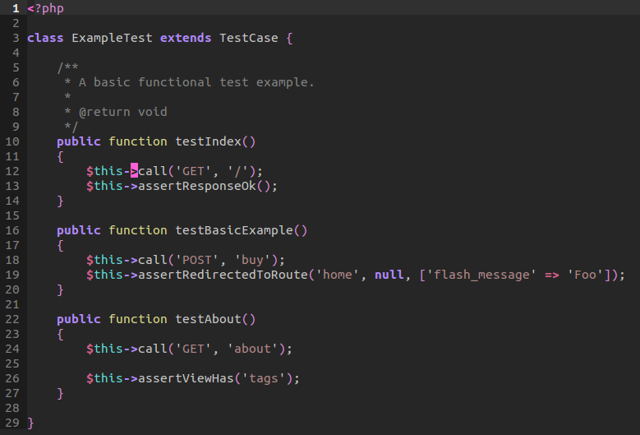
32_view composers: View composers allow you to pass data to a view based on a certain view or section within a view that is available. In other words, instead of having your controllers pass through a tags array, you can create a view composer to handle the data that is passed through. Now, we could simply inject a tag repository in order for us to grab the data from a dedicated repository. However, we want to separate the concern of the controller from the concern of grabbing tag value. In many ways, the view composer offers a substantial benefit in loading content in certain sections of a page that include a side bar or section where the data must be presented.

Within our routes, we've created two get routes of index and about. Both use the resources of the Routes Controller for Pages.
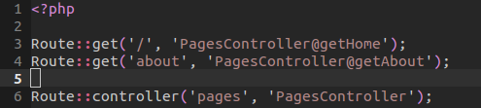

Within our Pages Controller, we are returning two views:
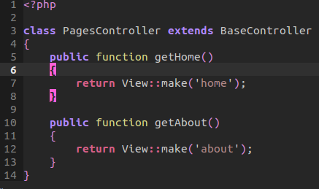

Now within our master page, we are loading a few items of content. Including a separate partial of navigation, sidebar, and content.

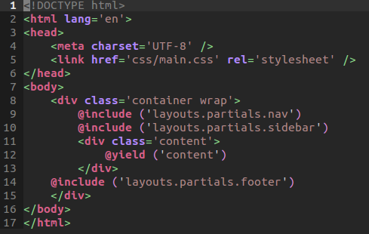

It's pretty obvious how all the other components are organized. The content, in particular, will load a custom title and description. Everything else is the same. Except our sidebar will load its own data:

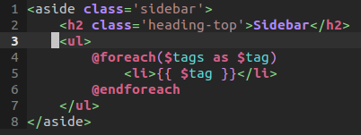

Within the sidebar, we are loading a header and for each tags present in the data pass through, display the topic in a wrapped list item.

Now for the magic.

First, we will separate our view composers into a dedicated file. We can include this file on initial start up by including a require statement within our global file:

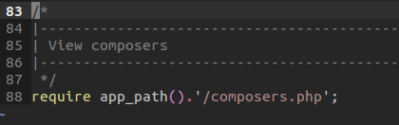

Next, within our composers file, we load up a view composer. Now, we could use a closure to return a view, but we want to make the handle of grabbing and persisting that data to a repository pattern. As such, we will pass through a Side bar composer that will then interact with our repository. If you decide to do it this way, remember that the composer object must use a compose method in order for view composer to work.

Within the Side bar composer, we will inject the flat tag repository within the constructor. We will then include a method of compose that will grab the current instance of view, and load the data from the repository. The view composer will only render that data when the sidebar is included or used within a view. We are not limited to just main blade templates, we can use partials as well.

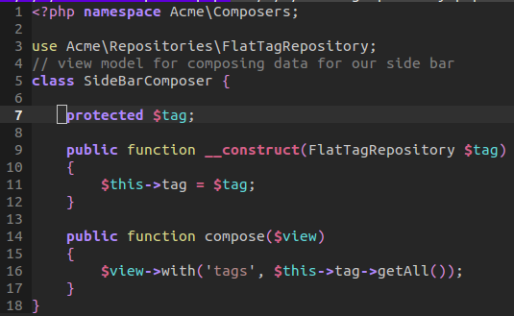

Finally, we will simulate the creation and persistence of data by returning our array of data. All-in-all, this is pretty darn cool for loading data, especially tags, only when need in a certain view:
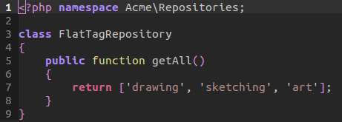

33_search essentials: In this lesson, we take a look at building a simple search functionality for our posts. Let's say you had about five or six post within your database that included a title and post. How would you go about searching those results?

We went ahead and added a search bar on our page and stylized it. For our request, we will be making a GET request and not a POST. This is because we want to search an available database freely. Notice we enter our place holder and name
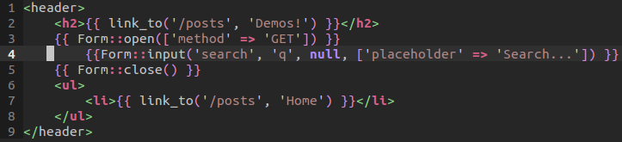

Next, within our route, we will be requesting through a get request. We grab the query through our Request facade. We then take advantage of a repository. We could use a model, which we do within our commented out section. Our model would use the scope search functionality to search its entities base on the query and search. It would then return an array of object values to which we would display our results.

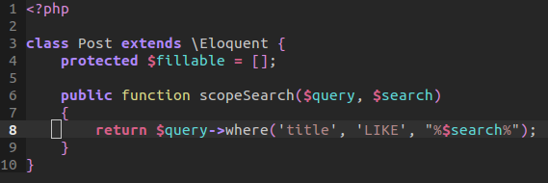

Notice how our query is using LIKE. The LIKE description allows us to find a query in title that is like our search. In this instance, the $query is an object that is automatically inserted inside the scope search whereas the search variable itself is pass through in the commented out section in routes. But notice we are using wild cards to select our search. We specify that we want to find a word that begins as such and ends as such –it even handles searches of words that can be found in whole words. If you want the search to be strict, you can get rid of the wild cards.

But for our example route, we are using a repository to persist or access the database. Our repository will have two functions, a search and get all method. We can use either to grab a search or all of our posts. We return these posts to our view of home to then iterate through:

Notice that we are only displaying results if they do exist. That is, if we do a search and nothing returns, our view will display a “No posts returned” message.

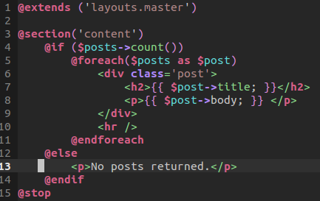

Now within our repository, we use Post model to query our database for a LIKE query, ordering by the created date, and returning the object collection.

Our get all function will return post that are ordered by created at.

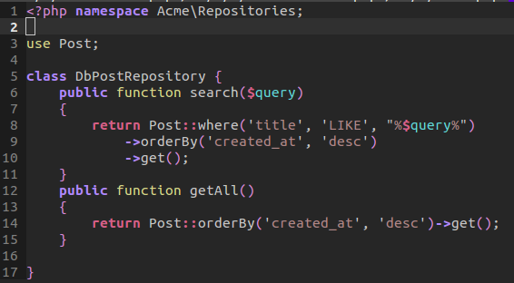

And that's how we search a table and display information. But what about two tables when searching?

34_When to interface: Time for some more bread and butter. PHP is an object oriented language that encourages the use of contracts and inheritance. Specifically, the use of interfaces is essential in extending new features without modifying existing functionality.

Let's take an example in which we have a billing interface. This interface will be a binding contract that specifies any class that implements such an object, must implement all methods. By implementing and using interfaces we can have similar functionality between two different implementation. The interface is not concern with the logic of either implementation. Instead, it is a binding form that outlines the available features an implementation must use. We demonstrate how both a stripe implementation and a theoretical service can both implement one interface. We can then bind the the interface to a specific implementation. When we are ready, we can make the application outside the IoC container.

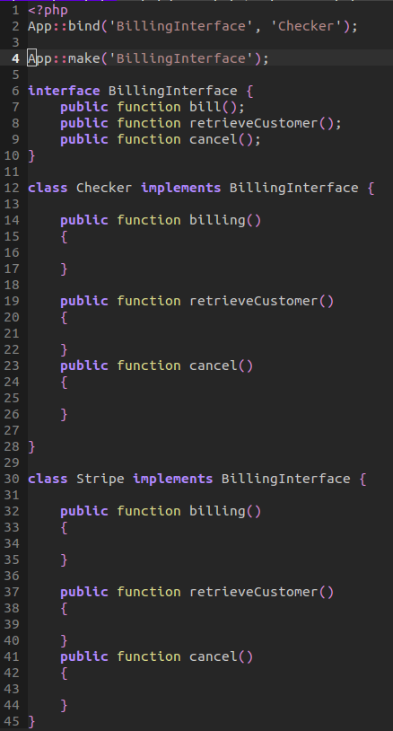

If we were to look at the queue config file, we would notice that we can define one of four differently supported queue drivers. How can laravel do this? By taking advantage of an interface, we can implement multiple queue drivers because each share common functionality but differ in their implementation.
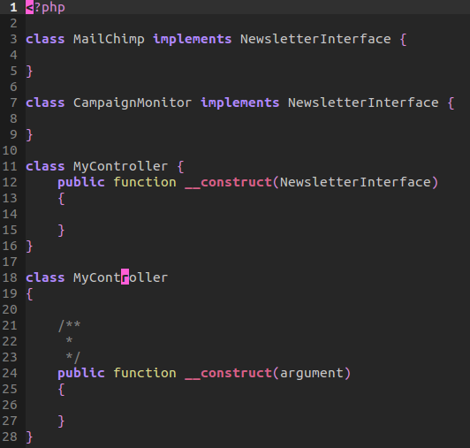
Because we use interfaces, we can easily mock and test them instead of worrying about testing a concrete example. Our concern, again, is available features not actual application. We demonstrate this in our final example. We have two different implementations. Notice that we are injecting a dependency within a constructor. The controller is not concern which implementation is actually used. Instead, it worries about the available methods. It is using the interface, not a concrete example. This, again, makes it easier to test objects.

35_model events: Laravel has the ability to listen for key events to occur within models. Such listener events are already registered within Laravel and thus can be used anytime by calling the static binding of a model that is being used.

Within our routes page, we will be creating a simple instance of a new order that entails a title attribute. How do we grab the event of saving a new order? By using the model's inherited method of saving. Yes, by calling saving method, we grab the current model that is passed through. We can then use that model as a means to validate the data before insertion. Or we can do whatever we please. Following this method, we can then transfer our validation to a custom method of validation.

Now we could leave the model saving listener within our routes, but a better place to put it is, of course, in the model itself. By doing so, we can associate some common methods when a model is saving, saved, updated, updating, deleted, or deleting. The point is, its cleaner to keep the these sort of method calls within our model. Another thing to think about is creating a base class that uses the method. That is, we wouldn't want to keep specifying a boot method in each model. We would extract this out to an external service provider that would handle events in which a model is saving. But for now, we can understand the point of a model saving.

Notice we create a new instance of an order, we then call the method save. When we call save, we will in turn call the method saving. If saving returns false, then the order will fail and dump the errors from the order object. Else, it will return a successful message.

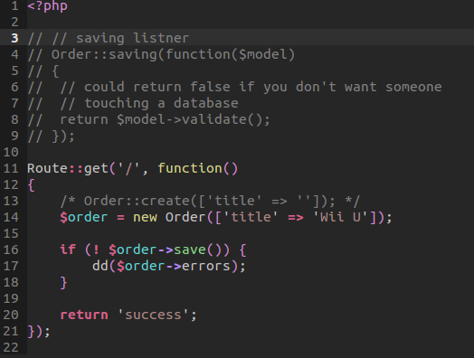

The success of such an event lies within the order object. Notice we use a validate method in which will grab the current attributes of the model and compare those against a set of rules. If the validation fails, it saves the error messages in the objects public variable errors and returns false. If it passes, returns true.

The boot method is actually part of Laravel. Any model that uses eloquent can also use a custom boot method. This boot method tells Laravel to boot or call whatever methods needed within this calling when the model is first referenced or used. We of course use the parent boot method of Eloquent. We then call the static binding of saving to the model to which calls the model's validation. Overall, we offered a cool way to validate our model through listening to key events.
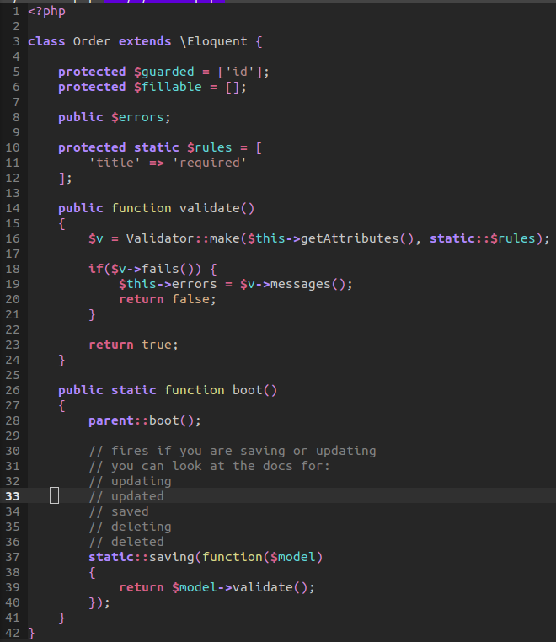

36_just use ctags: A couple notes. Use a package manager to grab the latest ctags based on your OS. I went ahead and assigned the F8 key to generate a new tags file for ctags reference. To generate a new ctags file on terminal: ctags -R dot.

After that, it's as easy as calling tags and the name of the class or method we would like to find. Think of it as fuzzy search on steroids:

:tag Route

by doing so, it will find the proper object. To navigate to the next possible selection:

:tn for next routines.

37_Laravel Remote Component: One of the newest features added Laravel 4.1 is the feature of remote commands. Such commands can be used to handle production environments and other complicated commands that are a bit repetitious. Perhaps SSH into our production server and then pulling in the latest changes. We can run these sort of commands through a remote command. Within our config/remote.php file, we indicate our remote server connection. Such a production array will be used via the SSH task runner facilities in Laravel. One including the Facade call of SSH:

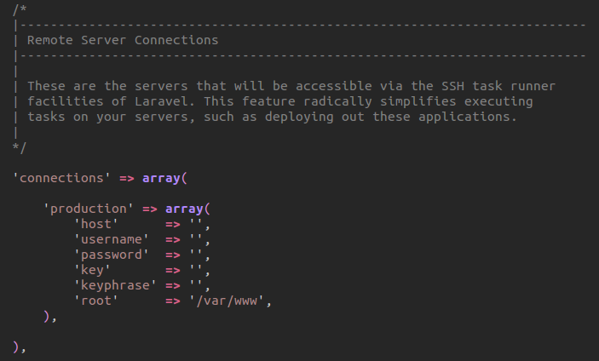

We will notice that one of our providers is indeed the Remote Service Provider. As such, each Facade can then be lazy loaded if it has not already been initialized.

We can then call:

artisan command:make RootCommand

This will create a new file within our application's commands directory. From within here, we can specify a few protected settings. Such as the name of our command. The description of the command. And the fire event. This fire event will call out when we call our command. Now within a more complicated environment, we would of course run other commands, but for this example, we will change our directory into the production root directory where our Laravel application lives. We will also touch a finished text file to demonstrate that our command works. Notice we are using the facade SSH. This is using SSH into production array that we have above. By doing so, we can easily handle some server environment settings via a simple call.

Be sure to register your command with the artisan file. This will add any new commands to artisan. Alternatively, you could also add them as a service provider which is explained in an another lesson.

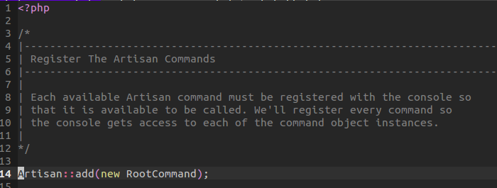
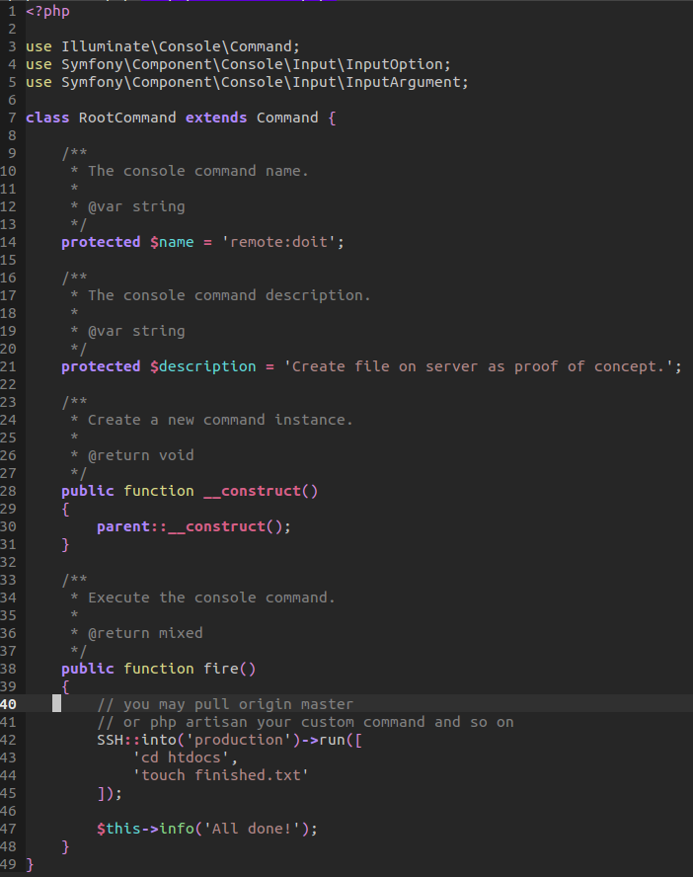

38_Mock that thang: PHP unit offers a built-in mockery service that allows you to mock objects. However, PHP unit's mock service is not considerably the best. Instead, a wonderful alternative is Mockery. Mockery allows you to mock objects for testing. It does so in a clear and concise language.

In this video series, we will look at how to mock and object and why we should do so.

There are two primary reasons to mock an object: one is testing an object's features and the other involves far less memory. Because of this, Mockery allows better performance in mocking objects than directly creating new instances of an object.

In our test example, we will be mocking the Bar object. Our concern is not to test the actual methods within the Bar object. Because the Bar object would have its own tester directly. Therefore, we will be creating a mock of Bar. This mock will assume that the object should receive a request of 'do it' method. It should receive this method call with a blank array. We will then hijack the return statement and thus return a string of 'mocked.' Next, we pass this mock object on over to a new instance of Foo. Notice we are injecting the dependency. My injecting a dependency, we are able to test the mock of that object and not rely on a direct instantiation. This allow better performance handling. When the fire method occurs, we can then assert that the output will match the hijacked mocked object return statement. The main thing to take away from this test is that mocking the object is testing the Foo object to make sure it can call the object it was giving as a reference in the constructor. Moreover, we are not concerned directly with the mock object but that of the Foo object we are interacting with.
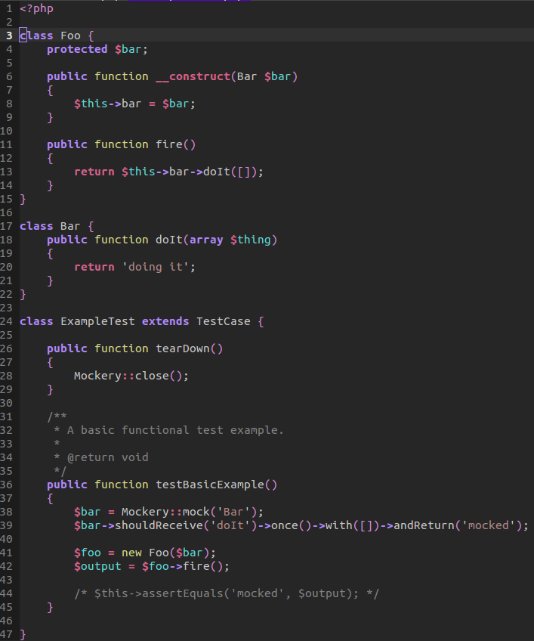

Now that we understand the benefit of Mockery, let us dive into a real world example. First off, let's mock a Curl object service. This curl service would make a post request to a curl service that would then return some JSON or something. The point is not to worry about the direct data that is returned to the post method. Instead, we will be mocking the object and hijacking the return. In a sense, we are not concerned with the direct data that is returned but, more importantly, the functionality of calling such a method.

Within our newsletter object, we inject the dependency of curl. Next, we have a method that adds an item to a list. We then call the post method from the injected dependency. We pass through an array of data.

Remember to always tear down our Mockery object by calling close on static!

Within our test of newsletter, we test that a user can be added to a newsletter. We mock the curl object and assume it should receive a post method, once, and will return a string.

We send through the mocked object and then grab the returned result. We pass the assertion test because it does indeed returned the correct string as a return value.
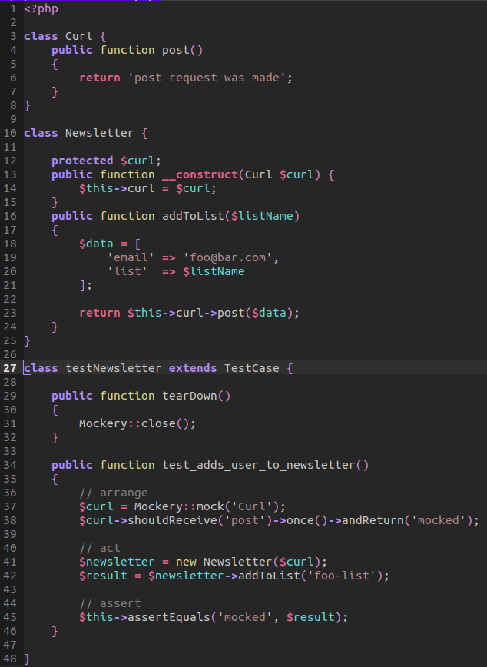

39_Decoding Facades: Facades give us the pretty static interfaces we are so use to while working with Laravel. They allow us to get pass the need to inject dependencies, instantiate new objects, and any other conflicts within the IoC container. In many ways, Laravel's Facades offer us syntactic sugar in order to support classes that allow access as an object in the IoC container.

But how do Facades work?

Let's use the Form object as an example. The Form object is available as a means of creating a form tag element along with other necessities that we can bind and use. But for now, the Form object when called within Laravel is somehow being used. We can use the open-close methods and other HTML form building methods. But how does it resolve such a calling?

Within the Facade folder within our Illuminate vendor folder, we will find the Form object that extends the Facade. By extending an object, we can overwrite current methods and functionalities that are dedicated directly to that object's purpose. One of these methods are the Facade Accessors. This method will return a string call of 'form'.

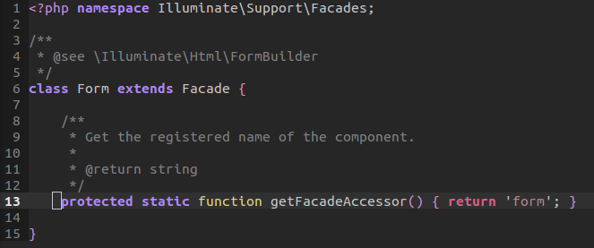

Now let's go to the abstract object Facade. The Facade object will contain a protected static reference for a resolved instance. Whenever we call a Facade, we are taking advantage of the extended abstract class' __callStatic magic method. This magic method will handle the resolve for us. First, it needs to grab an instance of the current Facade. To do this, it will call the get Facade root.
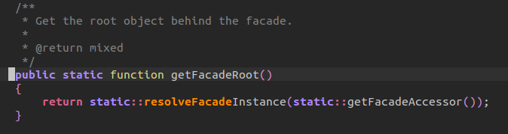

Within this method, we then call the resolve Facade instance, passing through the static calling of getting the facade accessors. Within this, we are actually returning the string 'form' from above.

The resolve method will then check if the reference is an object. If it is, then it will return it. Else if resolved instance contains a reference of such a name, then return it. Else, it will then default to it calling the application instance being facade. This calling of $app[$name] will immediately resolve an instance within the IoC container by automatically binding the instance.

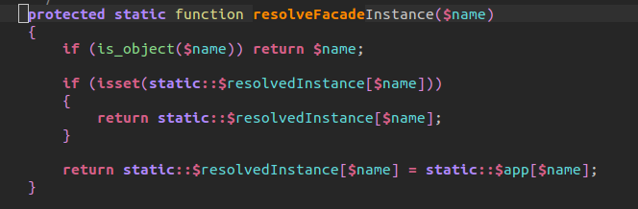
When this returns back to our magic method, we are essentially calling the following:

Form::open() => $app['form']->open()

See how this works, the little magic happens thanks to the automatic binding Laravel offers in the resolve facade instance.

From here we have a switch count that will count the number of arguments that are resolved in the magic method. Up to four will return the instance, else, it will call the function as an array with arguments. This will allow as many arguments for us to pass.

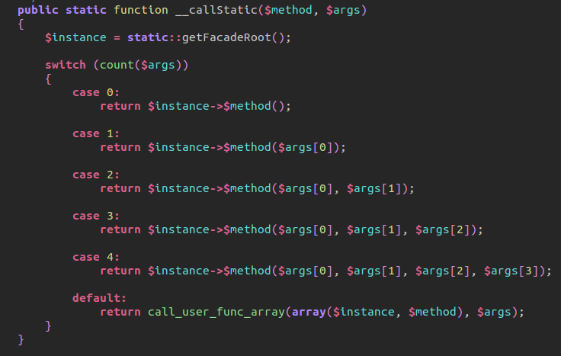

But where is the methods we actually call? Sure we resolve them the object instance, but where are they actually called? This is done within the Form Builder object. A cool way to find the Facade's original class is: echo get_class(Form::getFacadeRoot())

So the next time someone says Laravel is not secure because it uses static bindings and calls in the global space, we can refer here to see that such Facades are not static calls but are actually instances that are resolved out of IoC container.

40_Vagrant: Vagrant allows you setup a virtual environment inside your machine that can simulate 100% of your production environment. The main problem it solves is: my machine only bug.

There are a number of problems that occur when you update your operating system. We may have PHP on our system, we may want to manage a version version or server environment that are massive buckets of code. Instead, we should version each of our developer's environments into a separate box or portion so that one doesn't interfere with the other.

Vagrant allows an intuitive way to simulate a developer's environment so that it responds in likeness to a remote server environment.

To get setup, install vagrant and virtual box. However, this step, in itself, is actually kind challenging. First, never download anything from aptitude. Just don't. The repository that aptitude uses is out of data and is not compatible with the current virtual machine it supports. Second, make sure you enable virtualization in your BIOS. If you do not enable virtualization, virtual box will not work correctly. Specifically, it will not allow you to use any boxes that are capable of 64-bit architecture.

The best option when adding a box is to use bash's wget command. Go ahead and grab a copy of boxes from vagrant boxes: http://www.vagrantbox.es/

Once you add a box, go ahead and add it to Vagrant's available boxes. To do this, simply add a box by:
vagrant box add <friendly_name> <URL> remember the URL the path to the box you grabbed.

Once you add the box, go ahead and initialize: vagrant init <friendly_name>

If everything goes well, then you can SSH into your virtual machine by:

vagrant ssh

From this point you can create a bootstrap file to jump start your production environment. Remember to link your main machine's project files with Vagrant so you can edit in your local environment and then test in your vagrant production box.

