Laracasts via Jeffrey Way

\Casts

01_Laravel Installation for newbs: Installation via: composer create-project laravel/laravel <name_of_folder> –prefer-dist

Make sure you install the dependency manager called: Composer as a global tool in your terminal.

Within your composer.json file, it's best to include a “require-dev” environment option in your JSON so that you can include Jeffrey Way's plugin on the development process and not have it upload to your main application cloud.

02_From zero to deploy with fortrabbit:

- Setup an instance of Laravel on your system
- Setup staging vs production environments
- Copy remote settings and global variables to local
- Create remote git for local project
- Push
- Make sure debug is off and that your environments change correctly
- Unfreeze app –unless host purchase.

03_Atoms feeds decoded: In this screen cast, we decoded Atoms Feeds. We first grab our currently posted data, parse through it, posting to a blade template of the RSS feed to display. We send a response view so we can make an XML or Atom feed.

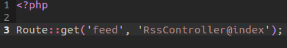
First, we register a simple Route to get a request for the feed of our website. This will, in turn allow us to use our controller:

Next, within our controller, create an array of data with a named index of lessons. We assign this value the name spaced table of lesson and we order by the published date. We organize this in descending order getting only 10 of the most recent. We return a response view which will allow us to view a page source of 200 -specifically expecting a render of XML data.

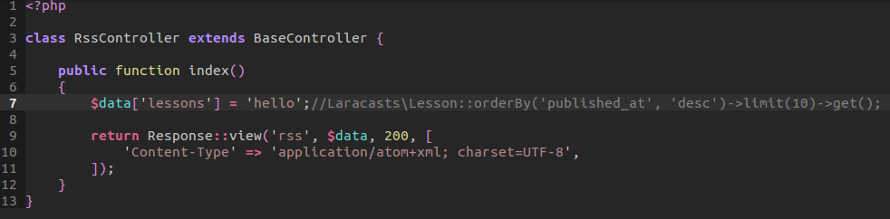

Next, within our RSS view page, we create an XML styled sheet that provides a link to our website. We also provide a call to the name spaced carbon now for atom string that will provide a dynamically added date for when something is updated. This will allow us to easily update information on our feed. We provide a for each loop that will display information for each feed provided . Including a link to the lesson, a summary of it, and title. All this information is provided through our lessons data which is again, provided from our array lessons. It goes through each index bit and outputs an RSS heading.

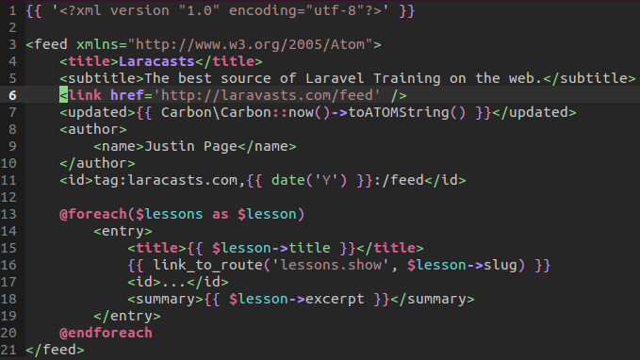

Finally, we have a helper function that will process the URI that was provided in our link. We will link to the link show route which will take advantage of our helper method below. This will parse the request from the show route. And grab all the data from lesson slug. We will then assign to out output array tag, the sub domain name, time updated, and finally the path. We implode the data based on do empty spaces –bunching it all together. All together, we have created an easy to implement RSS feed. All we need to do, is correctly adjust both our function to be used and our query of our lesson database to whatever we like to query.

04_Mailers: In this screen cast, we set out to create a mailer class that separates the functionality of mailing items to a user and that of the settings. Jeffrey Way shows us exactly how we can arrange our classes so that we can easily send emails to our users.

First, we need to adjust our app/config/mail.php file. That PHP file will contain all the information you need to input for easy to use SMTP submission. This will work by default when using the Mail object however, we can do better.

I'm going to walk step by step through the routes file, controller, as well as the mailers folder.

First, within our routes, we create a resource in which we register a RESTful route to be available to our application. We override the store method for a particular route. That is why we post it above the resource calling. So when the user visits: http://127.0.0.1/users/create then that user will be directed by this route.
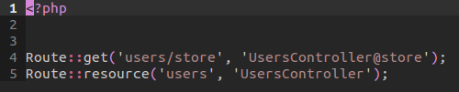

Within our controller we are calling the use of the name space of Acme\Mailers\UserMailer as Mailer. This means that we are technically using all the functions within the User Mailer file that we will be looking at later. However, this user mailer file inherits from the abstract class called Mailer. This means that we have access directly to the file we are using and its inheritance. We use Mailer because we already use it throughout the file. But technically, again, your calling the name space of User Mailer.
We then create a protected variable within the Users Controller that will be used to reference the Mailer name spaced. That way, we can have a local instance every time the users controller is rendered. We demonstrate this in the constructor:
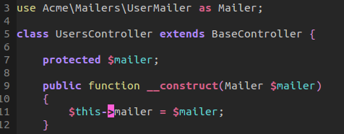

Now drawing ourselves back to the store method. We first do a simple query that finds a user by their identifier.

// footnote -you can use php artisan tinker to interact live on your application. You can create a new user and then add date to then save!

We grab that data through the above query. We then call the reference of our user mailer class to call welcome and send it the user object.

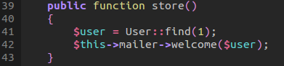

Within our User Mailer class, we extend the Mailer class to receive all its property functions
We call use User so we can have direct access to the user. Because we send user data through, we want to make sure we are interacting with the same user object! That is why we call User $user.
We then create a few variables to send over -including a view. All this calls the send to function.

By separating the welcome function and send to, we separate features from the functionality of sending an email.

We provided an additional cancellation method to demonstrate how we can categorize our methods to use our mailer abstract class.

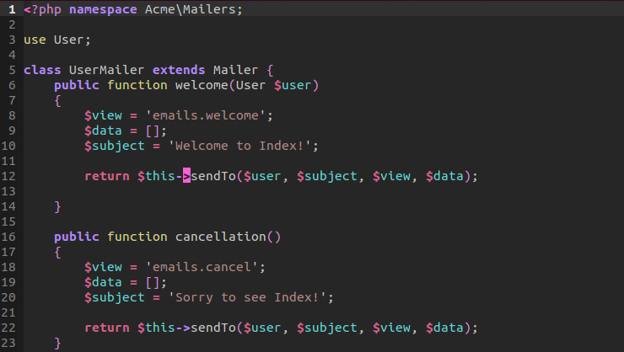

Lastly, within our abstract class of Mailer, we are using the Mail name space and we are grabbing all the parameter arguments from within our function. We call Mail send or queue. Either one will work, later on we will look at queue which will make our process faster to send emails instead of waiting for them to submit. For now, we send in our view, data, and a closure function. Notice we are sending in a message and then claiming to use the user and subject. Remember, the closure is a callback function that will run on callback with the use of user and subject. Sort of like when we use node js for a callback function. We run the function and then run this closure function for the callback. Notice we are not returning so this is a closure for running on callback.
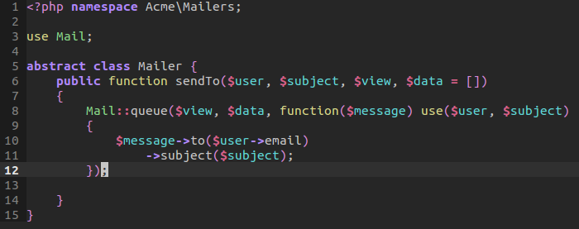

05_Environments and configuration: We can define environment variables easily within Laravel. To do so, we head on over to our routes.php to see what we serve as our default environment. Our default environment can be displayed by calling:

app()->environment or App::enviroment();

This will display whether we are in production or development mode. Obviously, if we are situated inside a production mode, we do not want to display certain information. Such as debug stack trace. We can turn off debug mode for production. To define which environment we like, we can define a default ternary operator in which we detect our environment inside the bootstrap start file. To define the setting, we return a default value of environment, and if not found, then return development as the environment.
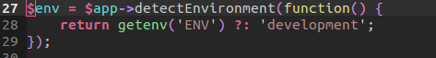

We can then set our default values within our config file. Specifically, we can define a development folder in our config file that, when defaulted to development, could be referenced. A simple example is setting up one database instance for development and another for production. We return an array of settings within the file.
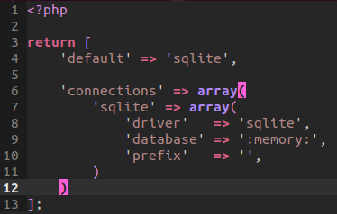

We grab the files details by calling the Config object getting the database file and its property of default. By default, since we are in development mode, will return sqlite as our default database.

Return dd(Config::get('database.default');

06_Many-to-Many relationships: Many-to-Many relationships can be described as table relationships that share a common feature that is related in many aspects. For example, a lesson can have many tags. So can tags have many lessons. If both can have many of each other, then, they are a Many-to-Many relationship. In this lesson, we executed a few commands to get the ball rolling on our code.

First, we created a Model of Lesson and Tag.

We then created a migration with three different migrations –the first two allow us to import a lesson and tag table with a few properties relating to it's name. Next, we create a pivot migration

Notice, that our pivot migration, creates a new table with a normal incremental identifier as well as a lesson and tag identifier. These will be then used in the foreign columns that reference the lesson_id and tag_id to reference their respective identifiers on lessons and tags table. This is very simple as it creates a foreign key that links both identifiers with a pivot table. By creating our many to many relationship this way, we can organize the way relationships are handled.

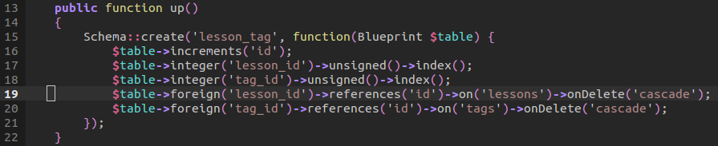
Next, after migrating all the tables into our database, we go ahead and start creating identical functions inside our models that allow us to define how lessons belongs to tags and visa versa.

This simple call will return the object's belongs to, which will be linked to the pivot table we created earlier.

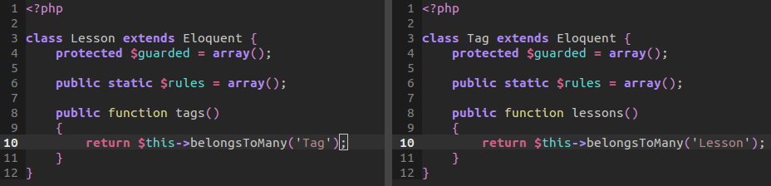
Lastly, we start returning that data. I'm going to discuss, first, the commented out code first.

We grab one lesson, which Eloquent will find in our database. We then return that find in a lesson variable. That variable is an object which has access to the tags method we created earlier. By returning lessons tag, we are essentially telling Laravel to find lessons that belongs to tags. That is, lessons who have been linked to the tags table via pivot.

We can alternatively call the full function if we want to chain events.

We can also do the same for tags! We just revers the callings we did for lesson.

Coming to a close, we grab the first lesson and attach a number. That number will attach a value of tag to the lesson. That is, the first lesson entry will be linked to tag 2. Thanks to the attach method, it allows us to easily call and attach a tag number dynamically. We return the results to see.

Remember, all pivot table entries are entered manually. But we can attach them through that simple call.

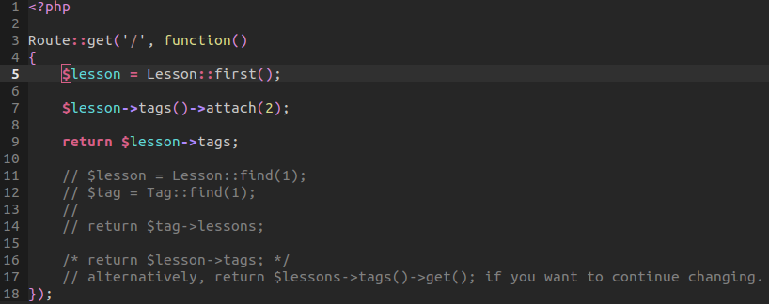
06_Easy asset management: In this lesson, we take a look at asset management OR files that require us to shrink, compile, and output towards a different output. One helpful tool for this, is guard!

Guard is a gem in ruby that provides management for our SASS, Coffee Script, as well as live reload!

We install all our gems and then call guard init inside our Laravel project. That will allow us to create a Guard file. That guard file will allow us to launch compass, as well as indicate input and output of our coffee script files. We can also indicate how we would like to compile and minify our other scripts for performance gain via uglify.

We also have a config file which is created from our compass file itself which will allow us to indicate where we want certain files to compile to. We can indicate source of sass, css, and the default http path.

After all our settings are set, we can call guard. Guard will then listen for any changes done in our laravel project. We can then add coffee script or SASS files. And after saving, it automatically will compile both into proper JavaScript and CSS respectively.

There's not much need for photos as we understand how to create asset management.

08_the ioc container: The inversion of control container is a powerful tool for managing class dependencies. These dependencies allow the developer to easily bind objects to other objects and thus create new instances of that object.

To demonstrate this, we will work with a small example and then jump into a larger example.

We first create class of Foo. That class will have protected instances that will be instantiated in the constructor. Those instances will include two other classes. We can then call make with that class of Foo which will provide the object of Foo along with the two inner objects of Bar and Baz.
This is extremely powerful because Laravel is allowing us to inject dependencies without having to manually code them in.

We can over write the make function with the bind call of App OR we can create an instance of the Foo object with a new object of Mock, this will make Foo an instance of Mock
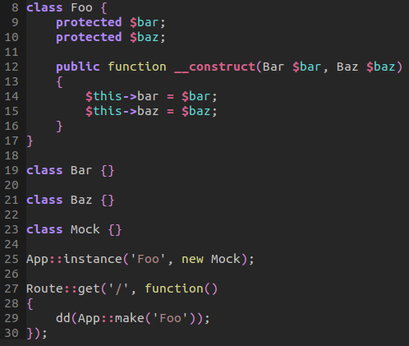

Now, let's move onto a more realistic example where this can apply. We have orders. Orders in which are used by a controller and are registered as a resource for multiple REST requests. That orders controller will have access to an order repository interface that will give us the ability to call out to our database and make requests. Those requests are separated by name space into their own respective files.

As indicated in the use call, we are using the Acme Repositories Order Repository Interface.

We then create an instance of that interface in a similar fashion as we did in the first example.

Next, within our function index –which is registered within the orders call– we call the method get all which will return a result from our database. Now behind the scenes, much more is happening:

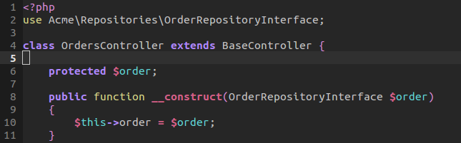

Within our interface, we are using a name space of the Acme Repositories. We provide an interface with the specified function of get all. This is an abstract function, in that it does not contain ANY body code. We include the code in the implementation of the interface:

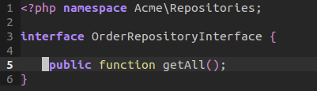

In our implementation, we use the name space of the Acme Repository. We then create a class that implements the Order Repository interface. Here, we provide the code.

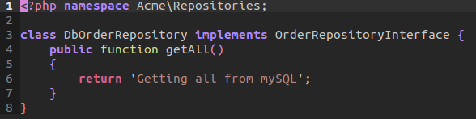

Now this is all great. We have separated our abstract class from our implementation. However, Laravel doesn't know that there is a direct connection with those two files. We need to bind them together!

This is where magic happens. The magic that is provided is binding the interface with the implementation. By providing the following code below, we do all this in one step. This is fucking powerful because we can bind multiple instances of implementation to an interface class! And this all doing it through one liner!

09_observables: The following topic actually solves a problem we where thinking of while learning laravel. That is, Laravel offers event listeners for when users, objects, or actions occur that our program will notice to then fire a list of events.

For example, let us say that we have users who register or log on. When a user logs on, just think of the amount of events that need to happen to keep the user logged on. For one, we need to make sure that their credentials are valid, they have made their payment, our session variables are correctly assigned, even other items of action. The point is, when a major event is fired or happens, we need to listen and then react to those changes within our application.

We are going to look at a small example, and then take this to a more realistic example. We can use the Event object to register a listening event. We name it user dot signup because that indicates that we are listening for the users object and then the function for their signup. It's not required, but it's a great way to artificially namespace and organize our event listeners.

We send in an object of user to then dump the output of a user and array.

Notice that in our index request, we do a simple query for the first user inside our database. We then fire an event. Imagine that a user logs on and then this event fires with the listener named along with data provided.
By doing so, we have a listener and a firer. We output the result and thus demonstrate a simple event listener and firer:

// both the array + the fire string will be rendered on the browser.

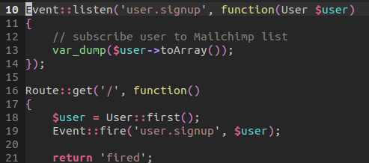

Now, what if we want to organize our events into a single user handler. Somewhere, where we can have multiple events listen and fire when activity occurs in our application.

Within our route, we create a single event fire that will call when we visit the index page of our application. We call the fire event on user sign up –this indicates that we are looking for the user event handler, and specifically, a function of sign up.

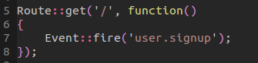

We register our subscription within our app/start/global.php file in order that we can use a single event handler file for for our users. We name space our event handler file with Acme\Handlers\ --sort of like providing the full path to the event handler of the user file.

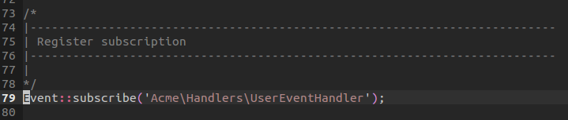

Now to the meat of our event handler. We indicate proper name space for our file organization AND we included a psr-0 auto load map in our composer.json file where we indicate that Acme is namespaced within App.

We create the class with a subscribe function. That function, along with the class, is subscribed. So that subscribe function is what provides the event object that is passed through to then listen to and register listeners. We need this function because it's what grabs the events object and then registers the listeners.

We register the names of the listeners as cancel and sign up –please note, we are using these when firing! Look above at our route when firing.

We then indicate that we are using the event handler's function. Notice we are using the entire name space and call to exact function –something similar to controllers and individual methods within it. We have both registered for listening. Both methods just die and dump a string. But as we can see, we can have multiple listeners in a single file handling multiple events.

We can also send in data to those functions when firing as well!

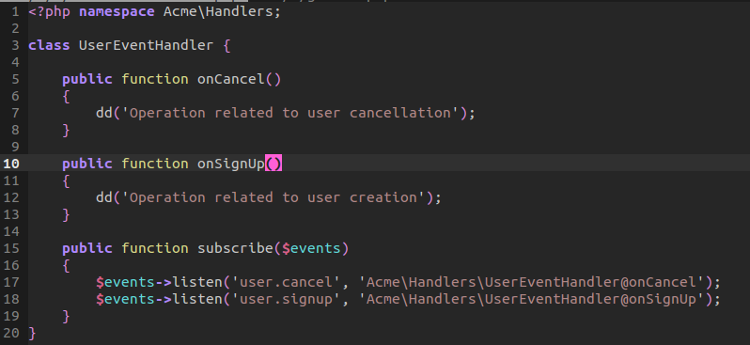
10_where do I put this: In this video lesson, Jeffrey instructs us detailed information on where to put certain files when structuring our code.

An interesting quote from Taylor Otwell is that the MVC mindset forces us to organize our code in a certain way –and that's bad because it obscures from organizing our models into single acting entities. We don't have to follow the organization of this file structure, instead, we can create our own organization that takes advantage of MVC that is customized for our use.

In this very simple and quick example, we create a Acme folder that uses psr-0 auto load. We then create several sub folders that use different features of our application. This application will all be organized from within these folders. Interestingly, we create an interface as well as a file to implement it. We name space both to use. We provide a simple function that dies and dumps a billing string.

We create a new instance of that class to then call the bill function in our route:
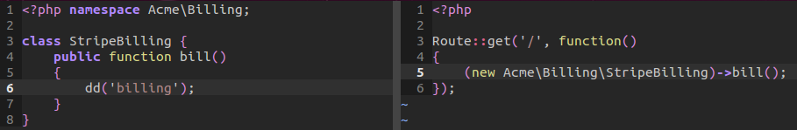
Another cool thing to note is that we don't have to keep our models in the model folder! Some have been moving it to custom folders so developers can easily reference and use those models elsewhere. It all comes down to using Laravel to our advantage and not getting stuck on having to use a certain file structure. Putting too much in controllers, models, and view, will obscure from the original functionality and purpose of the file itself.

11_understanding rest: REST is simply cleaning your URI request into elements that are organized and easy to understand. REST allows requests that allow you to create, read, update, and delete data. Sound familiar? Yes, CRUD! CRUD is used within REST to make request to the server. The difference is that RESTful request are made with keeping your request and responses organized into elements within the URI.

In this example, we use REST within the registration of resources. These resources are registered based on the name space we give the controller or what actually handles the requests and responses.

In our routes, we registered two resources. The first is a simple users route that will handle all CRUD request. The second combines the users request alongside questions for a deeper request specific to a user identifier. We will look at this more in a bit.
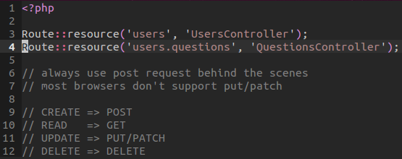

Now many get mixed up on the purpose of put and patch. Put is sort of like updating an entire entry within our data -replacing the entire bit. Whereas patch, is replacing a section of the data but not the entire thing.

I will display the entire routes as registered above:
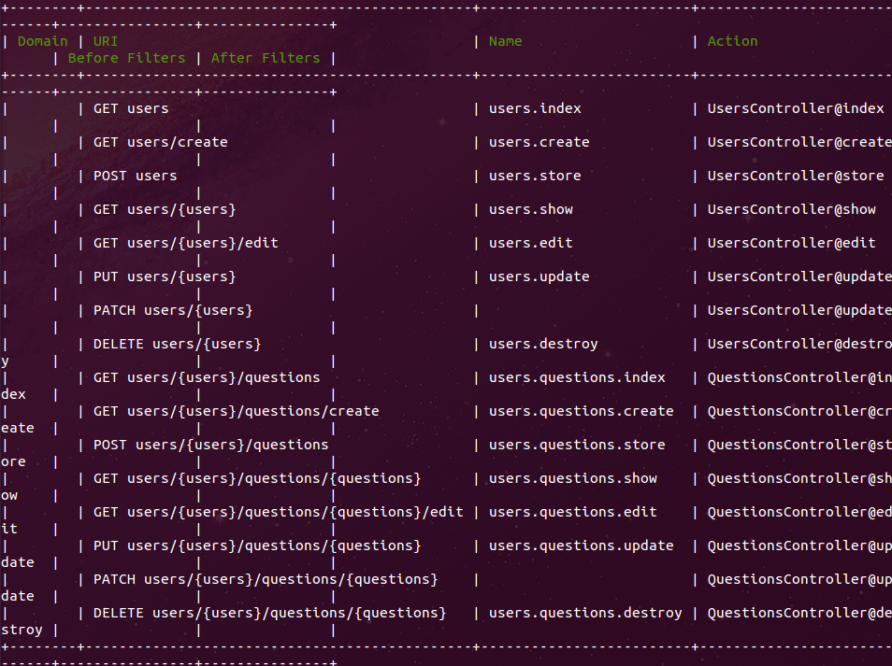
Notice that are GET and POST request are the same URI but they are handled by two different methods within the controller. We also have combination routes. For example, the users questions edit uri, will grab a question with an identifier that is associated with a particular user.

We can grab both parameters from the show method. We can then process the order and display results. I'm not going to show the entire controller but more can referenced inside the branch of this environment.

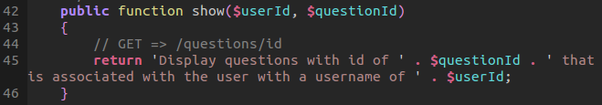
12_restful forms: Going with our route resource of questions, we will look at how restful forms can work in Laravel.

We register one resource, the questions resource in our route.

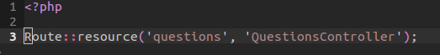

Now, we will create a controller that contains all our restful request. We are going to use this in conjunction with two forms in demonstrating updating, deleting, and saving a form.

Please refer to the below restful routes for reference:
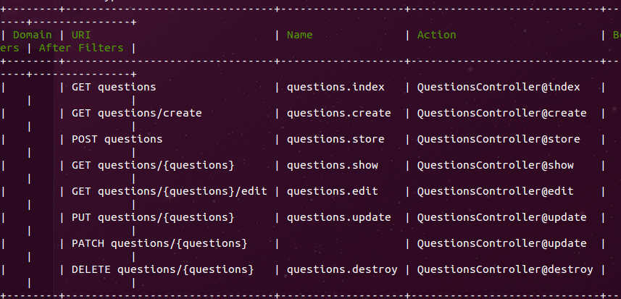

Our first form is a create method that will POST to store. The store method handles the direct post to the questions store function. Inside the function, we will have a submit button and normal form entries. The important part to note is that we are using an array provided argument for a route to then use to
post to the store method:

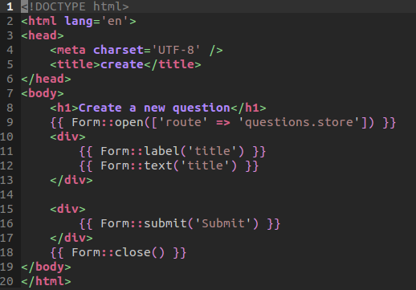

Now the next form will use the PATCH method to update a part of a question. Interestingly, some developers will interchange PATCH and PUT –both update a file but in different ways. PATCH for a certain section of a data update and PUT for an entire section update.

We use a direct URL redirect to questions/variable of identifier. That URL request will be handled by our controller to then display our current question. We hard coded the bottom result:
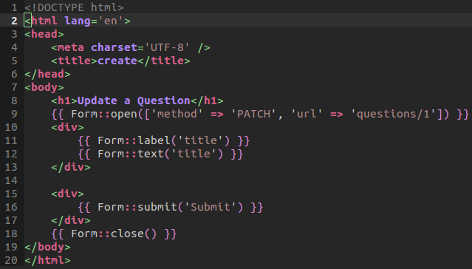

Lastly, what about deleting data? To delete data, we provide a show blade template that will provide a delete button. This button will submit through the method of delete –not an anchor tag with a get request! Never use GET for any data changing events! We use the route of questions destroy, providing a hard coded value for the second parameter of the route array. Once we submit the array data, viola, we have the result indicating that we destroyed the first identifier question.

Obviously, we would process that identifier in our database, to then delete.

// show blade template that displays the delete button.

// respectively, this calls the question method of destroy, which will return a message via Session object:

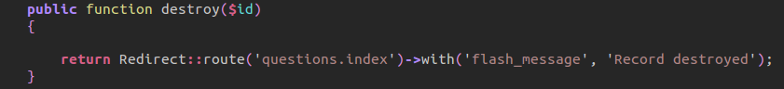

13_repositories simplified: Repositories are essential in abstracting your code into a persistent mechanism of design and implementation. Instead of having to write all our logic from within the controller, we can abstract that process so that multiple database, or other file type entries, can use this code and thus create greater flexibility.

We first began seeing how we might usually create a database query, we would normally do it in the controllers. Now this isn't a bad practice. Laravel makes it extremely easy to do this. But there is a problem that lies from with this concept. As our applications become larger, this becomes harder to test. Static method calls are hard to test, instead of reference methods. By abstracting our database queries into references, we can create a testing environment that pays off in the long run.

First off, we create a Repositories folder within our Acme folder. That folder will allow us to create our own repositories in which can have their own options. Now, generally, we can just use this files and be done. But abstracting this level, will allow us to follow dependency inversion. That is, we will depend on abstractions, not concrete implementations.

Thus, we will create an Order Repository interface. This interface will abstract our methods.
This interface will namespace itself in the Acme Repositories folder. We then create the abstraction along with two contracted methods:

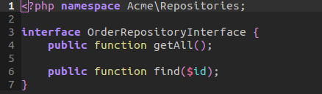

Once this interface is created, let us start using it.
We can implement this interface by first name spacing our DB Order repository. We then call an implementation of the interface. We also include a use of the Order –the model that allows us to call
out a query for the orders table.

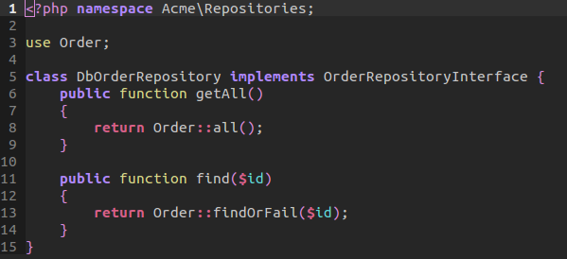

Now, within our controllers, we are going to use the namespace of the Order Repository Interface. We create an instance of that reference by first defining it within the constructor. This allows us to easily inject a dependency within our constructor which allows us now to have full access to the interface.
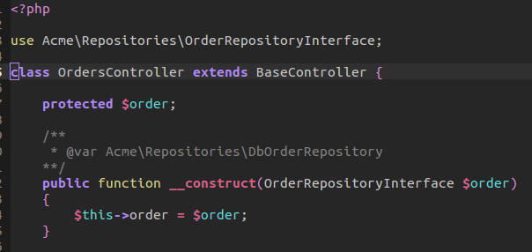

Next, we have two methods will test –the index and the show method. Mainly, the index method. We can reference the order by calling the objects own instantiation of the order object to then call the method of get all. By doing so, we can get all the queries because they where define, not in the controller, but of course the implementation of the orders interface: the DB Order Repository.

Now, we are going to go to aside –real quickly– and see how we can use the interface in order to link it to the implementation –this is where the secret sauce comes in.

Now, within our routes, we register a single resource that using the orders controller. This way, we can call all our resources within our local environment. That is, http:127.0.0.01:8000/orders This will allow us to view all the routes. But where do we link our interface? We could do this inside the routes file –not problem. But, again, this will turn messy and not allow us to readily create larger scale applications. We need a place for all of our bindings. To do this, we will create a file called Back End Services inside our repositories folder.

As normally, we will namespace it to it's parent folder. We will then use the service provider by Illuminate. We then extend that feature of the service provider. We provide the calling of this, or the current reference to the app itself, and bind our interface to our order repository.

With that simple function, we have binding our interface and our repository implementation!

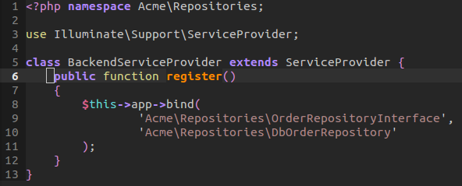

This is the link to where we can now call our request of orders and see all the results.
We can then simply switch out our implemented order repository for a file repository and it will work the same. That is, a file implementation will have access to those same queries, methods, and abstraction that we originally provided.

Take note that to create this back end service provider, we needed to add a small stub in our app/config/app.php file.

Again, the advantages are clear. Our controllers are cleaned up and we don't have to write complicated queries in the controller. We can simply default to a descriptive method. Because we are injecting our repository, it can be swapped with a mock. Finally, the third advantage, is that we have flexibility. The controller just needs a persistence mechanism. It doesn't care what you are using –it could be Mongo DB!

14_incremental validation: In this lesson, we took an incremental approach to writing server side validation via Laravel. We started with a very simple example of providing rules to validate and return errors. However, through the process, we can see that our controller was becoming far too messy for use. That is, the abstraction of the controller class was no longer controlling routes but handling validation logic. In some instances, this is an anti-pattern.

To fix this, we will look at a process of validation that allows us to easily implement an abstract class which allows us to extend rules into it. By doing so, this is a preferred method for creating further functions in aiding our validation.

First off, we create a Lesson model as well as a Lessons Controller. The model doesn't have any relative substance besides linking our Model to our Controller through the database of lessons itself –for which we created simply with a name, description, and video source input.

I'm going to walk through the controller first and then the view. However, we will dive into separate areas for independent understanding of the process.

We register a single resource for our lessons request –this allows us REST within the lessons URI.

To actually grab a resource, we will use the create method, that is, lessons create. We will use this view in order to verify our input and submit our data.

In this instance, we have a form tag that will post to the lessons store method of our controller –remember, we can generate a form via artisan.

We then create three inputs and a submit form button. Notice, that we are using the errors variable and grabbing the first instance of each error to then output a span tag. This will allow us to not have to render unnecessary tags when they are no longer needed.
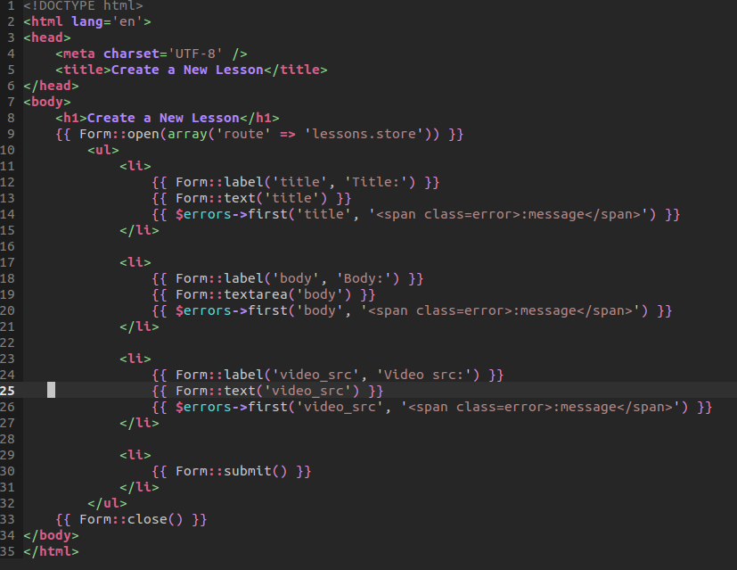

Back to our controller, the store method will now handle our validation. I'm going to explain the process and later I will break down the methods.

We check to see if the validator returns any errors. If it does, then we will redirect back to the create route with the errors that we generated –if any input is present, we will send the redirect with the input.

If the validation was successful, then grab the input and create a new instance to then save to the database. Redirect back to the create page and you can check your SQL for a new entry.
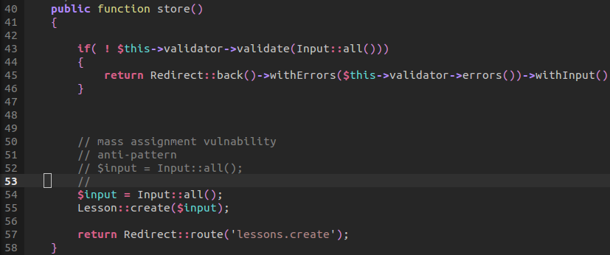
Within our Acme project folder, we created a Services folder that contains many services, including validation.

Now remember, within our Lessons Controller. We are using the Lesson Validator and not the abstract validator class itself. We are using that to then inject the dependency of the validator into the Lessons Controller. By doing so, we can have the validator dependency inside our controller and thus use it.

Neat, huh?

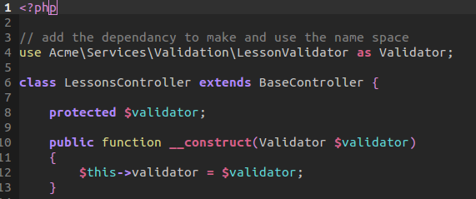

Now we will move on to the meat of our validation. The validator class is an abstract class, that is, it
doesn't need to be instantiated if it is extended. We name space it, as usual. We create a errors object to then grab all the messages we receive when errors are returned. We have a validate method and an errors return helper method.

Inside our validate method, we receive an instance of input, we then make use of the Validator class by abstracting it to the name space as V. We make a new validation with a static reference of the rules –remember we can use the static reference to refer to sub children of the class validator. We check to see if errors are present. If the validator fails, we push onto the errors the error messages and return false. In turn, our controller will use the helper method to see those errors. If there is no errors, then we will return true which will tell the controller to save the inputted data.

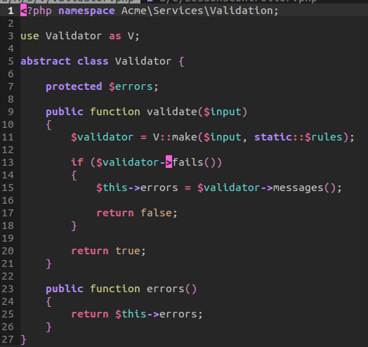

The cool thing is our extension of the abstract class within the Lesson Validator. We namespace it inside the same Validation space. But notice we create a static instance of the rules! This allows us to write rules from sub classes. That is, we could write a blog validator that extends the validator class. This, in turn, could use the same abstract methods to then call out to and use. This demonstrates the beauty of abstraction because it doesn't lock us down to one concrete example.

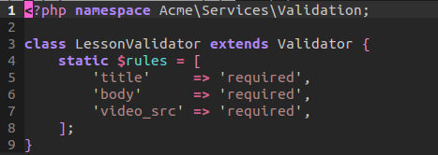

15_vim and laravel: Alright, this is a huge tutorial. As such, I will go through the differences that we added from our last commit. Keep in mind that our last two functions are located in our file type plugin folder under .vim.

The first is adding a few abbreviations to our script so we can easy type faster commands.
For example:

:gm+<space> will abbreviate to !php artisan generate:model
:gc+<space> will abbreviate to !php artisan generate:controller
:gmig+<space> will abbreviate to !php artisan generate:migration

As you can see, these abbreviations can save a huge amount of time.
The next change was for easy escaping. I mapped jj on insert mode to escape.

The next is auto changing the directory to match current file. For example, I may need to work on a .vimrc from my /var/www/ file. Well, what if I wanted to change to the directory where my .vimrc is? Well, I can do this by calling:

,cd

This will address us to change to the directory of the matching file. Very handy when working with multiple files.

Another addition is easier window navigation my setting our mappings to switch with the calling of Ctrl+w and then the direction we would like to navigate base on our traditional h, j, k, l keyboard inputs.

Another helpful adjustment is adding a to-do list to our project. This allows us to easily add more file projects to our project and thus allow us to create a sort of run down list on what we need to do. This isn't really important but it may prove useful when creating a check list for yourself.

Laravel offers common files that we access all the time. These include the route file, config/app, config/database, and composer file.

We normal mapped these to access them quickly:
<leader>lr : to edit the routes file.
<leader>lca: to edit the app/config/app.php file
<leader>lcd: to edit the app/config/database.php file
<leader>lc : to edit the composer file.

All these commands are preceded with the leader key as well as the L, standing for Laravel.

The next option added is a setting for faster CtrlP load. Because fuzz search has to index all the files, we need to make sure we wild card out both the vendor and the public forum folder for faster search results.

I'm going to stress that the next two functions were added to our file type plugin folder under PHP. We can then load those specific laravel functions when we encounter a PHP file. We added the following:

<leader>1 : will call a function to create a Class with an optional name space.
<leader>2 : will call a function to add a Dependency to an already existing Class as well as protected variables in addition to using the correct Name Space dependency.

For more info on implementation, check out the file. I may add the majority of these commands to that file. Also, I got rid of the auto completion, I may add it back if I miss it. The thing is, I added a SnipMate plugin for auto completing long task of code. I'm going to add a laravel snippet as well.

The auto completion can still be launched by Ctrl-P or Ctrl-N on insert mode.

Those are all the settings -Have Fun!

16_authentication essentials: Every application of any size needs an authentication system. This authentication implementation has been reviewed three different times throughout our Laravel lessons. We can take a supplement from this and go into a few other particular applications of authentication.

First off, we created a resource for our session's controller. This controller will be called sessions but doesn't particularly use any name spacing that is not already unique to a model. We create this controller with all the basic routes. But, we add the only array parameter argument that will only include an index, create, destroy, and store route. Interestingly, this allows us to not have to use ALL the available controllers found within our sessions controller. This solves the problem of using some but not all routes.

We over write or alias a few routes to call act as another. That is, a get request will call directly the destroy method –which of course is only called during a post call of a certain route. We also alias the create from the login request. Both are aliased or you can think of it as overriding the default routes.

We create a route of profile. This will return a message, welcoming the user, with their email address. We grab the email address from the static call of the Authorized user object, specifically, their email address.

Our default route of index, will be named as home. That is, the route will be referenced from within the Route object as home. We return a view of hello. That view of home will just return a home page welcome.

//Routes
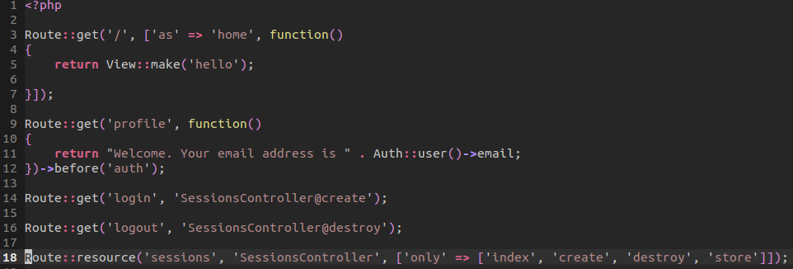

Now, within our controllers, is where the true grunt work happens. First, our create method will call a simple View object to make the sessions folder of create. The create page is very similar to our other authentication pages –but I'll display it below.

Our store method will grab the input from the Input object. Then it will attempt to login the user. This will use the input from both the email and password field. If the attempt was successful, then it will redirect to the intended route. That intended route is home. That route will be sent a variable of flash message. That message can then be used within the view or blade templating area.

If the message was unsuccessful, then we will redirect back, that being the login page, with the flash message of invalid credentials and the original input –email address if valid.

Lastly, we will have a destroy method. The method will call logout –which clears the session of the authenticated user. Next, we can redirect home with the flash message that we have been logged out. Notice that the redirect back home is using the home static method. That method is using the home magic method to reference our 'as' index call from earlier. Notice that the message of the flash is sent alongside the redirect to home -we don't have to re-indicate it again within our controller.

That does it for the controller method. Pretty simple, eh?

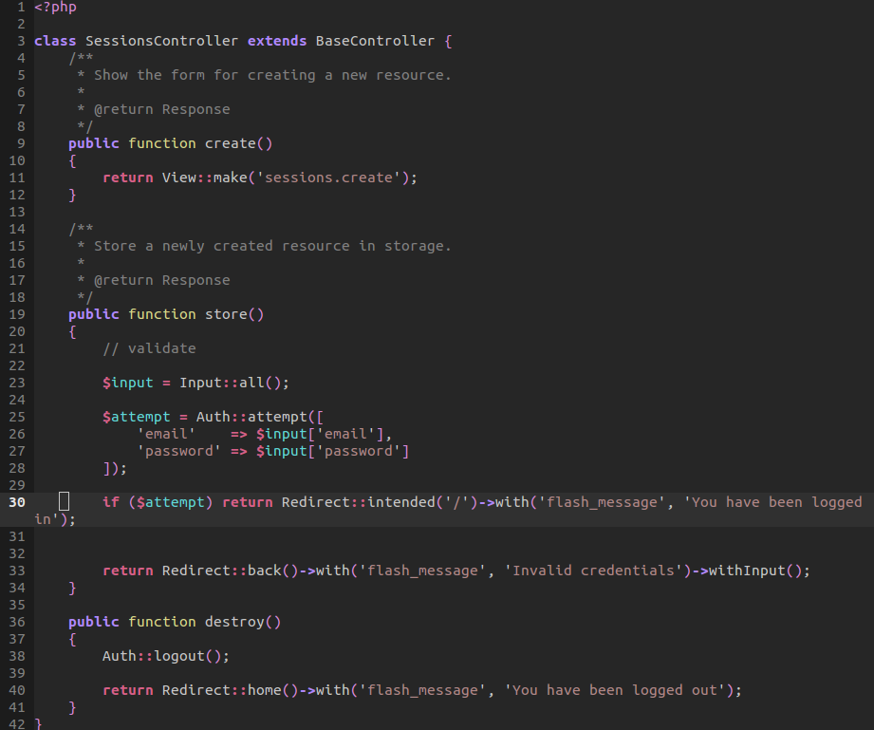

Our default page will be extended within both our create and login view. We add a quick style tag. We then include a conditional that will check if our Session object has the flash message set. If so, it will render the div tag alongside the Session flash message. That way, we have some feedback to our login process.

We create another div tag of container that will yield the content of any of our blade extended files.

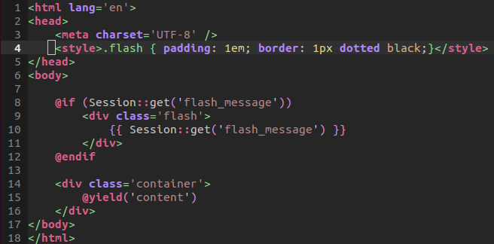
Our create blade page will extend the layout, create a form that will post directly to a route –the session's store method! This is interesting because we can post directly to a controller and not necessarily a page. Our login form is simple. Handled by the logic in the above controller.

Our hello page, again, only has the text 'Home Page' in the yield content section.

17_Queues: When we work with queues, we are essentially putting task that where usually handled by our server onto a stack and then sending those requests to someone else to handle. In a sense, it's like ordering print jobs at office depot. The cashier will process your request but won't make you wait while he does the job to then return to you. No, he fills out a ticket request, puts it on a stack of jobs to do later and handles them when there is free time to process the order. That is all queues are and with Laravel, it's really easy!
First, we will take advantage of Iron_MQ. Iron offers us an awesome package we can include from within our composer file. We include this add on to then use with our artisan commands. We now have access to iron as a queue tool. Don't forget to head on over to app/config/queue.php and edit your settings. Set your default to iron, and fill out your iron array for the proper credentials.

Also, register your app at iron.io

Once you have done this, you are now in business. Go ahead and first create a subscription. This subscription will tell iron that is should listen to this particular address for when a post request is sent.
php artisan queue:subscribe app http://short-snippet.eu1.frbit.net/queue
Here, we are registering our application for the queue and subscribing the queue route for post.

Next, we need to edit our routes to test out our queue!

Within our routes, we create a Queue push call. This call can push either a class or closure. In this instance, we are passing a class and an the current time to show something dynamic being added.

When this is called on the index, we are pushing this queue. Now the queue will listen for this request and when iron sees this, it will post the data back to the queue address to then call Queue Marshal. Marshal will call a task of fire within the current class. Our fire method will grab the data and append it to a time text file. That time text file will allow us to be able to show a file being appending dynamically. And that's it!

We have push a queue and then fired it with the help of iron.

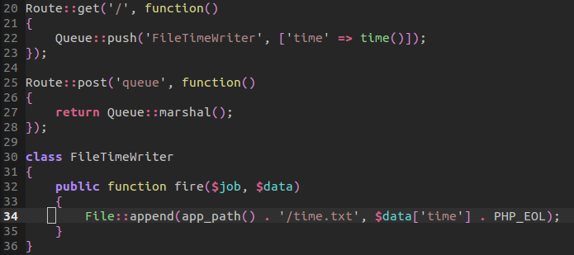
We went ahead and applied this technique to our mailer from an earlier lesson. All we had to do is call post within our mailer to then marshal or fire what's on the queue. That is, of course, our Mail queue! For more information on applying the queue with mailer, just check out the share snippets folder.

18_TDD-by-example: Test Driven Development is absolutely essential in developing your application by testing each component before building the actual implementation. In a sense, it allows you to see how you will solve a problem and test its solution before any exact execution.

The way we design our test is as follows:
- We write our test, outlining each process.
- We then write our implementations that are mocked or separated from the main application.
- Lastly, we release the full implementation, allowing the proof that the test works

We went ahead and created a shortcut map for our testing:

nmap ,t :!vendor/bin/phpunit app/tests/functional/SupportControllerTest.php<cr>

Make sure you have PHPunit installed on your system.

We begin by first allowing a call of tear down. This will call Mockery close. This will clean our plate for a new Mockery. If we don't tear down first, we will run into issues.

Our first test is to test whether a form to submit a request is displaying. That means we want to test our routes to make sure we get a status of 200 or OK for a GET request of our route support. We assert that that response is OK. We create that exact Route in our router.

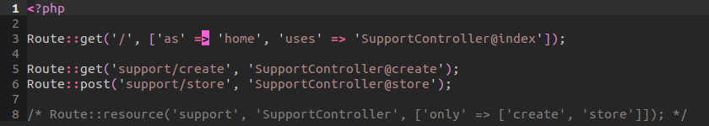
We can all our mapping to test this. Make sure you create a support/create view as we will assume the existence of that view. Next, we will work on next function test that will test submits from the support request upon form submission. To do this, we need to simulate data that will be sent through our view to our controller. Processing the input and sending it to a specific email and subject matter. In this test we are testing if the form is submitted and if it will be sent to the proper address.

We create some post data in our controller. This post data will be our assumption. We assume that the data. in which was submitted, had an email and body.

We then call Mail::shouldRecieve. Most Facades have built in testing components that allow us to assume certain actions. This is the power of facades in themselves for testing Objects and their responses.

We assume that we should receive a queue request once with a view of emails support, the post data that is submitted, and we will mock the form submission itself that will be sent. I will get to the closure in a second. Just remember that we are assuming that Mail::queue was called once with the following data.

Our Mockery::on is a special mock that will help us mock the Illuminate\Mailer\Message object. In a sense, we are saying on Mockery call do the following mocks.

We mock the Message object. We can now expect we should receive some data when we mock the Message object. We expect that our message should receive a to request with a specific email address, once. We return the static Mockery object so we can assume more test based on the same static object of mock.

We check to see that we should receive a subject with a certain title and only once.

We call closure with the message object.

If everything passes, we return true. Although a very long function call. When broken down, we can see that this mocks and tests all the necessary properties for verifying that our Form Submission does indeed work.

We then call a POST request on the support/store route. Making sure that our post data can be passed through.

We then assert that the we are redirected back home with a flash message data.

So, again, we call the POST data and then we assume we will redirect to a route with a flash message. The part that is being tested is the flash message part.

As a whole result, we have successfully tested our Form submission. We have demonstrated how we are testing what we should send and expect when we send that data.

// Controller

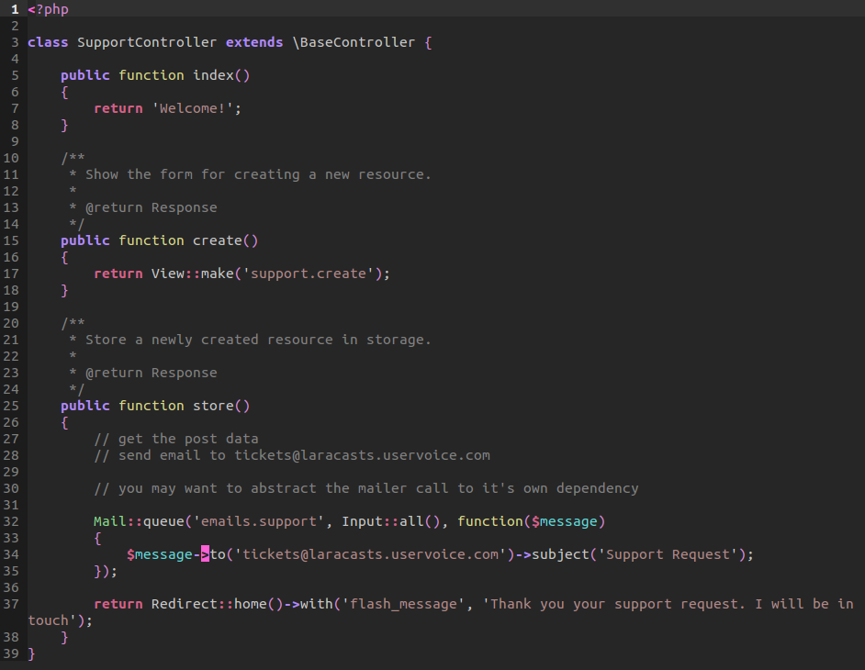

// app/tests/functional/SupportControllerTest.php
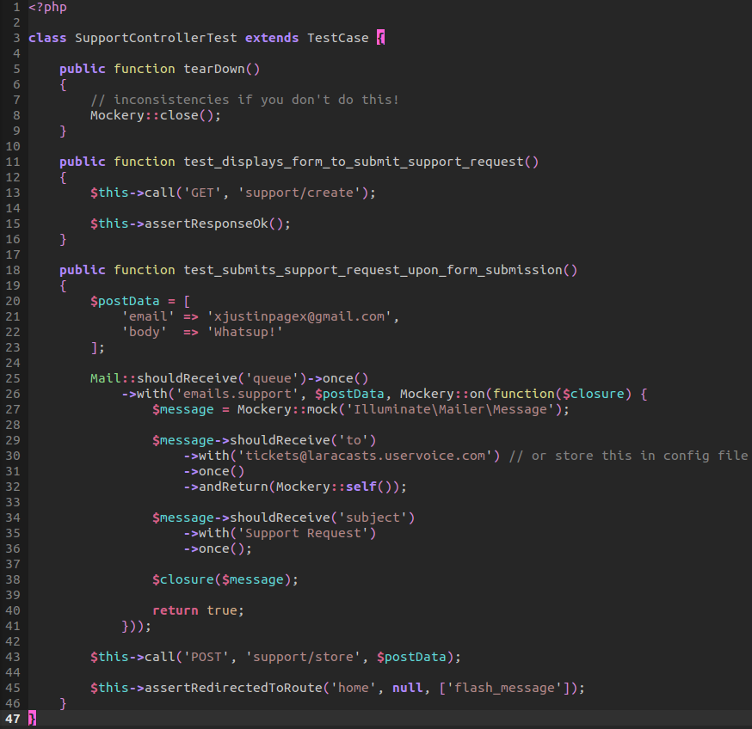

19_name spacing primer: Name-spacing is something really easy to wrap your mind around. It is PHP's solution to a common problem of having more than one file with the same name under a parent directory. As you know, you can't have two files of the same name in the same folder but you can have them in separate directories to distinguish their differences. In a way, that's all name-spacing really is. It's a convenient way to distinguish files with the same name without having to rename them.

To apply this to a more real world example, let us create a Billing folder with a Billing file. We can then create normal name space. The name space above defined the folder structure. That is, the file hierarchy.

Before anything else, you need to update your composer file to load the name spacing defined within Acme. We could put it under the classmap array within composer, but this will load all the files automatically. We would have to define each new structure. Instead, let us follow PSR-0 guidelines on name-spacing and add the name space of Acme to use the folder structure of app/ as it's parent directory, By doing so, we can properly define our name-spacing.

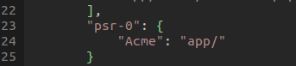

Now back to our billing. We can call the use of a namespace which will allow us to correctly define a namespace other than the previously defined one. In other words, we may get an error resulting from the namespace that we have within our folder structure on the top. We can add new name-spacing for PSR-0 to consider –such as Something. What if we had two different directories with the same file name? Well, we take advantage of aliasing the second file structure as something else. By doing so, we avoid conflicts and allow ourselves to easily namespace both.

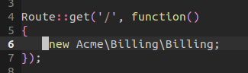
We demonstrate this within the constructor by dying and dumping the Something object. We instantiate this result within the route file by calling a get request. This just create a new instance of Billing using the available namespace:

Now what about that Mail object? We have two options. We can call a use within our object of Billing so we can correctly call it. Or we can not call use, and simply fix a forward slash in front of the Mail object. Both will work. It's a matter of practical style but more importantly readability. Which is easier will be up to you.

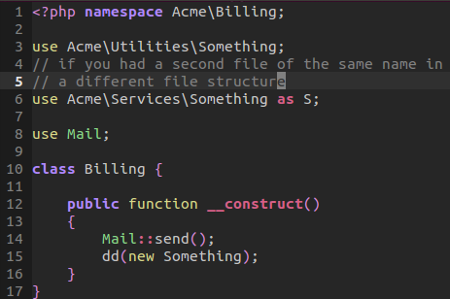

20_crons and commands: crons are scheduled events on the server that run on a given interval of time. They can then run certain scripts within a certain time period. In this lesson, we took a real world approach by scheduling an event that would delete a User Event's database. On Laracasts, many users have the ability to save their history lessons. However, this list of history could add up in a substantial amount when it comes to saving thousands and thousands of records. It would be easier for our application to run a command every month and clean up our database of records that are less than a month old.

First, we need to create a new command. To do this, we call:
php artisan command:make ClearHistoryCommand

Artisan will graciously provide us a generator for creator some boiler plate code for us. We mainly need the constructor as well as the fire method.

Now, we will simulate a repository that takes advantage of an interface that creates an instance of the events. That is, we are created an interface that is being implemented by the Database User Events Repository file. Doing so, we are following the repository pattern while injecting our dependency.

We simulate a script but indicate that this would be bounded to an entirely different file.

Our constructor will assign a reference of the events interface for user. We then call the parent of the constructor for the commands.

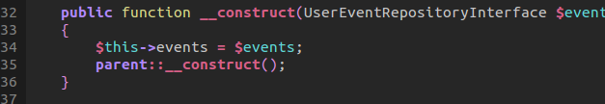

We then use the fire method that will use that instance. It will call the clean up function, which is defined within our database event repository. Once the process is finished, we log some info.
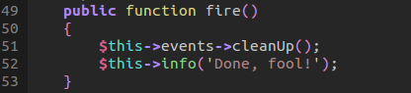

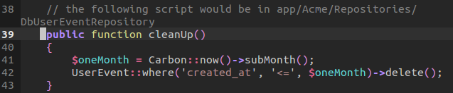
This above code will call:

to add this command and functionality to our instance of artisan, we would edit the artisan file ourselves:
app/start/artisan.php

We would add the new command but instead we want to resolve the command so we call a resolve which will bind the command correctly to our artisan script

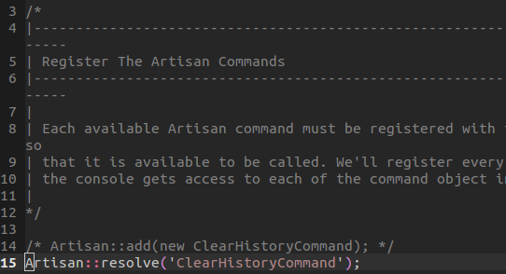

Now the last process for properly adding this command, is to create a scheduler which will act as our cron job. We will create a scheduler.yml file that uses YAML

I'm not too familiar with the way cron jobs work but I do understand this file. Be sure to remember that this is fortrabbit specific. We will first will create a property with a type, where the script should launch, and what arguments we should provide. We briefly take a look at intervals which is used by our cron script. This particular script runs once every month at 12 UTC time –if we wanted every day or every hour, we would use the wild card *.

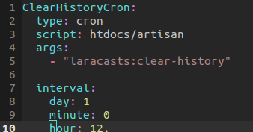

// explain how to register the command and scheduler script to fortabbit's worker.

Once you have your YAML file ready to go along with your artisan script, it is now time to register the product. That is to register the worker. To do this we go ahead and commit all our changes, pushing them to fortrabbit.

We then go ahead call the following worker, this will register the YAML file via ssh:

scheduler setup scheduler.yml

If we call scheduler status, we can see that our scheduler is setup.

