Agile Design Patterns with PHP

01a_What are Design Patterns: On October 1994, when four programmers from IBM published a book on Design Patterns, they became known as the big four. A set of twenty three problems and solutions where defined. A design pattern is an accepted solution for a common problem. Not everyone agrees with one. Some regard some of the design patterns as anti-patterns. With all these, these patterns are essential knowledge for an advanced programmer. They are well thought, excepted, tested, and are at a low risk solution.

However, since 1994, computers have changed as well as solutions and concepts. Some updates and variations have changed. As such, Robert C. Martin designed a book to meet these needs through an agile process.

This course will work through about twenty implementations of Agile Design Patterns. Each will discus what is it, how it works, how to implement it, and when to use it. The heart of a Design Pattern lies in the UML schema. Learn from the implementations, don't take them literally. Take the schema and then practice. Always add your own logic to each pattern to meet the needs of your project.

01b_UML Basics: The basic element of a UML is class. This is a simple naming convention. If it is an interface or an abstract class, it will be noted. The type and the name of the class will be separated at the top whereas the methods for the bottom. We can then define our methods as public or protected. We can also define if they receive any parameters or return any type of information:
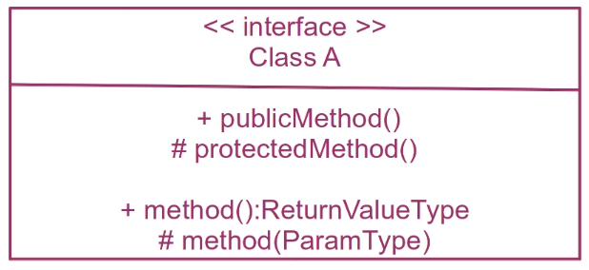

Class A uses Class B:
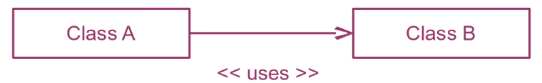
Class A creates Class B:

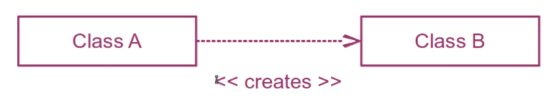

Class A implements or extends Class B:
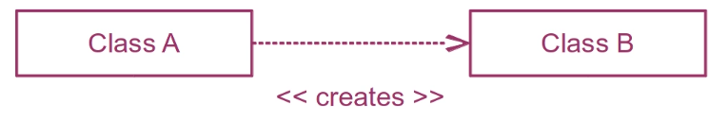

01c_Agile Manifesto and Software Craftsmanship: In the late 1990s where at a historical low. More than 80% of projects were failing. In February 2001, seventeen programmers met and discussed to come with four ideas.

The manifesto for agile software development means that “we are uncovering better ways of developing software by doing it and helping others do it. Through this work we have come to value:”

- Individuals and interactions over processes and tools
- Working software over comprehensive documentation
- Customer collaboration over comprehensive documentation
- Responding to change over following a plan

These ideas led to techniques such as XP, Scrum, Lean, etc. TDD, SOLID, and Design Patterns erupted from the Agile era. But programmers miss this idea. Software Craftsmanship never formalized until recently. In march 2009, the manifesto was released in the pursuit of the items on the left they have found items on the right to be indispensable:

- Not only working software, but also well-crafted software
- Not only responding to change, but also steadily adding value
- Not only individuals and interactions, but also a community of professionals
- Not only customer collaboration, but also productive partnerships

02_The Factory Pattern: This pattern allows us to separate the actions of one product from another. That is, the separation of concern from multiple classes. This allows us to decouple the necessary objects and methods from one class to another. Moreover, this allows each method to be concern on one action. The factory pattern encourages single responsibility. By doing so, we recognize that this pattern is good when the object doesn't have to reuse an object nor does it have to be concern how it creates another object.
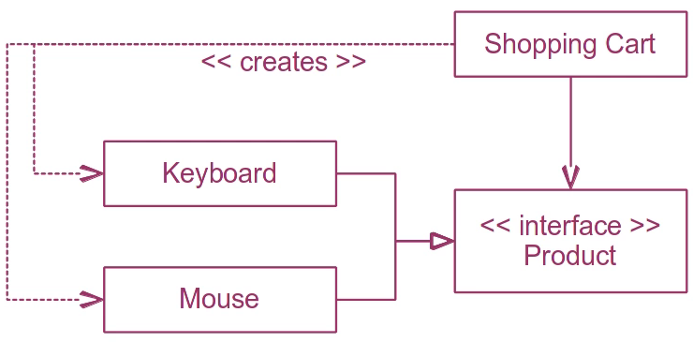

The factory method begins with us creating a Shopping Cart class. We create a products in cart array as well as a private variable to inject an instance of a dependency. Our constructor, when creating the shopping cart allows us to create a new instance of the Product Factory. This allows us to separate the concern of adding products to the factory and not the constructor itself.

Our add method, when called, is only concern for receiving the product identifier. This, in turn, will then be used to make a product via its identifier. Once the product is made, it's object will return an instance to be stored in the shopping cart array. Separation of concern by decoupling:
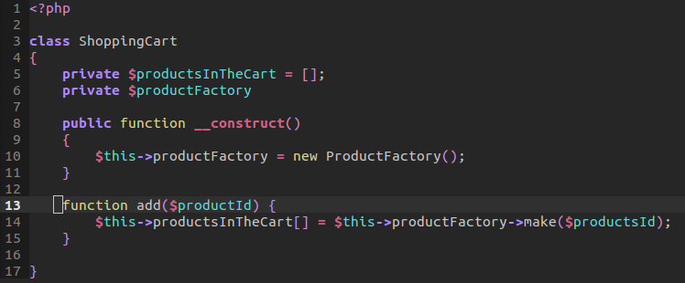

The Product Factory is where we will begin to create the object, this is the factory pattern. We determine whether the identifier is a keyboard or mouse. Our private method to check will return a boolean value depending if the product identifier begins with 'k' for keyboard. We create a mouse if it isn't available.
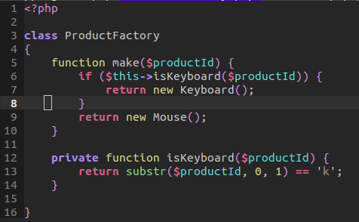

Now both products implement the product interface therefore binding the contract that both classes have against the definition of what a product is.
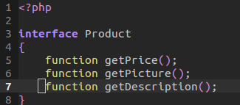

The mouse class is very similar to keyboard except mouse does not contain any definitions for its methods that it implements

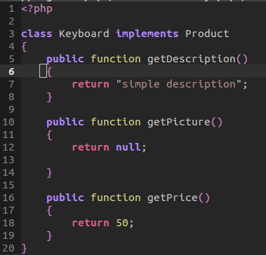

03_Gateway Pattern: The gateway pattern allows for persistence as well as separation of concern from the main application. The gateway pattern provides the separation of interacting with a specific type of object and its actual implementation.

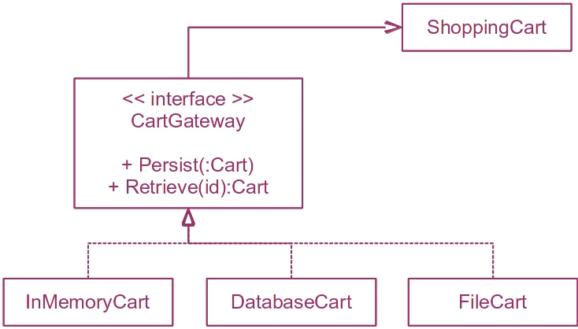

Within our Shopping History class, we want to keep a record of history for all our carts. To do this, our constructor will accept either a file cart or memory cart which are both of type cart gateway. These object allow for persistence, retrieval of current data, and getting the identifier of a recorded cart. Notice, however, that it isn't the concern of the gateway nor the shopping history as to how this actual works. We provide our own reference for both the gateway and the array of shopping cart identifiers.

When we call a shopping history by listing the the carts, we go through each shopping cart identifier provided earlier to then retrieve information. We call an instance of the gateway that was provided. Thus, we can retrieve all cart objects while separating our concerns.
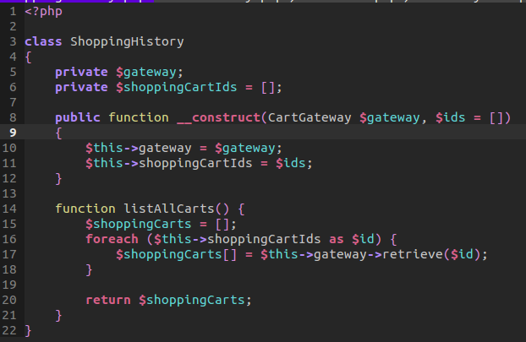

Our interface is extremely easy to understand as each Cart will implement these three methods.
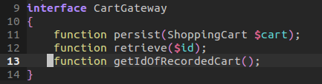

For our file cart, we will assume that the file identifier is the actual location of the file that serializes our cart object. We provide an implementation of getting the file identifier, storing a cart inside the file cart storage, and retrieving the contents of a certain cart.
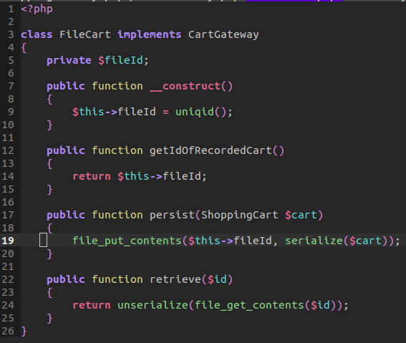

Our In Memory Cart works similar but assumes that we are using a private array to keep a persistence of our cart list. We can then retrieve that identifier again by grabbing it from the array. We can get the last recorded cart by grabbing the last pushed cart object.
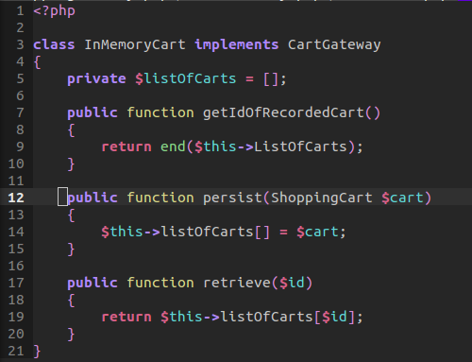

Looking at this at a higher level, we are providing a gateway to depend on the interface and not directly be concerned about the implementation of each Cart. This takes advantage of interface segregation and the use of the Gateway pattern. The interface interacts with the system persistence.

04_Proxy Pattern: A Pattern that will silently retrieve and create the necessary pieces to delegate the call to the newly created object. We will introduce another level of abstraction. Every cart object will depend on an interface. A cart proxy will check if an object exist, if not then retrieve. It will provide the proper response and thus the user doesn't know it's not directly the cart object.
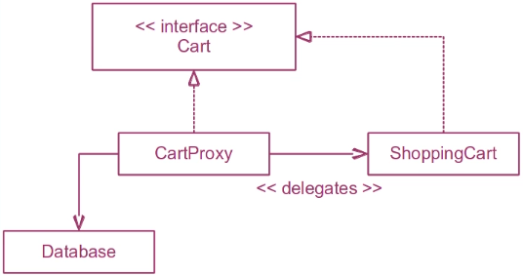

To begin, we have an interface that binds the contract between the Cart and that of the Cart Proxy and the Shopping Cart. The importance is separating the persistence layer of the database retrieval and that of the cart itself from the business logic.
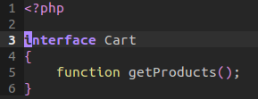

Our shopping cart itself will deal with persistence by grabbing the the product via persistence through database or memory. But it is our proxy that handles the direct logic.
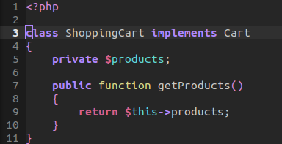

Next, within our proxy we define the actual logic and safe guard our instances through a slight implementation of another pattern, the singleton pattern. But, for now, we will cover the logic behind the proxy. When the Cart proxy is used by another object, we are using a new instance or a recently created instance of a cart. Notice that we check to make sure that the shopping cart is empty. If it is, we create a new instance. From here, we could use a gateway pattern to further abstract the implementation of the interface itself. Thus we are separating our persistence layer further –but, in my opinion, this is over kill. If an instance already exists, then return that already existing instance. Specifically, we return the call of getting a product.
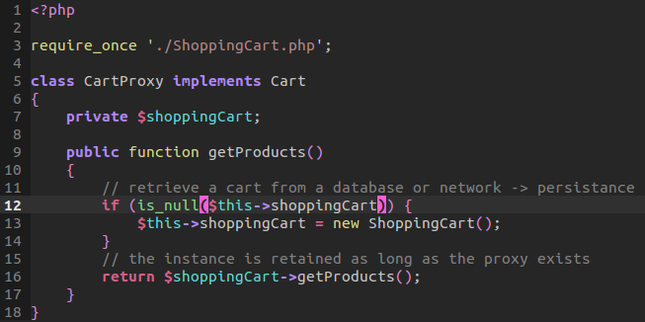

05_Repository Pattern: This is a kind of unusual pattern. This is the only pattern that is not including in the Robert C. Martin series. A repository, is a pattern that offers a glue between factories and gateways. The repository works with both the interface of a gateway and factory. This helps our clients to persist and retrieve data.

In case of a query of data and information is as follows:
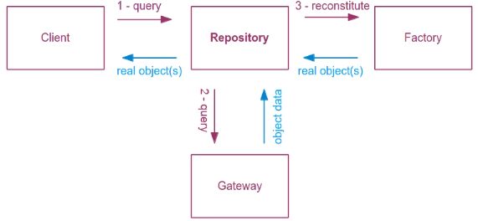

The client will do a query for an object to the repository. The repository will then talk to the gateway will then provide all the information from a database or a file. This is all the information the factory needs therefore it will get the info.

However, if you wish to use the repository to persist objects you need to have the client to talk to the factory for a real object. Then the client to persist it, it will add the object to the repository. It will persist the data through the gateway. The real object is also pass to the repository and then to the gateway. In some situations, the gateway can have real objects, but transforming them in real data is a usual case:
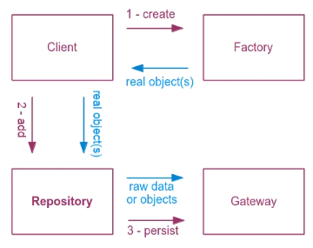

The implementation above will be an exercise in which the client directly interacts with the factory and sends that object to the repository for the gateway to persist it.

Let us analyze an implementation of such data:

The following example will allow us to query and obtain information from a product. We use this repository to work with both the factory and the gateway. We first create a private variable to remember our factory and gateway product. We then create a constructor that will remember an instance of both the factory and the gateway pattern. If we need to find all product types, we first create an array of all types that will then call a retrieval from the gateway. Remember, the gateway allows us to call a instance of the type to bring back an object of types. Here, it should be complicated logic returning all the targeted types that we wish to obtain from the gateway. This may be a database or in memory information –remember, this queries for data, not directly creating the objects.
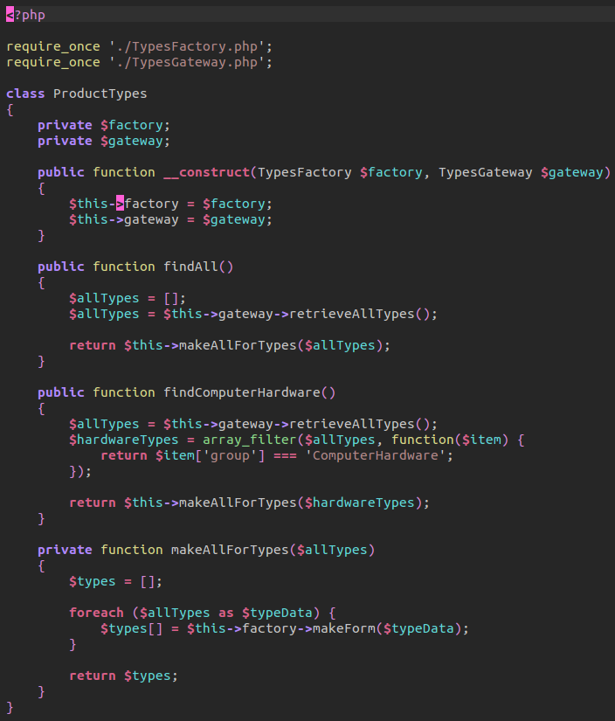

// Types Gateway
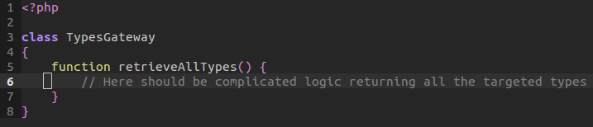
Now once we retrieve all our data, we then call our private function of making all types we retrieved, which will create the persistent data into an object! Within that make all types function, we have an internal array that will contain each type of data. We make each type of data via the factory. This will call the factories make form. This will send each available data that was created. Now jumping to the factory class, we need to check to see if the data is available or if nothing was giving. In this case, we return null. Else, we will return a new instance of the product type. Sending through the array data that is needed. This includes the product's category, name, and code.

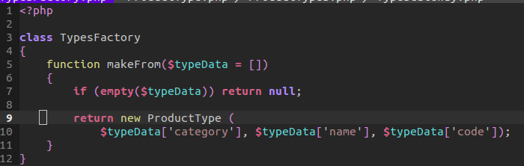

As we can see, the factory methods sole responsibility is to create the object. Within the construction of the product type itself, we assign it's own properties of the category, name, and code. Each object also has a magic method of get. This method will take the property method that you may ask for, make sure it is set or it will throw an error. This is sort of a double check for when you request data from a type of data that may not exist.

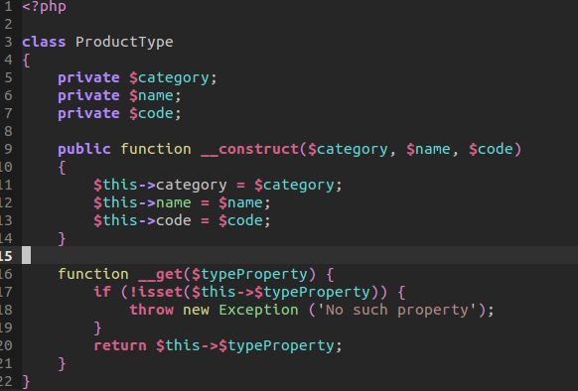

Jumping back to our Product Types Repository pattern, once we make an object, it's pushed in an object array type. We can then return types. This will then be returned by that find all method. In turn, we will have an array of objects that where persisted by the gateway pattern and made through the factory pattern.

But what if we didn't want to find ALL the persisted data, what if we only wanted to find a certain group of product types? We take the find computer hardware for example. We retrieve all types from the gateway as before. The difference, however, is we filter the array from all types down to a certain item group of computer hardware. This is done through a closure.

In the grand scan, we have the business logic, factories, and gateways talking with persistence. The repositories do not hold a list of objects. They only offer a breach between the factories and gateways. They offer a custom query language available for filtering different types of objects. There may be different persistence functions in order to persist objects that no gateway nor factory could understand.

06_Null Pattern: One of the most interesting patterns is the Null Pattern. Before we delve into this pattern, let us look at the behavior of null.

Within our PHP Unit Test Case, we will test the Null Object Pattern. We test the null behavior by running a few test:
- null added to an integer results like 0 adding to 2
- same thing goes for when concatenating a null value against a string.
- Null does equal to zero
- but also it is less than negative 1.
- We can assert that null and false are false
- Thus, null is a false condition in which will prove as the else statement will launch and not the if condition
- When we assert that null is an object, it is false –null is not an object

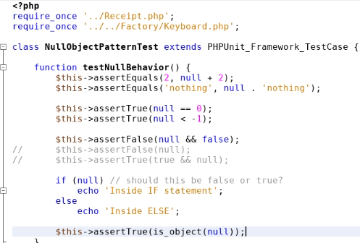

In our example, we will provide a null object. This will have all the methods implemented through the interface. But instead of providing real values, it will provide something we consider zero. Price will be zero, description is empty, and an image link is empty

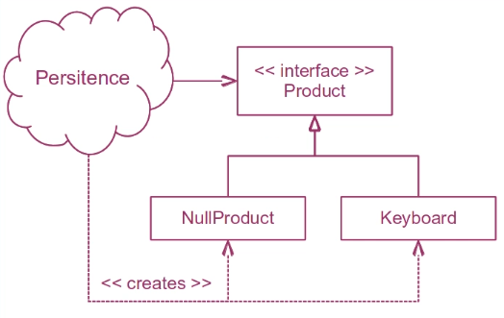

The advantage of the Null Pattern allows us to safely consider illegitimate objects that are available. In many ways, its a default object to be returned if none others are found. You may want to implement the repository pattern if you find yourself having to constantly ask your client whether they are checking to see if a a certain object is returned.

First, within our test, we create new object of Receipt. This receipt object has the ability to add products by an identifier and add a product's price to the total price of the receipt –makes sense? Finally, we have the ability to get the total price on the receipt. Now jumping back to the PHP Unit Test Case, we then create a new Keyboard object. That object allows us to get a description, a picture, and a price. Back to our Test Case, we then call to add that product's total to the receipt. Within the receipt, we type-hint that our expected product should be of type product –this is where we guarantee a binding of the product to contain a get price object. We then concatenate this value to the product total. We assert this value equals fifty –which it does pass.

Now this is all fine and dandy, but what if we wanted to find a product by id? We know that we can find a product by id zero but id one does not exist. This will result in an error because a null value would be returned because it is not an object. As stated above, null is not an object.
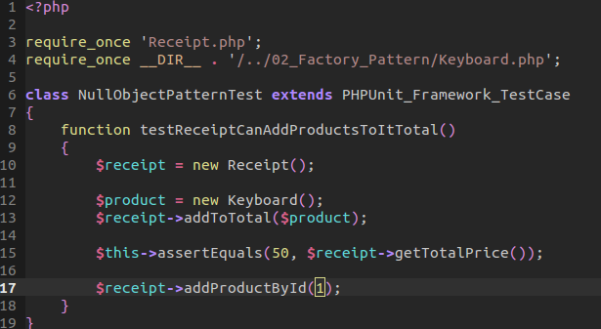
// Test Case

// Receipt
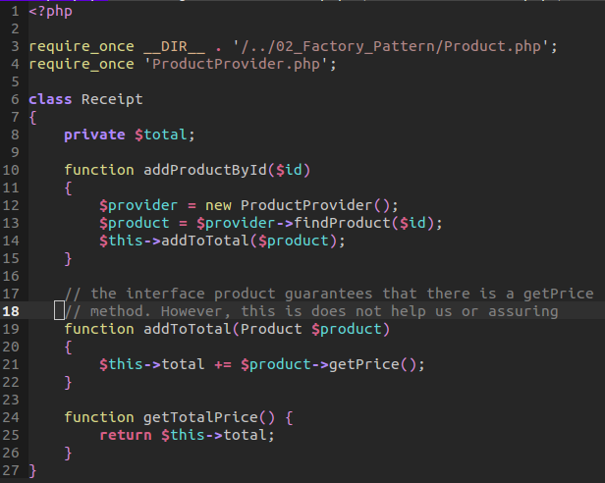

When we get a product by identifier, we first create a new product service provider. This service provider can be a gateway, a repository, or a database access –it doesn't matter. It is a service provider that allows the creation of objects. When we create this object we have access to finding a product by the provider. Now this is where the Null Pattern comes into play. We check to see what that identifier is. Zero means keyboard, if not, then we create a Null Product. This is smart because we are providing some sort of default for service provider. Instead of having our test fail, we have an alternative fall back that explains where something may not exist.
// service provider
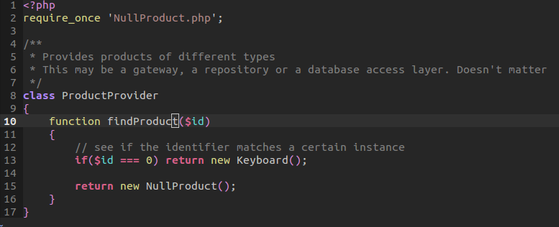

// Null Product implements Product interface –may need to require to have access
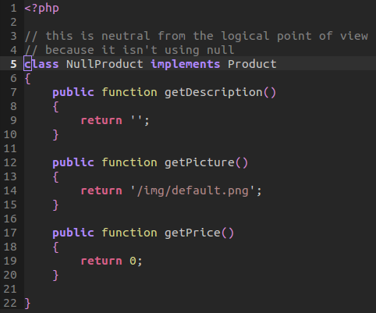

If we happen to be returned a Null Product, it won't affect the total price of the product. But if it is a normal product, it will!

Null Pattern is effective for providing a fall back if the client interacts with our Design and yet encounters an invalid object. An object that doesn't exist. This provides an easy way to implement any sort of logic behind the scenes while providing fall back.

07_Command Pattern: The command pattern is simple. It defines an interface of type command with a single method of execution. This is useful for a sensor that is waiting for an event to occur. It just executes it. It can provide some awesome solutions without the client having to know about it.
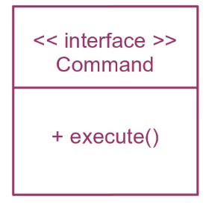

Then, we can imagine a sensor that listens for an event to occur in order for the implementation of an interface to execute a method base on that event.
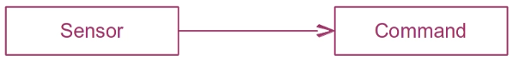

For example, we can use it to process a payment for an online web shop application. A Process Payment class will ask a User class to provide a payment method, this command will execute without the client knowing about it.
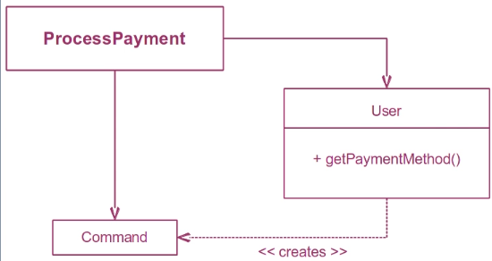

Let us begin with the process payment class, we require a user, a payment method, and a payment processing exception. We then call the process of a user payment. This requires us to create a user object base on their username. Now our user object has the ability to grab a payment method. This can either be set as either a Visa Payment Method or a Paypal Payment Method:
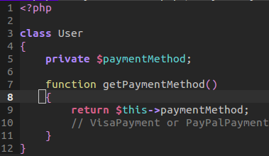

We call that payment method which will return an objects payment method. We then call our private function to execute the payment base on their payment method. We type hint the parameter by making sure the object is of type payment method. We then try to execute that payment method. Remember, that payment method is an interface that binds an execution method –what that implementation does largely depends on whether it's paypal or visa.

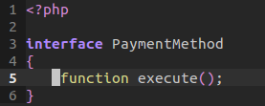

If it's a paypal object, then we will provide an executable as well as a to string method for when an exception might be thrown and the object is printed as a string.

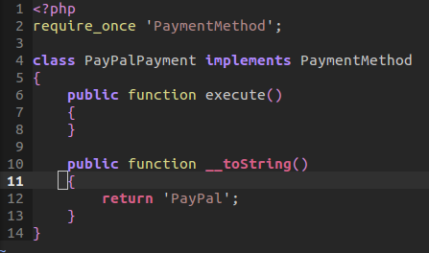

The Visa Payment class is very similar but elaborating on the execute method that would handle the complicated logic behind paying for a visa. This would in turn return true, or try to execute if the payment was successful.

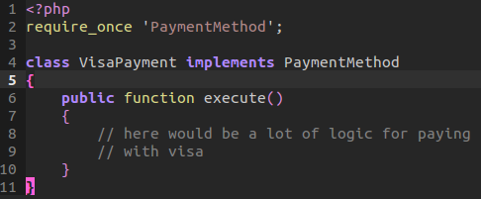

Now if the payment is unsuccessful, then we need to throw an exception that will output the current payment method error along with a message.
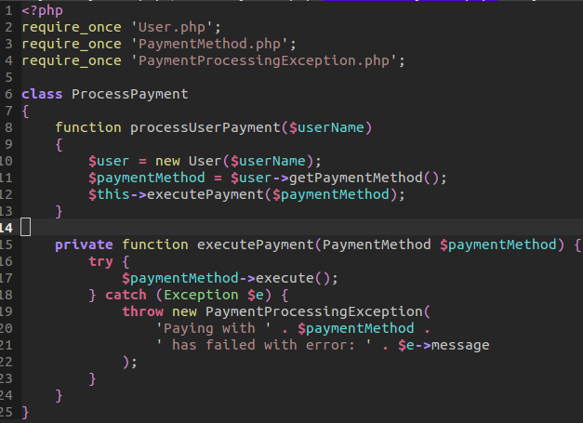

Creating a new payment processing requires loading it in memory and having the constructor for the payment processing exception send it's message to the parent static constructor.

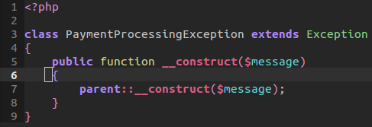

The command pattern opens a door to solutions in which offers a solution to payments. All payments are a transaction that has start points and an undo settings. We are using the undo function in many interfaces. The command object, after executing themselves are put on a list, the most recent is called and executed. For an undo, it will undo whatever would be executed.

08_Active Objects Pattern: Everyone has their favorite design pattern. The Active Object Pattern is very cool. The active object pattern is based on the command pattern. It has one method called run. It has to run each command it has in a link list (or in this case, an array). A command pattern consists of an interface. Each object implementing it is available to a client. If our active object is alive, we can run multiple commands. In this example, we demonstrate a super easy implementation of multiple objects handle in their own processes. In many ways, this allows our application to handle multiple processes at once. This implementation is cool, but not used all that too often for file upload. But it is implemented for use when working with objects that have to remain active while implementing this pattern.

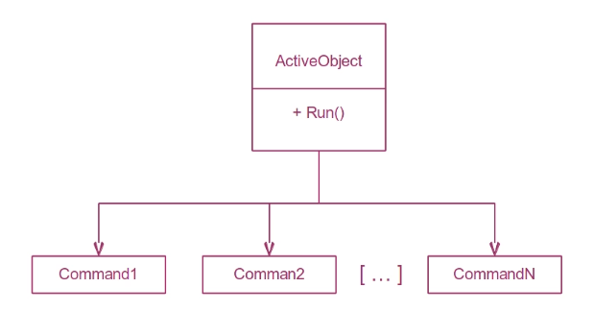

We will follow a pattern of TDD. This means we will develop a test to output our results as we run through each process to demonstrate an object that handles multiple files when uploading. To simulate an upload, we will divide the current size by the speed to indicate chunk in seconds. That chunk will be added to a total value when we execute an upload.

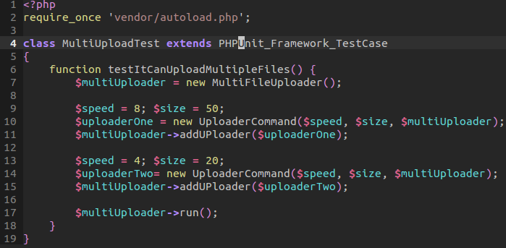
Our test will first create a new Multi file up loader that will handle our current uploads as well as allow the process of running an upload process until they are all finish uploading. We create a custom speed and size. We send this information, as well as the current instance of the multi file up loader to the up loader command. This uses the command pattern. Within our up loader command, we construct the object with the information of size, speed, and chunk of data that simulates an upload every so and so milliseconds. We then assign our current instance of the multi file object to our private variable of multi uploader -that way, we keep track of a current instance of our multi object up loader. Once we have created the uploader command, we then add that to our current multi uploader object. It will store each upload process inside a private uploaders array.

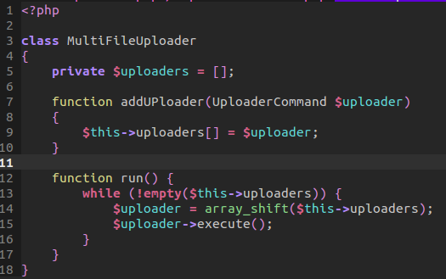

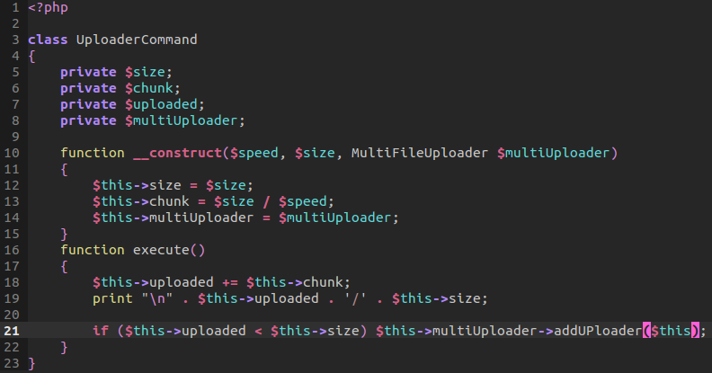

Now the trick here is simple, once we created all our loaded process of uploads, we call run. Run will execute via our multi file uploader. That run method will then launch a while loop that will check the current uploader array to see if it is empty. If not, it will shift the next upload process in the queue. We do this by grabbing the first object and calling its own execute method. When that execute method is called from that object, it possess it because it was created from an uploader command pattern above. We then add our chunk, the percentage of each time an upload takes place, to the uploaded section. We print our current result. Now if our upload is still less than our size, we push the current object process on the list. We go on to something else. When we return, we simulate the current process and thus keep checking until we have uploaded both files. As you can see, this gives power to each of our objects because it allows our application to multi-task between two active objects that contain their own commands.

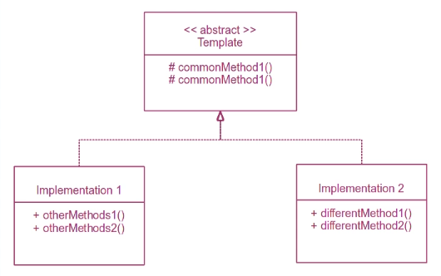
09_Template Method Pattern: This is one of those patterns that you can see everywhere. The main concept is to provide a common place where your code is and to not repeat yourself –DRY. The template pattern uses an abstract method that is being implemented by other classes that extend it. You cannot instantiate an abstract class. But you can extend it.

Think of the name. You're using an abstract template to encourage DRY coding. Let us start with our abstract method. This will contain two abstract methods that any class that extends it, can use. The cool part is that 'this' will refer to the instance of the object that calls that method. Thus, we can take advantage of using these methods in both implementations. Our inventory and payment provider are just objects that probably would be injected through the constructor. Next, we could call the remove from inventory and the retrieve payment method through either implementation since one will call a removal of that particular object or the retrieval of a price from a particular object. In both cases, it allows us the ability to use both the service and selling of a product.
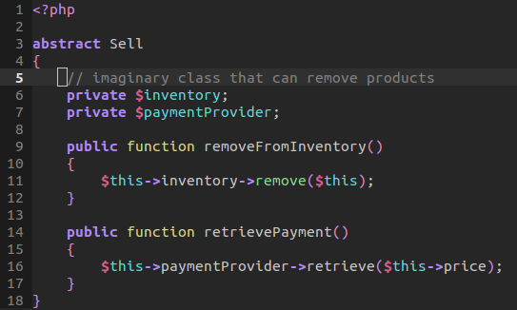

The only difference between one class that sells product and one that sells a service is its custom methods. For selling products, we call a provider object to order a new item base on this object. Whereas a service is not an item but must use, for example, human resource. Thus, we are using a particular human resource and marking it. The most important thing to grab from this is not to repeat yourself. However, using an abstract method does offer some challenges. You are coupling the abstract class with the selling of the product as well as the service. As such, you may consider other approaches if you cannot be sure these methods are universal through each extension.
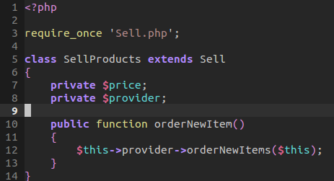
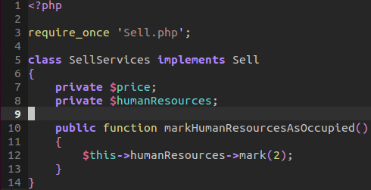

10_Strategy Pattern: There are many times we are confronted with difficult logical problems. In such cases, this pattern may prove useful.

This pattern consists of an interface that contains all the strategies we are to use. This calculator will use an interface that depends on a strategy that depends on the location of the seller.

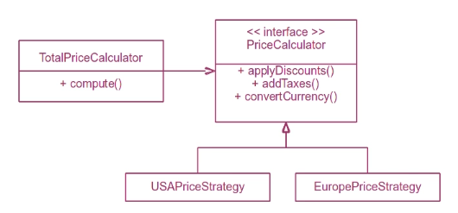

If we where to try an write all our logic in our Grand Price class, our class would be filled with about fifty lines of code that repeats itself –only varying on location. As such, it would be wise for us to use the Strategy Pattern as a way to maintain single responsibility as well as interface segregation. We can create a Grand Price class that will handle a calculation. It is not concern of how those calculations are handled but are determined by the caller sending through an object of type price calculator. We will first grab the price, use the pricing strategy provided to calculate discounts, taxes, and convert currency.

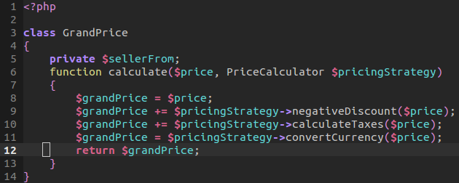

Every class that implements the interface will provide custom logic depending on its location.
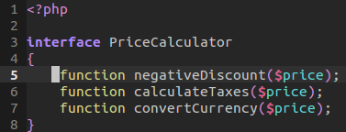

Our Europe Pricing Strategy differs from our USA Pricing Strategy:
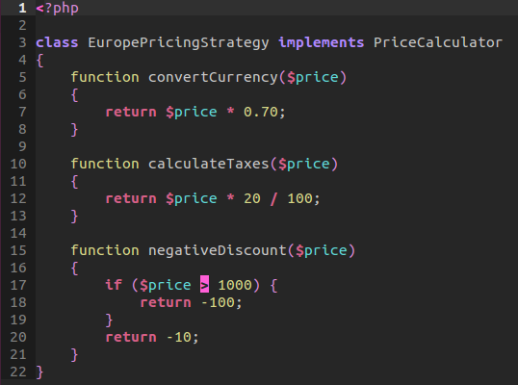
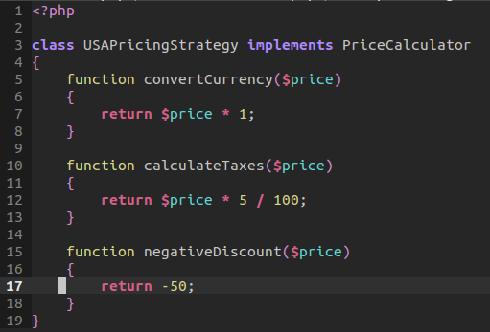

As a result, we are using a strategy pattern for building our application to wisely use a certain class over another. It all depends on what the caller of the Grand Price object provides that ultimately determines the logic behind this design pattern. Moreover, it separates are concerns and thus allows us to, again, not repeat ourselves.

11_Facade Pattern: Each time we go out on the street, we see buildings. But what we really see is the facade of a building. Behind every, lies a complex structure of stairs, apartments, and rooms.

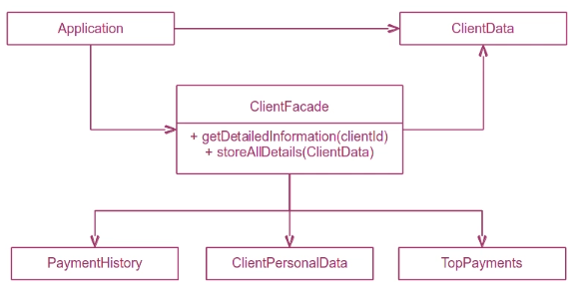

What we can take away from this ideal is a pattern that tries to separate the concern from the application on knowing how a class may gather data. Instead of having an entire class handle all the logic behind our application. We may separate that concern by using a facade. A class that handles the logic without over loading the strategy of how it might be implemented by another class.

We have three classes that handle logic behind finding the max a client has paid, their history of payments, and personal data that regards a client's shipping history.

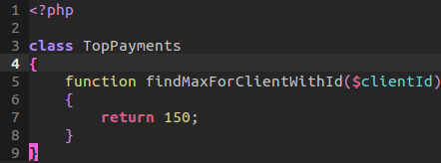

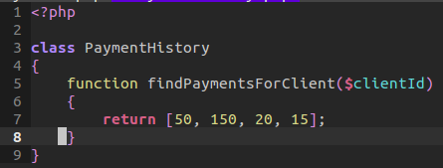

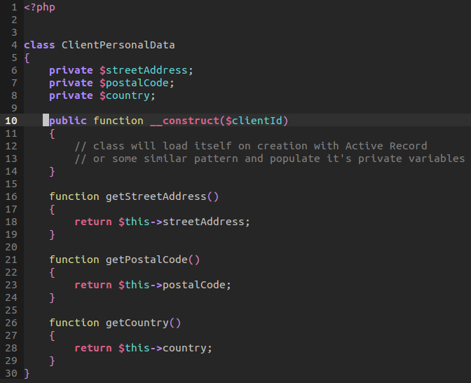

Now within our statistics, we inject a dependency by including a type hint of a facade. That facade will allow us to define the logic that will happen by the caller. Thus, we aren't stuck with one use of a facade. We could decide later to include another facade implementation and thus allow for an easy switch. We create a reference of that facade as well as a new client data object. That client data object would store all our processes and data that we will interact with.

Now when we request that we load all a client's statistics, we will have to provide their identifier. Once we do, we can then grab all the client data by that identifier. We store those returned values in an array. In turn, we store all those values to our recently created object through index. And that's all the statistics class has to worry about! Nothing else.
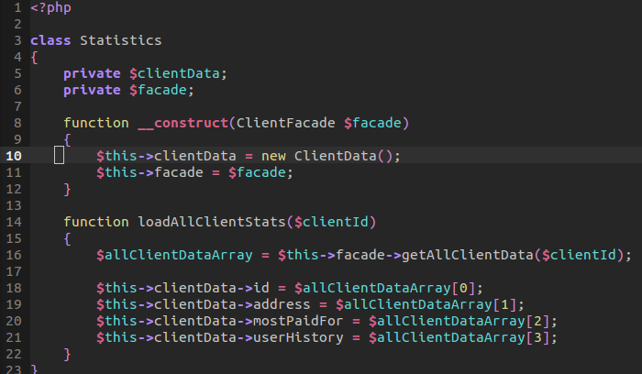

Now within our our facade pattern, when we request that data, all we are doing is returning an array that contains the identifier and numerous calls to private functions that use that client identifier.

Our client address will concatenate a string from the client's personal data –requesting all data through the method call from the client's personal data object. Our other functions follow a similar pattern by creating a new object for finding a payment history as well as a client's top payment. We can then send through an id to find a particular client's information.

Again, all the facade pattern is, is a simple means of hiding away complexity for the sake of understanding the application. Just as we see the building's facade, we don't have to see the inner workings of the building to know how it stands. Our application relies on the facade pattern to hide away complexity and provide a cleaner process.

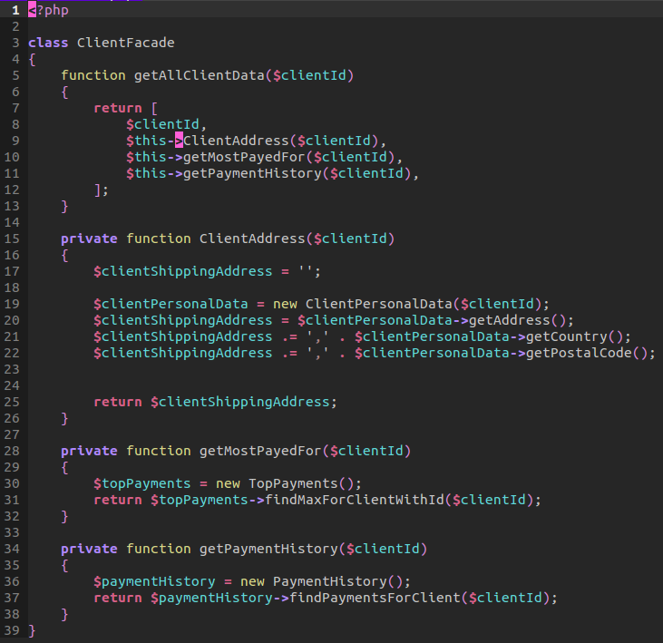

12_Observer Pattern: The observer pattern may be used for when an object's properties changes and wants to notify the user. Ever wonder how applications launch a notification pop-up window when data changes? Well, it uses an observer pattern to observe a change and then notify a client of that change. Here, we won't be concerned on how that user is notified but simulate a way for a user to be notified. In other words, when a user should be notified and now how a user should be notified (I.E. Email, notification pop-up).

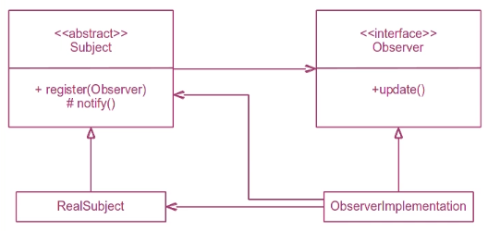

First, we will follow TDD by creating a test:

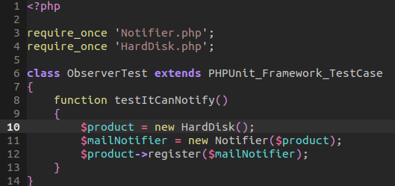

We first create the new hard disk object. That hard disk object will extend an abstract class that every product will share a common notifier method and register method. Our hard disk has the ability to set a price and get a price.
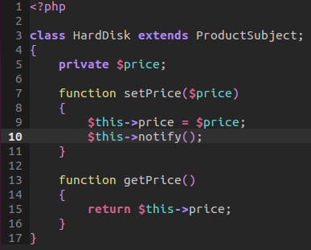

Now we will next create a new notifier. We will send through the constructor a reference to our recently created product. This creates that link between the hard disk and a notifier object. Our constructor will assign a reference of that current object. The notifier is of type Product Observer. All product observers share the common perspective of updating a status through the launch of notification.
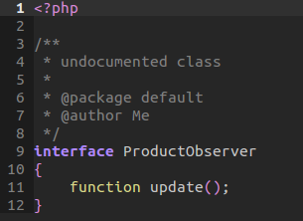

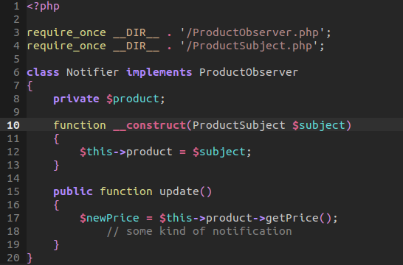

Going back to our tester, we will now register the notifier object to our product. This where we will jump around a bit. I'm going to provide the abstract class here so you'll understand that the extension of th abstract class contains the register method.

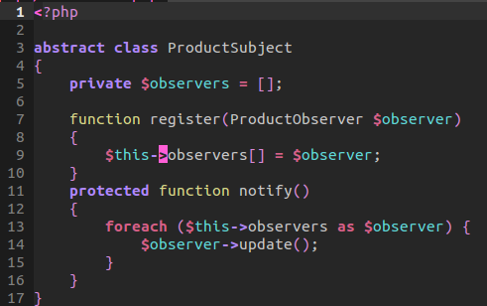

- When we call the register method from our tester, we send through that mail notifier. We expect it to be of type Product Observer –which it is! We then push this on a stack of observers.
- Now when Hard Disk sets a new price, we will assign its current reference to the price provided. We will also call notify.
- Notify will reference the inherited function of notify from the Product Subject abstraction
- We go through the stack of observers. We then call update. Update will reference the notifier to which will call the current price of the product it has as reference
- This is where that link comes into play. As soon as notify is called, we get the new price and then do whatever notification we want –email a user, pop-up window, whatever.

This is the observer pattern and it's super easy to implement if you want to keep track of object's and when their properties change.
13_Mediator Pattern: Although difficult to implement and often ever used, the mediator pattern should be considered as it is a respectable design pattern.

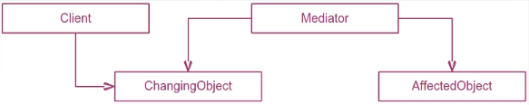
A mediator is an object that has a link to two other objects that change one object will effect another, The facade pattern can be associated with this design pattern. The facade effects other classes from a call outside. The mediator is like a facade but it hides everything from the business side of our application. A client will use an object and when it is changed, the mediator will affect another object.

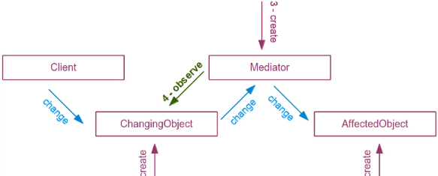
When we search a letter in vim, we alter the client text field and thus change an entirely different object.

An observer object is created and an affected object is created. A mediator is connected to both objects. The mediator will observe a changing object –event based or pattern. A client will just use a changing object and do something on it. Whenever the object has changed, it will notify the observer, this instance the mediator will then call the affected object to change.

Again, this pattern is quite complex and hardly ever used. But for simplicity, I will mention that the observer pattern is tied as an extra layer to handle the changes or listen for changes of when an event occurs. Sort of like a push on queue to process later.

First our client will interact with the changing object. However, before this, let us create the mediator as well as the changing object and affected object for the client to interact with.

Our mediator pattern has two private variables to contain a reference of both the changing object and the affected object. This is how it mediates a change between the two. Now our constructor will register this object within the observed class that will contain a queue of potential observers.

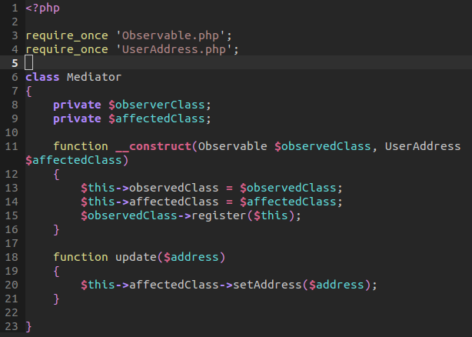

Now when we register our observer we have the ability to now notify our object when a change occurs. This change will of course come from the client. Now the observable class is an abstract class and therefore must be extended to be used. Thus, we can have multiple observers in which take advantage of listening for a particular object that the client will change. In this instance, an address:

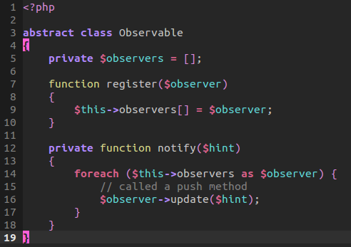

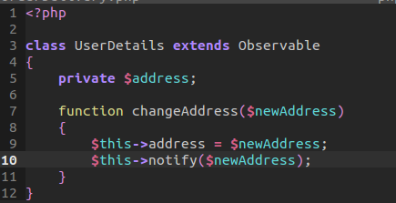

Now when our client makes a change to the address, that change is reflected in that object. However, the affected object also needs to show those changes. To do this, we call a notify method that is inherited from the abstract class. That abstract class will grab the hint, or in this instance, the address, and thus go through the mediator or listener to call update. That update function can be found back in the mediator object which will take the address and changed the affected object class with the address provided.

Now the affected address implements the user address class. Here, it will change it's own property of the set address to the current address:

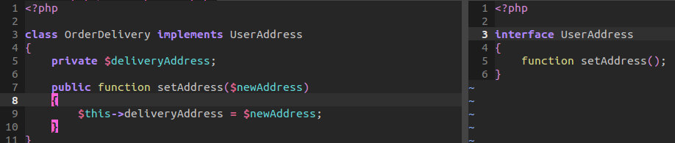
The mediator pattern takes advantage of both the observable pattern as well as its own to demonstrate a mediator or class layer that handles the logic. The client can affect first hand the object while the mediator respectively changes the affected object.

14_Singleton Pattern: A very controversial pattern that is loved and hated. Some say it is an anti-pattern and some say its a very well thought out pattern. You decide.

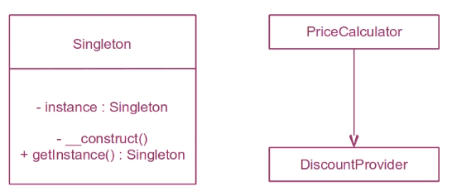

The singleton is a class capable of providing a single instance of itself. Every time a client needs an object of its type, it will use a get instance. Only when an instance is not available will it create it. Client side user interfaces, login, and even Facades take advantage of the singleton pattern –remembering an object's life cycle. By providing a single instance, this known as lazy loading. This is useful when creating an object that is expensive. If a service provides information from a slow source, then a singleton pattern can be used. However, be aware that as easy as it is to use, comes a danger. Pattern abuse is easy to achieve. This pollutes the global namespace. This makes testing more difficult. Take the time to learn this pattern but use it only when needed.

We will create a Price Calculator in which will calculate a discounted price. First, the caller will provide a product. This product will contain information of its price and identifier.

Next, we call an instance of the Discount provider. Now the calling of the instance is a static class. Jumping to the Discount Provider we can see that our instance is a private variable. Also, the constructor is private which disallows the creation of an instance. The only publicly available functions to call are the discount and the instance. The instance will check to see if the private variable is set. If not, it will call a new instance of the object and then return.

That's the design pattern! All it does is it makes sure that we only provide one instance of a complicated object. Perhaps the constructor has to set the discount and would require an expensive amount of time.

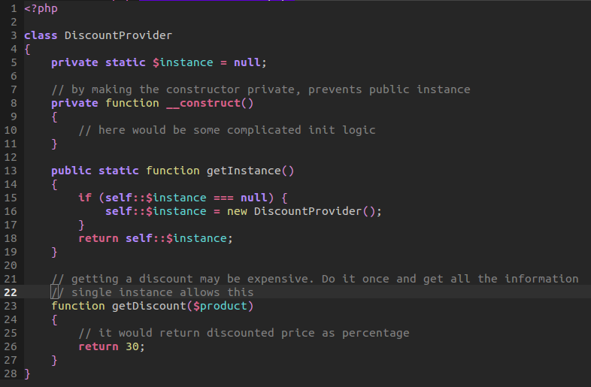

Now back to our compute method. We grab an instance and then call the discount provider to get a discount base on product id.

Next, we get the price and multiply the discount to then subtract the original price. We return the final result for the discounted value!

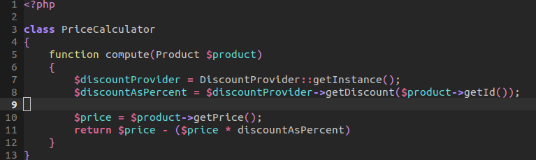
15_Monostate Pattern: Is singularity a good idea? In some situations, we need to use a state that is persistent. The singleton pattern tackled this problem. The warning behind the singleton is that it is varied in comparison to the mono-state pattern. The mono-state has private variables and dynamic setters and getters.

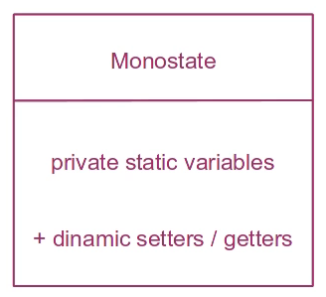

The monostate is very similar in the sense that it allows us to keep a persistence of value from an object from one instance to the next. Instead of using the singleton pattern that uses lazy loading, we can use the monostate pattern. The monostate pattern takes advantage of static variables.

In our example, we will follow TDD by creating three objects. Our end goal is that our assertions, the value ten, match those of calling of dynamic methods.

We first create two new instances, and then set a value. We then check the assertions on both values to see that both are true. We do so, again with a new instance, by asserting once again the value that we want to create.

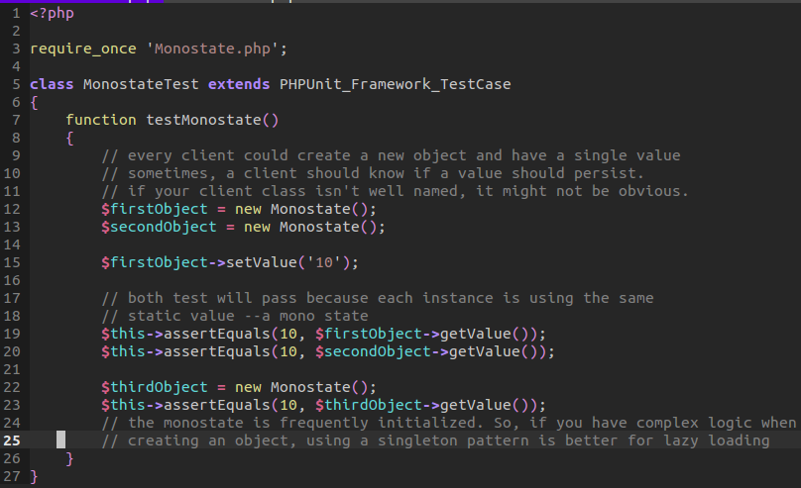
Now within our monostate class, we create that static value that maintains persistence. Both our setters and getters have one goal in mind in that they both assign the values to the static variable value. By doing so, we have the ability to maintain the monostate value. This allows persistence across objects. However, there are risk involving this design pattern. The monostate is frequently initialized. So, if you have complex logic when creating an object, using a singleton pattern is better for lazy loading that accounts for the expense of creating the object.

16_Abstract Server Pattern: This is the simplest pattern ever invented. The tail of the shop owner who started a web shop that was a seller. He started selling red roses. He hired a programmer to keep track of the shops as classes and objects. The Red Roses where pretty simple.
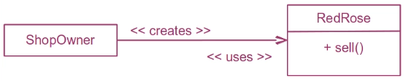

However, as the store progressed, so did the demands of the client. The client wished to sell more than one instance of a rose. That is, sell more than one type. This is where we would take advantage of the abstract server pattern. This abstract server pattern abstracts the implementation of an interface from the client so they are no longer concern with using the actual implementation but, instead, an abstraction. The client, in turn, isn't concern about how the rose is created nor the type of rose object. It is abstracted so different types can be used that are part of a larger class of Roses.

To handle this, we will follow TDD principles, breaking down each of our test cases to demonstrate functionality.

First, we will test if a shop owner can sell red roses. That is, a type of roses. We create a new instance of Red Rose. Red Rose implements Roses, all roses share the common feature of selling and checking to see if a rose is sold.

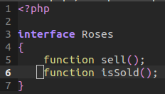

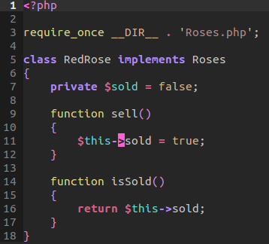

Our red rose will implement these methods by demonstrating a simple get and set method. Now our shop owner, when created, will expect a type of rose. We send this instance of the rose to the constructor of the shop owner. The shop owner will assign an instance of the rose class to a private variable to be used later. Because of this type of dependency inversion, we are able to abstract the type of rose to be used. We can then call shop owner sell. That, in turn, will call directly the instance of that rose object that was passed. Calling specifically its sell method.
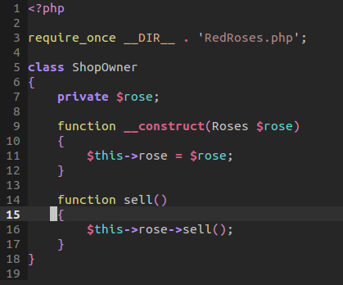

That sell method, jumping back to a type of rose, such as Red Rose, will set the property value of the that object of whether it was sold or not to true!

Thus, when we assert true whether our red rose is indeed sold, we can assume true because the shop owner took advantage of not the red rose but a type of rose it sold.

This same level of abstraction can be used to take advantage of implementing another feature of roses, such as yellow or white.
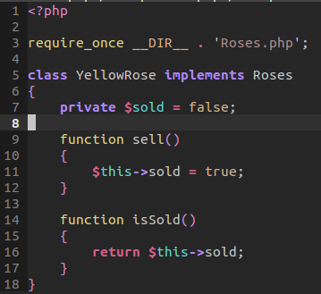

In end result, it is not up to the choice of the shop owner to know what flower they should use. Instead, the client, or the agent that uses the shop will provide the type but only within the other sub class files will not expect a certain rose but an abstraction of that rose.

That is why our test can create a new yellow rose, send it to the shop owner, and then the shop owner will call the instance of the rose to set true that it was indeed sold. We can then assert true once again that the item we sold is indeed sold!

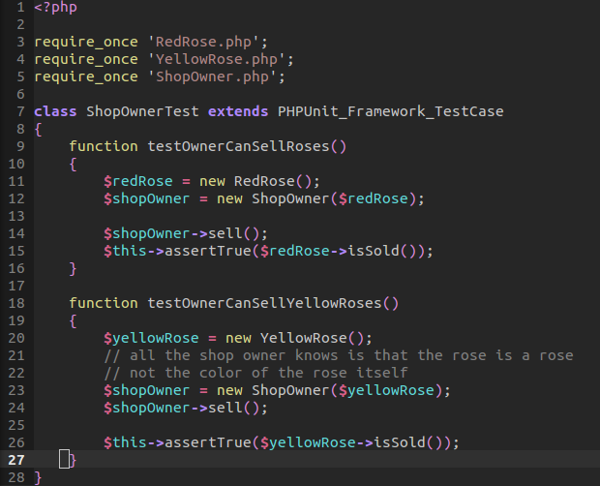

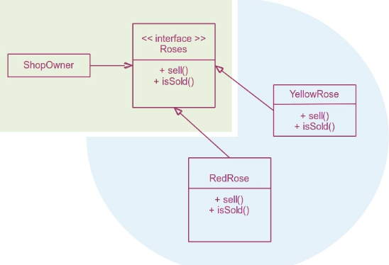
The shop owner does not depend on what type of rose it gets. It can sell any rose it likes. The dependency was inverted. The rose depends on the roses interface thus respecting dependency inversion. A new rose type, white rose, would use the same interface. The application will be extended by the same functionality. The open-close principle was respected because of this interface.

17_Adapter Pattern: In real life, there are countless situations where we would use this pattern. What if we wanted to connect our old audio system to a new output surround system. An adapter can be used to make the connection. If it happens that you travel across continents, American's need adapter to connect frame to local. We can apply this concept to our software. We may have an old product and clients may want to interact with a new product. Modifying them is almost impossible. Our current software may have to interact with third party software. The only choice is to write some code that will adopt one input and take the other response to which to translate for our application to understand.

Imagine our owner was successful with the flower shop. He created a boutique to sell roses. Our new web shop has to be re-written. Our abstractions are higher level and better defined. Our shop owner became nostalgic and therefore wanted us to adapt the old application while interacting it with the new language.

On the left, we have the current web shop. It has its methods. On the right, we have the old roses interface. There is no way we want to modify these applications. Imagine, if we change one aspect, we have to change it all. A change to an interface means changing all the interfaces.

What we want, is some sort of module, to hook into the product application and work with it properly.

We will use a Roses to Product Adapter. It will implement the product interface and handle calls from the old application. Being an implementation of the product interface, it will be accepted throughout our application. The classes will not know or have an idea of the adapter.
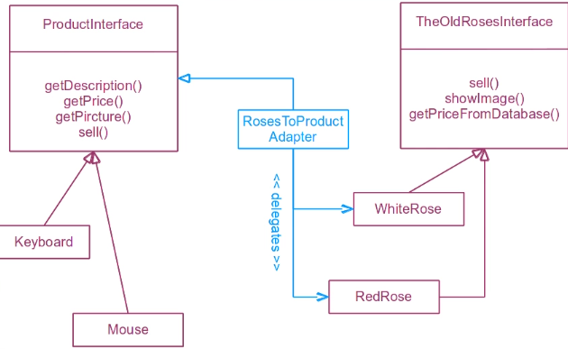

Our old rose interface is just an interface in which a a Real White Rose class will use:
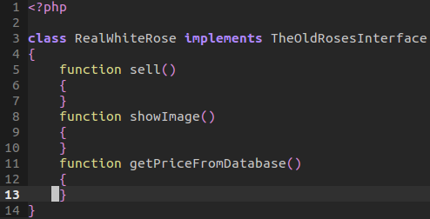
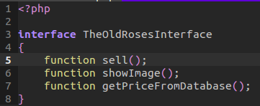

As we can see, we implement the methods but we are not concern with the actual use of these methods.
The new application, as we know, is the product interface. Any product that implements the product interface will use these methods. It is to our advantage that we adopt the adapter class so we can interact with an older implementation.

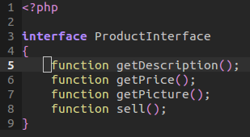

Our Rose to Product adapter will implement the above interface. We create a private variable that will contain the instance of rose or the class that we would like to use. This will be an instance of the rose class that is attributed to our legacy code. It could also be a plugin of some sort –it is injected through the constructor for proper dependency injection. We then implement the use of the current methods that are available in rose to simulate a like functionality. That is, the product interface doesn't know we are using it directly to interact with the rose class. Instead this adapter will simulate the proper product methods. If it is a rose, then it will use the available rose methods, but do so under the product methods. Thus, if a method does not exist, that we need to use, then we can easily return a default value or string. The rest of the methods have a respective alternate method in the rose object.

In many cases the adapter can be more sophisticated. It doesn't matter because the concept remains the same. We can use this pattern for legacy classes or plugins to our current application.

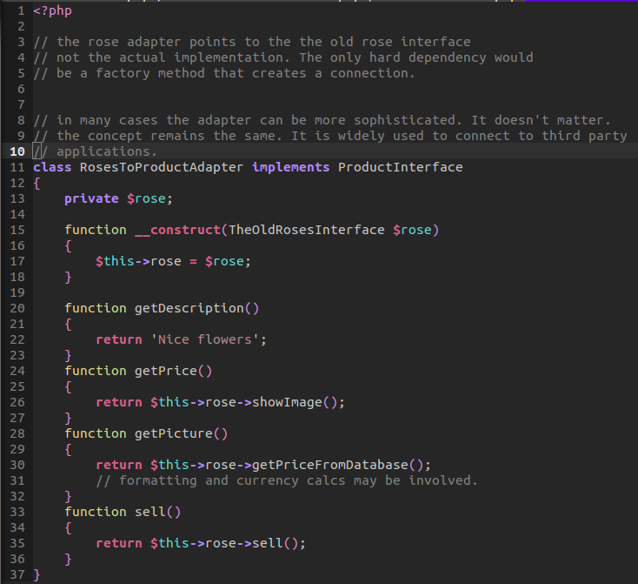

18_Bridge Pattern: Sometimes, we need flexibility on both ends of an adapter pattern. Changing classes in our code and patterns. The Bridge pattern, as oppose to the Adapter Pattern, which is used after the fact that you need to adopt the code. The Bridge Pattern is setup for greater flexibility. However, the bridge pattern is the most complicated pattern. It relies on, Abstract Server, Template method, and strategy pattern. While also following the adapter pattern.

Our hierarchy demonstrates that our direct payment and credit payment both use visa and master card. Both visa and master card are repeating. The only difference is that both prefer a certain way to function. When we see this, we may think about using the bridge pattern.

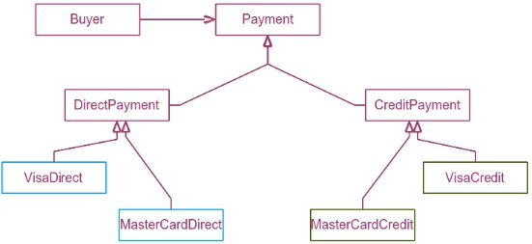

Our UML will require ten different classes. The bridge pattern requires such an implementation.
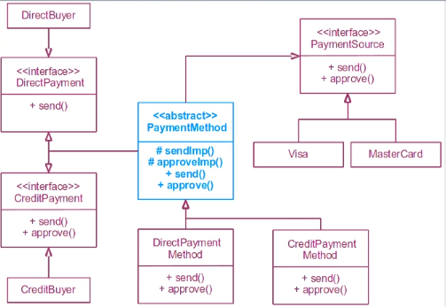

The flow event is as follows, the direct buyer will call the send method. The send method will be a payment class and its send method. This is all abstract. The abstract send method will be implemented by the direct payment method. This send will call back the send method of the abstract class that uses the delegation to either visa or master card. Finally, the process is done and the payment is done

The credit buyer will be similar with the only difference is that we have to care about the approval of the payment. The buyer will use the same payment method for abstraction, but this case will be the credit payment method. This will in turn be delegated to the payment source of visa or master card. The direct buyer can also use the payment source which will be automatically approved. Both implement both interfaces. This gives the ability for both the direct buyer and credit buyer to use the bridge payment to then call either direct or credit payment and thus we delegate to the payment source of visa or master card.

I'm going to walk us through a Direct Buy and then walk through credit payment.

We begin with the Direct Buyer class that will contain the method pay now. The pay now will use the direct payment method which will inject a dependency type of Direct Payment. Remember, Direct Payment will be implemented by the abstract class of payment method which will then be extended by Direct Payment method. As such, the direct payment method will be using a form of direct payment method. When the pay now method is called, it will call the payment send method:

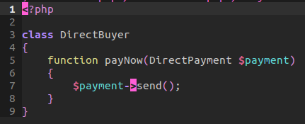

This payment send method is an abstract method of payment method. The payment method is an abstract class, and as such, each method that extends it must use it! It must use both approve and send.
In turn, the payment method will allow both extensions to be able to call a set payment source. Setting the payment source is up to the store when interacting with the buyer.
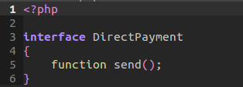

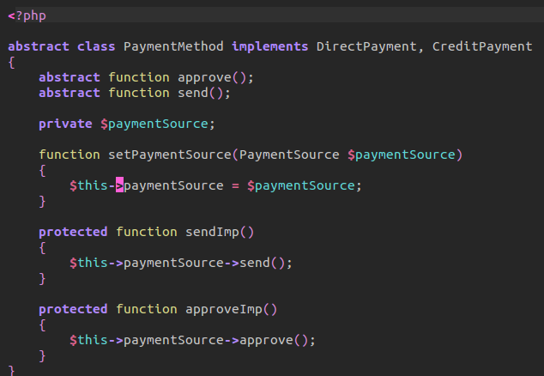

When we call send from the direct buyer, we are calling direct payment method which extends the above abstract class. As such, we then call the parent to send the implementation. We will assume that the payment source has been sent through. We then call the implementation of the payment source method of send.
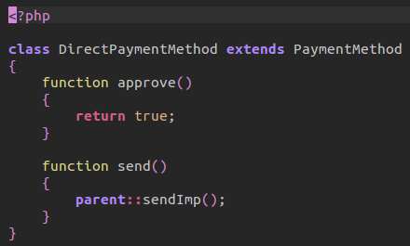

Next, we then call the the payment source type. Any payment source will use the implementation of a payment source. Both payment sources use the interface of approval and send.

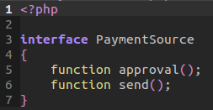

This payment source can be either be visa or master card. It is not the concern of the payment method which, just calling the abstraction of both send and approval is what is important. In either case, of visa or master card, we use the approve and send methods. This involves talking to the bank and approving the sum. The other is the process of transferring the money –the final transaction.

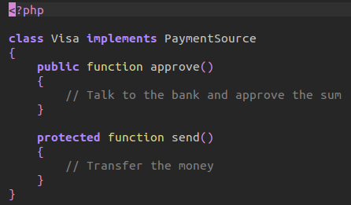
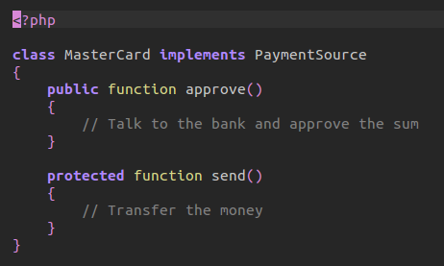

As you can see the payment method is not concern, just focusing on the implementation.

Direct Buy
- Direct Buyer will pay now while uses the direct payment interface which will in turn will be implemented by an abstract class that demands any extensions to implement a contract.
- The extension of such a direct buy is handled by direct payment method. It will use the bridge pattern to approve and send the implementation of a chosen payment method.
- That payment method will interact with the implementation of a payment source which would be either visa or master card.
- Payment will return true if successful.

Now the credit implementation works very similar except that it needs to use the approve method found in the credit payment method class.

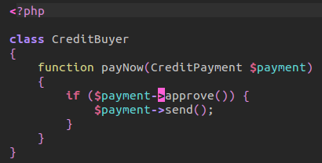

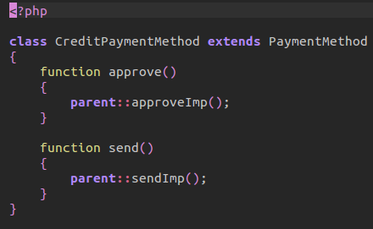
We will use a Credit Buyer class that will first check if the payment has been approved. Long winded, this will draw itself back to the Credit Payment method that will call the approval implementation of its parent.

As we can see, the approval for credit expects a call to the parent to actually check, whereas another extension of direct payment doesn't need to check for approval.
This is proven through by the interface of Credit Payment:
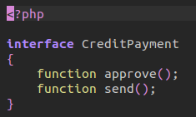

The parent method will use the send implementation. The send implementation will call the payment source of either of master card or the visa card. The only difference is that this approval needs to approve the of the implementation to use it. If true, then we can call send. So, in many ways, there is only one checker already available.

19_Composite Pattern: Much simpler to implement. The composite pattern has a simple principle. Keep a list of each objects and call a method on them. Both the objects and composite object will use the same interface. Instead of doing one thing with the order place, it will do a series of operations on an object. The composite pattern will add the type of the interface.
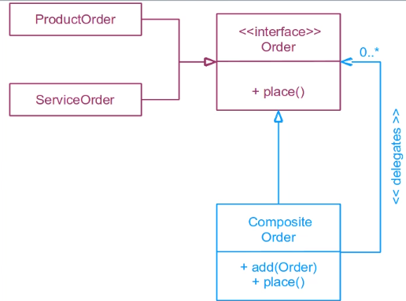

Our example will produce a composite order that will place multiple orders in the service. The ordering interface is our main object.

We have an order interface that will place contain one function of place. This function is to be implemented through each kind of order.

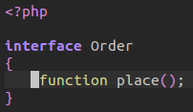

A product order will implement the order method by contacting the warehouse to place an order:

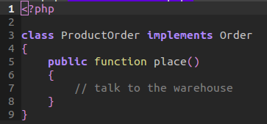

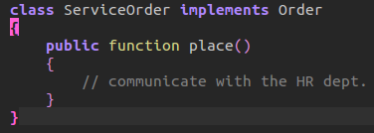

Now the interesting perspective here, is that the composite will implement the same interface as that as the orders. This is interesting because the abstract pattern does not. That is, multiple actions and behaviors happen behind the scene very similar to the object pattern. However, the active object from a list is separates the interface of the order and that of the actual implementation. Here, the composite pattern shares the same interface.

Each order that is placed on the composite order will be stored in a private array that is of type hints.
When the order is to be finally placed, we call an array walk that will grab each increment for which the call back function will then call the order place method that belongs to the logic of either Product Order or Service Order.

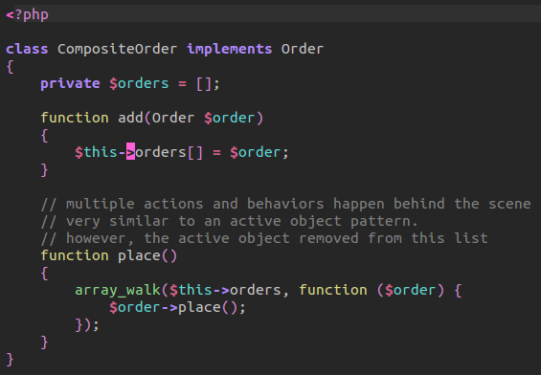

20_Visitor Pattern: this is one of those patterns that are rarely used and only applicable in certain situations. This is useful when you can't modify all the classes but extend it. It is also a way to use many many relationships.

For our example, we will have a client that will use an interface that is of public method. This will use the visa and paypal payment option. Both will use the interface of payment visitor method that will use a visit method. Finally, both implementations of the HTML payment description or simple payment description. Both implementations are pointing to the both interfaces. Of payment visitor and payment method

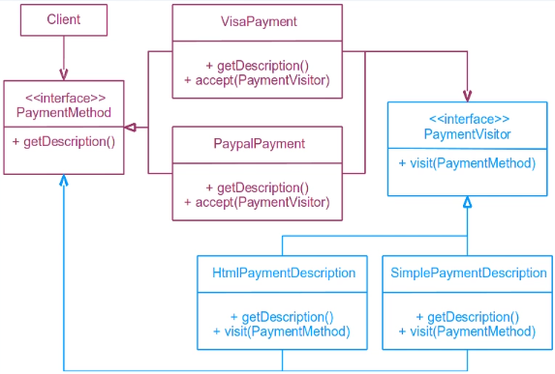

We will work from a TDD perspective in that we will be developing two cases that will test whether a simple description or HTML description has been returned.

We begin by creating a new instance of the simple payment details which implements a payment visitor interface.

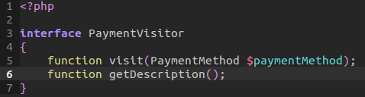

The simple payment method will return it's private variable of description. The visit method will expect a type of Payment method. It will then use that payment method to grab the description and assign it to the private variable:

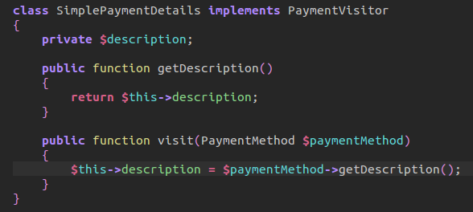

Next, we create a new Visa Payment which is implemented a payment method interface:
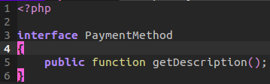

The payment method will use the get description method to return a visa description. It has a new method of accept that will expect a payment visitor. It will then call the visit method from that expected type, passing through a reference to the instance of the current Visa Class.

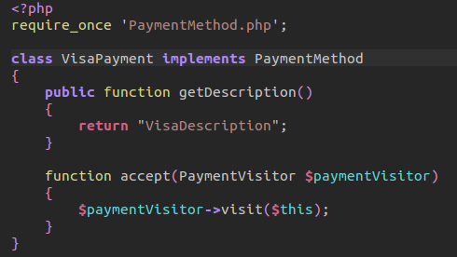

Once we create both the simple payment method and the visa payment, we need to provide the glue that links the two together. We pass through the visa payment accept method, a reference of the type of payment visitor, which will be a simple payment detail. We then call the simple payment detail visit method with a reference of the visa payment. This, in turn, will call the description of that reference to assign the return value of getting a description –that is, the visa description will be assign to the simple payment private description.

Now, we can assert what our visa description should be by getting the description of the simple details directly.

The same thing can be applied again, but this time, a different visitor class. The HTML Payment details will assign the description with a tag string element that grabs the description of the visa payment. Same thing, just returns some tags.
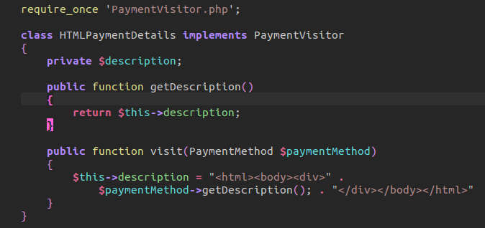

Our test pass and we can see how we can use a visitor pattern to visit two different kinds of implementations.

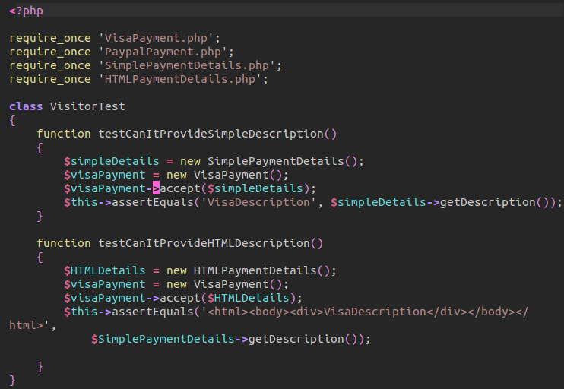

As a final thought, this design pattern should be used if necessary. It is not a pattern you will design naturally as a solution. What it will do, however, is help you get out of a situation.

21_State Pattern: A finite state machine has a discrete number of states it can pass through. Each state knows about the next one until the end. Others remain at their destination or final state.

A State Pattern can be used with a switch statement or an if-else statement. One of these solutions, is the state design pattern. The pattern uses the pattern of a central class that can call several implementations of a state.

In our example, we have an order tracker which will have a state of delivery. That will get the next update. The update will be updated to a new state by another object. There will be three implementations. Processing is still in the warehouse. The second state is when the order is on route. The third is when the order is delivered.

Because this logic is interesting and useful, we will create this pattern:

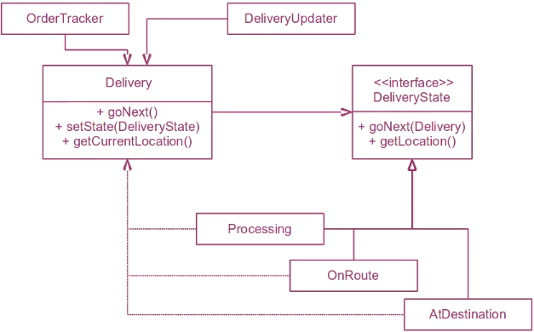

Our design pattern will create an order tracker that will track each delivery and its current state. It will have the ability to update and change states while maintaining its current state.

We will follow a TDD by example. Our TDD example will have the ability to create all three states and test its current location to an assertion.

Our first test will test if we can create a delivery with an initial state at warehouse.
We first create a new delivery sending through a new processing object. Our delivery object focuses on binding the current state by the processing object. It also has the ability of grabbing the current state, moving on the next state, and setting the current state by the state object. Notice that we delegate our delivery state to the processing object that is passed through:
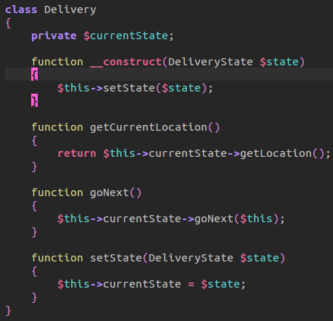

Notice that we pass through the current reference of the object when we call the next state. That is because our processing object will handle the ability of delegating a new reference of our object to an entirely new state.

Our processing object will have the ability to return the current location of the warehouse. This return will be reference by the Delivery Object. Our go next method will take that Delivery object and set it's state to the new instance of on route. Remember, we have three states to go through, by passing a new object, we are passing through the current state of our object and setting a new state by delegation.

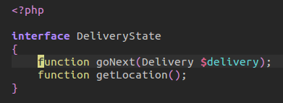

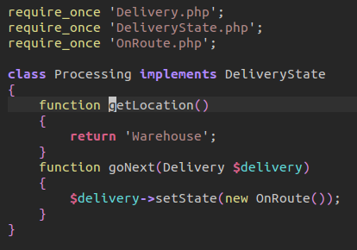

Our test will assert that the current location of our delivery is warehouse. Because of linking our processing object to the delivery object, we are able to return the current assertion.

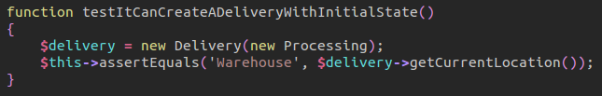

Our next test will test whether our delivery object will go from a processing state to that of on route. We create a new delivery object passing through the same reference of the processing object. But notice, before we check our assertion, we go to the next state of our delivery.

Drawing back to our delivery object, when we call go next, we call the reference of go next on the current state. That current state is none other than processing object passing through the reference of the Delivery object. Now, going back to the processing object, we type hint an expected delivery object. We call that delivery object to set the state to on Route! The only difference now is that the delivery object will take that on Route object and set the current state of the delivery object to the state that was passed through. Now the Delivery object is referencing the new on Route object as the current state. That way, when our test asserts that the package is on the train, that delivery location will delegate a reference to on the train because we are referencing the current state as on route!

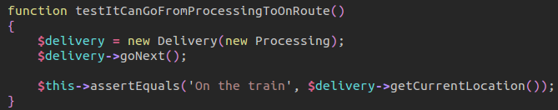

I will provide a reference of the on route, notice how the on route maintains a similarity to the processing object, the only difference is its current location and the fact that go next will create a new instance of At Destination. Both follow the implementation of the Delivery State object.
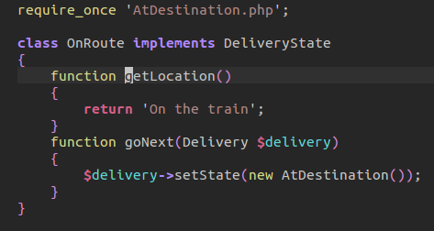

Our final two test will be combined so that we can see that we can move the final destinations state but also maintain the ability to keep our current state –even if we go next.

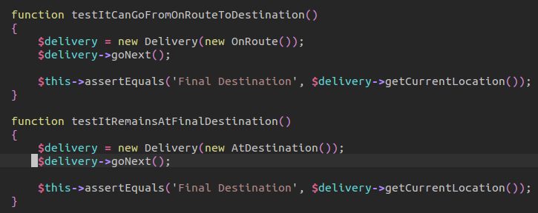

Our Route, as mentioned, will go to the next state of delivery, at destination. Since destination maintains the same functionality of a delivery state, the get location method returns final destination. And our go next method will have a next state, but that next state will be the same state.

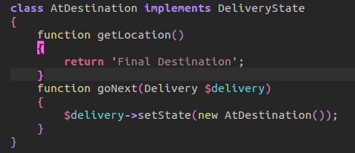

Whenever a delivery updater calls go next, the object will go to the next state. Once it goes to its final state, even if ask to go next, it will remain at the final state.

This pattern is extremely useful when developing an application that must maintain multiple states without having to resort to if-else or switch statement logic.

22_Decorator Pattern: The last pattern we will talk about is the Decorator pattern. If you remember the Visitor Pattern, it allowed us functionality without having to change the classes. But it was complex.

The decorator pattern fools the client to be using a payment method. As define originally, however, it will use a decorator pattern that something a client expected but is actually provided by a paypal or visa payment. This done by providing a reference of the payment method. In turn a display of details will extend a decorator pattern, allowing default functionality and additional features by just extension.

In this example, we will be using TDD as a client to which it will grab a description. Whether that description is directly provided through a callback from the paypal or is also formatted is not known by the client to actually live inside a payment method. That is, it doesn't know that calling the description is being delegated to a payment method. And that a special payment description may be an extension of the original decorator patter. The client isn't concern with those necessities. What it is concern with is the ability to grab a description and that's it. This features are improved through a decorator pattern that acts as a means to decorate our expectation with extra features we might need.

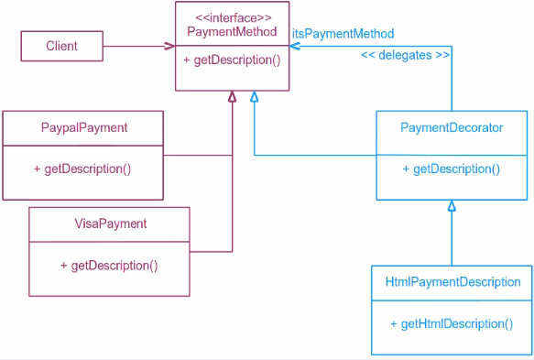

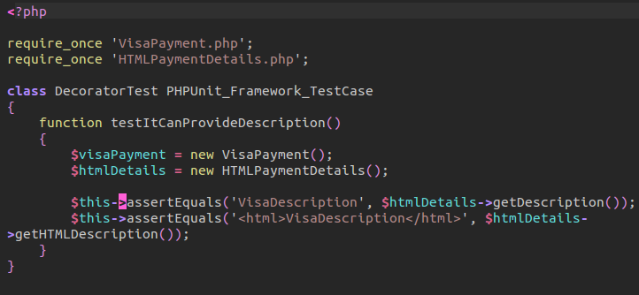
We begin, as usual, with the creation of a test case that will assert the idea of obtaining a description from an HTML payment details. We can grab the direct description or a description wrapped in HTML tags.

We first create a new visa payment. This visa payment will be an implementation of a payment method.

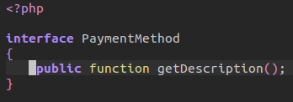

Our Visa Payment will allow us to return a simple string description.

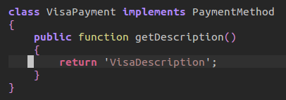

Alternatively, you can use the same for a Paypal description –I'm not going to post that because, honestly, you just need to rename the class to paypal payment and the return string.

Now the payment decorator is where design pattern can be seen. Our payment decorator will be implementing the same interface as both the visa payment and paypal payment class –the payment method. This time, however, we will be providing a constructor to this abstract class. An abstract class can implement a binding contract but cannot be implemented itself –only extended. When we create an extension of the payment decorator it will use the constructor to assign a reference to the payment method class. We also provide an implementation of the description class that will call the payment method description method. Notice that this is where we get the string from the delegated action of a payment method.

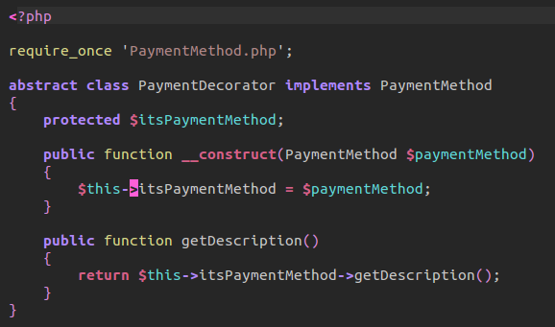

When we create a new extension of the decorator by an HTML payment details class, we provide an additional feature of an HTML tag description –it basically calls the private variable payment method to then return the description. Notice that our HTML description is an extended feature not part of the original abstraction.

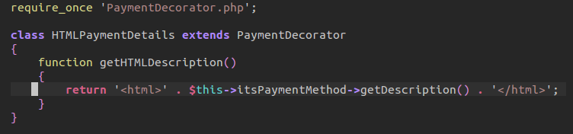
Now, when we conduct our first assertion, we are returning a delegation of our payment method to return a description. The next assertion, the client doesn't directly know that the HTML description is not part of the payment decorator but is an extension of the original feature. This is why we call it a decorator pattern in that we can extend features and decorate or customize our usability. In the second assertion, we expect a description wrapped in an HTML tag.

