Praece Render App Template
Build a working web app by describing it in plain language. This template gives you a ready-to-run app (login, admin, database) that lives on Render, and a setup where Claude Code builds and ships every change you ask for.
You set things up once (about 30 minutes), with Claude doing the technical parts. After that, you open Claude, describe what you want, and Claude builds it and puts it live.
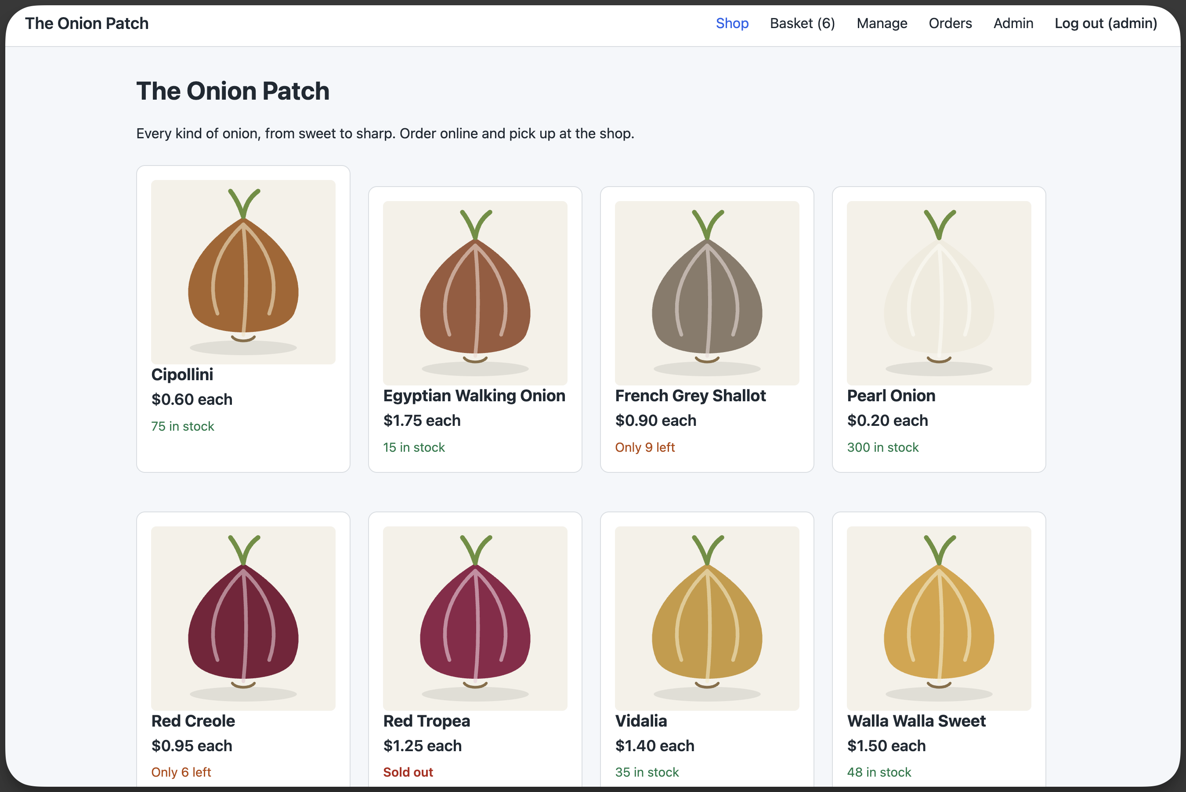
An example: an online shop built from this template by describing it to Claude.

What you'll need
- A GitHub account. GitHub stores your app's code. Sign up if you don't have one.
- A Render account with a payment method. Render runs your app and its database. Sign up at render.com using Sign in with GitHub, which saves a step later. The app uses Render's paid Starter web service and Basic database plans (pricing).
- A Claude plan that includes Claude Code (Pro, Max, Team, or Enterprise).
- Optional: a custom domain (like tracker.yourcompany.com) and access to change its DNS settings.
Using a company GitHub organization, Render workspace, or Claude Team/Enterprise plan? This guide assumes accounts you control. In an organization, some steps may need an owner or admin to approve them, and company rules can get in the way. If a step doesn't work as described, these are the usual places to look:
- GitHub: approving apps for an organization (Render and Claude are both GitHub apps), and rulesets that block pushing straight to main (Claude ships by pushing to main).
- Render: connecting GitHub and workspace roles.
- Claude: Claude Code on the web.

Step 1: Make your own copy of the template
- Open the template on GitHub: github.com/justinpecott/praece-render-app-template.
- Click Use this template → Create a new repository.
- Choose the Owner (you or your organization) and a Repository name, like equipment-tracker.
- Choose Private.
- Click Create repository.
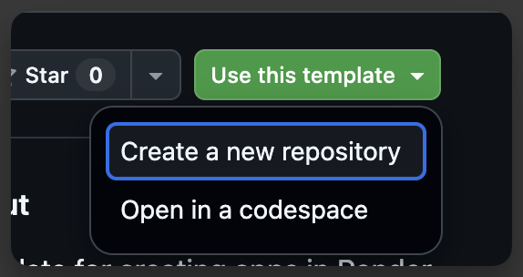

Step 2: Set up Claude Code on the web
Claude Code on the web runs Claude in a private cloud computer that has a copy of your repository. Claude needs three connections: GitHub (to read and save code), Render (to watch deploys and read logs), and network access (to install packages and check your live site).

2a. Connect GitHub
- Go to claude.ai/code.
- Follow the prompt to connect GitHub and install the Claude GitHub app.
- Under Repository access, choose Only select repositories and add your repository.
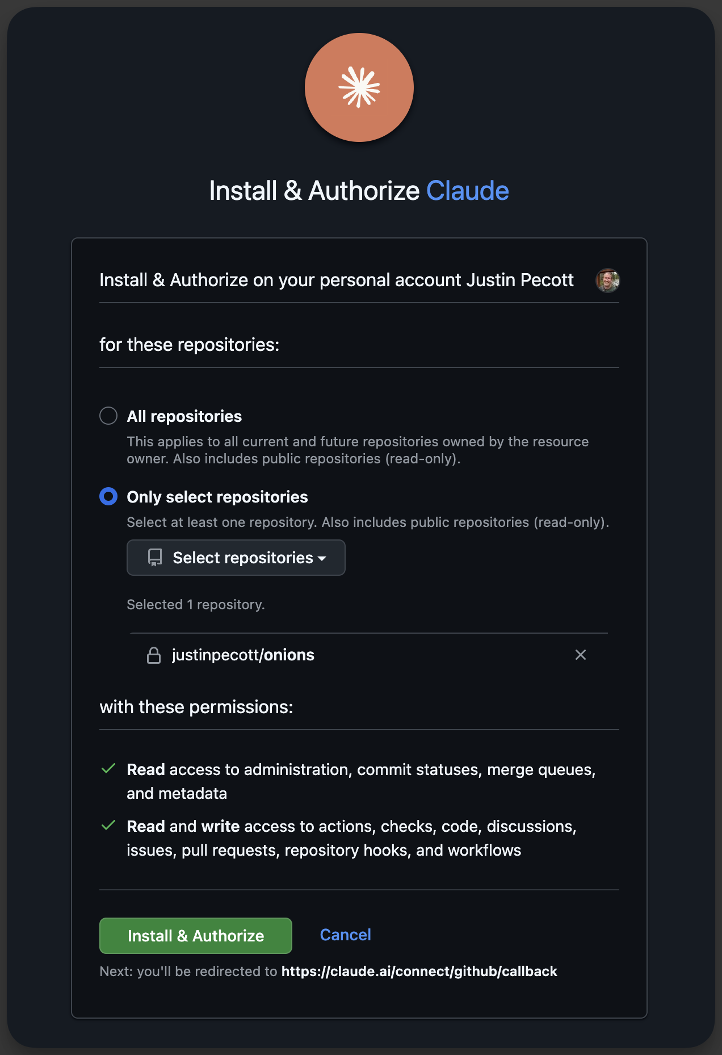

2b. Connect Render
- On claude.ai, open Settings → Connectors.
- Find Render and click Connect. Sign in to Render and approve access.
- If you belong to more than one Render workspace, Claude will ask which one to use the first time; pick the one your app will be in.
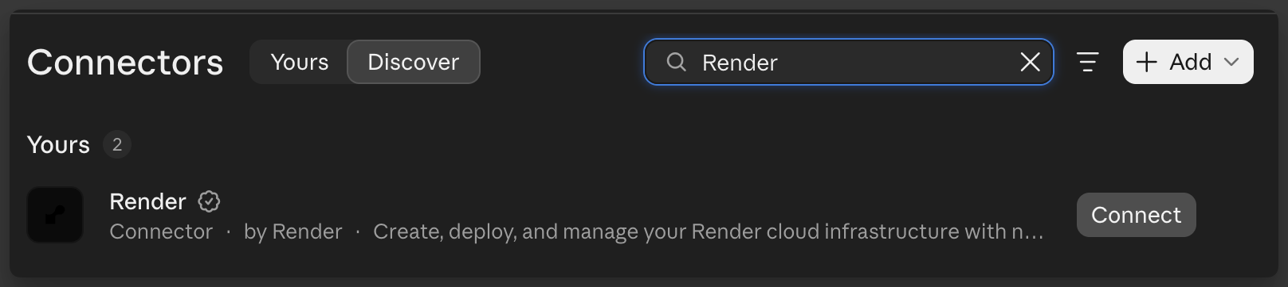

2c. Connect the GitHub connector (optional)
In Settings → Connectors, also connect GitHub. This lets Claude look at issues and pull requests. It isn't required for building and shipping.

2d. Create an environment
- In claude.ai/code, click the environment menu (it starts out as Default) and choose New environment.
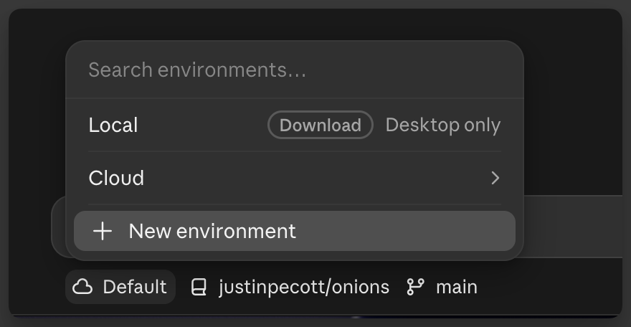
- Give it a name, like your app's name.
- Under Network access, choose Limited. In Allowed domains, enter *.onrender.com (and your custom domain, if you have one, on its own line), and tick Allow package managers. This lets Claude install what the app needs and check your live site, and nothing else.
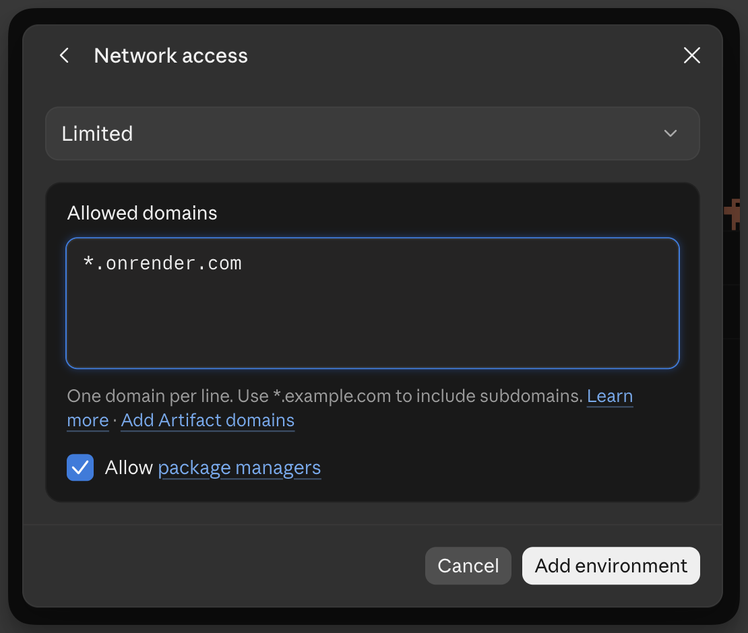
- Leave environment variables empty. Your app's secrets live in Render, not here.
- Click Add environment.

Step 3: Name your app with Claude
- In claude.ai/code, select your repository and environment.
- Type: Set up this project.
- Claude asks what to call your app and suggests a name. The name becomes part of your app's web address (like equipment-tracker.onrender.com), so pick something you're happy with; it's hard to change later.
- Claude saves the name and tells you to set up Render. Keep this session open; you'll come back to it.
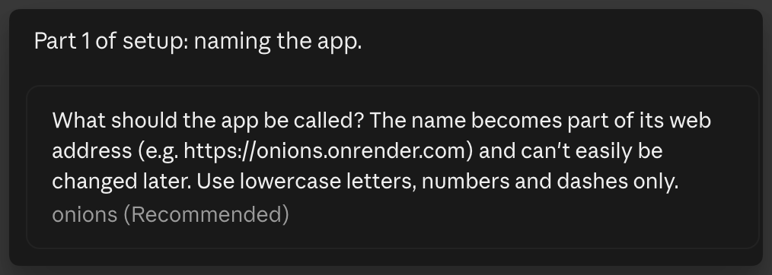

Step 4: Put your app on Render
Render reads the render.yaml file Claude just updated and creates everything from it: the web app, the database, and the connection between them. It also sets up automatic deploys: every time new code reaches the main branch on GitHub, Render rebuilds the app, updates the database (runs migrations), and switches to the new version only if it starts up healthy.

4a. Let Render see your repository
- In the Render dashboard, click New → Blueprint.
- The first time, Render asks you to install its GitHub app. Choose Only select repositories, pick your repository, and click Install.
- Under Connect a repository, find your repository.
  - If it's not listed, click Configure GitHub (or Configure account). On GitHub, under Repository access, add your repository and click Save.
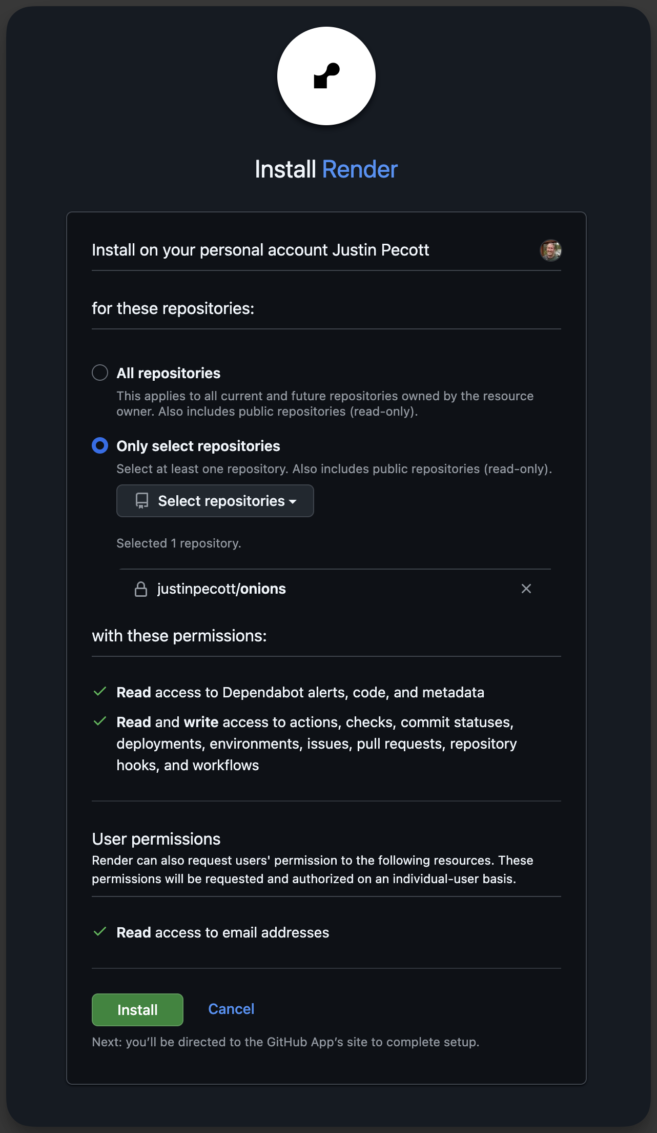

4b. Create the Blueprint
- Click Connect next to your repository.
- Give the Blueprint a name (your app's name is fine). Leave the branch as main.
- Render lists what it will create: a web service and a PostgreSQL database with the name you chose in Step 3. If it still says my-app, go back to Claude: the name wasn't saved yet.
- Click Deploy Blueprint.
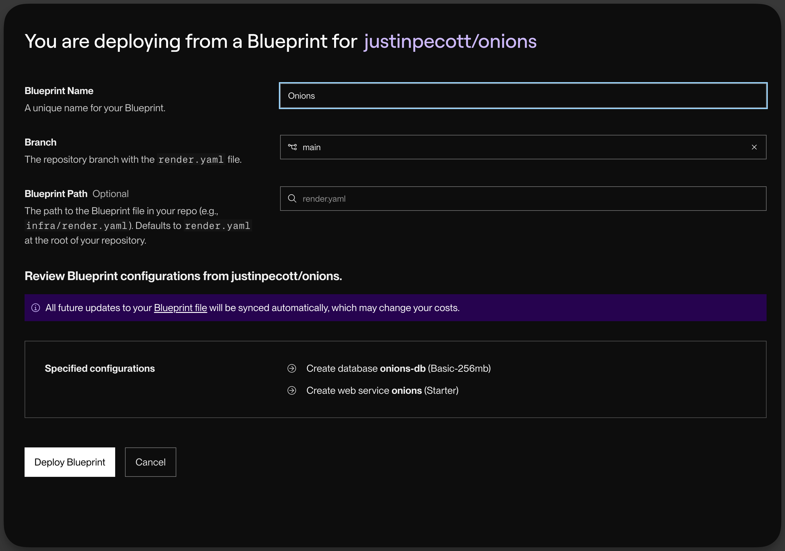

4c. Watch the first deploy
- Open your web service in the dashboard. Under Events, the first deploy runs through build, pre-deploy (this is where database migrations run), and deploy. This takes a few minutes.
- When it says Live, click the https://<your-app>.onrender.com link at the top of the page. You should see a login page. You don't have an account yet; Claude creates one in Step 5.
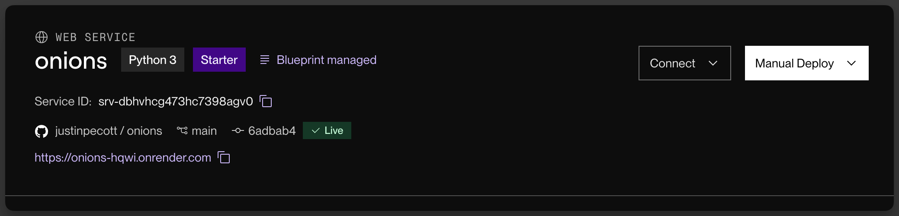

4d. Check automatic deploys and migrations are on
These come from render.yaml, so they should already be set. To confirm, open the web service's Settings and check, in the Deploy section:
- Auto-Deploy: On Commit.
- Pre-Deploy Command: includes manage.py migrate.
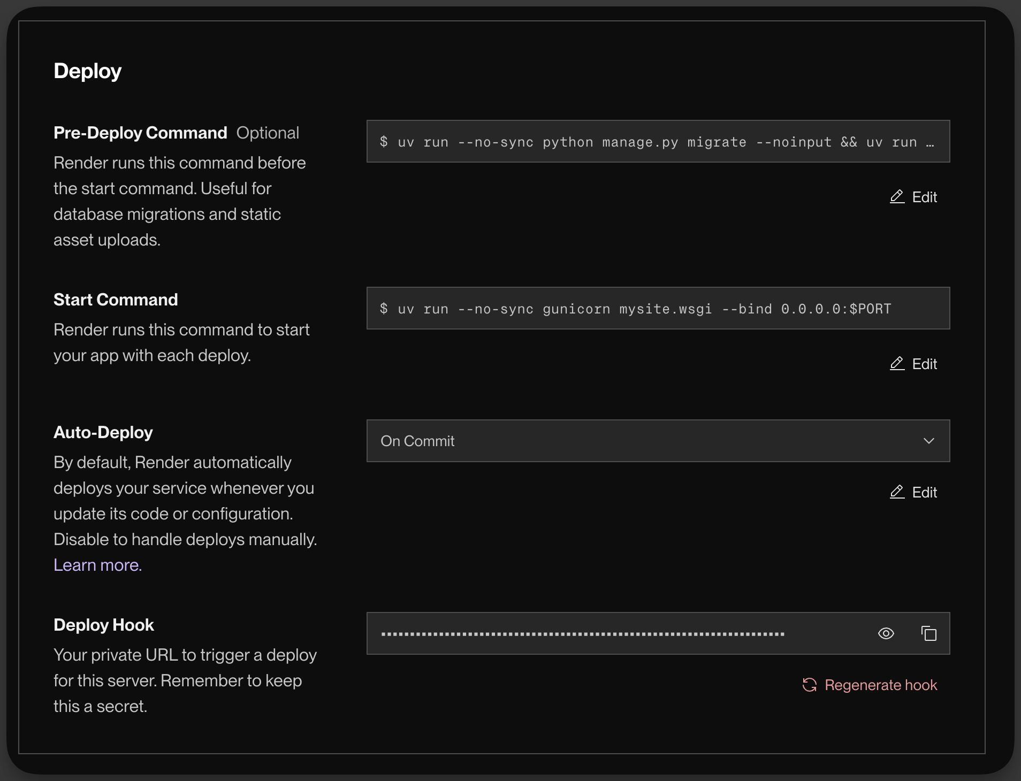
Further down the same Settings page, Health Check Path should be /health/.

Step 5: Finish setup with Claude
- Go back to your Claude session from Step 3 and type: Render is ready.
- Claude will:
  - find your app on Render and record its name and address,
  - create your admin account and redeploy,
  - give you the web address, username (admin), and password.
- Save the password in a password manager. Claude shows it only once.
- Open the web address, log in, then go to Admin → Change password (top right) and choose your own.
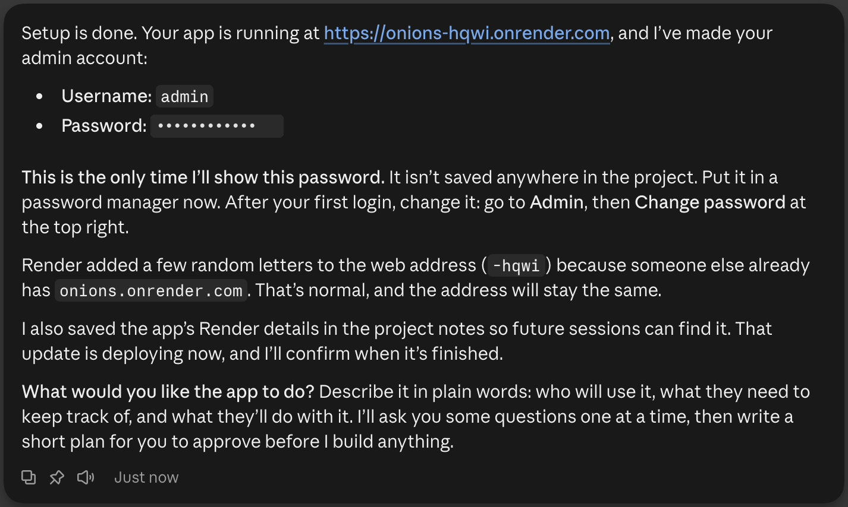
You can add more people in Admin → Users → Add user. Tick Staff status for anyone who should be able to use the admin.

Step 6: Describe your app
Start a new session and tell Claude what you want, in your own words:
We need to track our equipment: name, serial number, where it's installed, and when it was last serviced. Show me what's overdue for maintenance on the home page.
Claude asks before it builds. For a new app or a big feature, Claude interviews you first, one question at a time, usually with answers you can click. It asks who uses the app, what it keeps track of, what people do with it, and who can see and change what. Then it writes up a short plan for you to approve and builds the first piece. For smaller changes it asks a quick question or two, and small fixes it just does. If you want it to skip the questions, say "just do it".
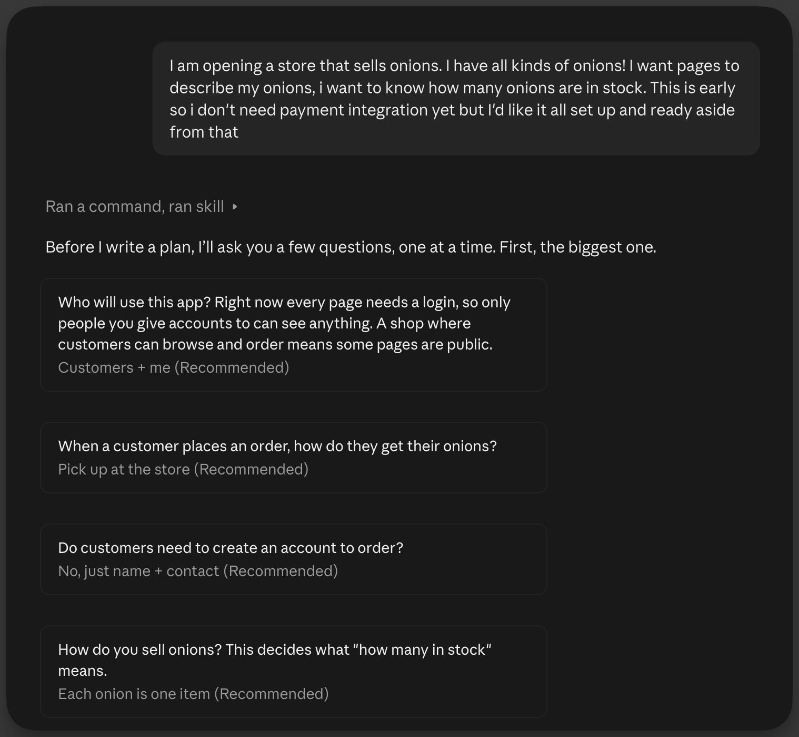
You can start the full interview yourself at any time by typing /grill-me.
Each time, Claude makes the change, saves it to GitHub, waits for Render to deploy it, checks the live site, and tells you what changed and where to look.
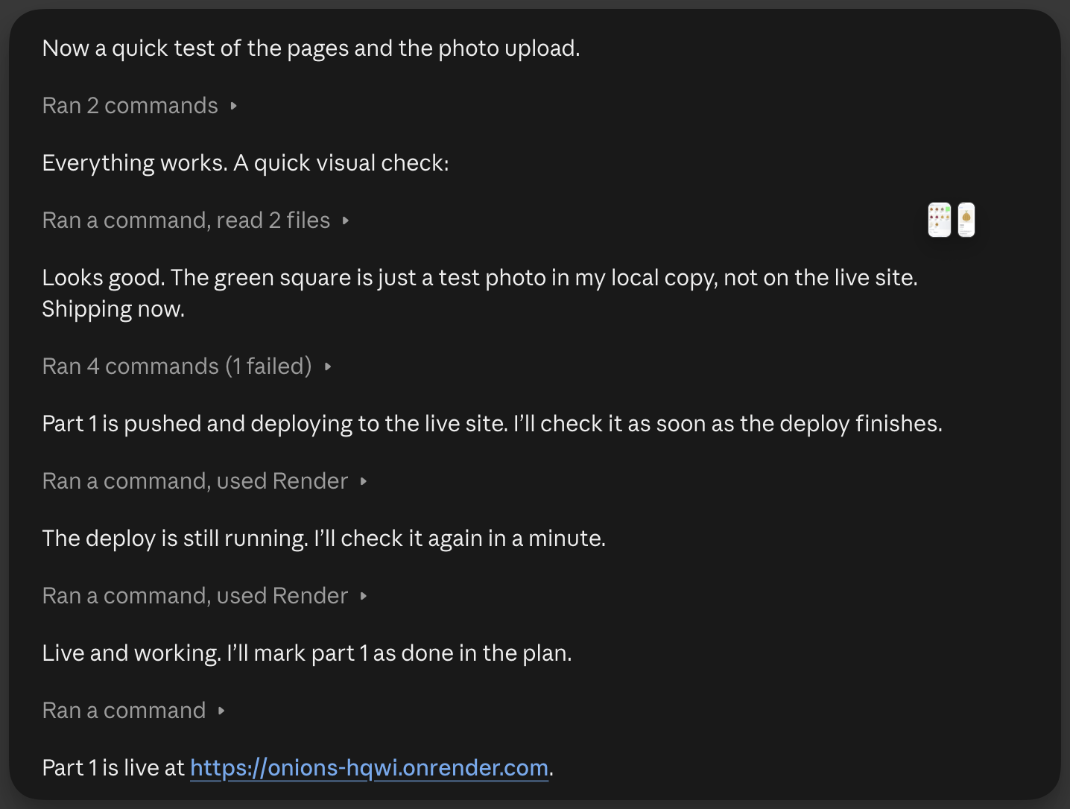

Tips
- Ask for one thing at a time. Small steps are easier to check and easier to undo.
- Look at the live site after each change and say what's wrong in plain words ("the date column is empty", "I expected this to be on the home page").
- Use fake data. The app is a prototype; never enter real customer information.
- Claude will ask before deleting data. If a change would remove information from the database, Claude explains what would be lost and waits for your yes.

Making another app
You only set up accounts, connectors, and the Claude environment once. For each new app:
- Copy the template into a new repository (Step 1).
- Give Claude access to the new repository. On GitHub, open Settings → Applications, click Configure next to Claude, add the repository under Repository access, and click Save (Step 2a).
- Start a session in claude.ai/code with the new repository and the environment you already made (Step 2d). If the new app will use a custom domain, add it to that environment's Allowed domains.
- Name the app: type Set up this project. (Step 3).
- Put it on Render: New → Blueprint. If the repository isn't listed, click Configure GitHub and add it (Step 4).
- Finish setup: type Render is ready. and save the new admin password (Step 5).
- Describe your app (Step 6).

Using your own domain (optional)
Your app works at its onrender.com address. To use your own, like tracker.yourcompany.com:
- Tell Claude: Use tracker.yourcompany.com for this app. Claude updates the app and tells you the DNS record to add.
- Add that record (usually a CNAME pointing at your onrender.com address) wherever your domain's DNS is managed.
- In Render, open the web service → Settings → Custom Domains and wait for the domain to show Verified and the certificate as issued.

Troubleshooting
A deploy failed. Ask Claude: "The last deploy failed. Check the logs and fix it."
The live site shows an error. Tell Claude what you did and what you saw. Claude reads Render's logs to find the cause.
Claude says it can't reach Render. Reconnect Render in claude.ai Settings → Connectors, then start a new session.
Forgot the admin password. Another staff user can reset it in Admin → Users. If nobody can log in, open the web service in Render, click Shell, and run:
uv run python manage.py changepassword admin

For developers
Django 6.1, Python 3.14, Postgres 18, deployed with a Render Blueprint (render.yaml). Project rules for Claude are in CLAUDE.md.

Running locally
uv sync
uv run python manage.py migrate
uv run python manage.py runserver
Without DATABASE_URL set, the app uses a local SQLite file (db.sqlite3). On Render, migrations run automatically in the pre-deploy step. See .env.example for all environment variables.
Lint and format: uv run ruff check --fix . && uv run ruff format .

What's where
Path | What it is
render.yaml | Render Blueprint: web service, database, build/pre-deploy/start commands
CLAUDE.md | Instructions Claude follows in every session
.claude/skills/grill-me/ | The /grill-me planning interview
docs/ | Created by Claude: the app brief and plans for big features
mysite/settings.py | Django settings (Render detection, database, allowed hosts)
mysite/views.py | Home page and /health/ (used by Render's health check)
mysite/management/commands/ensure_superuser.py | Creates the first admin on deploy
mysite/management/commands/wait_for_db.py | Waits for the database before migrations run
templates/ | Shared layout (base.html), login, and home page
static/css/site.css | Site styles

