# 

# 

# **OPTIMIZING CONTAINERFILES USER MANUAL**

28 April 2023  
Document Version 2.0  
Lockheed Martin Corporation  
Emma Zimmerman, Christopher Shields, Yekaterina Saburova,   
Justin Pitera, Sadia Orpi, Dylan Lorrilliere

|  |  |  |
| --- | --- | --- |
| Team Member | Role | Sections Worked On |
| Emma Zimmerman | Product Owner | Product Edition (Version), Product Description, Technical Documentation, User Documentation |
| Christopher Shields | Scrum Master | Product Edition (Version), Product Description, Technical Documentation, User Documentation |
| Yekaterina Saburova | Developer | Product Description, Technical Documentation, User Documentation |
| Justin Pitera | Developer | User Documentation, Technical Documentation |
| Sadia Orpi | Developer | User Documentation, Technical Documentation |
| Dylan Lorrilliere | Developer | Product Description, Technical Documentation, User Documentation |

## 

## 2. TABLE OF CONTENTS

PRODUCT EDITION (VERSION) 4

PRODUCT DESCRIPTION 5

TECHNICAL DOCUMENTATION 5

● PRODUCT DESCRIPTION (SYSTEM) 5

● PRODUCT ENVIRONMENT 10

● SYSTEM REQUIREMENTS 10

● MAINTENANCE REQUIREMENTS 10

USER DOCUMENTATION 11

* PRODUCT FEATURES11
* INPUTS AND OUTPUTS11
* INSTALLATION AND CONFIGURATION INSTRUCTIONS12
* OPERATING INSTRUCTIONS 13
  + Creating a Container 14
  + Creating a System 16
  + Viewing Systems 18
  + Viewing Containers 21
* FAQs 24

## 3. PRODUCT EDITION (VERSION)

|  |  |
| --- | --- |
| 0.1 | * A graphical user interface to facilitate interactions between the user and the application. * A local .NET database to hold any data needed in the application. |
| 0.2 | * Utilize the graphical user interface to create systems, create containers, and save them in the database. * Versioned entities of systems stored in the database to allow for old states to be referenced. * Allow Files to be added to the database. |
| 0.3 | * Include a generalized database path so any computer can access the database. * Utilized C# System.IO to save files to the computer disk. * The ability of the application to find and store the number of occurrences of files in a system. * A process for the application to find duplicate and shared files. |
| 0.4 | * The ability to fully optimize a system created by a user. * Files organized by their different file types * The optimization of a given system output in a text file. * A system viewer to see the dependency tree for a system. |
| 1.0 (current) | * The functionality to delete a system or container. * A container viewer to view all of the containers in the program. * Improved user interface |

## 

## 4. PRODUCT DESCRIPTION

This product is an application designed to aid software developers by automating the process of containerization. The application allows users to create a container, import files in the container, create systems, and connect systems and containers. The product will then optimize all of the Containerfiles in the system and output these optimizations in a text file.

## 5. TECHNICAL DOCUMENTATION

### PRODUCT DESCRIPTION (SYSTEM)

This product is designed to run on Microsoft Windows. Once downloaded from the repository, users will have access to a graphical user interface where they can interact with the application.

#### Welcome Screen

As shown above, the user will be presented with four different options; create a system, create a container, and view existing systems or containers.

Create Container Screen

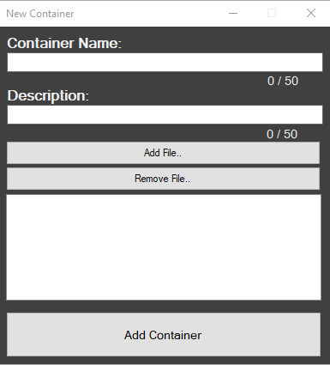

In the New Container form, the user provides a name and a description for a new container along with importing any files they would like to include in the container.

#### Create System Screen

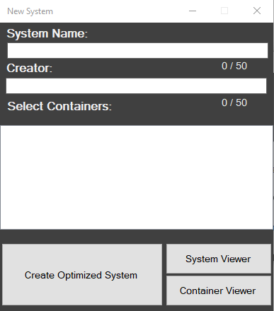

In the New System form, the user provides a name for the system along with the name of the system creator. Users will then select containers they’d like to connect to the system. Once the system has been created, it will immediately be optimized. Then, the user will be brought to the System Viewer.

#### System Viewer

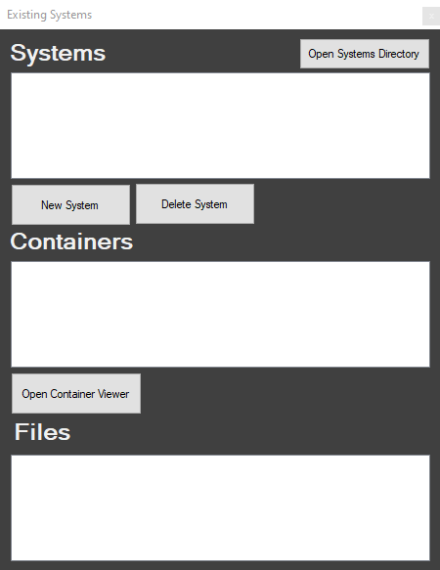

In the System Viewer window, the user can view any system that currently exists within the application. Once a system is selected, the viewer will display all the containers associated with that system. The user can then select any container present in the system, and the files within that container will be displayed in the Files list. The user will also have the option to delete a system.

#### Container Viewer

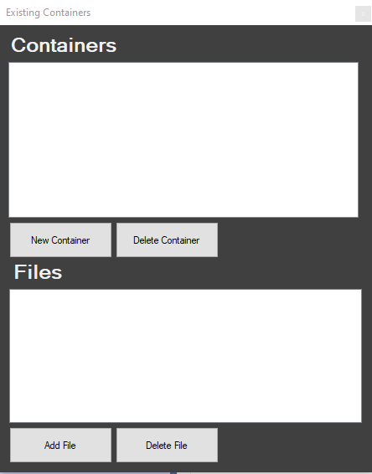

In the Container Viewer window, the user can view all of the containers currently saved in the application. Once a container is selected, the user will be provided with a view of all of the files in the container. The user will also be able to add or delete any containers or files.

### PRODUCTION ENVIRONMENT

This application will run on any PC that has the latest version of Microsoft Windows and the .NET framework installed.

### SYSTEM REQUIREMENTS

This application requires :

* Microsoft Windows Operating System
  + The latest version installed would be recommended to ensure full compatibility
* Latest version of Microsoft .NET
* Microsoft SQL Server Express
* 20 MB of storage
  + Although the size of the database file may grow.

Note: This application utilizes a local database, therefore it is not a supported database transport on Linux. Any change to the database file location could result in a “System.PlatformNotSupportedException” exception.

### MAINTENANCE REQUIREMENTS

There are no maintenance requirements for this application. If any issues arise (ie, the application not responding or freezing), it is recommended to force quit and restart the application. If the issues persist reinstallation of the application may be necessary.

## 

## 

## 6. USER DOCUMENTATION

### PRODUCT FEATURES

This application can be run on a machine that uses a Windows Operating System. Its main goal is to assist users by automating the process for optimizing Containerfiles.

Above is the initial screen the user will see upon startup. Here, the user can select from a few different options. “New Container” will allow the user to create a new container by providing the necessary files. Similarly, “New System” will allow the user to create a brand new system and allow them to connect any containers to the system. “System Viewer” provides the user with a view of all the systems currently saved in the application. From here, users will be able to view the dependency tree of a system or delete a system of their choosing. “Container Viewer” provides the user with a view of all of the containers currently saved in the system and the ability to delete any containers or files.

### INPUTS AND OUTPUTS

Inputs from the user will include menu navigation throughout the application. Typed input will also be necessary to: name a system, provide a username for a system, name a container, and provide a description of a container. Finally, users will import files into the application while creating a container.

Outputs for this application will include Continerfiles outputted as text files in their respective system's folder. These files will detail the optimization of all containers in a system. There are no other outputs.

### INSTALLATION AND CONFIGURATION INSTRUCTIONS

To download the prebuilt release:

1. Go to the project’s GitHub page.
2. Click on the “Releases” tab near the top of the page.
3. Find the latest release and click on it to see the available files.
4. Download the 7zip compression file by clicking on the name.
5. Extract the contents of the 7zip file to a directory of your choice.
6. Run the ‘Container File Optimizer.exe’ file to start the application.

To build the project manually from source, follow these steps:

1. Clone the project's GitHub repository to your local machine.
2. Ensure that you have installed a copy of Microsoft Visual Studio and the .NET framework.
3. Open the ‘Container File Optimizer.sln’ file provided in the root directory of the project source - that is the project file.
4. Right click on the solution in Solution Explorer in Visual Studio and then select Build. Go to the bin folder under your project folder and look for the EXE associated with the solution file’s name.

### 

### OPERATING INSTRUCTIONS

Upon startup, the user will be shown a startup screen (shown below) where they will be able to select between a few buttons that provide options before continuing.

* “New Container” - This will allow the user to create a new container.
* “New System” - This will allow the user to create a new system.
* “Existing Systems” - This will bring up the existing systems screen which allows the user to view all the systems currently saved in the application. A view showing the dependency tree for each system will also be available. Systems can also be deleted here.
* “Existing Containers” - This will bring up the existing containers screen which allows the user to view all the containers currently saved in the application. Containers can also be deleted here.

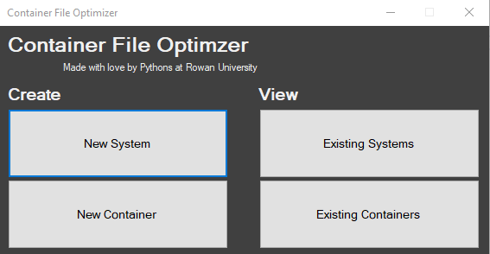

For First time users, it is recommended to begin with the “New Container” Button.

#### Creating a Container

Once the “New Container” button has been selected in the startup screen, the user will be brought to the new container screen (Shown below).



Steps for creating a new container are as follows:

1. Enter the name for the container (Warning: A container must be given a name to continue).
2. (Optional) Enter a description of the container.
3. Select the “Add File” button. This will bring up a file explorer where the user can select files to import.  
   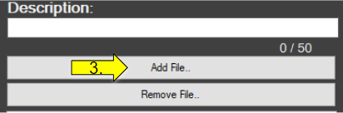
4. Select the files that the user wants to import and then select the “Open” button.  
   This will close the file explorer and add the files to the list below.  
   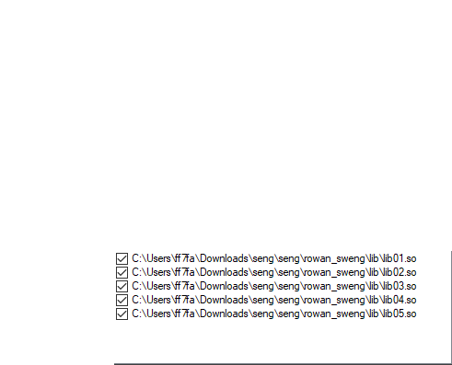  
   Note: The list shown is a checklist list. When the user finishes selecting the files from the file explorer, all of the files in the list will automatically be checked.
5. (Optional) Click the remove file button to remove any checked files from the list.
6. Click the “Add Container” button.   
   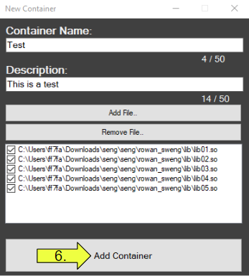

#### Creating a System

Once the “New System” button has been selected in the startup screen, the user will be brought to the new system screen (Shown below).



Steps for creating a new system are as follows:

1. Enter the name for the system. (Warning: A system must be given a name to continue)
2. Enter the username for the user creating the system. (Warning: A username be given to continue.)
3. Select the applications the user wishes to select from the checklist list (Shown below).  
   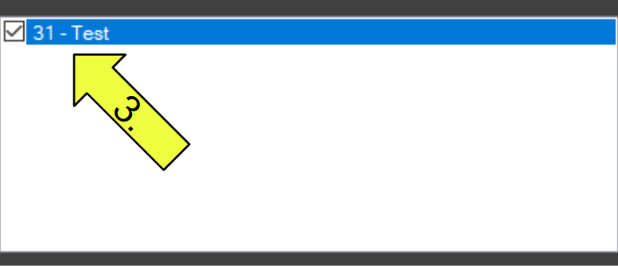  
   Note: The user can select as many containers as they want. Any checked containers will be connected, and any containers not checked will not be added.  
   Warning: At least one container must be selected to continue.
4. Click the “Create Optimized System” button

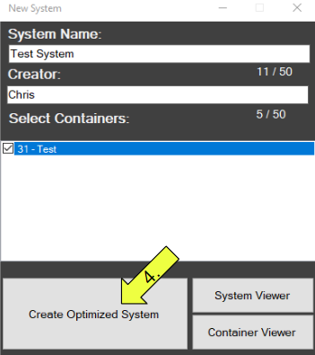

Note: Once this button is selected, the system will be optimized, and the optimization files will be added to the appropriate folder. The user will then be taken to the System Viewer.

#### Viewing Systems

Once the “Existing Systems” button has been selected in the startup screen, the user will be brought to the System Viewer screen (Shown below).

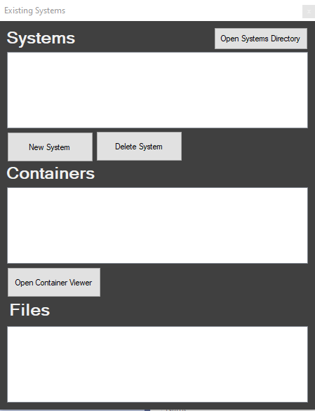

Steps for the System Viewer are as follows:

1. Select the system to view from the system list.
   1. Once a system has been selected, the “Containers” list will be filled with all of the containers in that system.
2. Select the container from the “Containers” list to view.
   1. Once a system has been selected, the File list will be filled with all of the files in that container.
3. Select a file from the “Files” list.
   1. This will bring up a pop-up box that will tell the user which containers in the system the selected file is in.  
        
      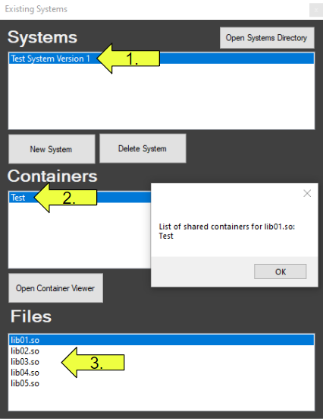
4. (Optional) Select the “Delete System” button to delete the system the user currently has selected.  
   Note: This will also delete all of the optimized files for the system from the application.
5. (Optional) Click the “New System” to be brought to the create new system screen.  
   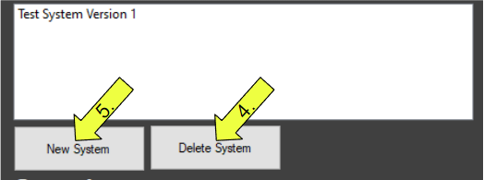
6. Click the “Open System Directory” button to be taken to the system directory.  
   
7. Click on the folder for the optimized system to view the optimization files.



### 

#### Viewing Containers

Once the “Existing Container” button has been selected in the startup screen, the user will be brought to the container viewer screen (Shown below).

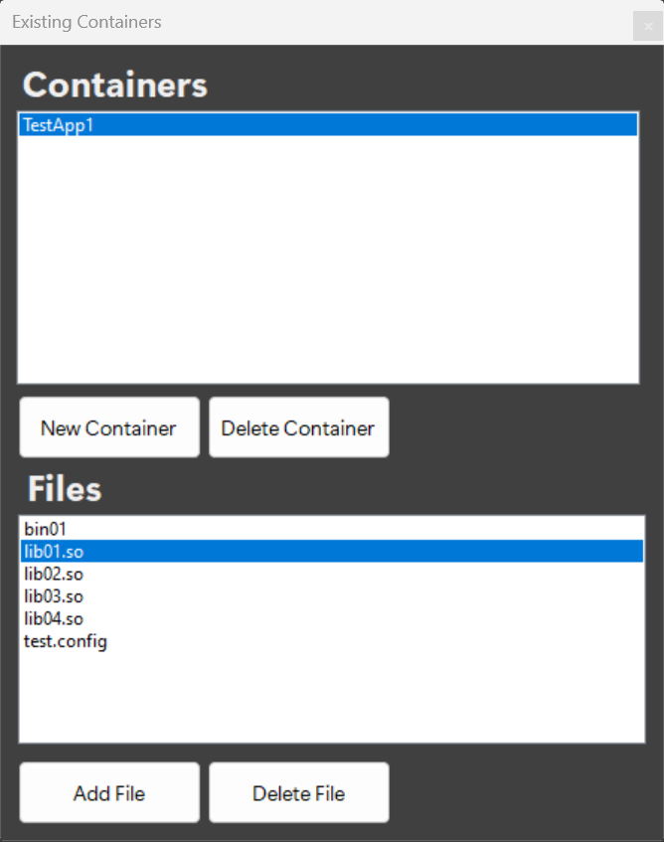

Steps for the Container Viewer are as follows:

1. Select the container from the Container list to view.
   1. Once a system has been selected, the File list will be filled with all of the files in that Container.
2. Select a file from the File list.  
   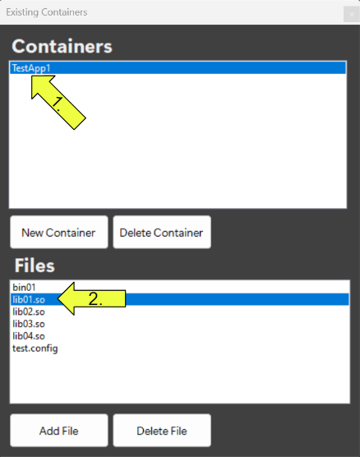
3. (Optional) Select the “New File” button to enter a new file into the container.
4. (Optional) Select the “Delete Selected File” button to delete the File the user currently has selected from the container.  
   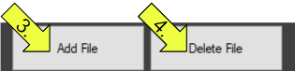  
   Warning: Adding a new file or deleting a file container will not change the optimized files for any systems the container is connected to. In order for any changes to be made to the optimized files, a new version of the system will need to be created with the modified files.  
   Note: This will only delete the file in the selected container. The file will not be deleted in any other containers it is a part of.
5. (Optional) Select the “New Container” button to navigate to the create new container screen.
6. (Optional) Select the “Delete Container” button to delete the Container the user currently has selected.  
   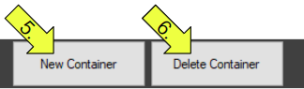  
   Warning: While this will delete the Container from any systems that it is connected to, the optimization files for these systems will not be changed. If the user wishes to change the optimization files, a new version of the system will need to be created with the modified containers.

### FAQs

#### New Container Error Message

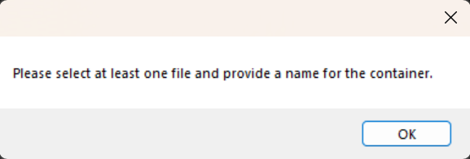

If this message is displayed, it may indicate that certain information is missing such as a container name or selection of a file to be added to the container. To resolve this, please ensure that all required attributes are provided for the container.

#### New System Error Message

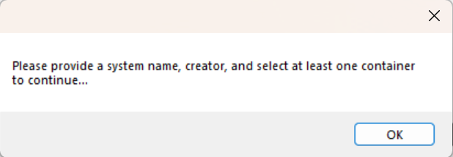

If this message is displayed, it may indicate that certain information is missing such as the system name, creator name, and/or selection of a container to be added to the system. To resolve this, provide the missing attribute(s) for the system.

#### Delete Container Error Message

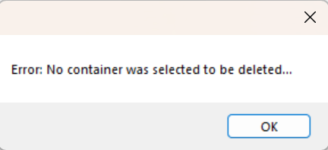

If this message is displayed, the user has not selected a container to remove. To resolve, please click on the container(s) you would like to remove.

#### Delete File Error Message

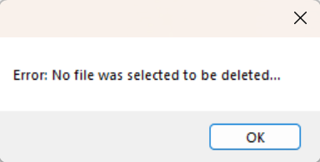

If this message is displayed, the user has not selected a file to remove. To resolve, please click on the file(s) you would like to remove.

#### Delete Systems Error Message

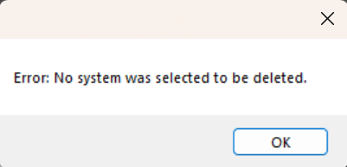

If this message is displayed, the user has not selected a system to remove. To resolve, please click on the system(s) you would like to remove.

* Duplicate Container Message

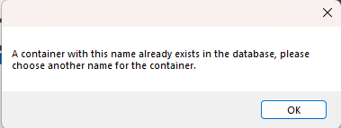  
If this message is displayed, the user has attempted to create a container with a name that already exists in the database. To resolve, the user should choose another name for the container before continuing.

* Question: Is the user able to modify a system?  
  Answer: Users can only modify a system by deleting containers, deleting files from a container, or adding a file to a container. For these changes to take effect on a system a new version must be created.
* Question: What if the user receives the error message: “System.PlatformNotSupportedException: LocalDB is not supported on this platform”?  
  Answer: This error may occur if the user has changed the location of the database file location and might crash the application. This may require the user to reinstall the application.