**Effects of Environmental Variables on a Nearshore Arctic Fish Community, 2001–2018**

Justin T. Priest1, Franz J. Mueter2, Scott W. Raborn3, Trent M. Sutton1

1University of Alaska Fairbanks, College of Fisheries and Ocean Sciences, Department of Fisheries, 2150 Koyukuk Drive, Fairbanks, Alaska 99775, USA

2University of Alaska Fairbanks, College of Fisheries and Ocean Sciences, Department of Fisheries, 17101 Point Lena Loop Road, Juneau, AK 99801, USA

3LGL Ecological Research Associates, Inc, 4103 S. Texas Avenue, Suite 211, Bryan, TX 77802, USA

Corresponding author: Justin Priest, justin.priest@alaska.gov

# Abstract

Nearshore fish communities comprise a fundamental part of Arctic marine ecosystems and serve as an important subsistence resource. As changing climate conditions affect Arctic waters, nearshore fish communities may also shift; however, how these communities will respond to climate change is not well understood. This study summarizes trends from a unique long-term (2001–2018) nearshore fish sampling program in Prudhoe Bay, Alaska, in the central Beaufort Sea. Abundance data (*n* = 1.78 million fish) from daily sampling (July–August) at four stationary sampling locations showed distinct shifts in fish community metrics. Since 2001, annual species richness has significantly increased by approximately one species per decade (p = 0.004) while water temperature has warmed by approximately 1.4°C (p <0.001). Results from non-metric multi-dimensional scaling (nMDS) and Permutational Analysis of Variance (PERMANOVA) models indicated that species composition based on biweekly catch data has significantly changed across years with distinct variations among sample locations and throughout the season. Salinity and water temperature significantly affected multivariate species composition; univariate species models showed that the abundances of five species changed significantly over time and were associated with changes in water temperature and salinity. The species positively associated with shifts in the aquatic environment appear to be eurythermic and/or euryhaline generalist species such as Broad Whitefish *Coregonus nasus* and Saffron Cod *Eleginus gracilis*. Such patterns of altered species compositions demonstrate that continued long-term changes in environmental conditions will likely favor generalist species, potentially causing substantial shifts within the Arctic nearshore ecosystem.

Keywords: Beaufort Sea, Nearshore fishes, Community assemblage, Abundance changes, Species richness

Please cite as: Priest JT, Mueter FJ, Raborn SW, Sutton TM (XXXX) Effects of environmental variables on a nearshore Arctic fish community, 2001–2018. Polar Biol

# Introduction

Climate models predict that the effects of environmental change will be felt most acutely in the Arctic, with far-reaching and cascading ecological consequences. Shifts in climate conditions include a predicted increase in sea surface temperatures, while Arctic mean annual temperatures will outpace global averages and rise 3–10°C over the next 80 years (IPCC 2014). Effects of climate change are much broader than just temperature; precipitation is predicted to increase 30–50% and the observed mean annual sea-ice spatial extent is expected to continue the observed decrease of 3.5–4.1% per decade (IPCC 2014). The persistent presence of sea ice and its effects on local ecosystems are unique in the Arctic Ocean. The reduction of Arctic sea ice has increased coastal erosion rates, which has increased suspended sediment load and reduced benthic and water column primary production (Bonsell and Dunton 2018). Reductions in primary productivity and increases in temperature have direct implications on the ecological responses of many cold-adapted taxa (e.g., calanoid copepods and amphipods) and fishes such as Arctic Cod *Boreogadus saida* that consume these prey (Bradstreet and Cross 1982; Gradinger and Bluhm 2004). As a result of such dependence, changes in Arctic environmental conditions are expected to impact regional fish assemblages.

Fish abundance is affected by environmental conditions such as water temperature and salinity because individual fish exhibit behaviors to optimize growth and survival (Cushing 1990; Monaghan 2008). Requirements for water temperature and salinity conditions may vary by life stage, especially for diadromous fishes (Werner and Gilliam 1984). As poikilotherms, fish have internal temperatures that are regulated by their environment, which affects their rate-dynamic parameters (e.g., metabolic rate; Pauly 1980). Conditions outside of their optimal thermal ranges can be lethal, but it is often difficult to determine sub-optimal or sub-lethal effects (Coutant 1987). Within estuarine areas, salinity can fluctuate widely on a daily basis, and subsequent osmoregulation can incur a substantial energetic cost (Bœuf and Payan 2001). Both marine and diadromous fishes (e.g., gadids and salmonids, respectively) living outside of their optimal salinity limits can experience substantial reductions in growth or higher natural mortality (Arnesen et al. 1993; Dutil et al. 1997). Therefore, environmental conditions are reflected in the presence or abundance of individual fishes and in fish community composition (Jackson et al. 2001; Collie et al. 2008). Ever-fluctuating weather and water conditions can cause Arctic fishes to adopt migratory life-history strategies to utilize multiple habitats, leading to a higher probability of encountering favorable conditions (Craig 1984; Power 1997; Roux et al. 2016).

Despite the variable polar environment, nearshore Arctic waters are host to a variety of fishes. Whitefishes, such as Arctic Cisco *Coregonus autumnalis*, Broad Whitefish *C. nasus*, Least Cisco *C. sardinella*, and Humpback Whitefish *C. pidschian*, are amphidromous, tolerant of moderate levels of salinity, and capable of far-ranging migrations (Bond and Erickson 1985; de March 1989; Fechhelm et al. 1993). Arctic Cisco in Alaskan waters originate in the Mackenzie River, Northwest Territories, Canada, and are transported >500 km east as juveniles via easterly winds pushing surface currents (Fechhelm and Fissel 1988; Fechhelm and Griffiths 1990; von Biela et al. 2013; Zimmerman et al. 2013). In contrast, Broad Whitefish, Least Cisco, and Humpback Whitefish spawn in rivers across northern Alaska (Craig 1984, 1989; Fechhelm et al. 1994). Juvenile whitefishes spend summer months feeding in the estuaries and deltas along the coastal Beaufort Sea, and overwinter in deep, freshwater pools or areas of upwelling in local rivers (Craig et al. 1985; Fechhelm et al. 1999; Seigle and Gottschalk 2013). Arctic gadids, predominantly Arctic Cod, are also ecologically important and support the Arctic marine ecosystem with their numerical prevalence and high energetic content (Elliott and Gaston 2008; Harter et al. 2013; Thorsteinson and Love 2016). This species undertakes migratory behaviors, ostensibly to encounter habitats with favorable conditions, helping it to be a key linkage between abundant zooplankton, such as calanoid copepods and amphipods, and higher trophic organisms, such as Black Guillemot *Cepphus grille*, ringed seals *Pusa hispida*, and beluga whales *Delphinapterus leucas* (Bradstreet and Cross 1982; Harter et al. 2013). Pacific salmon *Oncorhynchus* spp. have also been documented in the Arctic, with a natal population in the Mackenzie River in Canada (Irvine et al. 2009). Arctic anadromous species undergo movements to find suitable conditions in this dynamic region, and subsequently make up a disproportionately high percentage of the fish community in nearshore waters of the Alaskan Arctic.

In addition to playing a key ecological role in coastal marine ecosystems, nearshore fishes also provide important subsistence food for local indigenous communities (Fechhelm et al. 2007; Thorsteinson and Love 2016). While there are no commercial fisheries in Arctic federal waters, subsistence fisheries in the nearshore Alaska Arctic are important social and nutritional contributions to local Inupiaq communities (Fechhelm et al. 2007; NPFMC 2009). Although these fisheries have limited economic impact, ecological changes to Arctic fish communities would have substantial social ramifications for biological and human communities (Moerlein and Carothers 2012).

Previous studies in Prudhoe Bay and the Alaska Arctic have often focused on single species or lacked long-term monitoring (Fechhelm et al. 1993, 1999; Thedinga et al. 2013). Assessing long-term trends and spatial patterns of species composition is imperative for understanding how fish communities respond to changes in environmental variables over time, especially in nearshore populations (Neves et al. 2016). Further, examining species composition in a multivariate framework provides a more comprehensive understanding of changes occurring to the fish community as a whole, rather than to one or two species individually (Fechhelm et al. 1995).

In this study, we assessed long-term changes in the Arctic fish community in response to shifts in environmental conditions within a nearshore semi-estuarine ecosystem in Prudhoe Bay, Alaska. We hypothesized that ongoing shifts in Arctic environmental conditions would result in measurable changes in fish populations over the past two decades (2001–2018). To quantify changes in fish community metrics, we assessed: 1) effects of environmental variables on species composition; 2) seasonal and interannual trends in species composition, abundance, and variability; and 3) temporal patterns in species richness and rare species presence. Given the importance of nearshore Arctic fishes to terrestrial and marine ecosystems and to local subsistence users, it is critical to understand how fishes respond to dynamic changes in environmental conditions.

# Methods

## Study Area

This study was conducted in the Arctic Ocean along the coast near Prudhoe Bay, Alaska, 2001–2018 (Figure 1). Prudhoe Bay is a semi-estuarine bay of the Beaufort Sea formed near the mouth of the Sagavanirktok River delta. The Sagavanirktok River is a braided river with an annual discharge of 1.5 km3/year (USGS 2018). The immediate surrounding coastal waters are shallow, with the 6-m depth contour less than five km from most parts of natural, unaltered shore. Several barrier islands are also within 15 km of shore (Ross 1988). Much of the terrestrial environment around Prudhoe Bay has developed infrastructure for the extraction and processing of oil and natural gas, with many permanent structures inland from the coast. Several oil extraction and processing facilities have been constructed on man-made islands that are connected to shore with gravel causeways and bridge breaches (Ross 1988).

## Fish Sampling

Four stations spaced approximately 27 km apart along the coast were established for daily fish monitoring (Figure 1). From west to east, these sites are identified as Site 220 (1 km west of the West Dock causeway), Site 218 (West Beach drilling pad), Site 214 (Niakuk drilling pad), and Site 230 (eastern side of the Endicott Causeway). Fish monitoring occurred at each of the four sampling locations using side-by-side fyke nets, each with an opening of 1.8 m by 1.7 m, opening towards the coastline, with a 60-m block net leading to shore. A 15-m blocker wing was attached to the outer edge of each net cod end. Using this bi-directional sampling method, fyke nets intercepted and caught fish moving along the shoreline in either direction. All block nets and wings were constructed from 2.5-cm stretch mesh, while the fyke net mesh consisted of 1.27-cm stretch mesh. Three consecutive throats were located behind each 1.7-m frame opening, with the outermost throat having a functional width of 11.4 cm. Net specifications were consistently used during the study, with a modification in 2009 to add a vertical metal bar to the fyke net funnel to prevent entry by marine mammals.

Sampling sites were operated from approximately 01 July through 01 September each year, with the precise dates of installation and removal for each site varying annually. Each net was checked daily unless conditions prevented sampling, and fish were identified to and enumerated by species according to Mecklenburg et al. (2002), George et al. (2009), and Thorsteinson and Love (2016). Length measurements were collected for a subsample of pre-determined species using protocols established in Fechhelm et al. (2002), Priest et al. (2018), and Green et al. (2018), and fish were released offshore away from the cod-end openings to minimize their recapture. Field sampling protocols, including sampling sites, were largely unchanged from 2001 to 2018.

## Environmental Data Sources

Environmental variables examined were water temperature (°C), salinity (ppt), discharge for the Sagavanirktok River (m3/s), and wind speed and directionality (km/h; east/west). Water temperature and salinity data were collected daily during each sampling event at each site near the fyke net cod ends using a calibrated handheld YSI 30 salinity / conductivity / temperature meter (YSI Inc., Yellow Springs, Ohio) at the bottom, mid-point, and just below the surface of the water column. For data analyses, measurements taken near the top of the water column were used as measurements at other depths were not always taken. Daily Sagavanirktok River discharge data were collected by a U. S. Geological Survey (USGS) gaging station approximately 170 km upriver from the river mouth near Pump Station 3. Wind data were collected hourly by the National Weather Service (NWS) at the Deadhorse Airport meteorological data collecting site (PASC) located 12 km inland from Prudhoe Bay. Wind direction was recorded hourly as cardinal direction (0–360) and averaged for each biweekly period using the circular mean, then converted from polar to cartesian coordinates to get the East-West unit vectors using:

,

where *r* is the absolute wind speed in kilometers per hour, which resulted in positive values for easterly winds and negative values for westerly winds. East/West winds were used in the analysis rather than absolute wind speeds because of their effects on alongshore flow and upwelling/downwelling dynamics (Nikolopoulos et al. 2009; Pickart et al. 2009).

## Data Analyses

Abundance data were recorded by net site and each net side for each species; however, both net sides were aggregated for analyses. All years (2001–2018) were included for analysis; while fish catches from 2014 were known to be influenced by local seismic testing, catches were predominately within previously observed ranges (Streever et al. 2016). Fish abundance data were pooled and standardized by the combined sampling effort as biweekly catch per unit effort (CPUE) by species and station in a 17 species by 280 biweekly samples matrix. All environmental variables were assessed in a correlation matrix, with no variables that were highly correlated (>0.5). Response variables for multivariate analyses were CPUE values for each species which were fourth-root transformed, while explanatory environmental variables were square-root transformed. All response and environmental variables were standardized to the percent of the maximum transformed catch or environmental variable. The CPUE values for each species were transformed to mitigate the influence of large catches and standardized to species maximums so that each species had the same weight in the analysis, regardless of the abundance. All significance testing was done at the α = 0.05 level, and data were imported and analyzed using the statistical program R Version 3.6.1 (R Core Team 2019).

## Effects of Environmental Variables on Species Composition

To determine the effects of environmental variables on species assemblage structure (Objective 1), we first computed pairwise Bray-Curtis distances among biweekly samples based on the fourth-root transformed and standardized CPUE data. The Bray-Curtis dissimilarity matrix was then used to visualize differences among samples using an ordination, relate differences in species composition to environmental variables using Mantel correlations and model multivariate dispersion using permutation-based ANOVAs.

To visualize differences in species composition among samples, we reduced the matrix of species abundances to three dimensions using non-metric multidimensional scaling (nMDS) to achieve a stress value of less than 20% (Kruskal 1964). To prevent rare species from dominating multivariate analyses, we restricted analyses to those species with an abundance greater than 100 fish, all catches combined (Poos and Jackson 2012). Multivariate analyses were conducted using the “vegan” package in R (Oksanen et al. 2019). A multivariate Mantel-type test (BIOENV; Clarke and Ainsworth 1993) was conducted by computing Spearman rank correlations between the biweekly Bray-Curtis distances computed from CPUE data and the corresponding Euclidean distances computed from different subsets of environmental data. The subset of environmental variables that resulted in the largest Mantel correlation was tested for significance using a Mantel randomization test and this subset, along with the spatial-temporal variables and , was used in subsequent analyses (Legendre and Legendre 2012). The relationship between environmental variables and dissimilarities in species composition was visualized and tested for significance using a linear regression of continuous variables and an ANOVA of factor variables on the ordination axes MDS1 and MDS2. Similarity percentages (SIMPER) were calculated to determine which species contributed most to the average Bray-Curtis dissimilarities between years, stations, and biweekly periods (Clarke 1993; Oksanen et al. 2019).

The optimal model of partitioning variability in species composition (as quantified by Bray-Curtis distances) based on environmental variables was determined by Permutational Analysis of Variance (PERMANOVA) using the standardized and transformed environmental variables. Biweekly periods with no data coverage in environmental monitoring were excluded from analyses. The explanatory variables for the full PERMANOVA model were, , , , , , and . The response variable was the Bray-Curtis dissimilarity matrix of transformed and standardized CPUE for all non-rare species, was one of four sample periods (i.e., period 1 = start date–15 July, period 2 = 16–31 July, period 3 = 1–15 August, and period 4 = 16 August–end date), and were from surface water measurements, and was the East-West wind vector. The best-fitting PERMANOVA model was determined using backward-stepwise model selection based on the marginal reduction in residual R2 associated with a given variable (Anderson 2001).

## Species Composition Changes Over Time

To assess how species composition may have changed over time (Objective 2), we used indices of species composition from the nMDS (nMDS axes scores) as response variables in several alternative model formulations. First, to test for trends over time, we modeled the nMDS time-series for all three axes as either a single time trend or separate trends by station (Year nested in station). Linear models were compared to Generalized Additive Models that allowed for non-liner trends over time. The full model was as follows:

,

where was each of the three multi-dimensional scaling axes and variables , , and were the same as defined for previous models. The smoothing parameter was tested against a linear year effect model and a model with a smoothed temporal trend across all stations; the top model was selected by AIC. In addition, we fit piecewise linear regressions over time that allowed for structural changes (breakpoints) in the time series to test for abrupt changes in species composition. The optimal number of breakpoints in the time series was tested using the Chow Test for structural breaks using package “strucchange” (Zeileis et al. 2002, 2003; Bai and Perron 2003).

Given that we found significant trends in species composition over time and as a function of environmental variables, we tested for whether catches or variability in catches of individual species have changed over time or in response to water temperature and salinity (Objective 2). Trends in species catches were investigated using linear regressions:

,

where is the biweekly CPUE of species *k*. As the magnitude of variability in community samples can be indicative of increased environmental stressors, we tested if the coefficient of variation in CPUE changed over time (Warwick and Clarke 1993). To quantify these temporal trends in the variability of catches for different species, we used a simple linear regression:

,

where was the annual coefficient of variation (CV) of the CPUE (four biweekly periods at all four stations) for each species *k*, regressed on . Linear models were not adjusted for Bonferroni corrections.

## Trends in Species Richness and Rare Species Presence

To investigate interannual and seasonal trends in species richness (Objective 3), we modeled species richness as a function of year and biweekly sampling period using Generalized Additive Models (GAMs) as implemented in the package “mgcv” in R (Wood 2011, 2017). We used GAMs to allow for possible non-linear trends commonly found in ecological modeling (Guisan et al. 2002). Species richness was modeled as:

where was the number of unique species across all sites combined for each biweekly period *i* in year *t*, α was the overall model intercept, was the year-specific deviation from the overall mean in year *t*, which wasmodeled as a random effect and the *fi* are smooth functions of the predictor variables. The variable was the *i*th biweekly sampling period (1–4). The random effects was assumed to follow a Normal distribution with mean 0 and variance . The full model was compared to models without effort, without random year effects, and to the null model (intercept only); the best-fitting model was determined using Akaike’s Information Criterion (AIC). Smoothing functions were restricted to 3 degrees of freedom to guard against overfitting and were tested against the null model.

To determine whether there were changes in the 15 “rare” species (≤ 100 individuals caught in all samples combined) that were excluded from the multivariate analysis of species composition, the probability of occurrence of each rare species was modeled using Generalized Linear Models (GLMs) with a binomial distribution (logistic regression) and a logit link. The expected probability of occurrence of a given species in year *t* and biweekly period *i* at station *s* was modeled as:

For each rare species, the most parsimonious model of logit-transformed probability of occurrence was determined using AIC.

# Results

## Fish Sampling

From 2001 to 2018, a total of 1,784,593 fish were captured in fyke nets and identified to one of 31 fish species (Table 1). Fishes that could only be identified to genus (*n*=76), were identified as hybrids (*n*=22), or those that could not be identified (*n*=2), were excluded from analyses. Of the 31 species used in analyses, 14 were rare species and 17 were non-rare species (Table 1). Total catch per species per biweekly samples (aggregated catch) ranged from 0 to 324,692 fish. The seven most abundant species accounted for approximately 92% of all fish recorded in this study, with the most numerous species (Arctic Cod) accounting for 33% of the total catch. Six species (Arctic Cisco, Arctic Flounder *Liopsetta glacialis*, Broad Whitefish, Fourhorn Sculpin *Myoxocephalus quadricornis*, Least Cisco, and Rainbow Smelt *Osmerus mordax*) were present in all biweekly station samples.

## Effects of Environmental Variables on Species Composition

From 2001 to 2018, environmental conditions at the four sampling stations varied both temporally and spatially. Water temperature ranged from 2.1 to 12.7°C (mean = 8.1°C), and salinity ranged from 0.14 to 28.7 ppt (mean = 11.4 ppt). Annual water temperature increased significantly over 2001–2018 (linear regression, slope = 0.08, SE = 0.021, p = 0.001), but there was no significant change in salinity among years (linear regression, slope = 0.06, SE = 0.096, p = 0.53). Among stations, water temperature fluctuated substantially but was highest on average at station 230 and lowest at station 220, while salinity was highest on average at station 220 and lowest at station 230 (Figure 2). Discharge from the Sagavanirktok River ranged from 39.3 to 327.7 m3/s (mean = 135.1 m3/s, SD = 54.1), with a significant increase in discharge from 2001–2018 (linear regression, slope = 65.17, SE = 31.83, p = 0.045). Wind speed ranged from 10.5 to 36.1 kph (mean = 17.1 kph, SD = 3.84), with a mean direction of 42.9° (i.e., Northeast). There were no significant changes in wind speed (linear regression, slope = 0.05, SE = 0.028, p = 0.109), while the East-West wind directionality shifted to become more easterly (slope = 0.02, SE = 0.008, p = 0.015). Results from a correlation of environmental variables showed that the most correlated variables were salinity and Sagavanirktok River discharge (-0.28).

Results from a multivariate Mantel-type test on the biweekly catch matrix showed that the optimal subset of parameters describing species composition were comprised of , , and (correlation 0.391), with a Mantel statistic r = 0.288 and p < 0.001. As a result, only these three parameters and the spatial-temporal variables and were used in the subsequent nMDS assessments and PERMANOVA models. The nMDS was fit in three-dimensions with a convergent stress of 0.156. Analysis of the nMDS by environmental vectors revealed that species composition had significant temporal associations for biweekly periods and years (R2 = 0.442, p < 0.001; R2 = 0.048, p = 0.003, respectively). Species composition was associated with water salinity (R2 = 0.571, p < 0.001), while water temperature was marginally significant (R2 = 0.021, p = 0.058). We also found that species composition was significantly different among stations (R2 = 0.306, p < 0.001).

While there was substantial overlap in species composition among all stations, there was a clear divide between eastern (214 and 230) and western (218 and 220) sampling sites. The nMDS centroids of the eastern and the western stations were outside of the 95% CI ellipse for each group (Figure 3). The top five species accounting for the difference between these sites were Round Whitefish *Prosopium cylindraceum*, Threespine Stickleback *Gasterosteus aculeatus*, Pacific Herring *Clupea pallasii*, Ninespine Stickleback *Pungitius pungitius*, and Arctic Grayling *Thymallus arcticus*, which contributed 37.1% of the differences from the similarity percentage analysis. Pearson correlations between species catch and the three nMDS axes identified the dominant species affecting species composition: Threespine Stickleback was the species most associated with axis 1 (correlation = 0.753), Round Whitefish was the species most associated with axis 2 (correlation = -0.697), and Arctic Flounder was the species most associated with axis 3 (correlation = 0.756).

The marginal PERMANOVA model containing , , , , and explained 47.5% of the sample variation. There were significant associations between the species composition and each of the five variables: (marginal R2 = 0.029, pseudo-F = 13.9, p = 0.001), (marginal R2 = 0.087, pseudo-F = 14.0, p = 0.001), (marginal R2 = 0.110, pseudo-F = 17.6, p = 0.001), (marginal R2 = 0.012, pseudo-F = 5.6, p = 0.001), and (marginal R2 = 0.026, pseudo-F = 12.8, p = 0.001). The sequential (Type I) sums of squares PERMANOVA model () showed effects of water temperature (R2 = 0.017) and salinity (R2 = 0.026) on species composition, even after spatio-temporal variables were isolated.

## Species Composition and Abundance Changes

Model selection results of the nMDS axes time series showed that nMDS axes 1 and 2 were best fit with a non-linear GAM framework (measured by reduction in AIC), while nMDS axis 3 did not have a significant annual time trend. For axes 1 and 2, there was a significant non-linear increase and decrease from 2001–2018, respectively, with the same temporal trend across all stations. Both nMDS axis 1 and 2 annual trends were highly non-linear (EDF = 8.9, p < 0.001; EDF = 7.1, p < 0.001, respectively). Results from the Chow test statistic (F-statistic) showed that of the 12 station/axis combinations, three showed weak support of one structural break (axis 2, Station 220; axis 2, Station 214; and axis 2, Station 218), with the Bayesian Information Criterion for these three slightly lowest at one optimal breakpoint; these three breakpoints were from 2013–2016. Based on these results, it was concluded that the overall time series of the nMDS axes showed no structural change.

The linear models of the CPUE for each individual species showed significant trends over time and associations with environmental variables. Six species changed significantly in abundance from 2001–2018: Broad Whitefish and Saffron Cod *Eleginus gracilis* increased in abundance, while Arctic Cod, Fourhorn Sculpin, Humpback Whitefish, and Least Cisco decreased in abundance (Table 2). The abundances of Arctic Flounder, Broad Whitefish, Fourhorn Sculpin, and Saffron Cod were significantly and positively associated with water temperatures. Only the abundance of Dolly Varden *Salvelinus malma* decreased with increasing temperatures. Salinity was significantly and positively associated with the abundance of Arctic Cisco, Capelin *Mallotus villosus*, Pacific Herring, and Saffron Cod; the abundance of Dolly Varden, Humpback Whitefish, and Least Cisco each decreased with increasing salinity. The annual variability of catches increased over time for Dolly Varden and decreased for Saffron Cod.

## Species Richness and Rare Species Presence

Species richness in the aggregated samples (year by biweekly period by station) ranged from 9 to 17 species, with a mean of 13.1 species present. Species richness was not significantly influenced by sampling effort, suggesting that the full community was sampled at all levels of sampling effort. Species richness showed a significant linear increase from 2001 to 2018 (GAM regression; slope = 0.11, p = 0.017) and a significant non-linear trend over the season (GAM; p < 0.001); Figure 4). While the rate of species richness trends varied among stations, the increasing trends in species richness over years and during the season occurred at all four stations.

Results from the binomial presence GLM of rare species (*n* = 14) from 2001 to 2018 showed significant increases each year for Slimy Sculpin *Cottus cognatus* (slope = 0.48, SE = 0.220, p = 0.028) and Burbot *Lota lota* (slope = 0.23, SE = 0.079, p = 0.003) and a significant decline for Bering Cisco *Coregonus laurettae* (slope = -0.10, SE = 0.043, p = 0.019; Figure 5). Two additional species showed a significant trend in presence over the course of the season: Chum Salmon *Oncorhynchus keta* and unidentified snailfish *Liparis* spp. both increased in abundance over the course of the season (biweekly periods 1–4; slope = 0.72, SE = 0.222, p = 0.001, and slope = 3.00, SE = 0.990, p = 0.002, respectively).

# Discussion

Our analyses found several changes in measurements of fish species composition as well as significant associations between environmental conditions and the fish populations of Prudhoe Bay, Alaska. Assessing the shifts in environmental conditions and commensurate changes in species composition provided insight into a region undergoing substantial climatic changes (IPCC 2014). Local and regional increases in some environmental drivers (e.g., water temperature, river discharge, eastern winds) and reductions in others (e.g., ice cover), were associated with changes in species abundances and proportions. With shifts in conditions, generalist species (e.g., Fourhorn Sculpin, Broad Whitefish, etc.) adapt to a wide range of conditions (including new and old conditions) to proliferate (Wilson et al. 2008; Fossheim et al. 2015; Kortsch et al. 2015). With competition and limited resources, we would expect increases in abundances of species that are better suited for these new conditions (e.g., Saffron Cod), and declines in abundance of species that are stenohaline and/or stenothermal (e.g., Arctic Cod; Fechhelm et al. 1992, 1993, 1995; Laurel et al. 2016; Dahlke et al. 2018; Vestfals et al. 2019). Continued increases in water temperature, river discharge, and eastern winds may create competitive advantage for a fish community that is more reflective of estuarine conditions and more anadromous in composition. Overall, this study found changes in fish species composition were associated with changes in environmental conditions in Prudhoe Bay and favored species that were more generalist in life history.

We identified 31 unique species in this study, representing 10% of the approximately 310 fish species known to inhabit the Arctic Ocean (Mecklenburg et al. 2011; Reist et al. 2006). Our study found that species richness increased significantly from 2001-2018 in Prudhoe Bay, Alaska, at a rate of approximately one additional species per decade. Changes in species richness have been documented in the distribution of southern Chukchi Sea fishes, as well as in lower trophic levels of planktonic diatoms (Reid et al. 2007; Mueter and Litzow 2008). Species richness increased nonlinearly throughout the sampling season, tapering off at the end of the season when species richness was highest and ice coverage was lowest. This was likely due to the historical trends in wind patterns and reduced ice cover (increasing fetch) during mid- to late-August, which caused nearshore increases in salinity and catches of marine fishes. Ecosystem transitions such as shifts in fish populations and expansion of their geographic ranges northward with warming marine water temperatures may lead to increases in fish species richness (Grebmeier et al. 2006; Hiddink and ter Hofstede 2008; Mueter and Litzow 2008; Bluhm et al. 2011; Stevenson and Lauth 2019). Previous studies have documented northern shifts in Arctic and sub-Arctic species distribution; for example, in 2004 several Pacific species of crabs and bivalves were documented in large numbers in the Chukchi Sea for the first time (Sirenko and Gagaev 2007). Additionally, fish and invertebrates captured in bottom trawl surveys in the southeastern Bering Sea demonstrated community-wide northward shifts, while northward expansions have been documented for the Pacific gray whale in the Chukchi and Beaufort seas and for orcas in the Canadian Arctic (Moore 2008; Mueter and Litzow 2008; Higdon and Ferguson 2009). Though no major changes in species composition because of increased rare species abundance are likely, the two rare species that increased in abundance (Slimy Sculpin and Burbot) are freshwater species, demonstrating either a potential shift in acceptable nearshore environmental conditions or possibly an expansion in the freshwater populations as individuals search for more suitable habitat. Spatial range expansion by freshwater fishes into the marginal estuarine habitat could be reflective of favorable recruitment conditions in local rivers, or the increased river discharge could be displacing and transporting freshwater fishes into the Sagavanirktok River delta (Lehodey et al. 2006).

In addition to increasing species richness, the species composition of Prudhoe Bay showed strong evidence for being influenced by spatio-temporal and environmental variables. Prevailing theories of life-history responses to environmental changes posit that changes to water conditions will result in observable changes to fish populations (Lehodey et al. 2006). While several environmental variables significantly changed over the course of the study (e.g., increased river discharge and eastern wind directionality), it is notable that annual water temperature increased by 1.4°C. Species compositions models demonstrated that catches were substantially associated with water temperature. At the individual species level, water temperature positively affects growth parameters of whitefishes and parabolically influences the growth of cold-water adapted Arctic Cod, maximizing growth around 5°C (Fechhelm et al. 1992, 1993; Laurel et al. 2016). Our study documented several species that changed in annual abundance and were associated with water temperature: Broad Whitefish, Fourhorn Sculpin, and Saffron Cod abundances were significantly positively associated with water temperature, while Humpback Whitefish were negatively associated with water temperature. As water temperatures increased over time, these relatively warmer-water associated species have benefited from the change in conditions and increased in abundance; Broad Whitefish and Saffron Cod have both been documented to be positively associated with water temperature (Fechhelm et al. 1992; Vestfals et al. 2019). Although these species were positively associated with water temperature, continued warming could push fish past optimal metabolic conditions or cause detrimental species interactions (e.g., increased trophic competition for limited resources; Reist et al. 2006).

Increases in water temperature could also be linked to changes in river discharge. The annual freshwater discharge from the Sagavanirktok River significantly increased 25.4 m3/s over the course of the study. While river discharge appeared only to have minor influence on models of species composition, the volume of freshwater input to nearshore areas strongly affected the other variables (i.e., salinity, temperature) which made it difficult to separate multicollinearity between variables. River discharge affected estuarine species composition and contributed to nearshore productivity by way of terrestrial carbon transfer, increasing habitat extents, and providing sediment transport to create barrier islands (Loneragan and Bunn 1999; Costa et al. 2007). Such contributions suggest that the significant changes in Sagavanirktok River discharge have the potential to disrupt fish community composition in nearshore areas.

We found a significant increase in easterly winds over the study period and associations between wind direction and species composition. The change to easterly winds increased the occurrence of marine upwelling events, which lowered local water levels and brought nutrient-rich, high-saline waters toward nearshore regions (Ross 1988). Easterly winds also facilitated the transport of juvenile Arctic Cisco from the Mackenzie River, while hindering movements of fish from the Colville River (Fechhelm and Fissel 1988). Under such wind regimes in Prudhoe Bay, Arctic Cisco abundance increased, while Least Cisco abundance declined. Wind direction in Prudhoe Bay also strongly affects both nearshore water depth and local salinity by causing upwelling or intrusions of marine waters to either retreat or advance shoreward, affecting species composition by drawing marine species to the study area.

While salinity did not change significantly over the study, it was important to all models of species composition. We found that salinity greatly affected species composition, with marine species being associated with higher salinity. The significant increase in river discharge likely influenced the distribution of salinity gradients in estuarine locations by extending or retracting freshwater plumes, which likely affected osmoregulation and feeding rates (de March 1989; Arnesen et al. 1993; Bœuf and Payan 2001). Salinity is also likely partially responsible for distinct spatial patterns. Each sampling station had a unique salinity profile; as a result, differences in species composition among stations were distinct in nMDS ordination. Similarly, species composition differences between eastern and western stations were influenced by species that were amphidromous and tolerant of estuarine fluctuations. Species that drove changes in species composition were euryhaline and eurythermal, indicating that there does not appear to be a shift toward more predominately marine or freshwater species types but rather a selection toward species that are more generalist in nature. Anadromous fishes are tolerant of a wide range of conditions and would be expected to be better adapted to greater environmental variability (Fechhelm et al. 1993; Bisson et al. 2009; IPCC 2014). Several species significantly changed in abundance and also were influenced by salinity, which included Humpback Whitefish and Least Cisco that were negatively associated with salinity and Saffron Cod that were positively associated with salinity. Local salinity conditions were also highly dependent on other variables such as wind direction and river discharge. Because salinity was important to many models influencing species assemblage structure, we posit that any potential future changes to wind patterns and regional precipitation will affect the nearshore fish assemblage by altering local salinity (Fechhelm et al. 1993).

One variable that was not examined in this study was sea ice extent and duration. This was primarily due to a lack of fine-scale sea ice data available from the National Snow and Ice Data Center. Sea ice is known to influence the distribution of Arctic fish species such as Arctic Cod, and is known to affect nearshore turbidity (Bradstreet and Cross 1982; Gradinger and Bluhm 2004; Bonsell and Dunton 2018; Dahlke et al. 2018). Researchers are currently processing high-resolution shorefast ice imagery that will cover Prudhoe Bay (A. Mahoney, University of Alaska Fairbanks Geophysical Institute, personal communication). However, preliminary modeling efforts of coarse-scale ice coverage did not show a relationship between species composition and regional sea ice indices. Future research should examine whether declines in sea ice influence patterns in nearshore species assemblage, as ice cover can affect ecosystem productivity and influence prey availability for planktivorous fishes (Hunt et al. 2002).

Although the multivariate methods used in this study parsed out the individual effects of each environmental variable, multivariate approaches can be difficult to interpret and require careful implementation. Correlation between variables creates difficulty to assign effects, and this was addressed using a high threshold for multicollinearity to remove potential variables that would be conflated. Similarly, multivariate models make it difficult to ascertain precisely which species cause changes between samples and cannot quantify precise effects or even directionality of responses. By using both univariate and multivariate approaches to determine whether influence of environmental conditions, as well as effects by individuals, we were able to determine effects. The variability of the environmental conditions is also the likely reason explaining why the top PERMANOVA model explained approximately half of the variation of the biweekly catches. This high amount of residual variability is likely a relic of the natural environmental fluctuations. Given the considerable environmental fluctuations in the Arctic (e.g., solar insolation, temperature swings, and wind events), it is not surprising to see high amounts of residual variability in the PERMANOVA models (Anderson 2001).

While this study did not address ages or age structures of fish species, many of the fishes captured were juveniles because the nearshore environment of Prudhoe Bay serves as an important nursery area for many early life stages (Craig 1984; von Biela et al. 2013). Nearshore areas are important habitats that provide a wide diversity of trophic contributions, increased nursery production of juvenile fishes, and ontogenetic migration corridors (Beck et al. 2001; Sheaves et al. 2014). The variety of environmental conditions within the Prudhoe Bay nearshore area, comprised of a gradient of water temperatures, salinities, and turbidities, ideally allow juvenile fishes to have access to a range of conditions that optimize their growth (Cyrus and Blaber 1987; Marchand 1991; Thorpe 1994). Changes to environmental conditions or to the community structure of populations may have a detrimental effect on the recruitment of juveniles of many species (Bailey 2000; Vinagre et al. 2009). Future studies are recommended to assess the impacts of changing climate conditions on juvenile recruitment.

The observed variability in catches were assumed to be reflective of local abundance and not a function of changing sampling efficiency. For example, changes in assemblage structure under different wind conditions were thought to be reflective of fish distributional movement patterns in response to wind and not due to changes in sampling selectivity or efficacy (Bergström et al. 2013). To counter changes in spatio-temporal sampling efficiency, we pooled samples to a biweekly sampling period (to account for short-term fluctuations and minor gaps in sampling) and grouped eastern and western sampling sites. The geographic spread of sample sites attempted to mitigate effects from any potential inshore/offshore or East/West species distribution by virtue of sampling locations that varied in proximity to river deltas and along isthmuses that extended into Prudhoe Bay. By having four sample sites and biweekly sample periods across broad spatial and temporal sampling units, fish catches were representative of nearly the entire Prudhoe Bay fish species composition.

Resilience of ecological communities during changes to their habitat or environment is a characteristic of healthy communities with high biological diversity and wide response diversity (Peterson et al. 1998; Elmqvist et al. 2003). Despite natural variability and shifts in environmental conditions, the observed changes in species composition in this study demonstrate a fish community able to respond to increased stressors. However, as the pace of environmental change increases, it is less clear whether the Arctic fish community will continue to have such resilience if variability of ecological community composition increases (Karr 1981; Pimm 1984; Warwick and Clarke 1993). If population variability increases, such warnings could indicate imminent sudden changes in community organization or collapses in abundances (Scheffer et al. 2001; Hunt et al. 2002; Carpenter et al. 2011). As a result, the continued monitoring of nearshore fish populations in the Beaufort Sea will allow for insights into how future species communities might organize and respond to perturbations in their natural environment with changing climate conditions.

# Literature Cited

Anderson MJ (2001) A new method for non-parametric multivariate analysis of variance. Austral Ecol 26:32–46

Arnesen AM, Jørgensen EH, Jobling M (1993) Feed intake, growth and osmoregulation in Arctic charr, Salvelinus alpinus (L.), following abrupt transfer from freshwater to more saline water. Aquaculture 114:327–338. doi: 10.1016/0044-8486(93)90307-K

Bai J, Perron P (2003) Computation and analysis of multiple structural change models. J Appl Econom 18:1–22. doi: 10.1002/jae.659

Bailey KM (2000) Shifting control of recruitment of walleye pollock Theragra chalcogramma after a major climatic and ecosystem change. Mar Ecol Prog Ser 198:215–224

Beck MW, Heck KL, Able KW, et al (2001) The identification, conservation, and management of estuarine and marine nurseries for fish and invertebrates. Bioscience 51:633–641. doi: 10.1641/0006-3568(2001)051[0633:TICAMO]2.0.CO;2

Bergström L, Karlsson M, Pihl L (2013) Comparison of gill nets and fyke nets for the status assessment of coastal fish communities. WATERS Report 2013:7. Havsmiljöinstitutet / Swedish Institute for the Marine Environment, Göteborg, Sweden

Bisson PA, Dunham JB, Reeves GH (2009) Freshwater ecosystems and resilience of Pacific salmon: habitat management based on natural variability. Ecol Soc 14:45. doi: 10.5751/ES-02784-140145

Bluhm BA, Gebruk A, Gradinger RR, et al (2011) Arctic Marine Biodiversity: An Update of Species Richness and Examples of Biodiversity Change. Oceanography 24:232–248. doi: 10.5670/oceanog.2011.75

Bœuf G, Payan P (2001) How should salinity influence fish growth? Comp Biochem Physiol - Part C Toxicol Pharmacol 130:411–423. doi: 10.1016/S1532-0456(01)00268-X

Bond WA, Erickson RN (1985) Life history studies of anadromous coregonid fishes in two freshwater lake Systems on the Tuktoyaktuk Peninsula, Northwest Territories. Can Tech Rep Fish Aquat Sci 1336:

Bonsell C, Dunton KH (2018) Long-term patterns of benthic irradiance and kelp production in the central Beaufort Sea reveal implications of warming for Arctic inner shelves. Prog Oceanogr 162:160–170. doi: 10.1016/j.pocean.2018.02.016

Bradstreet MSW, Cross WE (1982) Trophic relationships at high Arctic ice edges. Arctic 35:1–12. doi: 10.1016/0266-9838(93)90013-8

Carpenter SR, Cole JJ, Pace ML, et al (2011) Early warnings of regime shifts: A whole-ecosystem experiment. Science (80- ) 332:1079–1082. doi: 10.1126/science.1203672

Clarke KR (1993) Non-parametric multivariate analyses of changes in community structure. 117–143

Clarke KR, Ainsworth M (1993) A method of linking multivariate community structure to environmental variables. Mar Ecol Prog Ser 92:205–219. doi: 10.3354/meps092205

Collie JS, Wood AD, Jeffries HP (2008) Long-term shifts in the species composition of a coastal fish community. Can J Fish Aquat Sci 65:1352–1365. doi: 10.1139/F08-048

Costa MJ, Vasconcelos R, Costa JL, Cabral HN (2007) River flow influence on the fish community of the Tagus estuary (Portugal). Hydrobiologia 587:113–123. doi: 10.1007/s10750-007-0690-x

Coutant CC (1987) Thermal preference: when does an asset become a liability? Environ Biol Fishes 18:161–172. doi: 10.1007/BF00000356

Craig PC (1984) Fish use of coastal waters of the Alaska Beaufort Sea: a review. Trans Am Fish Soc 113:265–282. doi: 10.1577/1548-8659(1984)113<265:FUOCWO>2.0.CO;2

Craig PC (1989) An introduction to anadromous fishes in the Alaskan Arctic. Biol Pap Univ Alaska 27–54

Craig PC, Griffiths WB, Haldorson L, McElderry H (1985) Distributional patterns of fishes in an Alaskan Arctic lagoon. Polar Biol 4:9–18

Cushing DH (1990) Plankton production and year-class strength in fish populations: An update of the match/mismatch hypothesis. Adv Mar Biol 26:249–293. doi: 10.1016/S0065-2881(08)60202-3

Cyrus DP, Blaber SJM (1987) The influence of turbidity on juvenile marine fishes in estuaries. Part 1. Field studies at Lake St. Lucia on the southeastern coast of Africa. J Exp Mar Bio Ecol 109:53–70. doi: 10.1016/0022-0981(87)90185-7

Dahlke FT, Butzin M, Nahrgang J, et al (2018) Northern cod species face spawning habitat losses if global warming exceeds 1.5°C. Sci Adv 4:1–11. doi: 10.1126/sciadv.aas8821

de March BGE (1989) Salinity tolerance of larval and juvenile Broad Whitefish (Coregonus nasus). Can J Zool 67:2392–2397

Dutil J-D, Lambert Y, Boucher E (1997) Does higher growth rate in Atlantic cod (Gadus morhua) at low salinity result from lower standard metabolic rate or increased protein digestibility? Can J Fish Aquat Sci 54:99–103. doi: 10.1139/f96-148

Elliott KH, Gaston AJ (2008) Mass-length relationships and energy content of fishes and invertebrates delivered to nestling Thick-billed Murres Uria lomvia in the Canadian Arctic, 1981-2007. Mar Ornithol 36:25–34

Elmqvist T, Folke C, Nystrom M, et al (2003) Response diversity, ecosystem change, and resilience. Front Ecol Environ 1:488–494. doi: 10.2307/3868116

Fechhelm RG, Bryan JD, Griffiths WB, et al (1994) Effect of coastal winds on the summer dispersal of young Least Cisco (Coregonus-sardinella) from the Colville River to Prudhoe Bay, Alaska: a simulation model. Can J Fish Aquat Sci 51:890–899. doi: 10.1139/f94-088

Fechhelm RG, Dillinger Jr. RE, Gallaway BJ, Griffiths WB (1992) Modeling of in situ temperature and growth relationships for yearling Broad Whitefish in Prudhoe Bay, Alaska. Trans Am Fish Soc 121:1–12. doi: 10.1577/1548-8659(1992)121<0001:MOISTA>2.3.CO;2

Fechhelm RG, Fissel DB (1988) Recruitment of Canadian Arctic Cisco (Coregonus autumnalis) into Alaskan waters. Can J Fish Aquat Sci 45:906–910. doi: 10.1139/f88-110

Fechhelm RG, Fitzgerald PS, Bryan JD, Gallaway BJ (1993) Effect of salinity and temperature on the growth of yearling Arctic Cisco (Coregonus autumnalis) of the Alaskan Beaufort Sea. J Fish Biol 43:463–474. doi: 10.1111/j.1095-8649.1993.tb00581.x

Fechhelm RG, Griffiths WB (1990) Effect of wind on the recruitment of Canadian Arctic Cisco (Coregonus autumnalis) into the central Alaskan Beaufort Sea. Can J Fish Aquat Sci 47:2164–2171. doi: 10.1139/f90-241

Fechhelm RG, Griffiths WB, Bryan JD, et al (1995) Application of an in situ growth model: Inferred instance of interspecific trophic competition between anadromous fishes of Prudhoe Bay, Alaska. Trans Am Fish Soc 124:55–69. doi: 10.1577/1548-8659(1995)124<0055:AOAISG>2.3.CO;2

Fechhelm RG, Haskell SP, Wilson WJ, Griffiths WB (2002) Nearshore Beaufort Sea fish monitoring in the Prudhoe Bay region, 2001. Report for BP Exploration (Alaska) Inc. by LGL Alaska Research Associates, Inc., Anchorage, Alaska

Fechhelm RG, Martin LR, Gallaway BJ, et al (1999) Prudhoe Bay causeways and the summer coastal movements of Arctic Cisco and Least Cisco. Arctic 52:139–151. doi: 10.1007/s

Fechhelm RG, Streever B, Gallaway BJ (2007) The Arctic Cisco (Coregonus autumnalis) subsistence and commercial fisheries, Colville River, Alaska: A conceptual model. Arctic 60:421–429

Fossheim M, Primicerio R, Johannesen E, et al (2015) Recent warming leads to a rapid borealization of fish communities in the Arctic. Nat Clim Chang 5:673–677. doi: 10.1038/nclimate2647

Gradinger RR, Bluhm BA (2004) In-situ observations on the distribution and behavior of amphipods and Arctic cod (Boreogadus saida) under the sea ice of the High Arctic Canada Basin. Polar Biol 27:595–603. doi: 10.1007/s00300-004-0630-4

Grebmeier JM, Overland JE, Moore SE, et al (2006) A major ecosystem shift in the northern Bering Sea. Science (80- ) 311:1461–1464. doi: 10.1126/science.1121365

Green DG, Priest JT, Gatt KP, Sutton TM (2018) Beaufort Sea nearshore fish monitoring study: 2018 annual report. Fairbanks, Alaska

Guisan A, Edwards TC, Hastie T (2002) Generalized linear and generalized additive models in studies of species distributions: setting the scene. Ecol Modell 157:89–100. doi: 10.1016/S0304-3800(02)00204-1

Harter BB, Elliott KH, Divoky GJ, Davoren GK (2013) Arctic Cod (Boreogadus saida) as prey: fish length-energetics relationships in the Beaufort Sea and Hudson Bay. Arctic 66:191–196

Hiddink JG, ter Hofstede R (2008) Climate induced increases in species richness of marine fishes. Glob Chang Biol 14:453–460. doi: 10.1111/j.1365-2486.2007.01518.x

Higdon JW, Ferguson SH (2009) Loss of Arctic sea ice causing punctuated change in sightings of killer whales (Orcinus orca) over the past century. Ecol Appl 19:1365–1375

Hunt GL, Stabeno P, Walters G, et al (2002) Climate change and control of the southeastern Bering Sea pelagic ecosystem. Deep Res Part II Top Stud Oceanogr 49:5821–5853. doi: 10.1016/S0967-0645(02)00321-1

IPCC (2014) Climate change 2014 synthesis report. Contribution of working groups I, II and III to the fifth assessment report of the Intergovernmental Panel on Climate Change. In: Team CW, Pachauri RK, Meyer L (eds) IPCC. Geneva, Switzerland, pp 1–151

Irvine JR, Macdonald RW, Brown RJ, et al (2009) Salmon in the Arctic and how they avoid lethal low temperatures. North Pacific Anadromous Fish Comm Bull 5:39–50

Jackson DA, Peres-Neto PR, Olden JD (2001) What controls who is where in freshwater fish communities – the roles of biotic, abiotic, and spatial factors. Can J Fish Aquat Sci 58:157–170. doi: 10.1139/cjfas-58-1-157

Karr JR (1981) Assessment of biotic integrity using fish communities. Fisheries 6:21–27. doi: 10.1577/1548-8446(1981)006<0021:aobiuf>2.0.co;2

Kortsch S, Primicerio R, Fossheim M, et al (2015) Climate change alters the structure of arctic marine food webs due to poleward shifts of boreal generalists. Proc R Soc B Biol Sci 282:9. doi: 10.1098/rspb.2015.1546

Kruskal JB (1964) Multidimensional scaling by optimizing goodness of fit to a nonmetric hypothesis. Psychometrika 29:1–27. doi: 10.1007/bf02289565

Laurel BJ, Spencer M, Iseri P, Copeman LA (2016) Temperature-dependent growth and behavior of juvenile Arctic cod (Boreogadus saida) and co-occurring North Pacific gadids. Polar Biol 39:1127–1135. doi: 10.1007/s00300-015-1761-5

Legendre P, Legendre L (2012) Numerical ecology, 3rd editio. Elsevier

Lehodey P, Alheit J, Barange M, et al (2006) Climate variability, fish, and fisheries. J Clim 19:5009–5030. doi: 10.1175/jcli3898.1

Loneragan NR, Bunn SE (1999) River flows and estuarine ecosystems: Implications for coastal fisheries from a review and a case study of the Logan River, southeast Queensland. Aust J Ecol 24:431–440. doi: 10.1046/j.1442-9993.1999.00975.x

Majewski AR, Walkusz W, Lynn BR, et al (2016) Distribution and diet of demersal Arctic Cod, Boreogadus saida, in relation to habitat characteristics in the Canadian Beaufort Sea. Polar Biol 39:1087–1098. doi: 10.1007/s00300-015-1857-y

Marchand J (1991) The influence of environmental conditions on settlement, distribution and growth of 0-group sole (Solea solea (L.)) in a macrotidal estuary (Vilaine France). Netherlands J Sea Res 27:307–316

Moerlein KJ, Carothers C (2012) Total environment of change: Impacts of climate change and social transitions on subsistence fisheries in Northwest Alaska. Ecol Soc 17:10. doi: 10.5751/ES-04543-170110

Monaghan P (2008) Early growth conditions, phenotypic development and environmental change. Philos Trans R Soc B Biol Sci 363:1635–1645. doi: 10.1098/rstb.2007.0011

Moore SE (2008) Marine mammals as ecosystem sentinels. J Mammal 89:534–540. doi: 10.1644/07-mamm-s-312r1.1

Mueter FJ, Litzow MA (2008) Sea ice retreat alters the biogeography of the Bering Sea. Ecol Appl 18:309–320

Neves LM, Teixeira-Neves TP, Pereira-Filho GH, Araújo FG (2016) The farther the better: Effects of multiple environmental variables on reef fish assemblages along a distance gradient from river influences. PLoS One 11:1–23. doi: 10.1371/journal.pone.0166679

Nikolopoulos A, Pickart RS, Fratantoni PS, et al (2009) The western Arctic boundary current at 152°W: Structure, variability, and transport. Deep Res Part II Top Stud Oceanogr 56:1164–1181. doi: 10.1016/j.dsr2.2008.10.014

NPFMC (2009) Fishery management plan for fish resources of the Arctic management area. North Pacific Fishery Management Council, Anchorage, Alaska

Oksanen J, Blanchet FG, Friendly M, et al (2019) vegan: community ecology Package. R package version 2.5-5. https://CRAN.R-project.org/package=vegan

Pauly D (1980) On the interrelationships between natural mortality, growth parameters, and mean environmental temperature in 175 fish stocks. ICES J Mar Sci 39:175–192. doi: 10.1093/icesjms/39.2.175

Peterson G, Allen CR, Holling CS (1998) Ecological resilience, biodiversity, and scale. Ecosystems 1:6–18. doi: 10.1007/s100219900002

Pickart RS, Moore GWK, Torres DJ, et al (2009) Upwelling on the continental slope of the Alaskan Beaufort Sea: Storms, ice, and oceanographic response. J Geophys Res 114:1–17. doi: 10.1029/2008JC005009

Pimm SL (1984) The complexity and stability of ecosystems. Nature 307:321–326

Poos MS, Jackson DA (2012) Addressing the removal of rare species in multivariate bioassessments: The impact of methodological choices. Ecol Indic 18:82–90. doi: 10.1016/j.ecolind.2011.10.008

Power G (1997) A review of fish ecology in Arctic North America. In: Reynolds JB (ed) Fish Ecology in Arctic North America. American Fisheries Society, Bethesda, Maryland, pp 13–39

Priest JT, Green DG, Fletcher BM, Sutton TM (2018) Beaufort Sea nearshore fish monitoring study: 2017 annual report. Fairbanks, Alaska

R Core Team (2019) R: A language and environment for statistical computing. R Foundation for Statistical Computing, Vienna, Austria. URL https://www.R-project.org/

Reid PC, Johns DG, Edwards M, et al (2007) A biological consequence of reducing Arctic ice cover: Arrival of the Pacific diatom Neodenticula seminae in the North Atlantic for the first time in 800000 years. Glob Chang Biol 13:1910–1921. doi: 10.1111/j.1365-2486.2007.01413.x

Reist JD, Wrona FJ, Prowse TD, et al (2006) General effects of climate change on Arctic fishes and fish populations. Ambio 35:370–380. doi: 10.1579/0044-7447(2006)35

Ross BD (1988) Causeways in the Alaskan Beaufort Sea. United States Environmental Protection Agency, Anchorage, Alaska

Roux MJ, Harwood LA, Zhu X, Sparling P (2016) Early summer near-shore fish assemblage and environmental correlates in an Arctic estuary. J Great Lakes Res 42:256–266. doi: 10.1016/j.jglr.2015.04.005

Scheffer M, Carpenter SR, Foley JA, et al (2001) Catastrophic shifts in ecosystems. Nature 413:591–596

Seigle JC, Gottschalk JM (2013) Fall 2012 subsistence fishery monitoring on the Colville River. ABR, Inc. – Environmental Research & Services, Fairbanks, Alaska

Sheaves M, Baker R, Nagelkerken I, Connolly RM (2014) True value of estuarine and coastal nurseries for fish: Incorporating complexity and dynamics. Estuaries and Coasts 38:401–414. doi: 10.1007/s12237-014-9846-x

Sirenko BI, Gagaev SY (2007) Unusual abundance of macrobenthos and biological invasions in the Chukchi Sea. Russ J Mar Biol 33:355–364. doi: 10.1134/S1063074007060016

Stevenson DE, Lauth RR (2019) Bottom trawl surveys in the northern Bering Sea indicate recent shifts in the distribution of marine species. Polar Biol 42:407–421. doi: 10.1007/s00300-018-2431-1

Streever B, Raborn SW, Kim KH, et al (2016) Changes in fish catch rates in the presence of air gun sounds in Prudhoe Bay, Alaska. Arctic 69:346–358. doi: 10.14430/arctic4596

Thedinga JF, Johnson SW, Neff AD, et al (2013) Nearshore fish assemblages of the Northeastern Chukchi Sea, Alaska. Arctic 66:257–268

Thorpe JE (1994) Salmonid fishes and the estuarine environment. Estuaries 17:76–93

Thorsteinson LK, Love MS (2016) Alaska Arctic marine fish ecology catalog. U.S. Geological Survey Scientific Investigations Report 2016-5038 (OCS Study, BOEM 2016-048)

USGS (2018) USGS National Water Information System - Sagavanirktok River near Pump Station 3, Alaska. https://waterdata.usgs.gov/ak/nwis/uv?site_no=15908000. Accessed 2 Apr 2018

Vestfals CD, Mueter FJ, Duffy-Anderson JT, et al (2019) Spatio-temporal distribution of Polar Cod (Boreogadus saida) and Saffron Cod (Eleginus gracilis) early life stages in the Pacific Arctic. Polar Biol 42:969–990. doi: 10.1007/s00300-019-02494-4

Vinagre C, Santos FD, Cabral HN, Costa MJ (2009) Impact of climate and hydrology on juvenile fish recruitment towards estuarine nursery grounds in the context of climate change. Estuar Coast Shelf Sci 85:479–486. doi: 10.1016/j.ecss.2009.09.013

von Biela VR, Zimmerman CE, Cohn BR, Welker JM (2013) Terrestrial and marine trophic pathways support young-of-year growth in a nearshore Arctic fish. Polar Biol 36:137–146. doi: 10.1007/s00300-012-1244-x

Warwick RM, Clarke KR (1993) Increased variability as a symptom of stress in marine communities. J Exp Mar Bio Ecol 172:215–226. doi: 10.1016/0022-0981(93)90098-9

Werner EE, Gilliam JF (1984) The ontogenetic niche and species interactions in size-structured populations. Annu Rev Ecol Syst 15:393–425

Wilson SK, Burgess SC, Cheal AJ, et al (2008) Habitat utilization by coral reef fish: implications for specialists vs. generalists in a changing environment. J Anim Ecol 77:220–228. doi: 10.1111/j.1365-2656.2007.01341.x

Wood SN (2011) Fast stable restricted maximum likelihood and marginal likelihood estimation of semiparametric generalized linear models. J R Stat Soc 73:3–36

Wood SN (2017) Generalized Additive Models: An introduction with R (2nd edition). Chapman and Hall/CRC

Zeileis A, Kleiber C, Walter K, Hornik K (2003) Testing and dating of structural changes in practice. Comput Stat Data Anal 44:109–123. doi: 10.1016/S0167-9473(03)00030-6

Zeileis A, Leisch F, Hornik K, Kleiber C (2002) strucchange: An R package for testing for structural change in linear regression models. J Stat Softw 7:1–38

Zimmerman CE, Ramey AM, Turner SM, et al (2013) Genetics, recruitment, and migration patterns of Arctic Cisco (Coregonus autumnalis) in the Colville River, Alaska, and Mackenzie River, Canada. Polar Biol 36:1543–1555. doi: 10.1007/s00300-013-1372-y

# Tables

Table 1. Total catch by species, mean catch and range per biweekly period, and percent present in biweekly catch per station. Species that are only included in rare species analysis (<100 total catch) are marked with †.



Table 2. Regression coefficients and significance levels for multiple linear regressions of annual mean catch-per-unit-effort on year, water temperature, and salinity, as well as a simple linear regression of the annual coefficient of variation (CV) in catch-per-unit-effort on year for each species, Prudhoe Bay, Alaska, 2001–2018. Significant effects (α < 0.05) are in bold.



# Figures

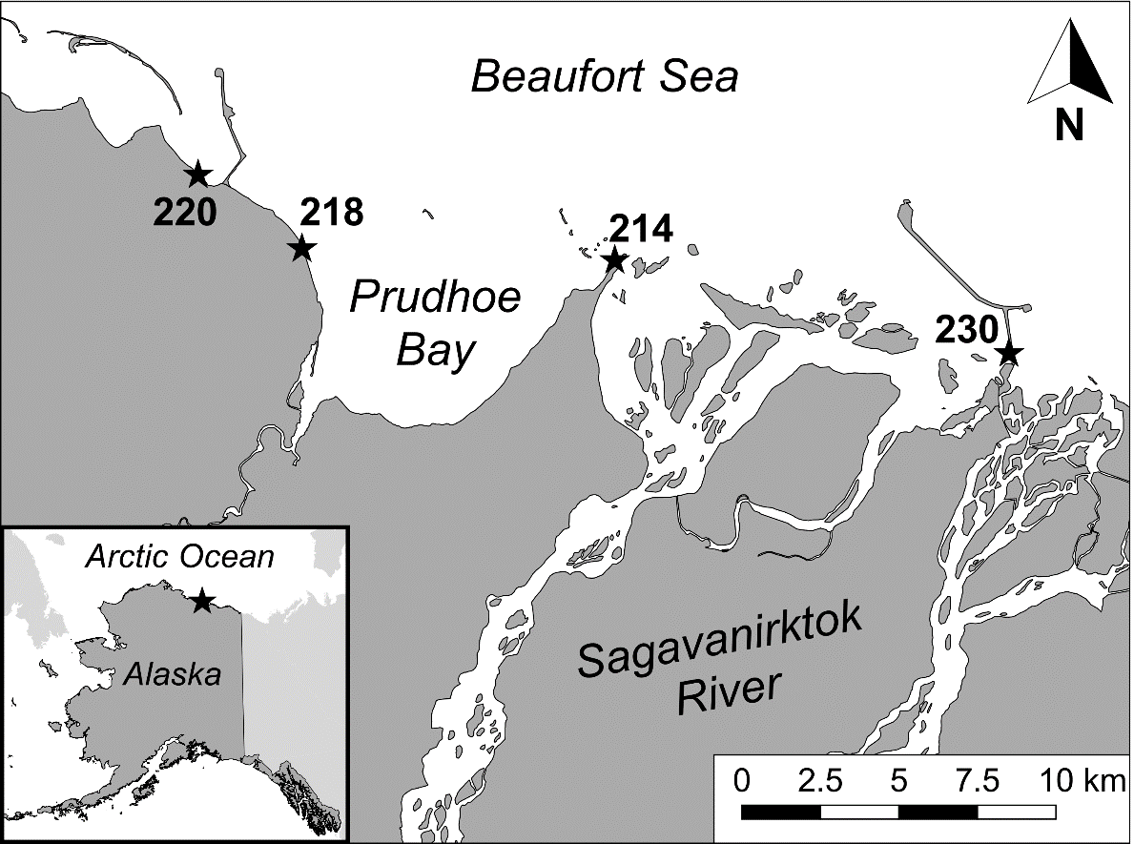

70.2°

70.3°

70.4°

148.5°

148.0°

Figure 1. Map of study sample locations, Prudhoe Bay, Alaska. Projection is in Alaska Albers, NAD83.

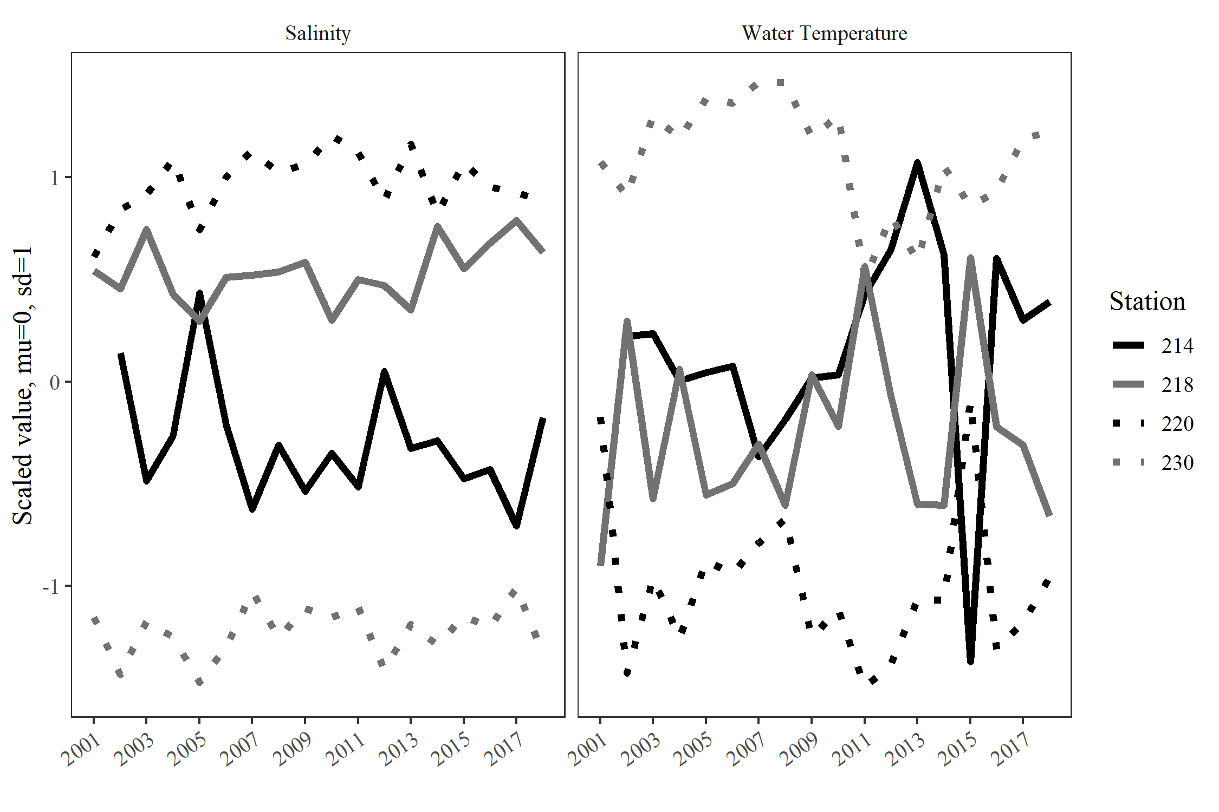

Figure 2. Annual variability in salinity and water temperature by station, Prudhoe Bay, Alaska, 2001–2018, scaled to µ = 0 and σ = 1.

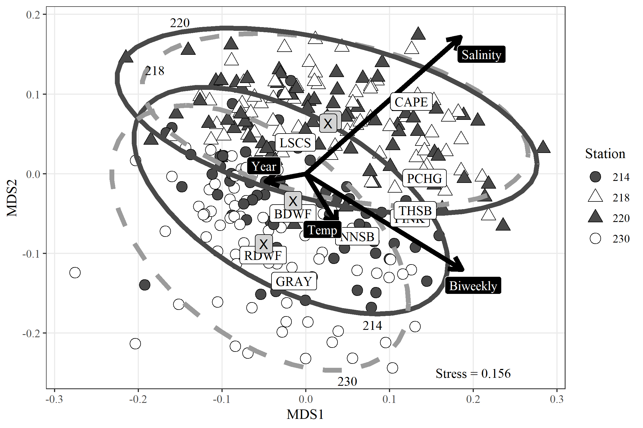

Figure 3. Non-metric multidimensional scaling (nMDS) ordination of fish species composition from Prudhoe Bay, Alaska, 2001–2018. Dashed ellipses are 95% confidence intervals; “X” labels mark centroids for each station. Environmental vectors of salinity, water temperature, biweekly period, and year are orthogonal to the gradient contours, pointing towards the direction of maximum association with the ordination. Displayed are the top nine species that were associated with nMDS axes 1 and 2, positioned according to their ordination score. Species codes are as follows: BDWF = Broad Whitefish *Coregonus nasus*, CAPE = Capelin *Mallotus villosus*, GRAY = Arctic Grayling *Thymallus arcticus*, LSCS = Least Cisco *Coregonus sardinella*, NNSB = Ninespine Stickleback *Pungitius pungitius*, PCHG = Pacific Herring *Clupea pallasii*, PINK = Pink Salmon *Oncorhynchus gorbuscha*, RDWF = Round Whitefish *Prosopium cylindraceum*, THSB = Threespine Stickleback *Gasterosteus aculeatus*.

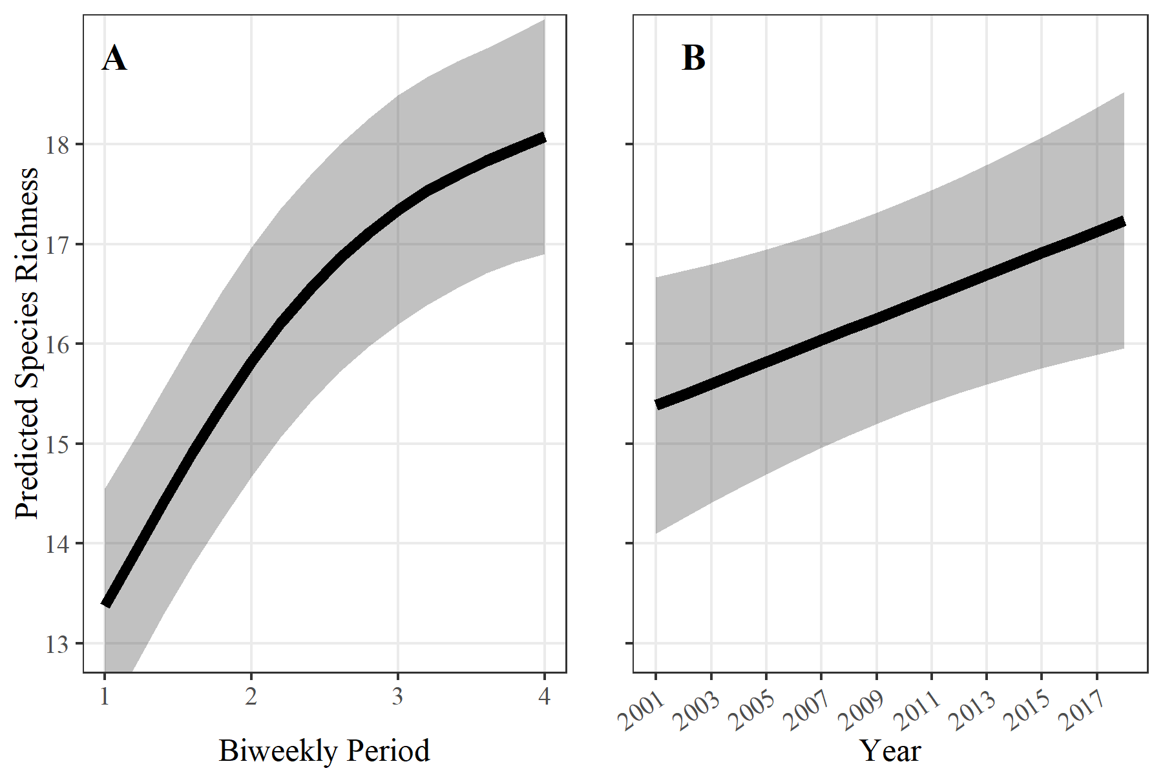

Figure 4. Predicted species richness by biweekly period (A) and year (B) for Prudhoe Bay, Alaska, 2001–2018, with standard error bands (+/- 1 SE). Modeled results from a Generalized Additive Model showed a predicted increase in species richness across years and biweekly periods.

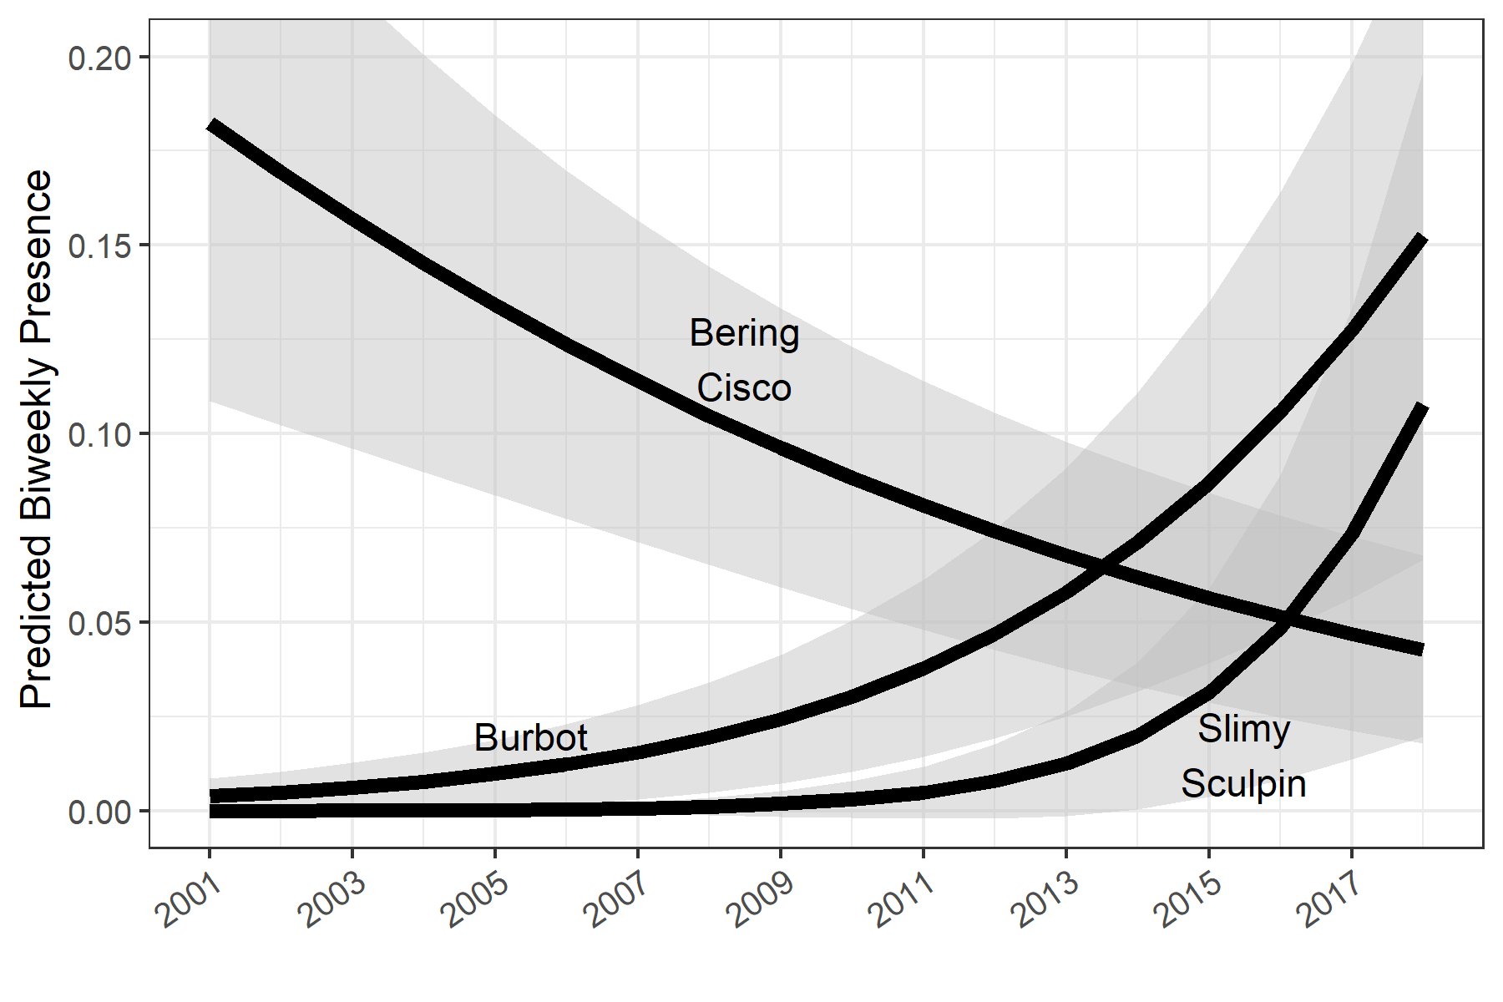

Figure 5. Predicted proportion of presence in a biweekly sample from a binomial Generalized Linear Model, Prudhoe Bay, Alaska, 2001–2018, all stations are combined. Only the three significant species are displayed. Standard error bands (+/- 1 SE) are shown as shaded areas.