T3L's contact point on the Web: http://www.univ-paris8.fr

Congratulations!
You are now the proud owner of a unique smartphone.

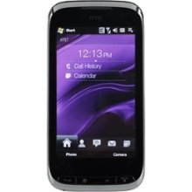T3L's Z-OrgluB: excellence made simple.

Setting up your smartphone

Buttons

A few simple buttons make it easy to turn your device on or off, adjust the volume, and switch between ring and silent modes.

- When you're not actively using your device, you can lock it to turn off the display and save the battery.
- When the device is locked, nothing happens if you touch the screen. Note thant you can still receive calls, text messages, and other updates.

You can also:

- listen to music:

- adjust the volume using the buttons on the side of the device while you're on a phone call or listening to music,

By default, the device locks if you don’t touch the screen for a minute. For more information, see Setting up the screensaver.

Setting up the screensaver

  - Press the ON button for 2 sec.
  - Use the WAKE button to choose the desired screensaver.
  - Press the ON button for 2 sec. again.
  - Use the SLEEP button to confirm the desired screensaver mode. For example: 3D Animated.
  - Press the ON button for 2 sec. again.
  - Your screensaver is set.

