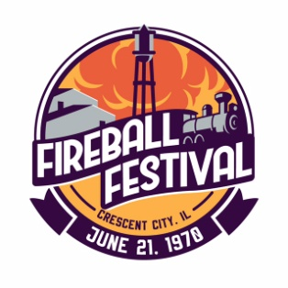 **2025 Fireball Festival Liability Waiver**

Thank you for your interest in participating in at the 2025 Fireball Festival!

I/We hereby accept responsibility for my/our own negligence and the negligence of any operator of my/our entry or equipment. I hereby agree to operate my/our equipment or vehicle in a safe manner, and adhere to all the rules set forth by the Fireball Festival committee, the Village of Crescent City, and the State of Illinois. I/We acknowledge I/We am/are liable for all medical and legal claims which may arise from participation in this event. I/We voluntarily agree to accept the risks of participating in this event on behalf of myself, my/our personal representatives, and my heirs and hereby voluntarily release the Fireball Festival committee, Village of Crescent City, and its directors, officers, employees, and agents from any and all claims, actions, causes of action, in law or equity, which may in any way or manner arise out of participation in this event.

I/We hereby grant the Fireball Festival committee permission to use my likeness in a photograph, video, or other digital media in any and all of its publications, including social media, without payment or other consideration.

I attest that I have carefully read, understand, and voluntarily agree to the terms listed above and the rules set forth by the Fireball Festival committee, the Village of Crescent City, and the State of Illinois shall be obeyed.

Printed name of Participant:

Printed name of Minor Participant:

Signature of Participant or Minor Guardian:

Address of Participant:

Email Address:

This waiver will be collected and kept on file for a minimum of 120 days in case of any future claims involving events hosted by the Fireball Festival.