Bamazon Screenshots for user workflows

Customer View

bamazonCustomer.js. Running this application will first display all of the items available for sale. Include the ids, names, and prices of products for sale.

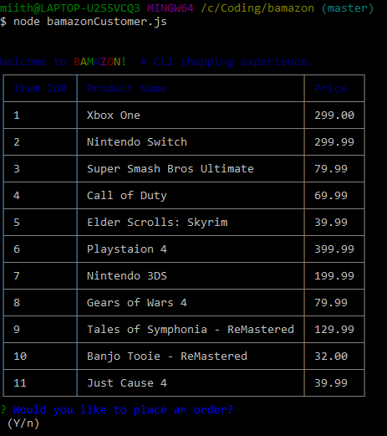

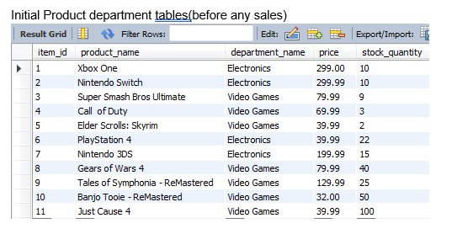

If the customer would like to place an order the following prompts will appear:

The first asks them the ID of the product they would like to buy. If not the correct item the customer can reselect:

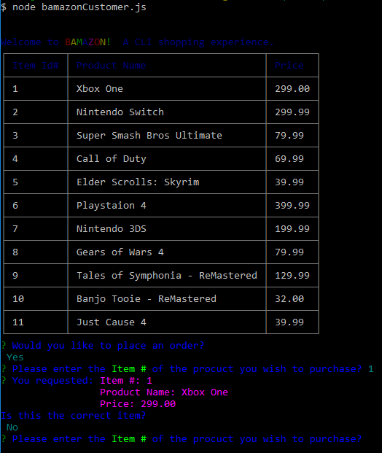

The second message asks how many units of the product they would like to buy. If the Quantity is over the amount in stock the application will notify the customer of how many are in stock and whether they would like to proceed with a different quantity:

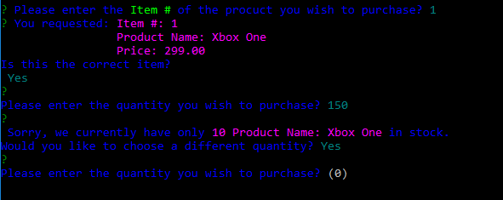

After selecting the quantity to be purchased the customer can then continue shopping and the inventory is visible to them again:

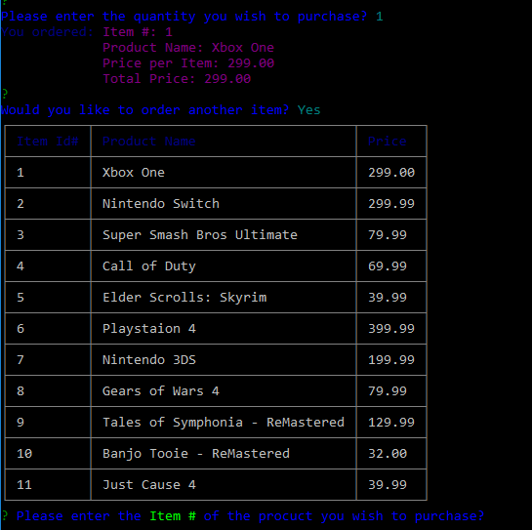

Total Price and Bill of Sale is now visible when customer is finished shopping:

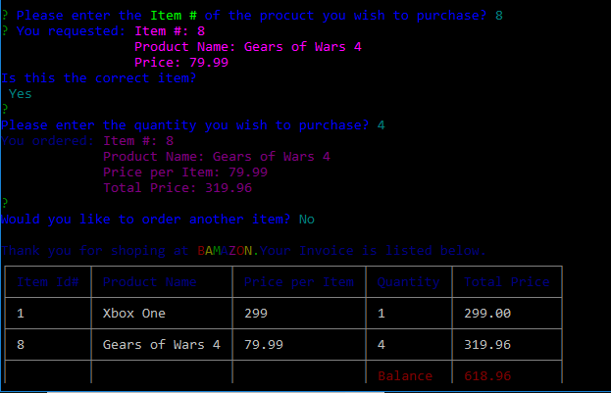

Database Pproducts table update following the purchase

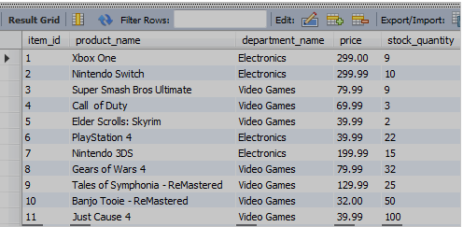

Manager View

Add New Product

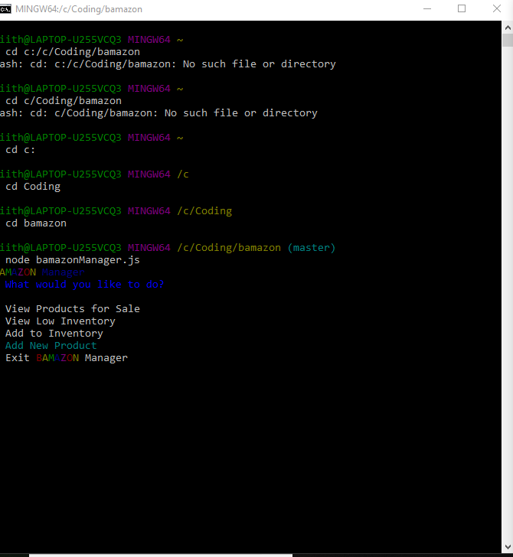

Enter Product Name

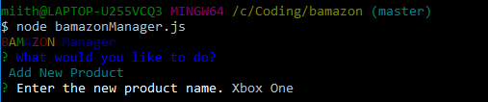

Enter Department Name

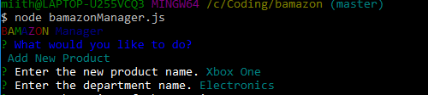

Enter Price

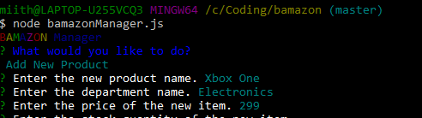

Enter Stock Quantity

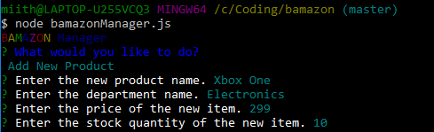

View of Product in Inventory with option to add more

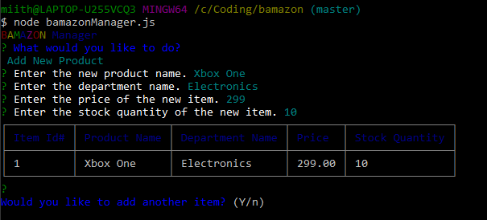

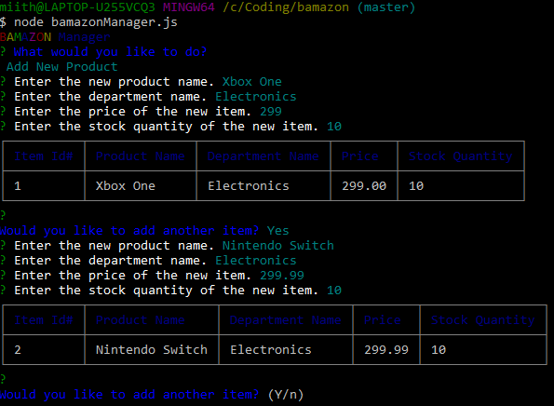

Selecting ‘No’ will return you to main menu

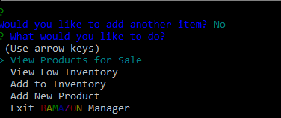

Add to Inventory

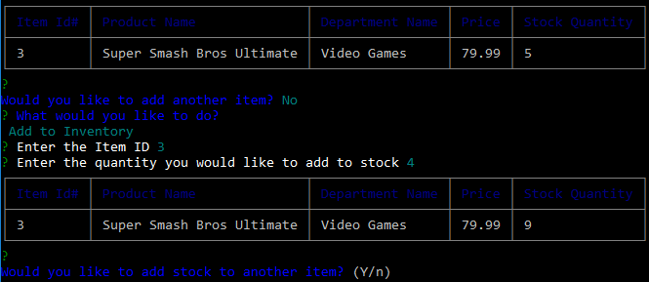

View Products for Sale

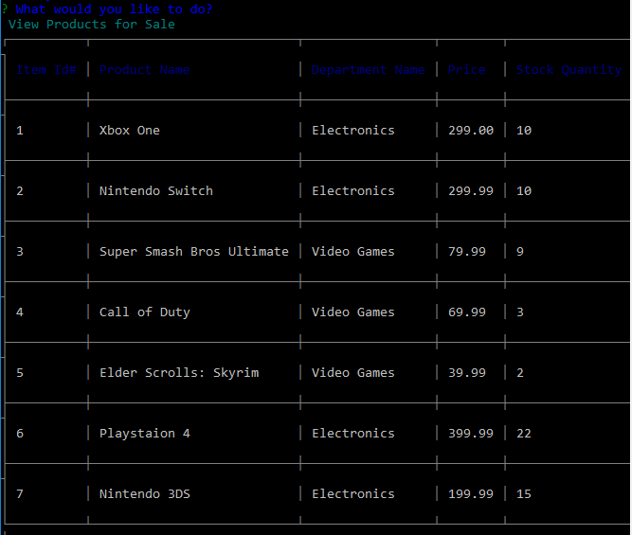

View Low Inventory

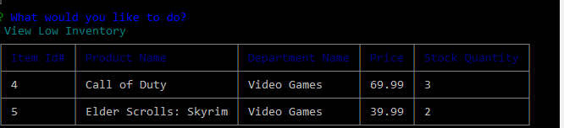

Exit Manager View

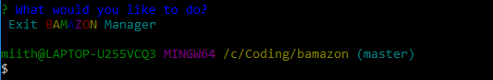

Supervisor